INTAHUB (PVT) LTD

Production
User Guide
INTAHUB (PVT) LTD

Contents
Production 3
1.1 Production Guide 3
1.2 Production Dashboard 4
1.3 Shift Type Management 5
1.4 Production Plan by Budget Summary 6
1.4.1 Budget Summary 6
1.4.2 Production Plan 8
1.4.3 Production Material Request Note 10
1.4.4 Production Progress 11
1.4.5 Dispatch Summary 13
1.5 Production Plan by Generated by FTR/ Sales/ Special Order 14
1.5.1 Food Transfer Requisition 14
1.5.2 Special Order 17
1.5.3 Food Transfer Note 18

Production

1.1 Production Guide

After clicking on the Production tab, you will be directed to the Production Guide window. In this window, you can view the,
- Budget Summary – Provides Steps of the Production Plan through Budget Summary

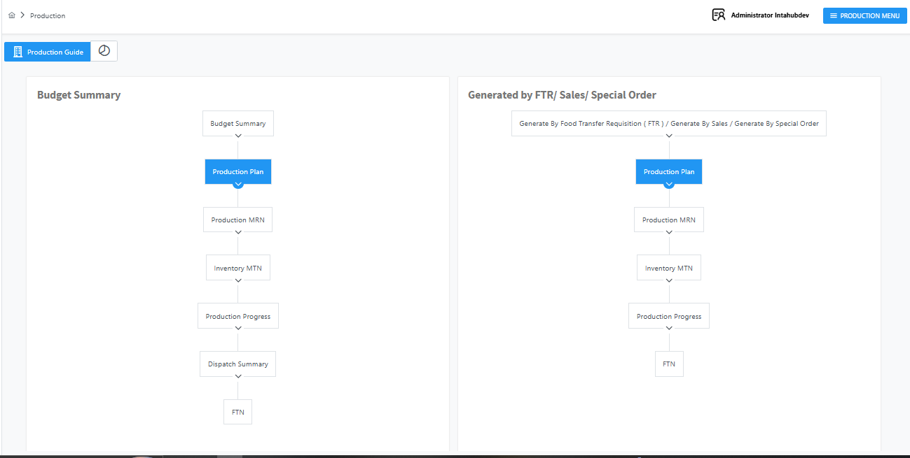
- Generated by FTR / Sales / Special Order – Provides Steps of the Production Plan through FTR/ Sales/ Special Order

1.2 Production Dashboard

By clicking the 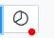 button, you can access a detailed overview of current production.

- You can Filter Daily Production Details dashboard view Using button.


- You can Filter Daily Production Details dashboard view Using button.


- You can Filter Daily Production Details dashboard view Using button.

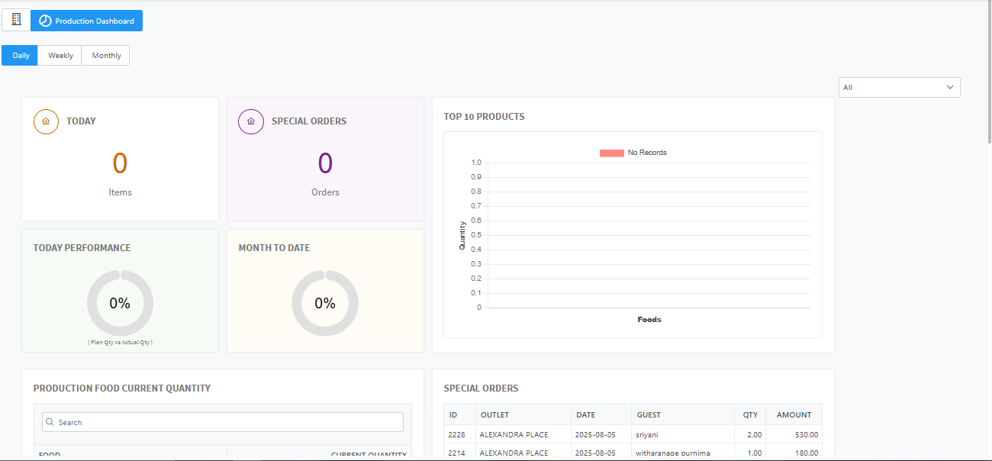

1.3 Shift Type Management

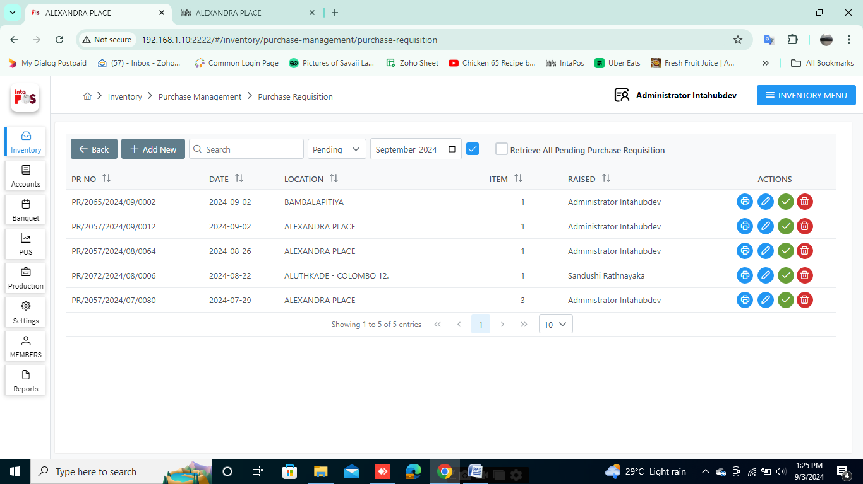
This allows you to create shift types used in production scheduling.
- To add new Shift Type using button.

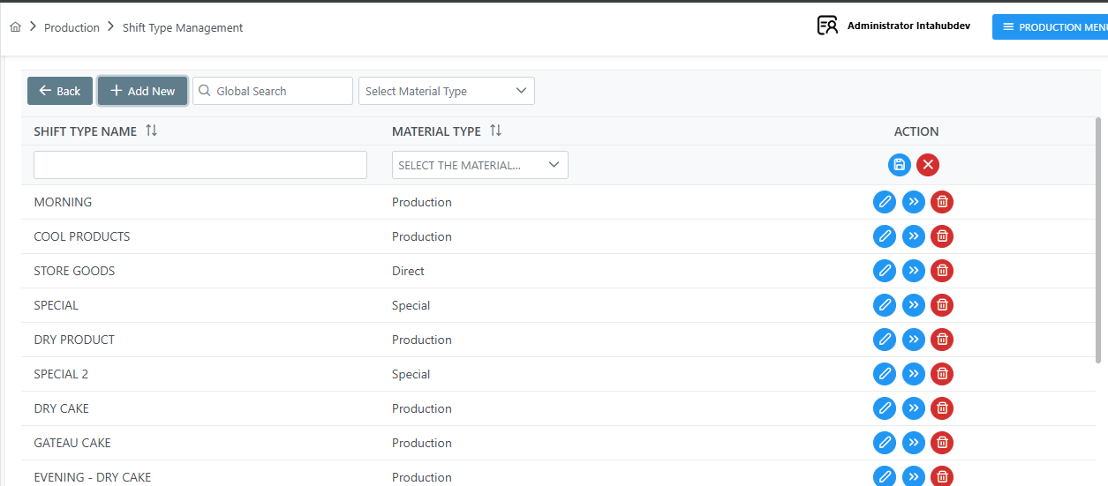
- You Can Save Shift Type using 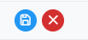 button.
- You Can Cancel Shift type using button.

- Select the Material Type can see available Shift type and You can also use the Global Search to filter and view specific records, as shown below.
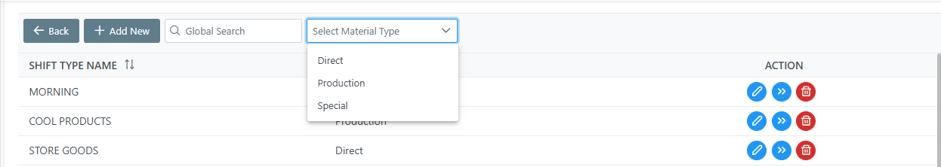

- You Can Edit or save a Shift type using button.


- You Can Delete Shift using button.


- You Can View the Shift using button.

After View the Shift, By Clicking button can Add Foods and Clicking button can Delete Foods.
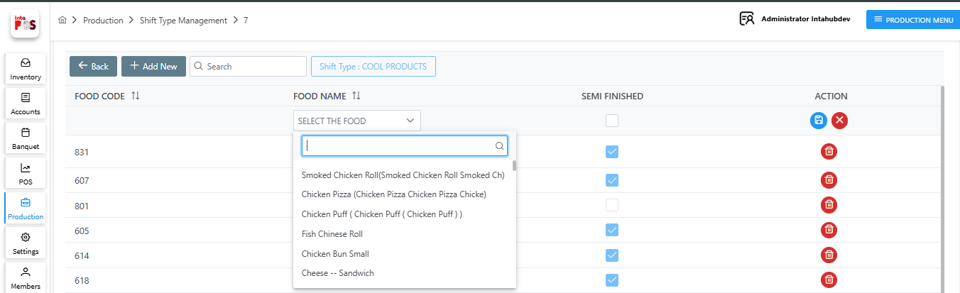

1.4 Production Plan by Budget Summary

1.4.1 Budget Summary
You Can Create Production Plan through Budget Summary. By using button add new Budget Summery.
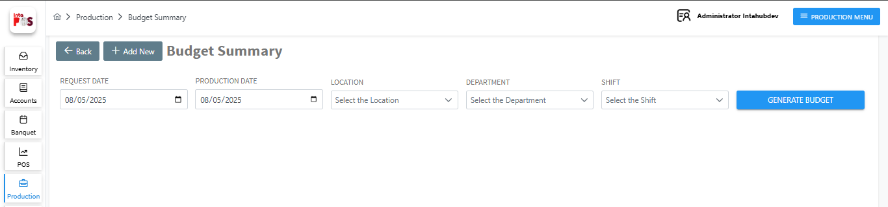


Once you have selected the Request Date, Production Date, Location, Department, and Shift, click the button to create the budget.

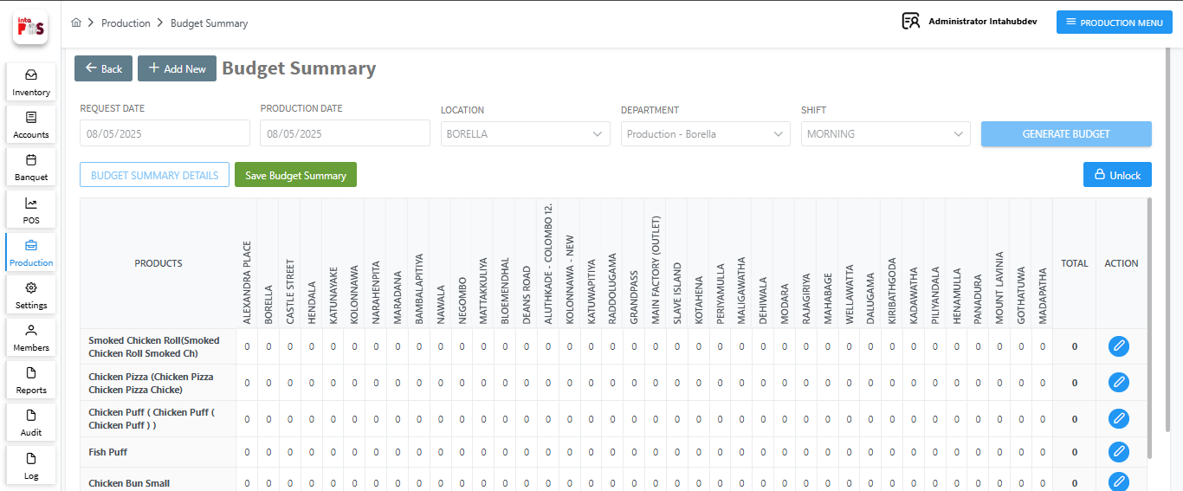
- To add quantities for each item by location, click on the button. After adding Quantities click on button Save the Record or click on button to Cancel.


- You Can Save the Budget summery, Clicking button as shown below.

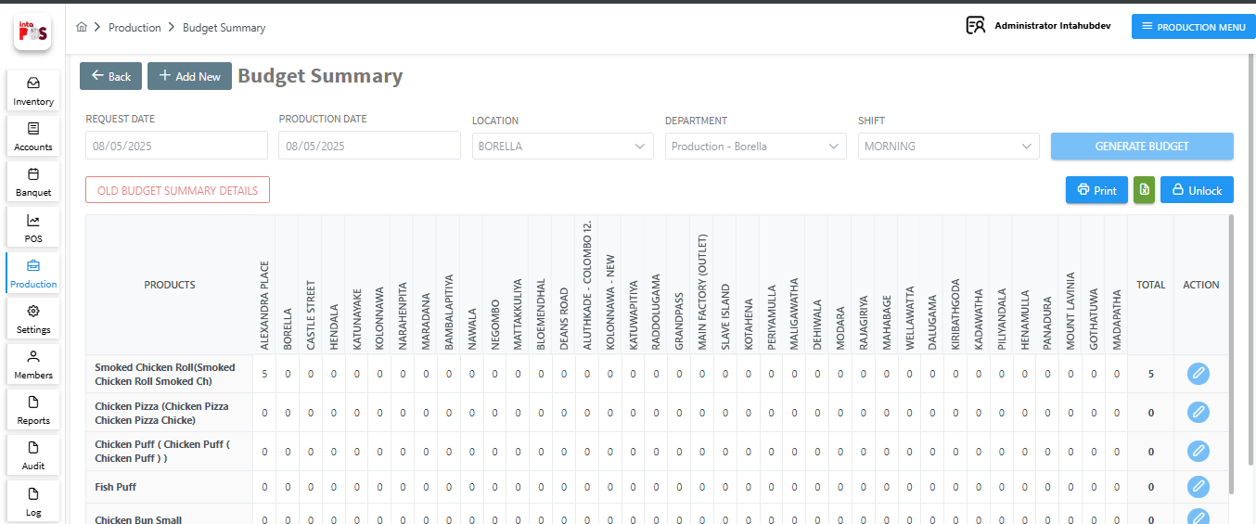


- Print the Budget Summery Using button .
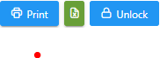
- Export the Budget Summery to the Excel using button.

- Can Unlock or Lock Action coloum using button.

1.4.2 Production Plan

When you save the Budget Summary, the Production Plan is generated automatically. Here can see Pending, Approved, Complete and Cancelled Production Plans by selecting the dropdown list.

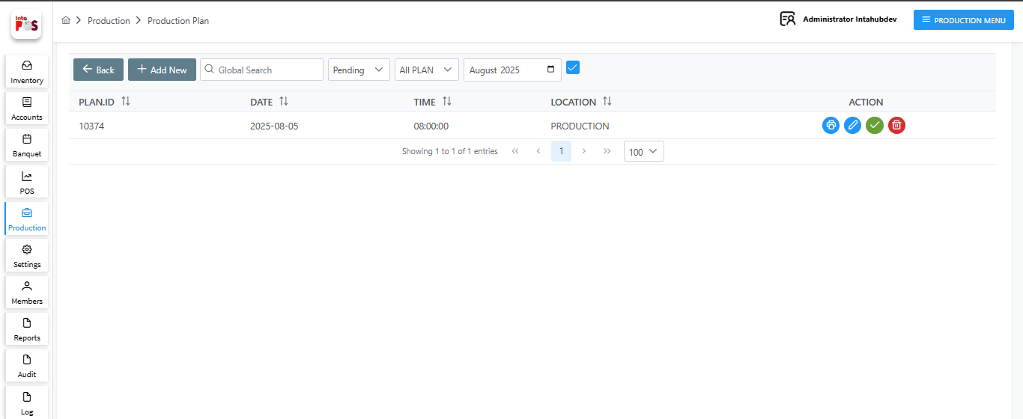
- Print a Production Plan using button.
- Delete a Production Plan using button.
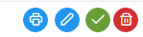
- Approve a Production plan using button
- Edit or save a Production Plan using button.

- After clicking the Edit button, Can add more Foods clicking button.
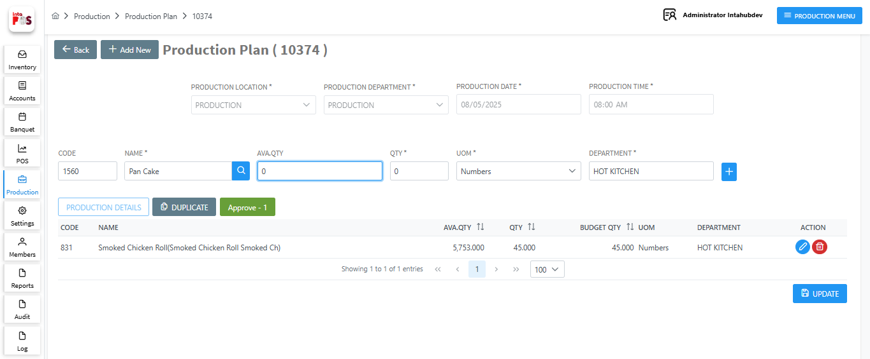
- You can add a new Food using  button.

- You can edit added Food details using button.

- You can delete added Food using button.

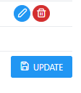
- Save the all Added Foods using button.

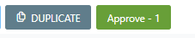
- Duplicate production Plan using button.

- Approve the Production Plan within the same window using the button.

Once Approve the Production Plan, it will appear in the “Production Material Request Note “.

1.4.3 Production Material Request Note

Once the Production Plan is approved, the required production materials for the food items are displayed in the “Production Material Request Note”.
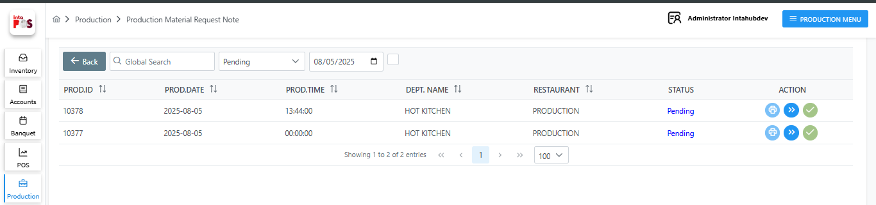
- By clicking the button, you can generate a Production Material Note by selecting a transfer location.
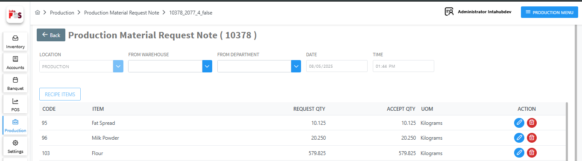
- You can edit added Accept qty details using button.
- You can delete added Item using button.


- You can Save the Note Using button.

Once you save it, the entry will appear in the “Created” panel. You can select that panel using the drop down box.
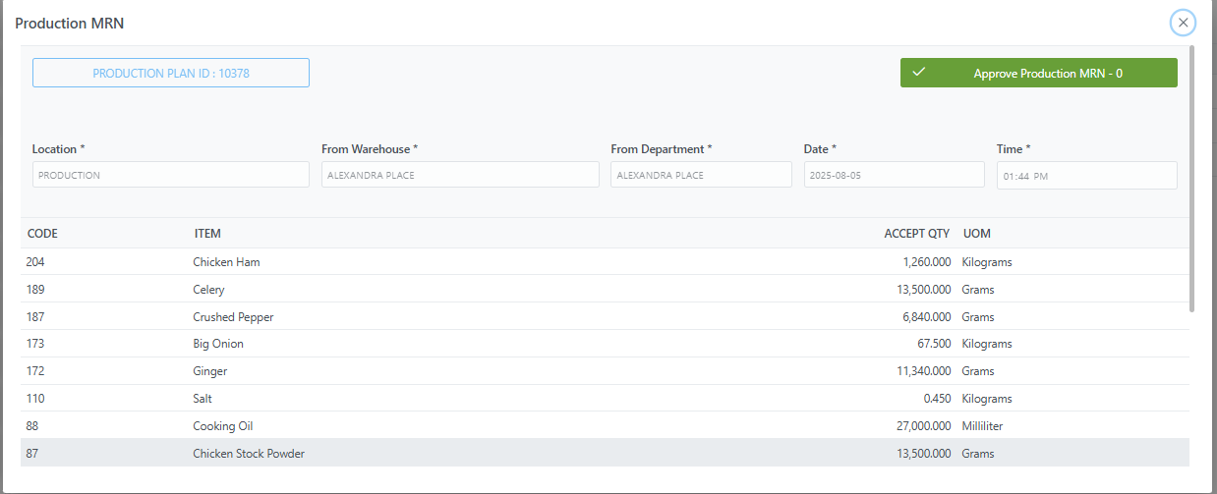

- Approve the Note using button.

Approved Production Material Request Notes appear in the “Inventory >> MTN Pending” panel and after it approved, the Production Material Request Notes move to the “Complete” panel.

1.4.4 Production Progress

This section includes Production Progress records from the Plan by Budget, Plan by Special, and Plan by Default. You can view each type by selecting it from the dropdown list.
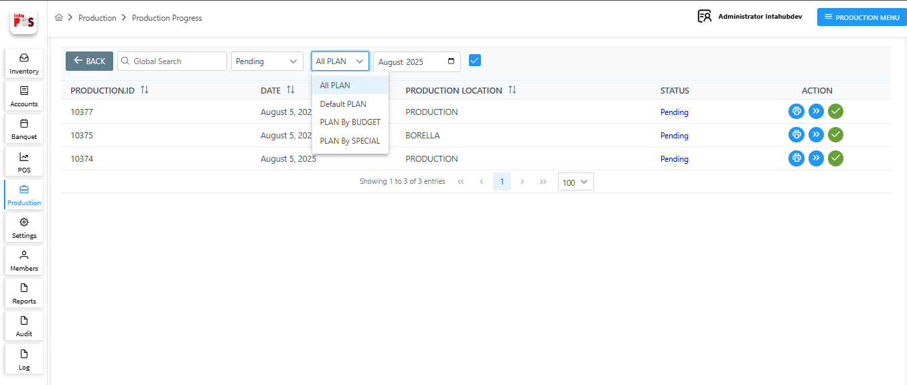

- Print a Production Progress using button.
- Approve a Production plan using button.
- View a Production plan using button and After MTN approval, the Produced Quantity can be edited by clicking a button inside the view.

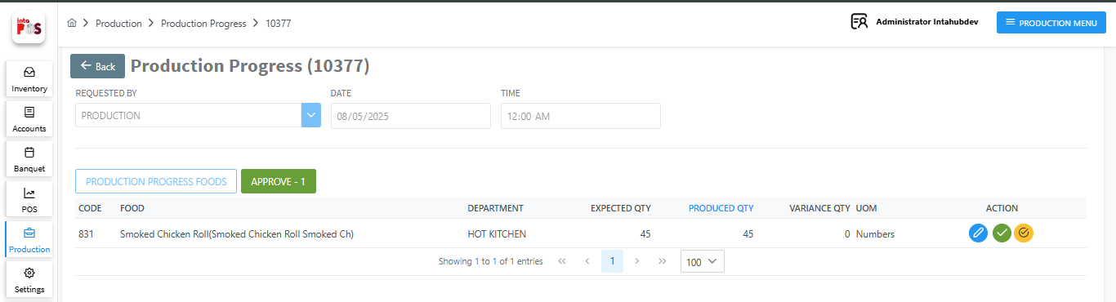

- Can confirm the Created Food One by One Using button.
- Approve Food One by One by using button.

- Approve all Food items at Once using button.

After Approve the Production Progress it will appear in the Approve window and you can select it using dropdown list as shown below.
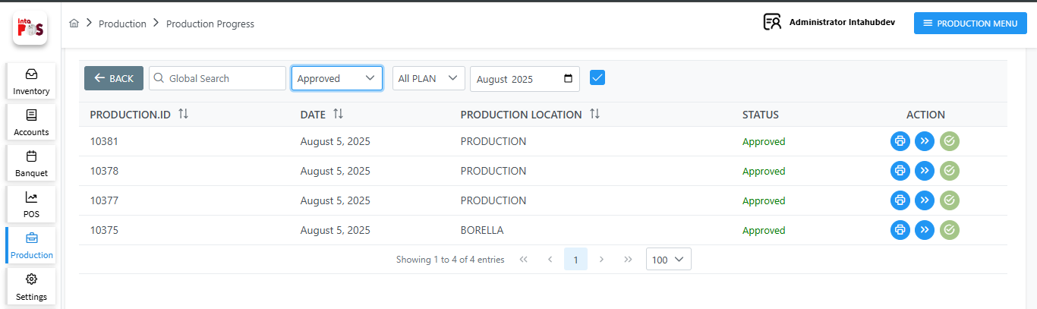

1.4.5 Dispatch Summary


Once the Production Progress finished, it can be loaded through this window by filling in the fields below and click button to generate the dispatch.
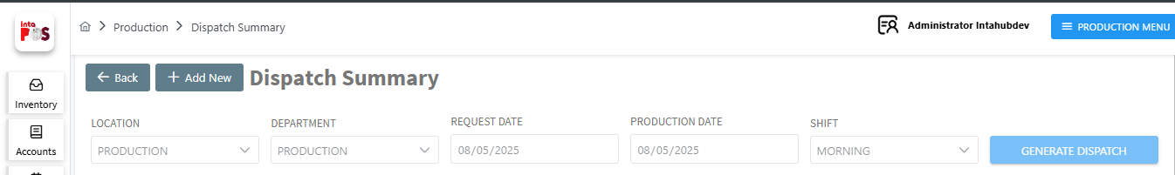

It Display the Transfer QTY for each location as shown below.
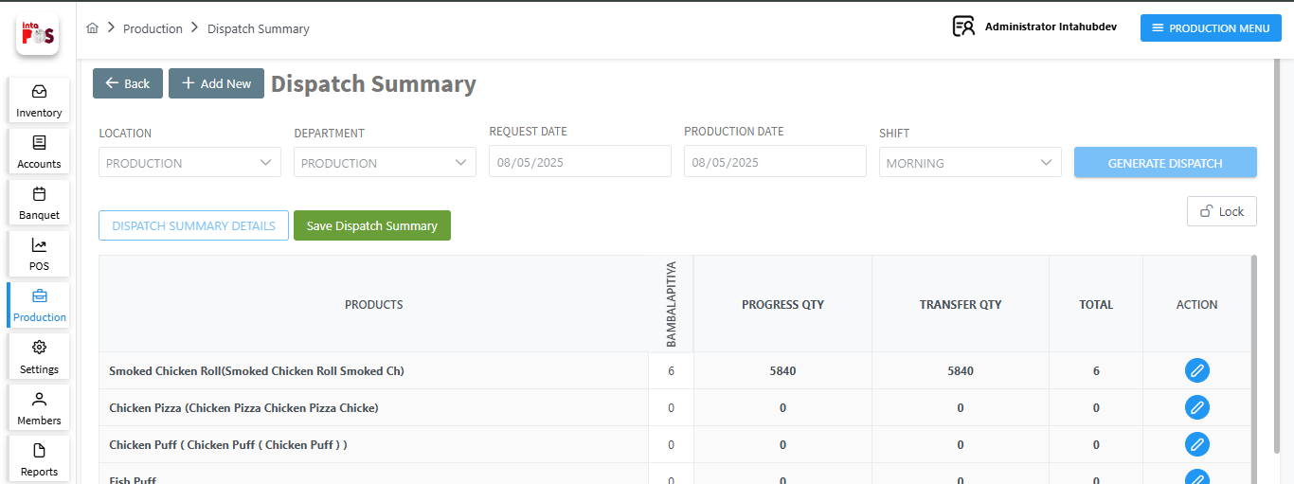

- Save Dispatch Summery using button

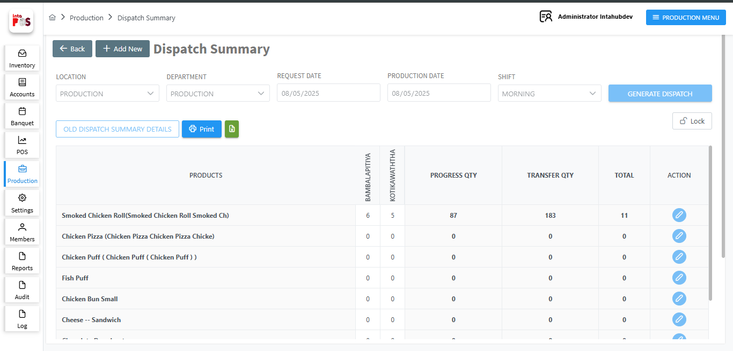

- Print the Dispatch Summery Using button .
- Export the Dispatch Summery to the Excel using button.
- Can Unlock or Lock Action coloum using button.

Saved dispatch summaries marked as finished products and loaded into the FTN Raise window, as shown below.

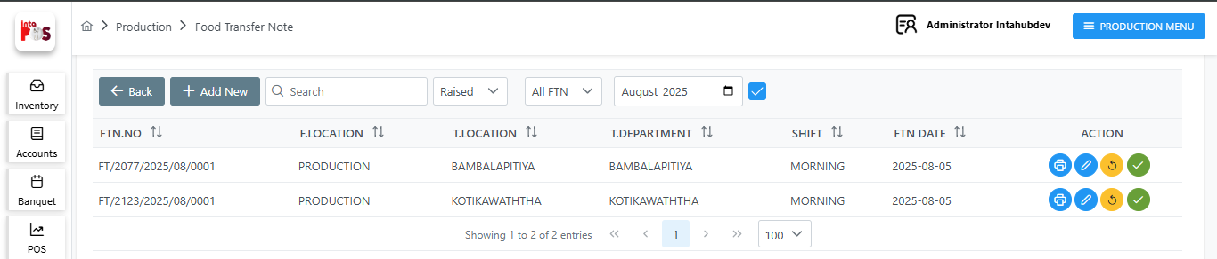

1.5 Production Plan by Generated by FTR/ Sales/ Special Order

1.5.1 Food Transfer Requisition
The window is showing available information of Department Requisition. By selecting Pending on dropdown list FTR is showing more information as follow.
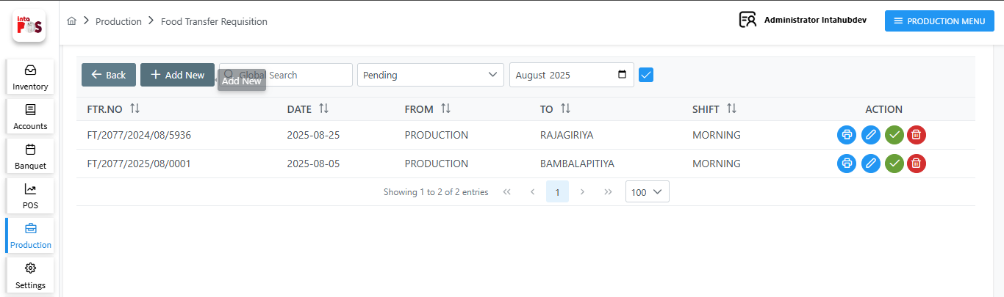
- When need to Request item to one location to another (i.e. between two restaurants) use this option. Here can see Approved FTR and Cancelled FTR by selecting the dropdown list.
- Can add more Foods clicking button and Select 'From' and 'To' locations, date, and shift to load the food for the selected shift.
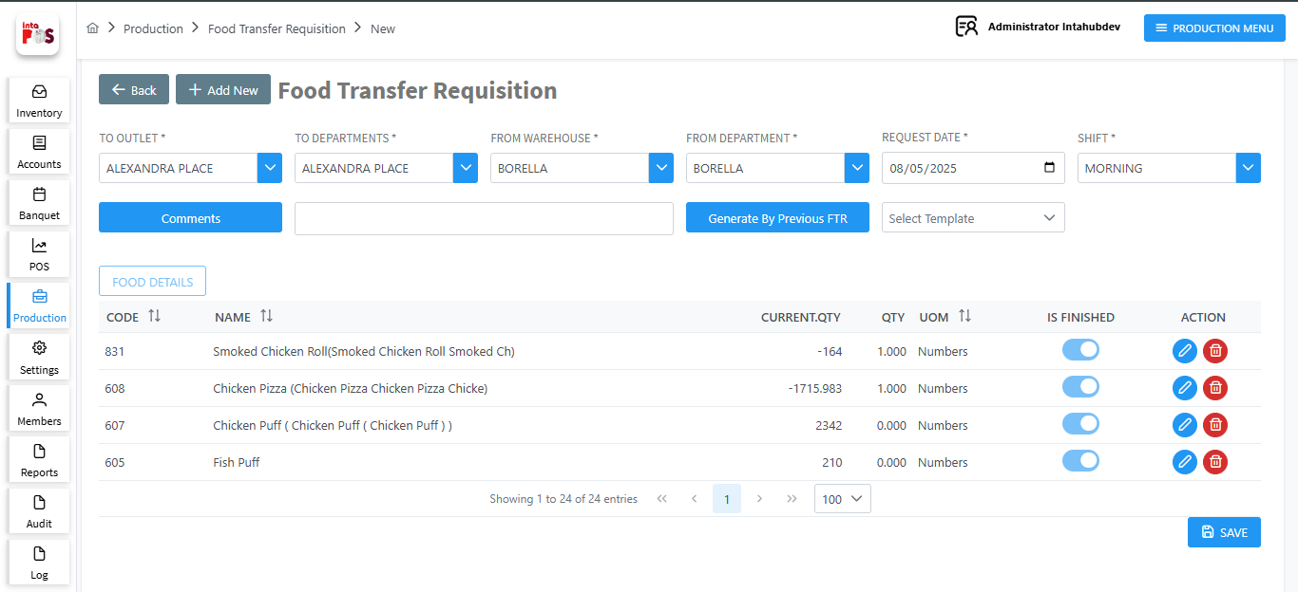
- Edit Food details using button.

- Delete added Item using button.

- Save the Note Using button.

- Save this Request Note as template using button.

- Add Comment Using button.

- Can Generate Previous Approved FTN using  button.

After approved pending FTR, In Here user Can be approve or delete that stock. The Received FTR are displaying in Approved FTR panel as follow.

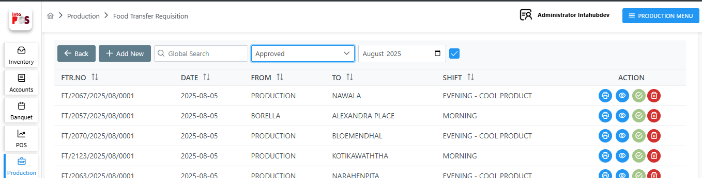
- Print a Material Transfer Requisition using button.
- View a Material Transfer Requisition using button.

- Delete a Material Transfer Requisition using button.

Once the FTR is approved, load it from the Production Plan by selecting the production details and using button as shown below.

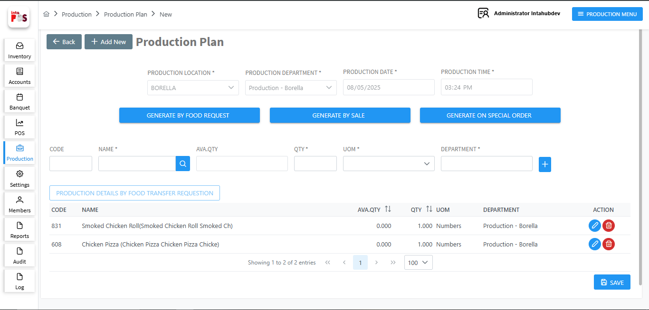

- You can add a new Food using button.
- You can edit added Food details using button.
- You can delete added Food using button.

- You can Save the Note Using button.

1.5.2 Special Order

When you create a Special Order through the POS, it will appear in this window.
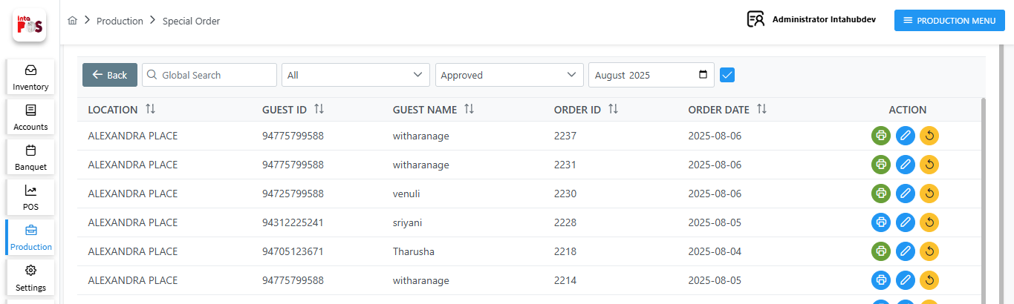
- Select the location, status (Approved or Finished), and date using the dropdown lists and calendar, as shown below.
- Print a Special Order using button.
- Edit an added Food details using button.
- Revert Special Order Again to the POS using button.

Once the Special Order Approved, load it from the Production Plan by selecting the production details and using button as shown below.
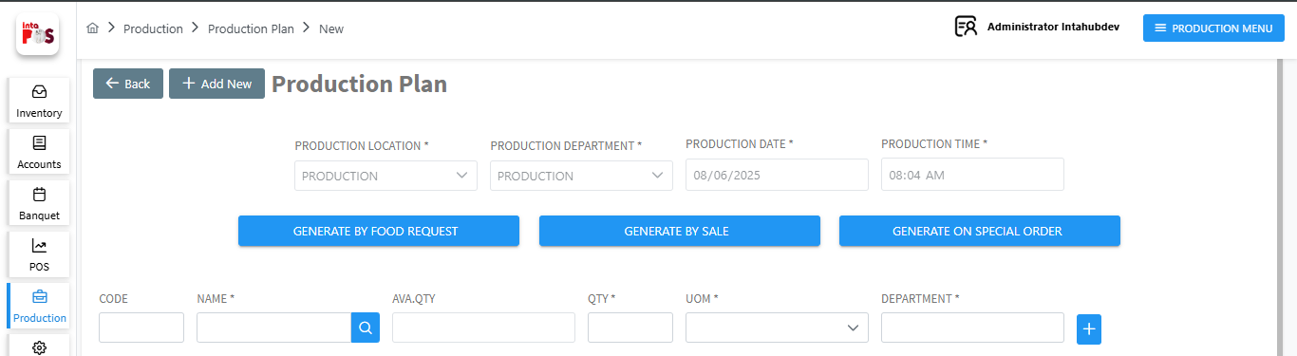
When the Production Plan approved the records will appear in the Finished Panel. You can select it using dropdown list as shown below.
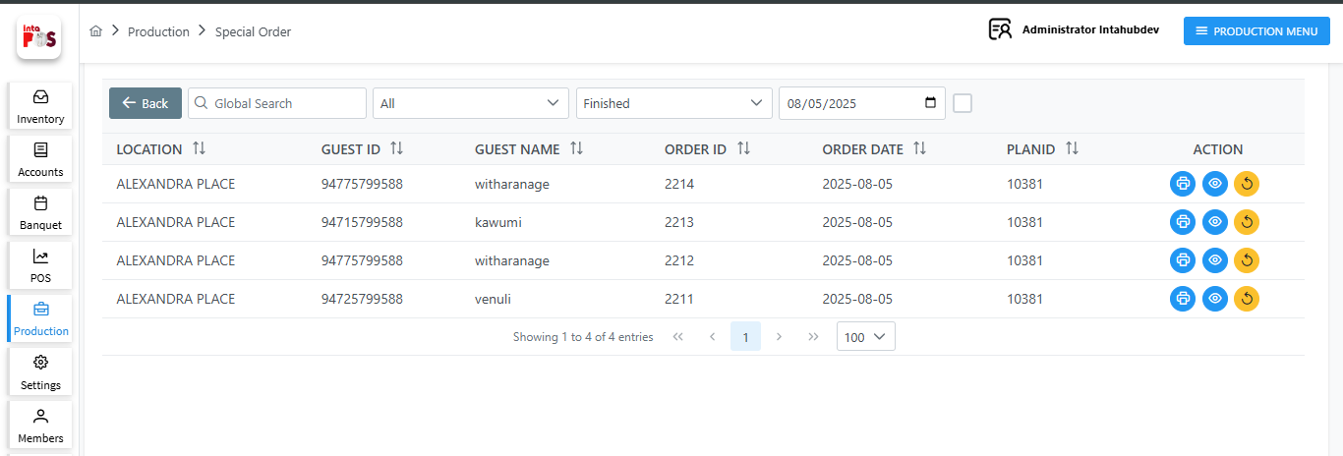

1.5.3 Food Transfer Note

When need to transfer selected item to one location to another (i.e. between two restaurants) use this option. Here can see Raise FTN and Approved FTN by selecting the dropdown list for good transfer as follow.

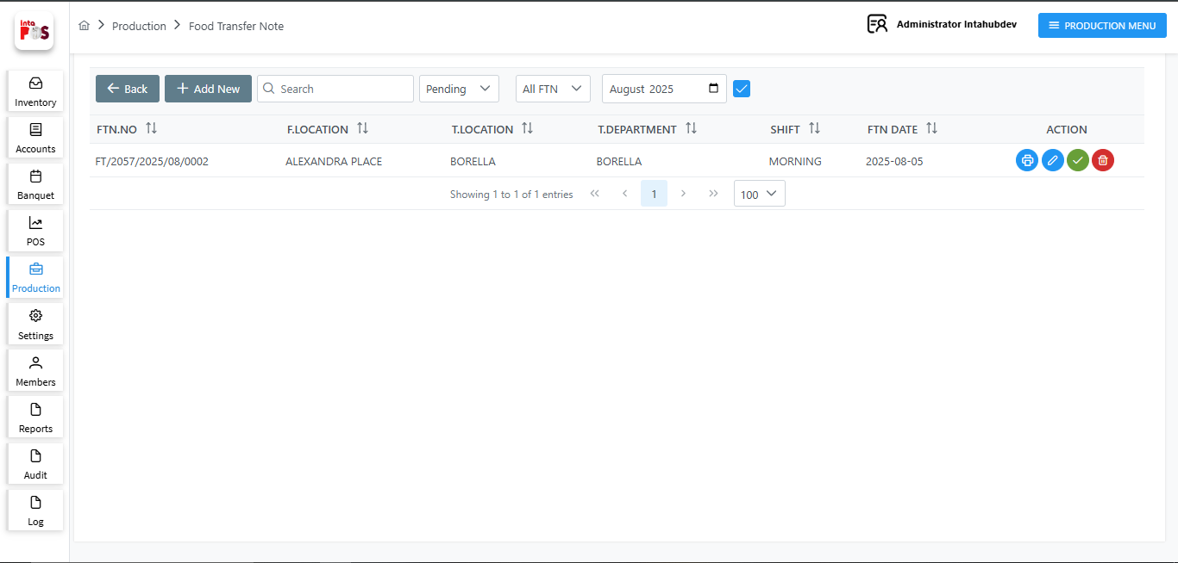
And also can select, Foods transferring is processing from where to where as follows.
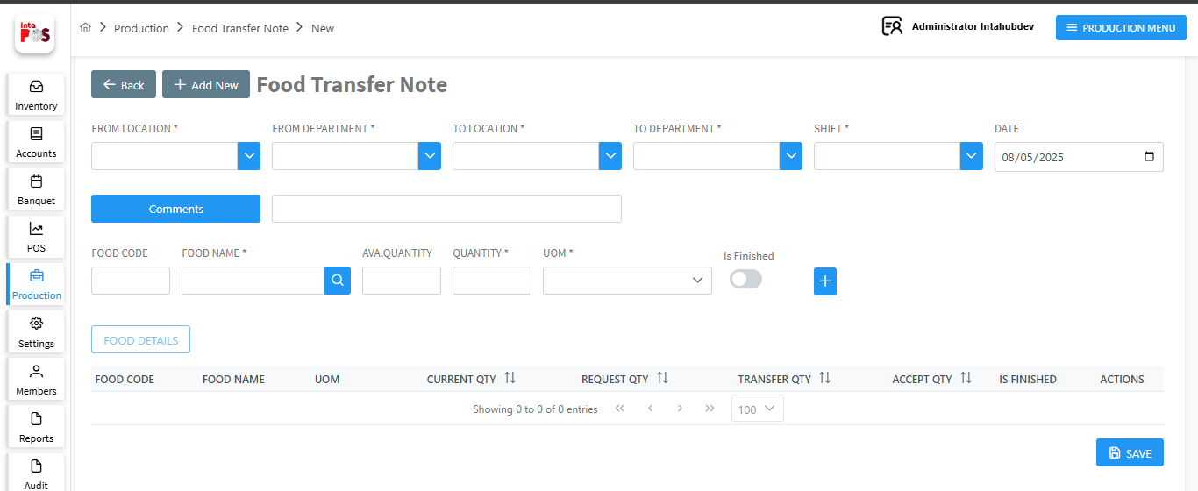
To add new FTN click button. And then enter Food names and quantities for new one in below table.
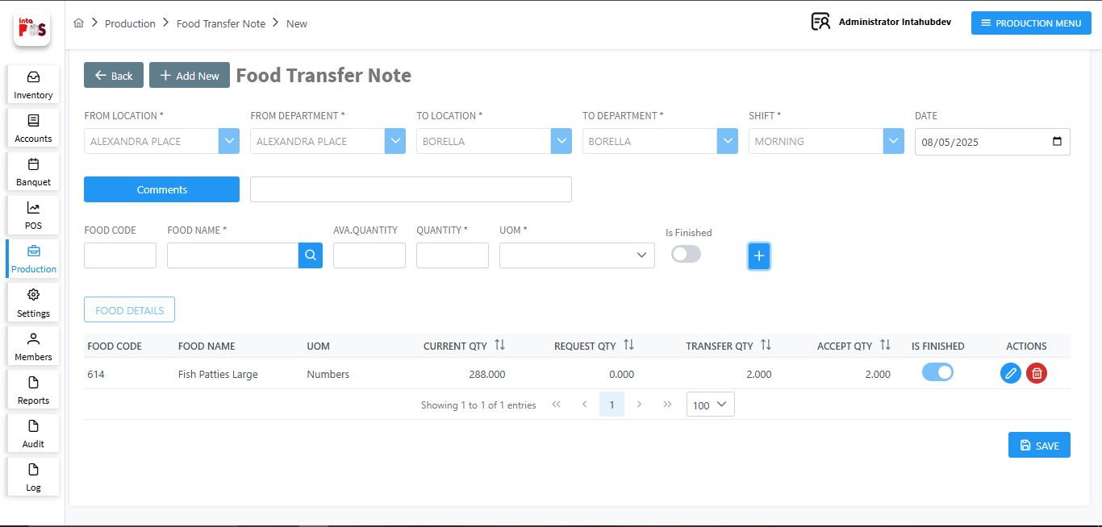
- Delete a FTN using button.
- Edit added Food details using button.

- Save the Note Using button.

Added FTN showing in Raise FTN window with pending status. In here user, should be approved pending FTN to transfer.
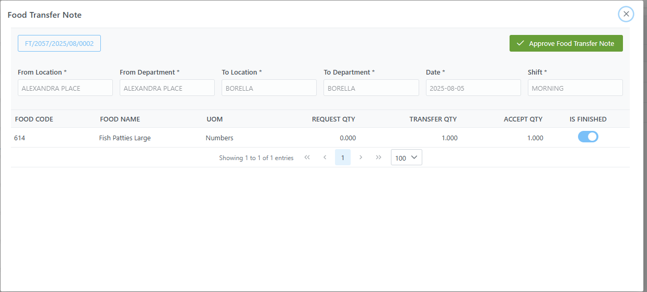
After approved pending FTN, then Stock Received to second user in restaurant two. User Can be approve or reject that stock. The Received FTN are displaying in Approved FTN panel as follow.
