Intahub (PVT) LTD.
Cloud POS System
User Guide
POS VER 4.0

Contents
Contents 2
1. Login 5
1.1. The Dashboard 6
3. Reservation management 8
2.1 Calendar Management 8
3.2 Quick booking Management 9
3. Order Management 10
3.1 Normal Order Management 10
3.1.1 Reorder 10
3.1.2 Order Comments 11
3.1.3 Order Quantity 11
3.1.4 Modifier 11
3.1.5 Cover number management 12
4. Fast Food Management 12
4.1 Direct sales 12
4.2 Fast food collects option 13
4.3 Save Order history 13
4.4 Fast food guest management 13
5. Tabs Management 14
5.1 Save Order history 15
5.2 Tabs: guest management 15
6. Order Operation Management 16
6.1 Line Discount Management 16
6.2 Full Discount Management 16
6.3 Complimentary Management 17
6.4 Service Charge ON/OFF 17
6.5 VAT ON/OFF 17
7. Split Order Invoice 18
7.1 Split by cover 18
7.2. Split by manual 18
8. Table management 19
8.1 Table transfer to other table 19
8.2.Tabs order assign to table 20
8.3. Table merge 20
9. Kitchen order management 21
9.1. Kitchen display unit 21
9.2. KOT / BOT printing 21
10. Delivery Management 22
10.1 Order Management 22
10.2 Guest Information Management 22
10.3 Rider & Delivery tracking panel 23
11. Payment Management 23
11.1 Payment Methods 23
11.1.1 Cash Payment 24
11.1.2 Cards (VISA/MATRO/AMEX) Payment 24
11.1.3. Cheque Payment 24
11.1.4. City Ledger 25
11.1.5 Duty Meal 25
11.2 Single Payment 25
11.3 Mix Payment 26
11.4 Multiple Payments 26
12. Admin Panel 26
12.1Cancellation 27
12.1.1 Order 28
12.1.2 Payment 28
12.2 User Reset 29
12.3 Shift management & Day End 29
12.3.1 Open Shift 30
12.3.2 Close Shift 30
12.3.3 Day end Process 31
12.4 Printer Reset 32
12.5 Receipt reprint 32
12.6 KOT reprint 33
13. POS Report (Cashier) 34
13.1 Daily Sales 34
13.2 Daily Product 36
13.3 Daily Category 38

INTAPOS Manual Version Updated
Date Updated by Version
01-08-2014 Dimuth V. 1. 0
06 -04 -2015 Chapa V.1.2
04 – 04 – 2016 Dineshika V.1.3
10-09-2024 Ashani V.3.0

GETTING STARTED
Welcome to the INTA restaurant portal guide. This manual is a step by step guide for executing the basic features of the INTA CLOUD POS systems.

Login
Use the login window to log in to the INTA Restaurant portal. Select user from the left panel in the log in window and enter valid password for the login.
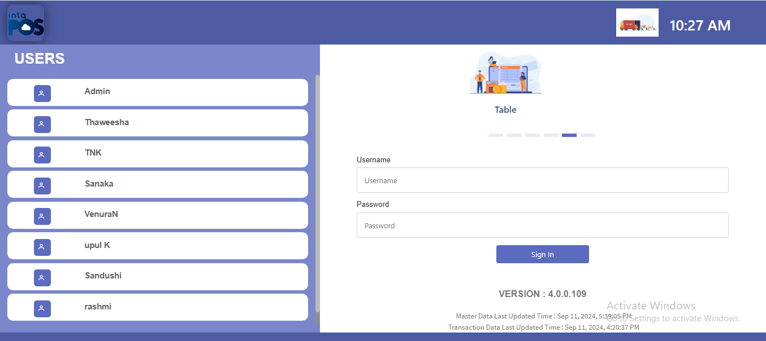
Note: The User name Password cannot be copied and Paste. And when log in proceed the following window will appear.
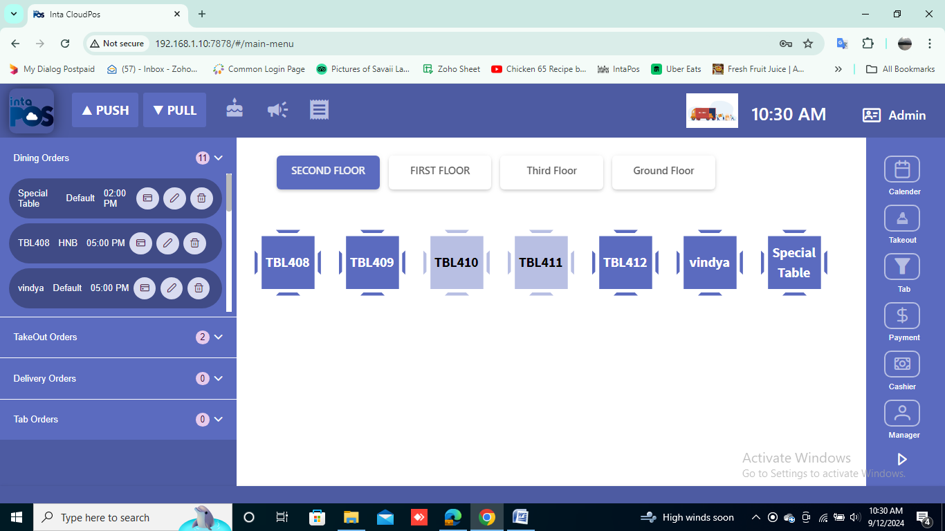

Header of the POS System
Once you click on username shown in the header of the application will prompt following window.
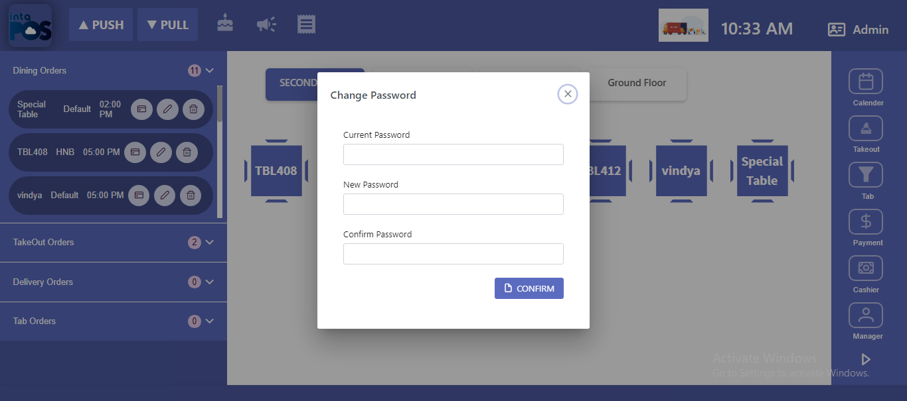
By click on below buttons can open these forms.
Checklists

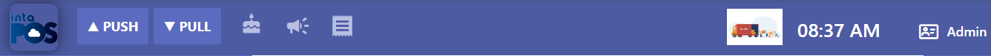
Guest Birthday
Promotions

Note: Once you click on Log out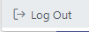Button, will log out from the Application.

The Dashboard

Once logged in, the dashboard will appear where the left hand panel shows the functions.
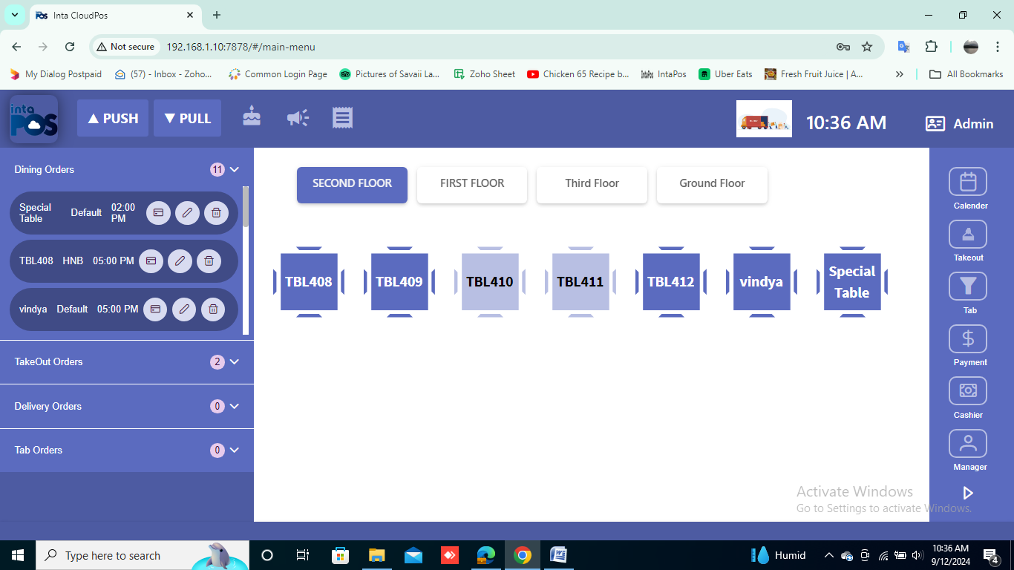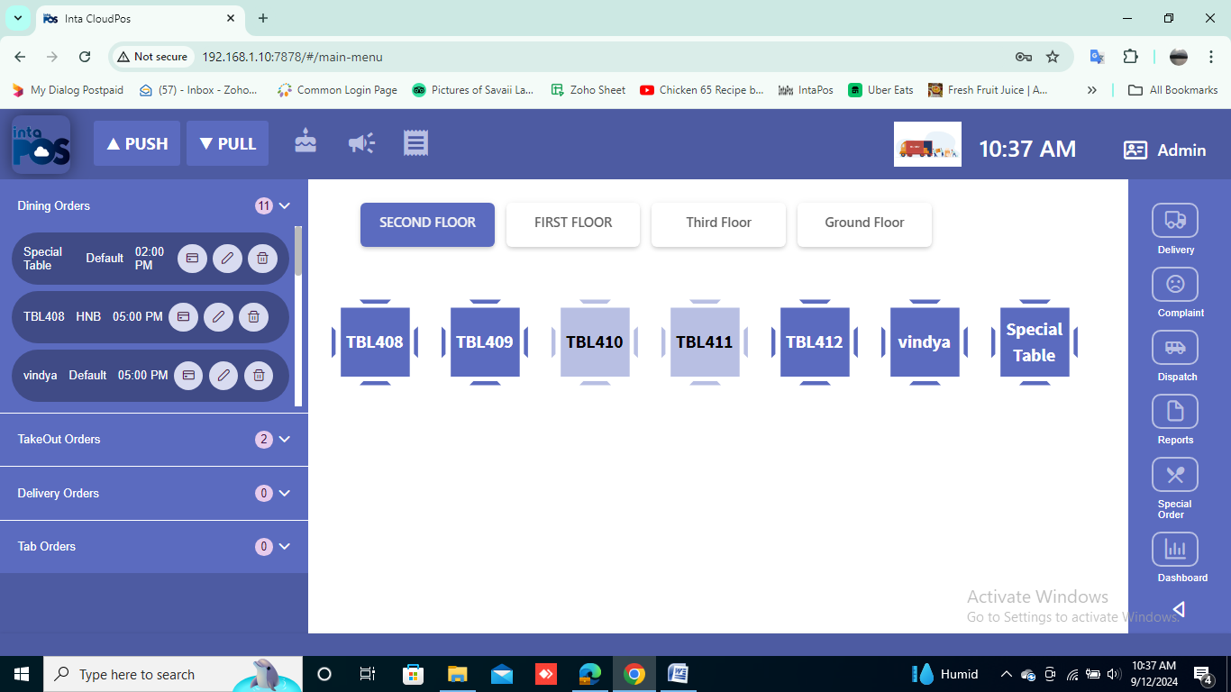

Manage Take Out orders
Manage admin panel

Reservation using calendar management

Manage all the payments

Cashier operation management

Generate Reports
For the special orders
For view the dashboard
Manage deliver details
For the Guest Complaint
Home/Office Delivery Management

Tabs for the people who doesn’t have tables

In the middle of the dashboard, the arranged tables are in equivalent to the floor plan of the restaurant as follows.
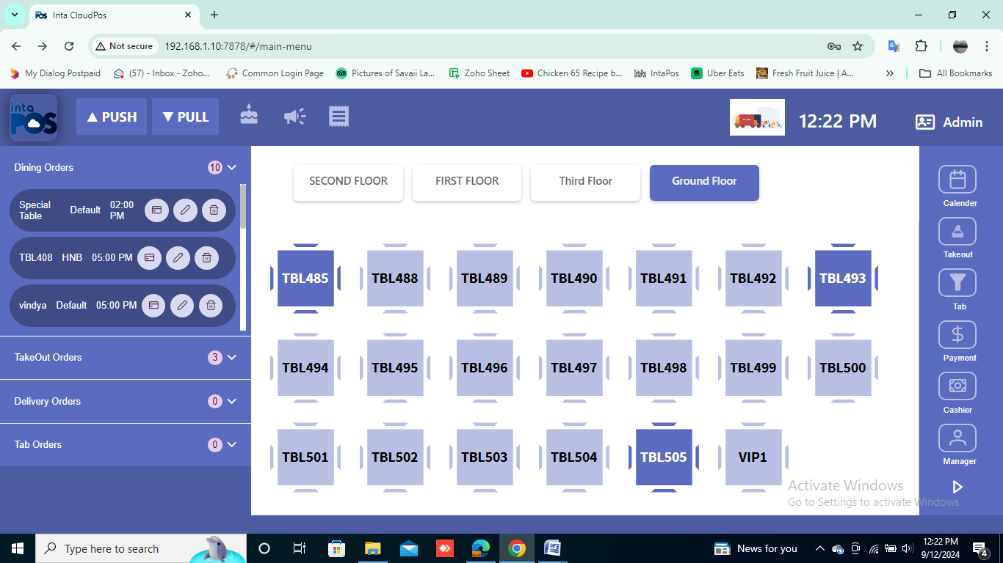

The occupied tables are highlighted in blue whereas the available ones are in light blue colour.
- The dashboard left panel available the reserved dining, takeout, delivery and tab orders. And the status of those reservations showed which are checked in and status of that reservations.

- More details of the reservation could be visible at the dashboard left panel with the order information.

The order can be cancelled by clicking delete Button and the reserved tables can be update, and payments by clicking these buttons.

Note: Reservations cannot be cancelled when the reservation already ordered foods and will get following Warning message.

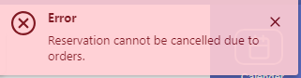

Reservation management

2.1 Calendar Management
Calendar management can be done by clicking buttonin the Dash board.
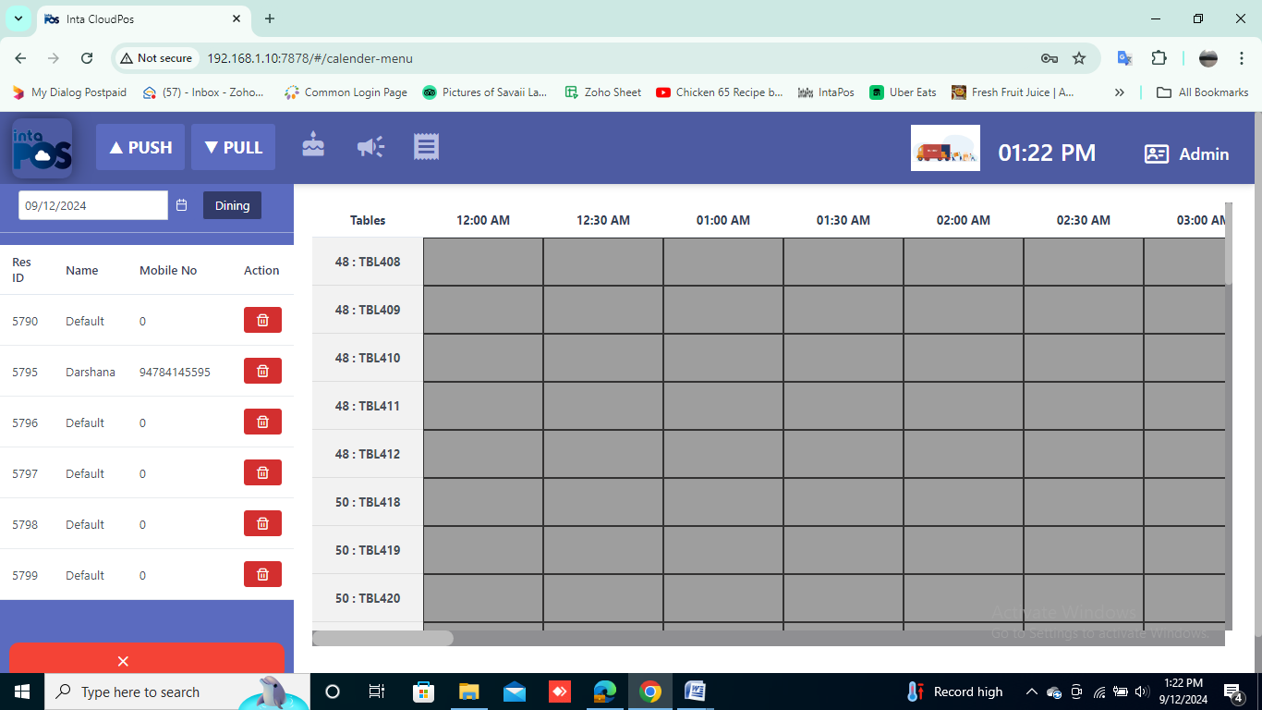

- To the far right of the reservation panel, represents the time and statuses of the reservations and includes an easy search date function.

When you click on a time slot and add new button, the below form can be obtained. Then a reservation can be done by filling this form.
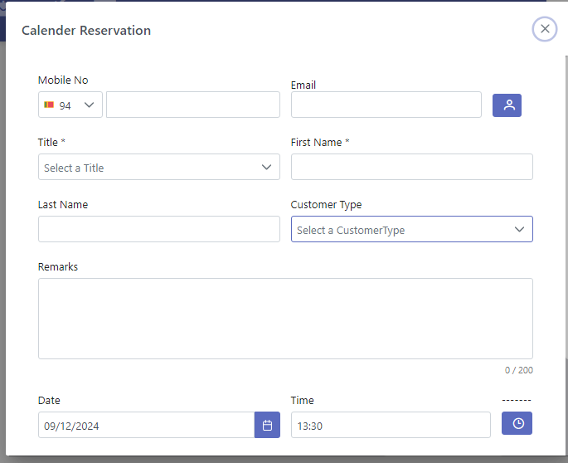
Note: The past time slots cannot be reserved, will show a warning message as follows.
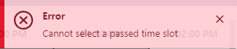

Once click on add sign in the below menu appearing, it will show following window to reserve table or tables prefer. Here this is available for table merging. That any tables can merge which refers to reserved person.
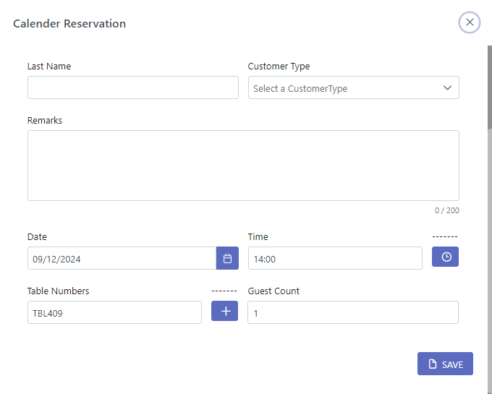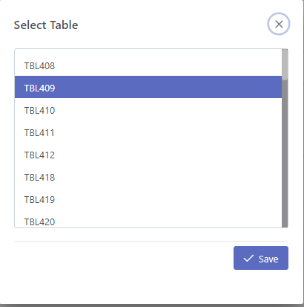

Quick booking Management

Tables can be reserved by the users with a waiter by clicking light colour tabs which represent in the dashboard.
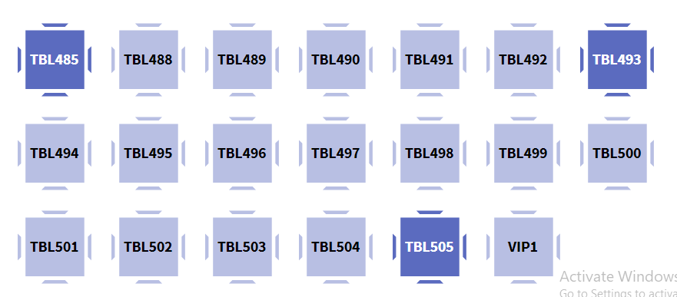

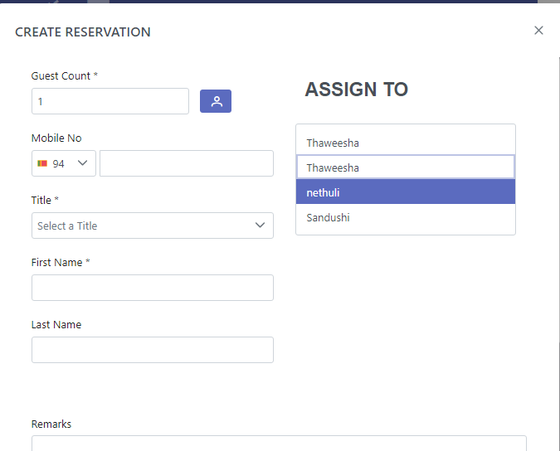

3. Order Management

3.1 Normal Order Management
Food Items can be ordered using this wizard. Food Items are grouped into several food types.
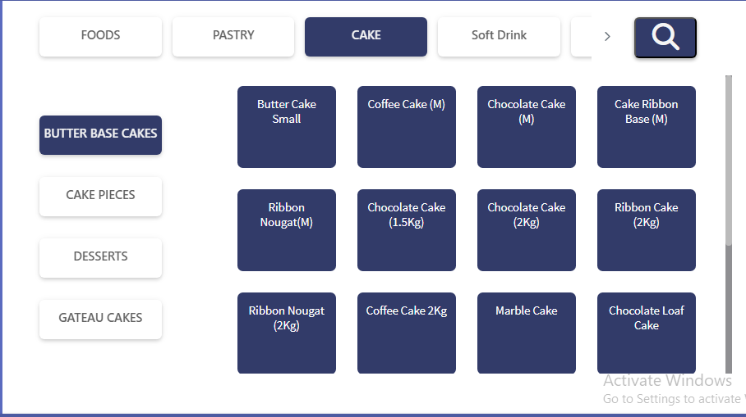
Food items according to food category and type
Food Category
Food Type

3.1.1 Reorder
Once some foods are ordered, they can be reordered again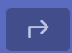.Button enables the reorder.
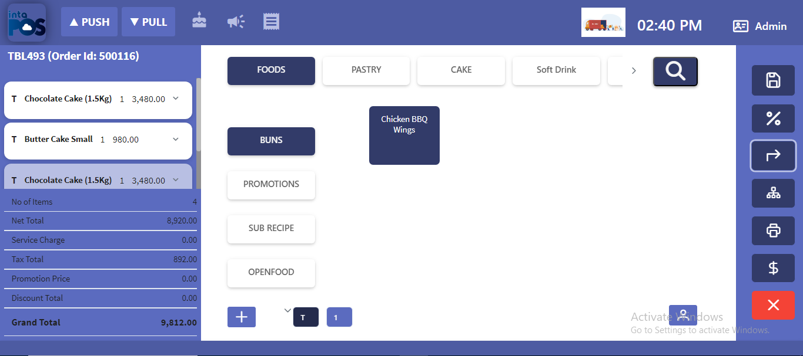

Note: The reordered foods will appear in white colour. It can be deleted or commented by clicking specific food item.

3.1.2 Order Comments

Once you click comment button on a food the below popup will appear.
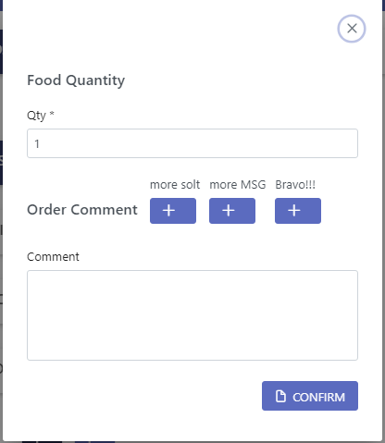

Note: Inside the comment box, you can type any comments regarding the food or order.After confirming the comment that will appear in the saved food order.

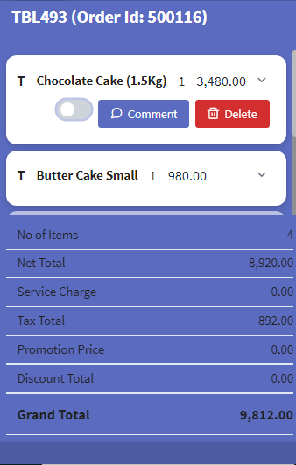

3.1.3 Order Quantity
By click the left or right arrow keys, the quantity of the particular food can be selected.
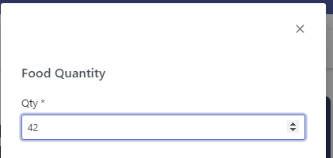

3.1.4 Modifier

3.1.4.1 Remove Ingredients
Ingredients can be added and removed to an item can be done through the modifier.
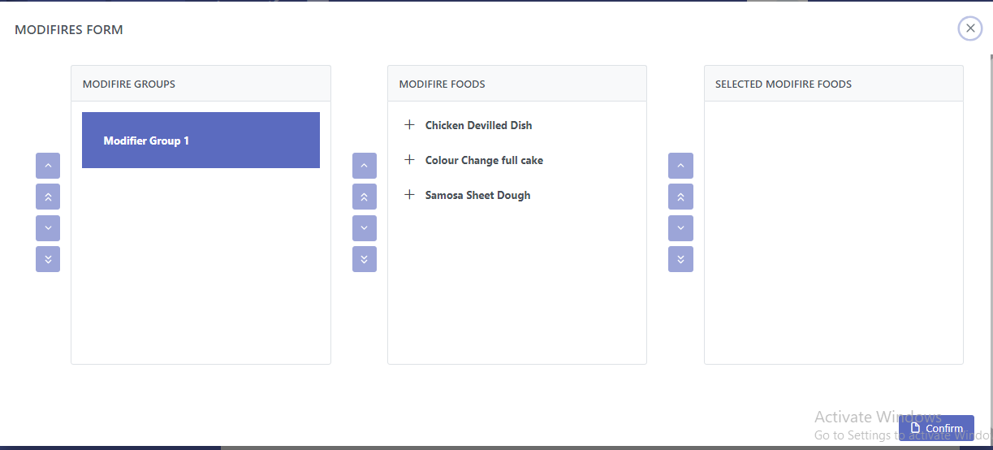

3.1.5 Cover number management
The orders can be made for the table or for each and every visitor. Cover number indicates the visitor.
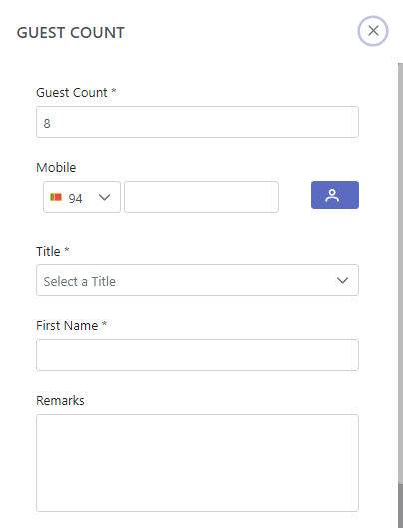
A Cover
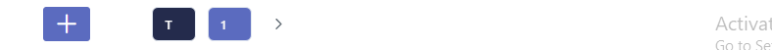

Note: Cover number can be add or remove by clicking arrow keys shown in the pop up menu.

4. Fast Food Management

4.1 Direct sales
Go to direct sales by clicking the button.
This is to sell items without reservations.
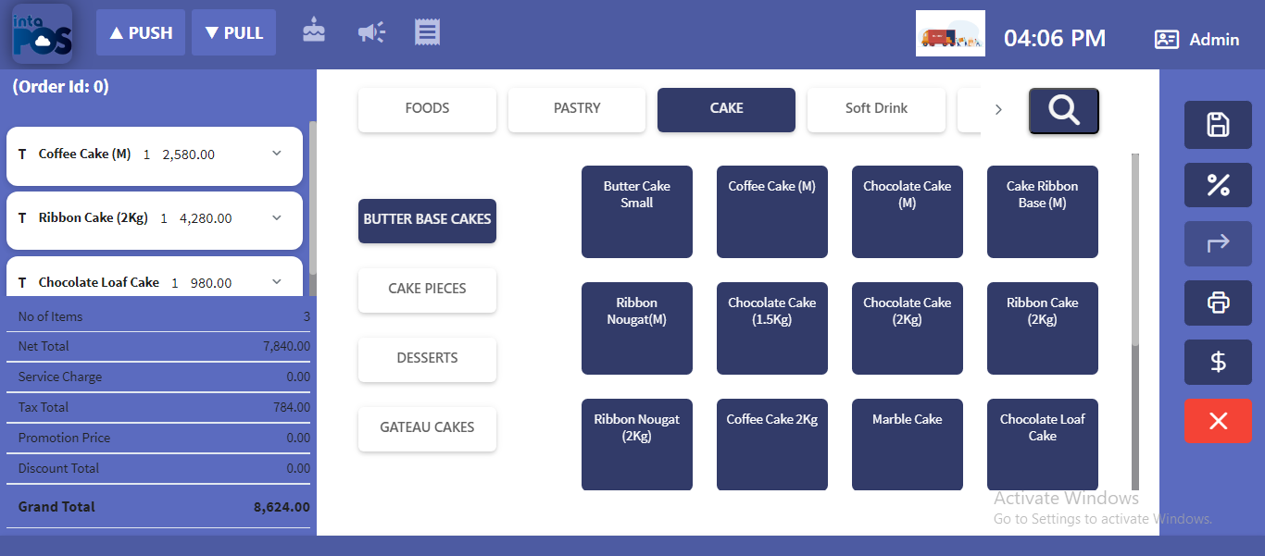
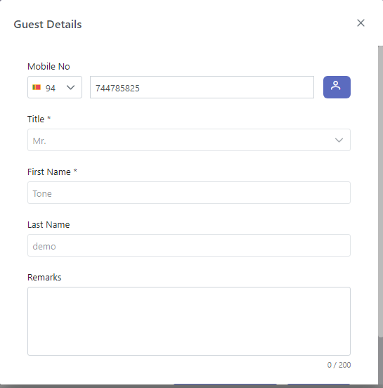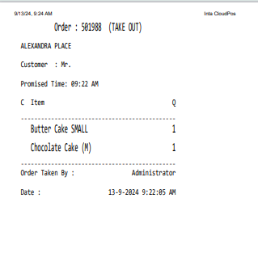

4.2 Fast food collects option
Pay the bills for fast food use option.

4.3 Save Order history
The Takeout details can be saved using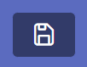option.
To view Takeout history click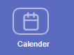 tab and click on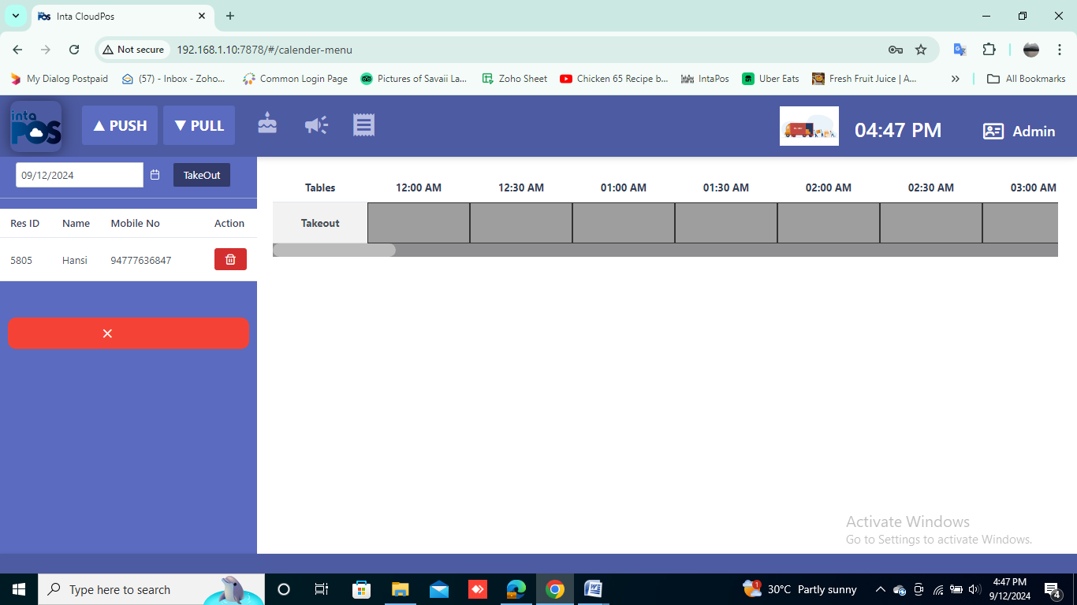 button.
The below window will appear.

4.4 Fast food guest management

Delivery section can be accessed by clicking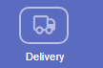button. Then can see this window to select delivery types.
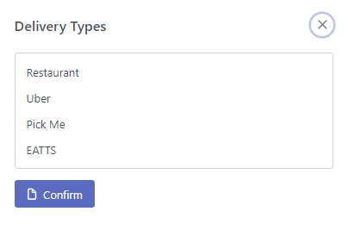
All the Home Deliveries can be handled using this section.
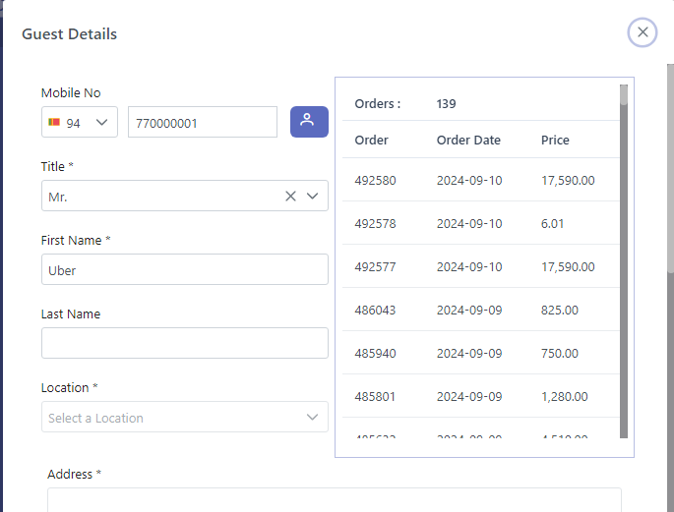

5. Tabs Management
Tab is come into play when the restaurant is fully occupied. Tabs referred to the customers those who don’t occupy a table. Tabs can be allocated to a table. Tabs can be done by clicking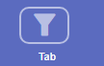button in the Dash Board.
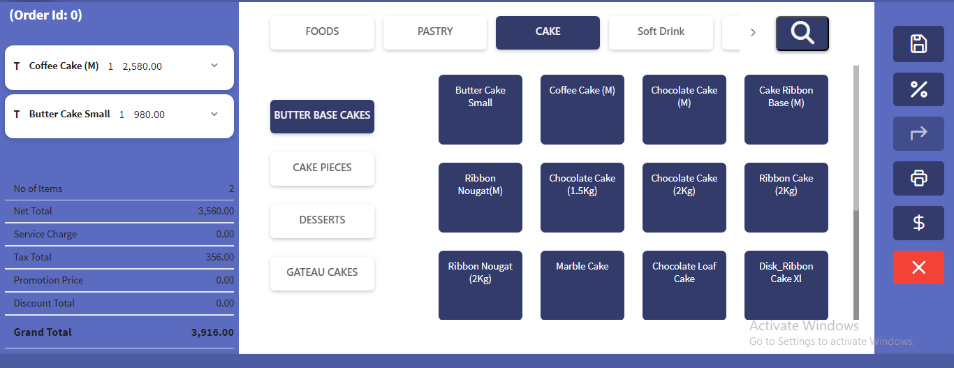

5.1 Save Order history
Click Tab button and go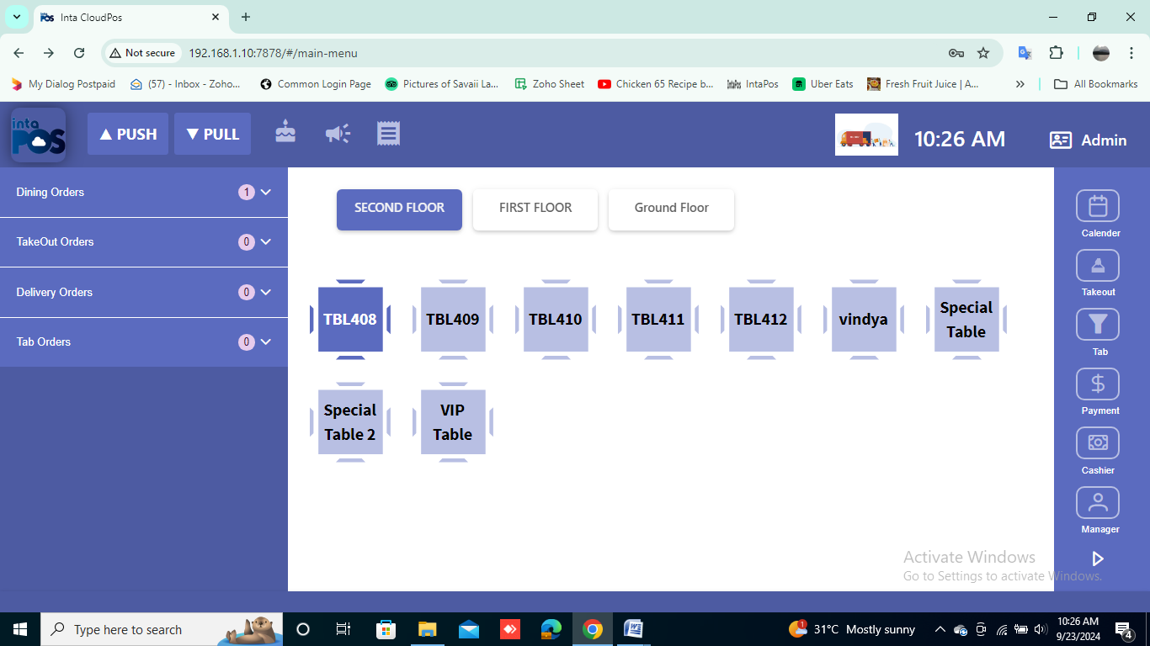in the main window to view the Tab Reservation history.
Tab reservation history will appear as follows by clicking tab orders.

5.2 Tabs: guest management
Register the Tab guest details.
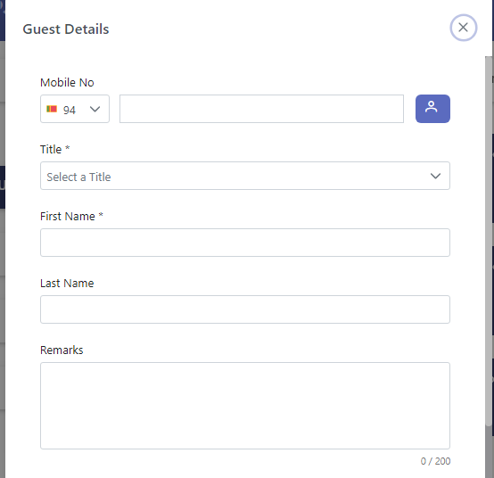

6. Order Operation Management
Discounts are handled by this section.
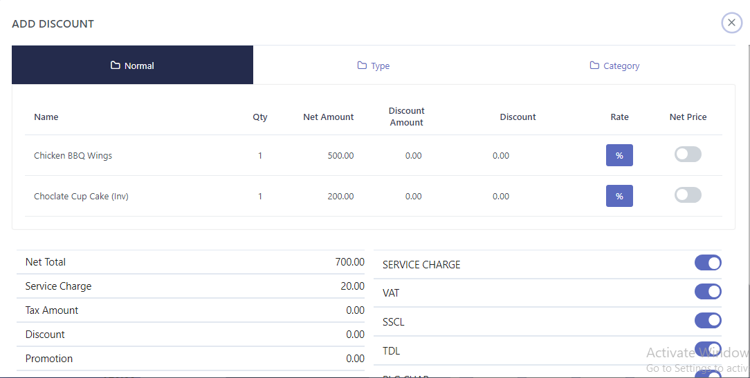

6.1 Line Discount Management

Apply discounts rates to each and every item.
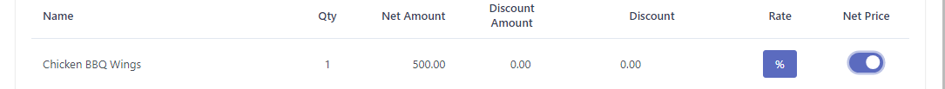

6.2 Full Discount Management

Apply discount rates to the final amount.
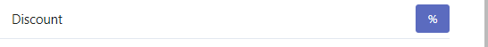
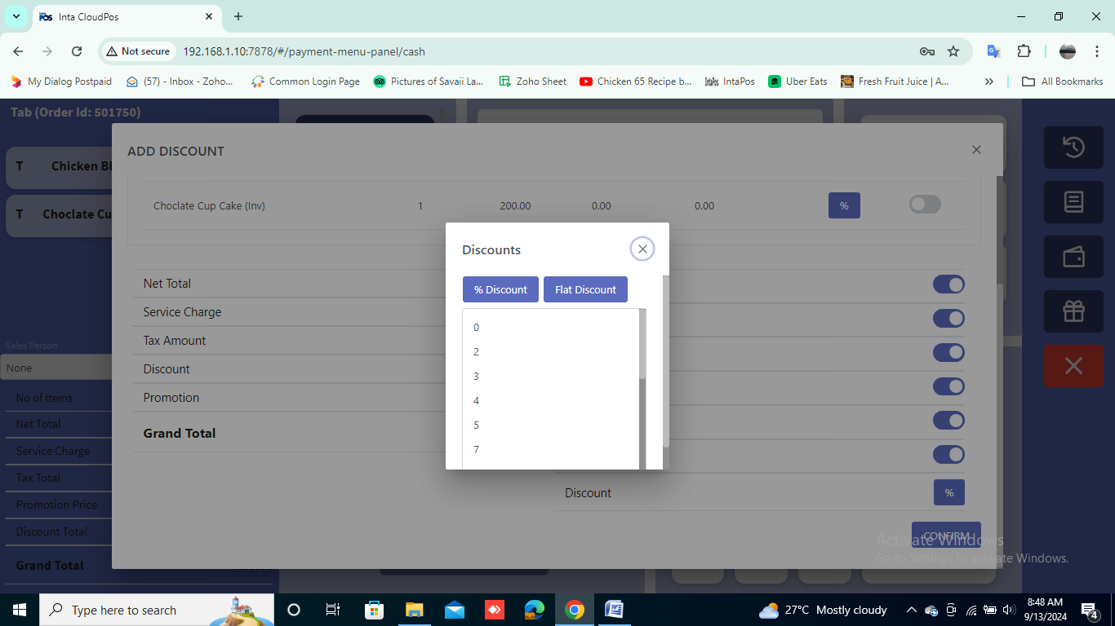

6.3 Complimentary Management

Some items could have 100% discount rates.
Different discounts rates can be applied by clicking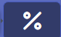 button in the order panel.
First, select the discount type
Add discount amount by below window.
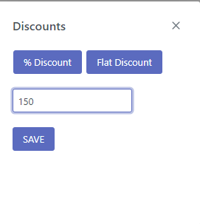
Add discount percentage by below window.
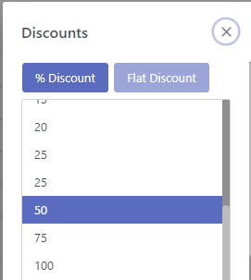

6.4 Service Charge ON/OFF

Service charges can be applied or omitted by click the SO On button.
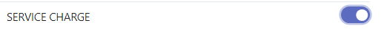

VAT ON/OFF
The Value Added Tax can be applied or omitted by click the Vat On button.
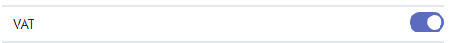

7. Split Order Invoice

Split Order invoice could be accessed by clicking the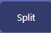button.

The invoice can be split according the requirements.
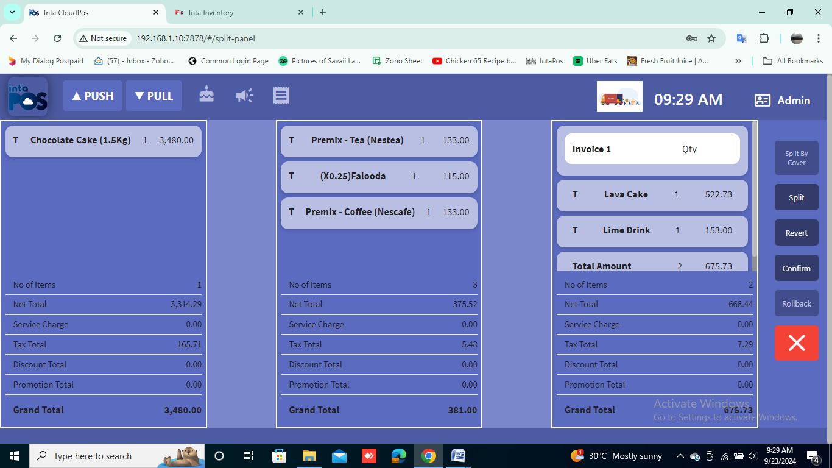
There are few buttons for the split function.

7.1 Split by cover
To split according to cover basis click the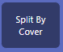button.
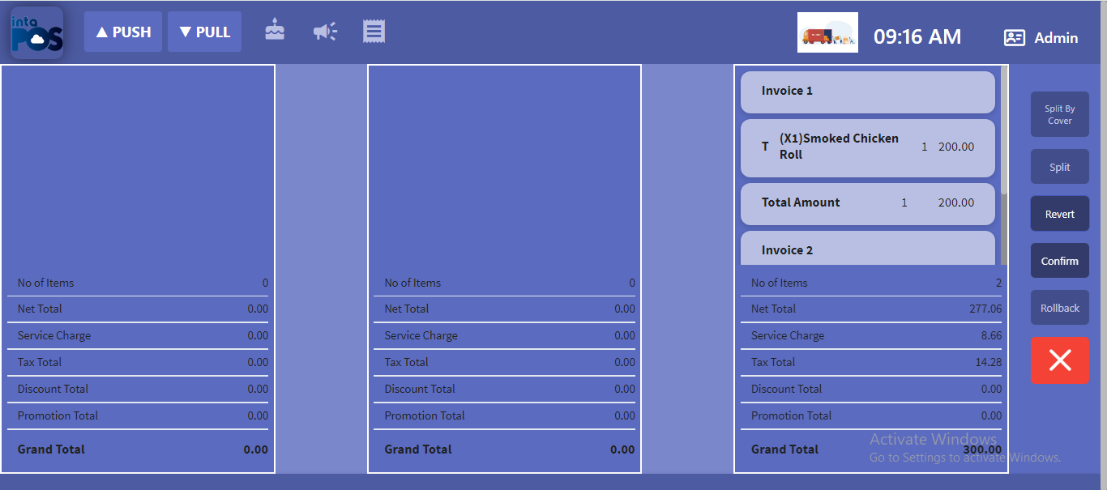

7.2. Split by manual
Manual Split can be done by clicking the on items that we have to split manually, and then by clicking on thebutton.

All the splits can be cancelled by clicking on the button.

8. Table management

8.1 Table transfer to other table
Change the table by clicking on an allocated table and then by dragging it on to an unallocated table.
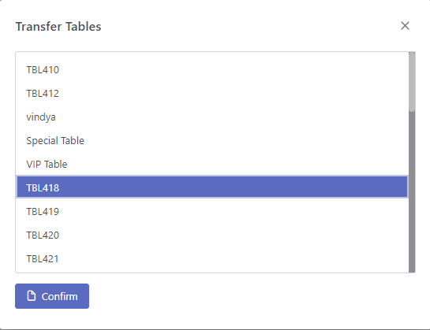

8.2. Tabs order assign to table
Tabs can be allocated to tables by dragging and dropping a tab to an unallocated table.
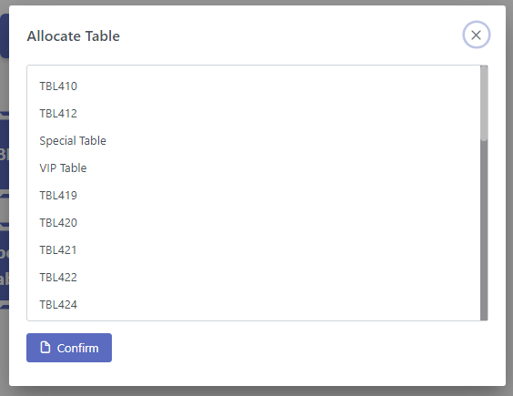

8.3. Table merge
One guest could be assigned with multiple tables in reservation tab.
First click on plus button.
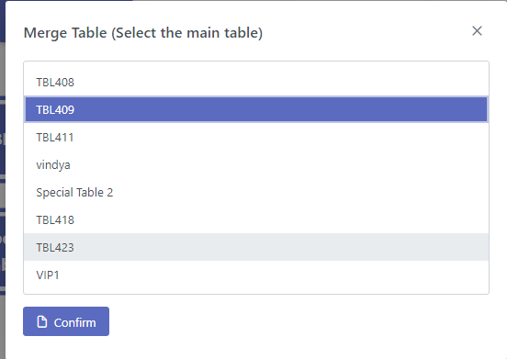

Note: Tables can merge floor wise or same floor wise.
Only 2 tables and 2 bills can merge.

9. Kitchen order management

9.1. Kitchen display unit

Display Kitchen Ticket Orders in displays of Kitchens.

9.2. KOT printing
Print Kitchen tickets and Bills.
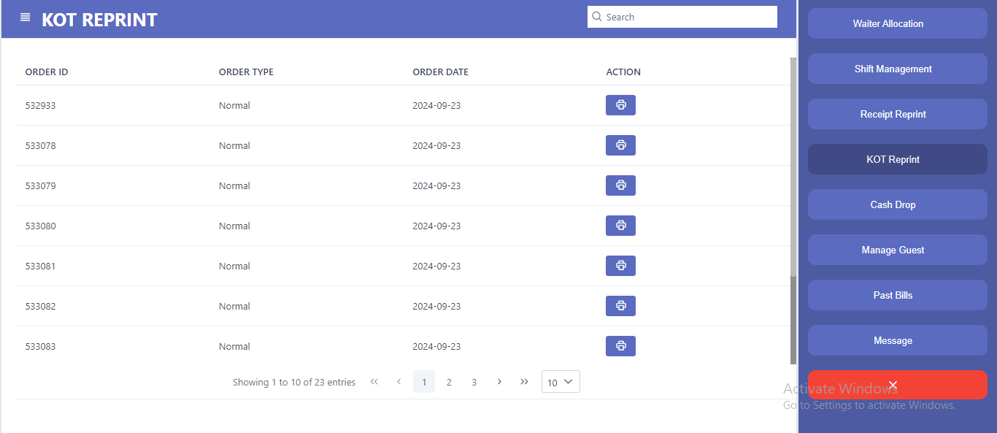

10. Delivery Management

10.1 Order Management
Orders can be made for the home delivery.

10.2 Guest Information Management
Guest information can be saved using the Guest Information Tables. This is to find the address of the place where the delivery has to be done.
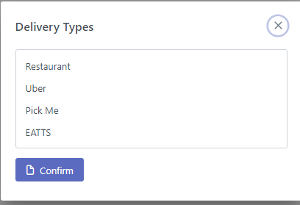
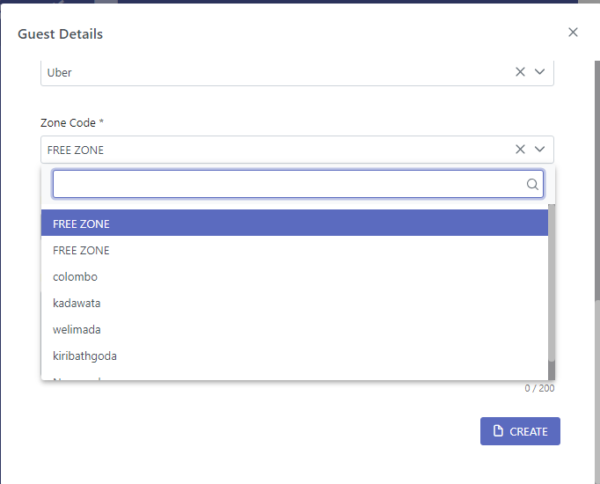
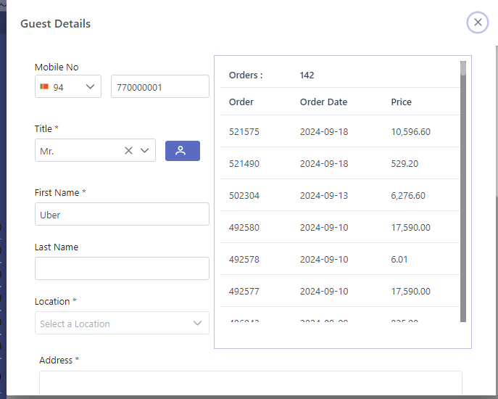

11. Payment Management

11.1 Payment Methods
Several payment options are available to pay the bills.
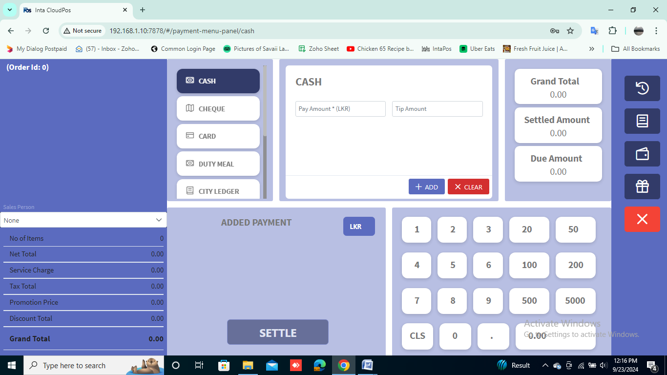

11.1.1 Cash Payment

Pay your bills with cash instantly.

11.1.2 Credit cards Payment
Use credit cards for your payment.
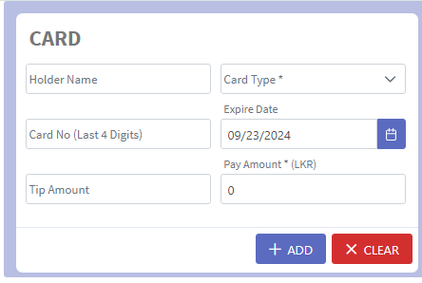

11.1.3. Cheque Payment
Checks can be acceptable.
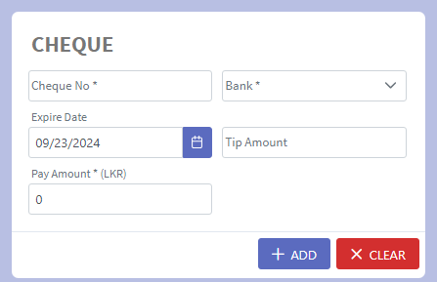

11.1.4. City Ledger
City Ledger accounts are the credit accounts provided by the hotel for regular customers.
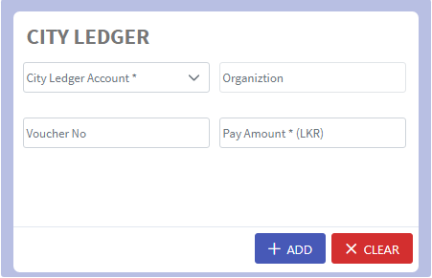

11.1.5 Duty Meal
Provide duty meals for the employees.
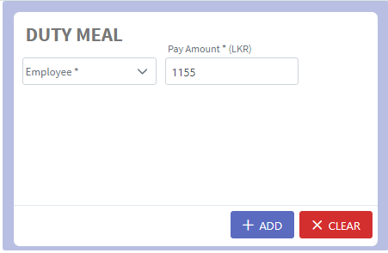

11.1.6 Advanced Payment
First create advance deposit and confirm it.
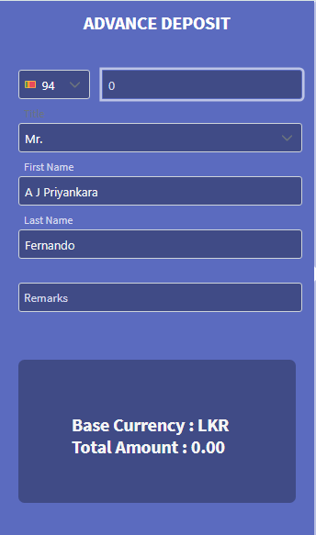
Then Guest can pay advance for their food orders.
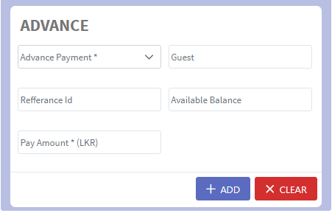

11.2 Single Payment
Single payments can be done using one of the above options individually. Select only one ID.
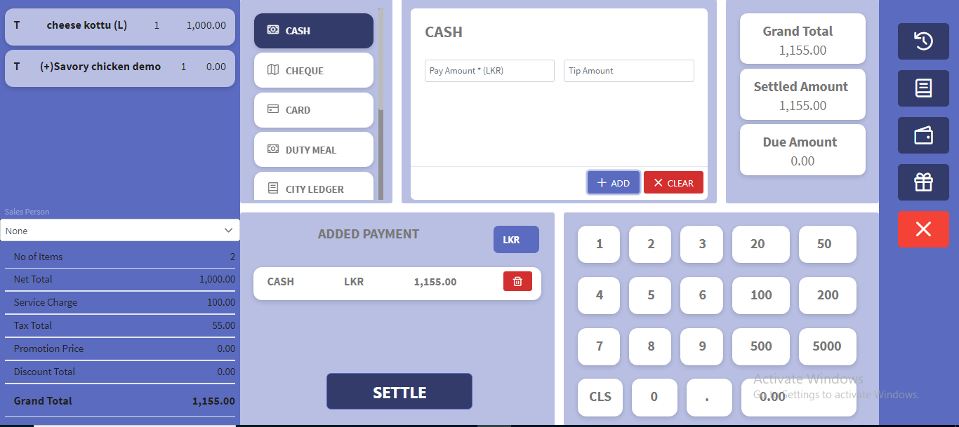

11.3 Mix Payment
Use multiple sources to pay your bill.
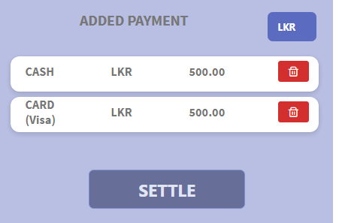

11.4 Multiple Payments
Note: One person can pay for multiple tables or reservations. But it should be only one type.
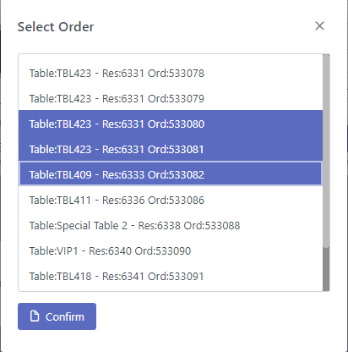

11.5 Other Payment
These payments add by 2 types. They are Final bill and for the order
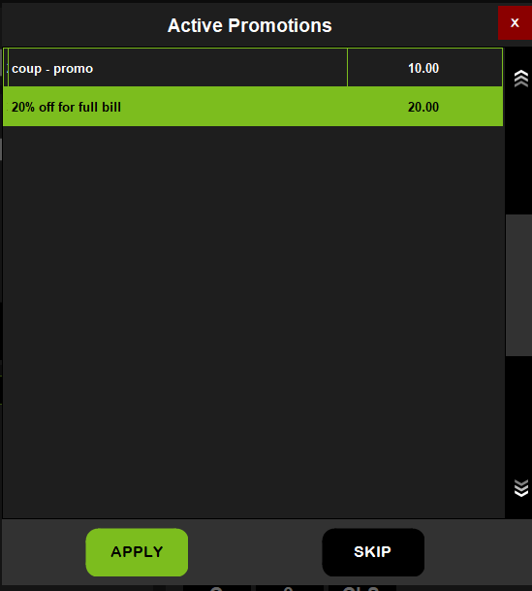

11.6 Gift Vouchers
Select a serial num and get gift vouchers.
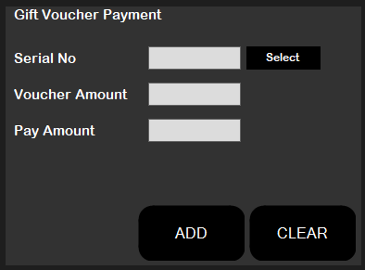

12. Manager Panel
Administration panel contains the administrative functions.
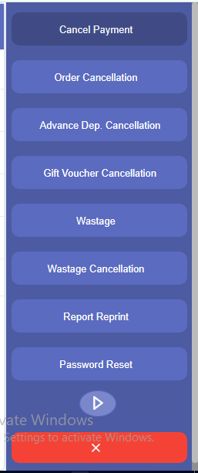
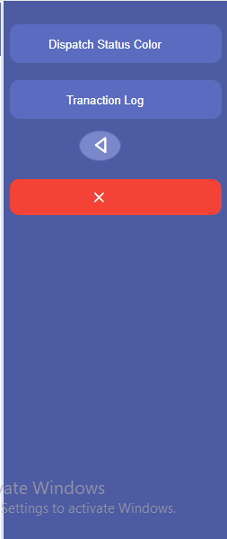

12.1Cancellation
Two types of cancellation can be possible.

12.1.1 Order
Cancel an order, can be found in the order cancellation tab in manager tab.
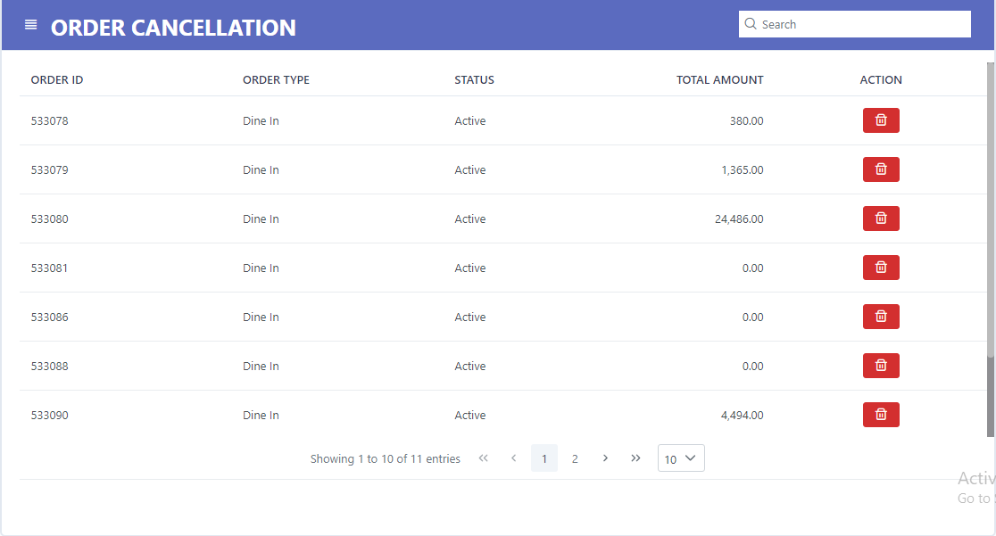
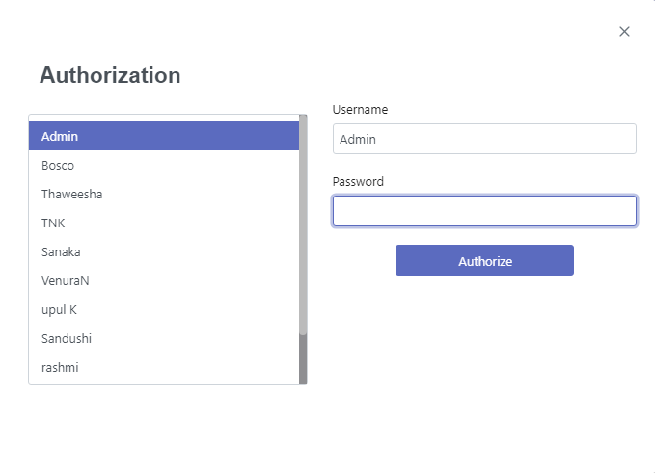

12.1.2 Payment
Cancel a payment, can be found in the payment cancellation tab in manager tab.
In the tabs, can cancel payments only dining.
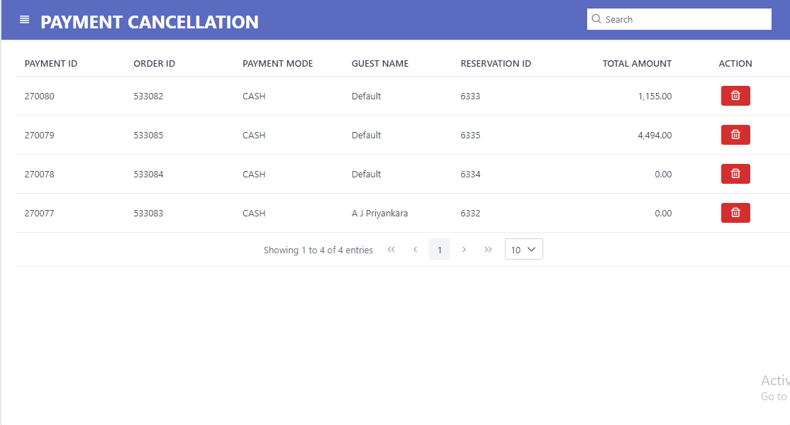
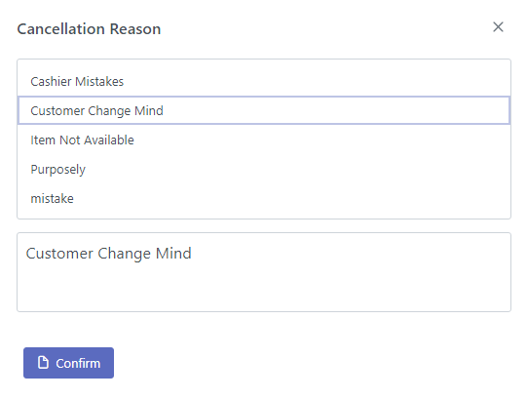

12.2 Password Reset
Reset the password of a user. If the password reset 123 is the default.
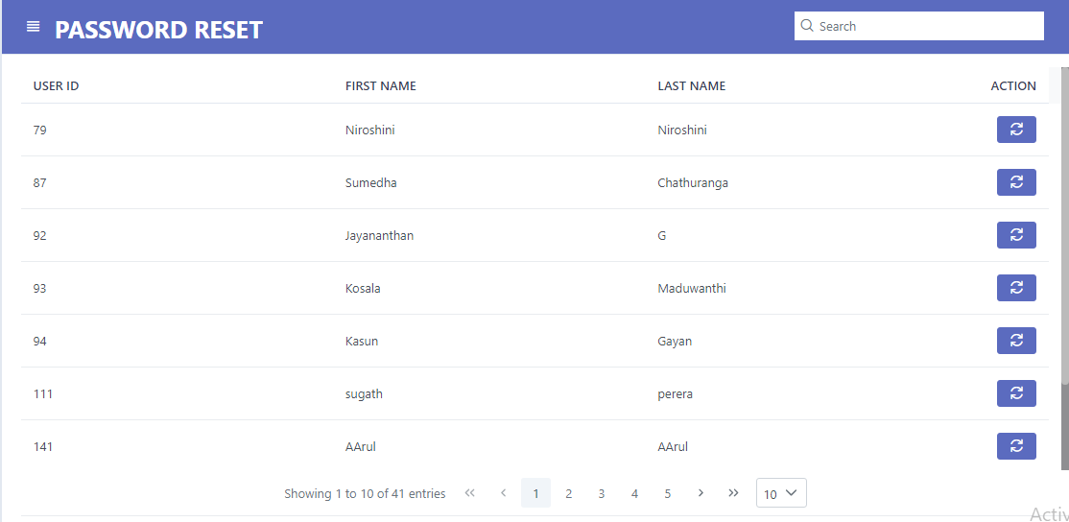

12.3 Shift management & Day End
To start the proceedings of a day a shift must be opened.
Shifts can be opened and closed under “Shift Management” in the Cashier section.
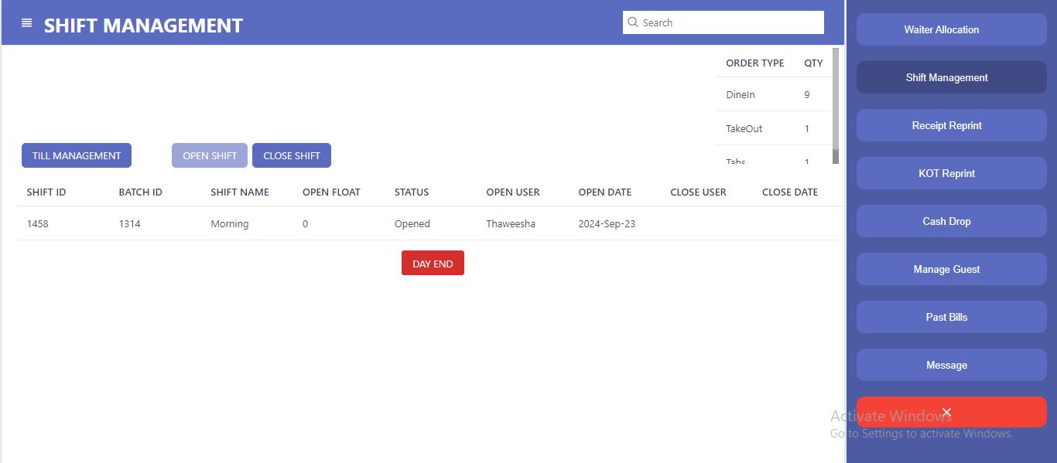

12.3.1 Open Shift
To start a shift, clicks the Open button in Shift Management window.
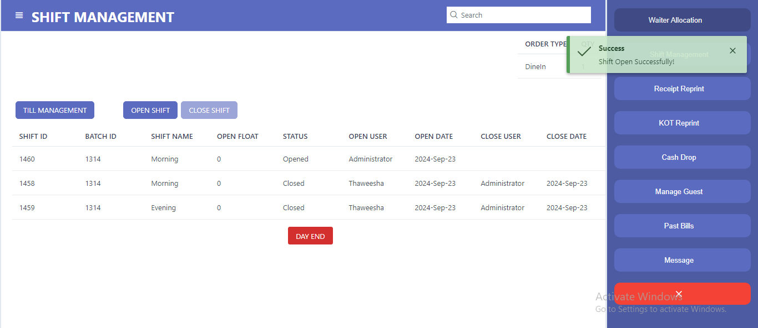

12.3.4 Day end Process
Click this button to indicate the end of day. I.e. end of all shifts for a day. To process the Day End, all the shifts must be closed and all the orders must be paid.
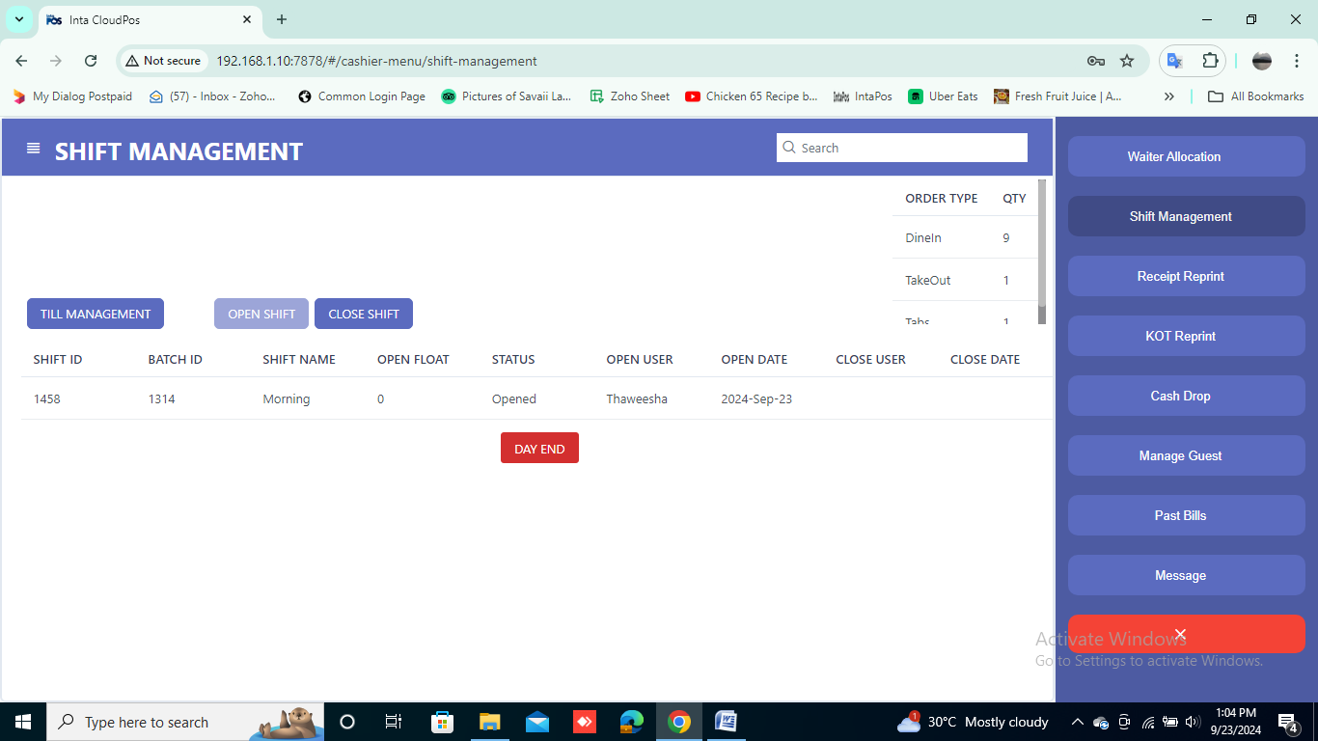

To the day end process to be completed it must ensure the shift is closed. Otherwise will get “close shift process should be run” message.

Once you click the button, a popup for the Authorization will appear. By typing the Username and password, the Day End process can be succeeded. To complete this process will asks for authorization from the admin.
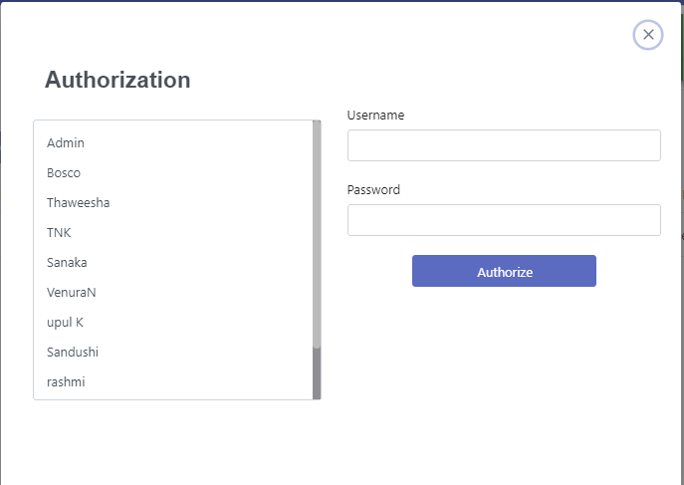

Once the Day End succeeds below confirmation message will appear.
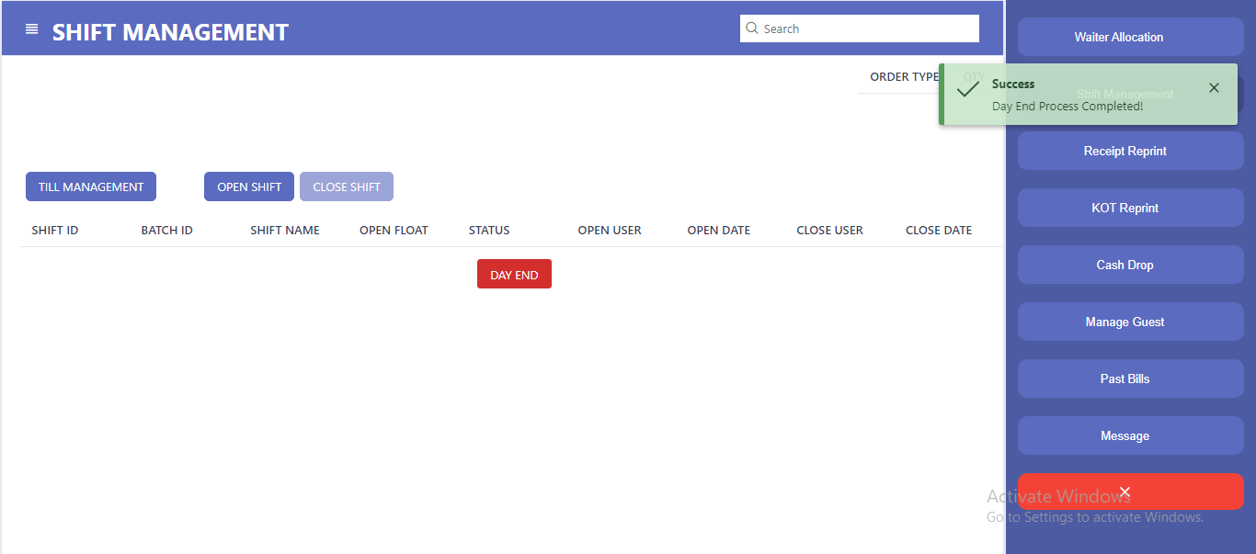
If some reservations are pending for the payment or not paid, the below message box will appear.
**Check all the tables, special orders, Active MTN, FTN tabs and reservations before run the day end. The Day End process enables you to find out whether all the payments are done or not.
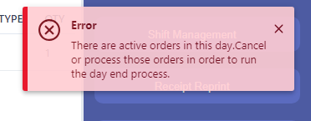

12.3.2 Close Shift
To finish a shift click the Close button in Shift Management window.
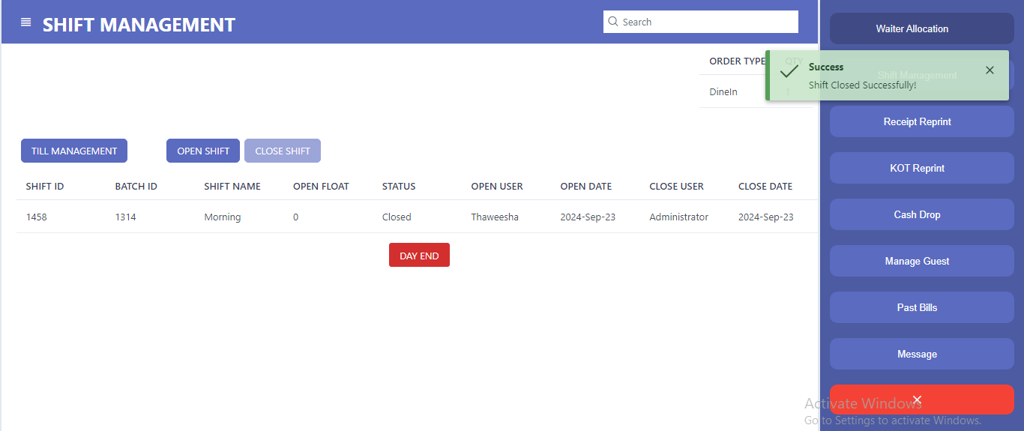
To close the shift close all tills, checklist and all balance of the day

12.3.3 Push and Pull

This is used to integrate data transaction between inventory and POS. When click on PUSH Button after day end process, all the transaction details updated in the inventory. And when click on PULL; it will process to get inventory update to the POS system.
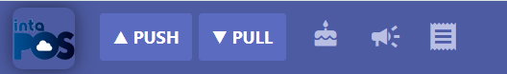

12.4 Report Reprint
Clear bill print queues. Use this facility when your printer is switched off or not connected to avoid the pending payment bills gets printed.

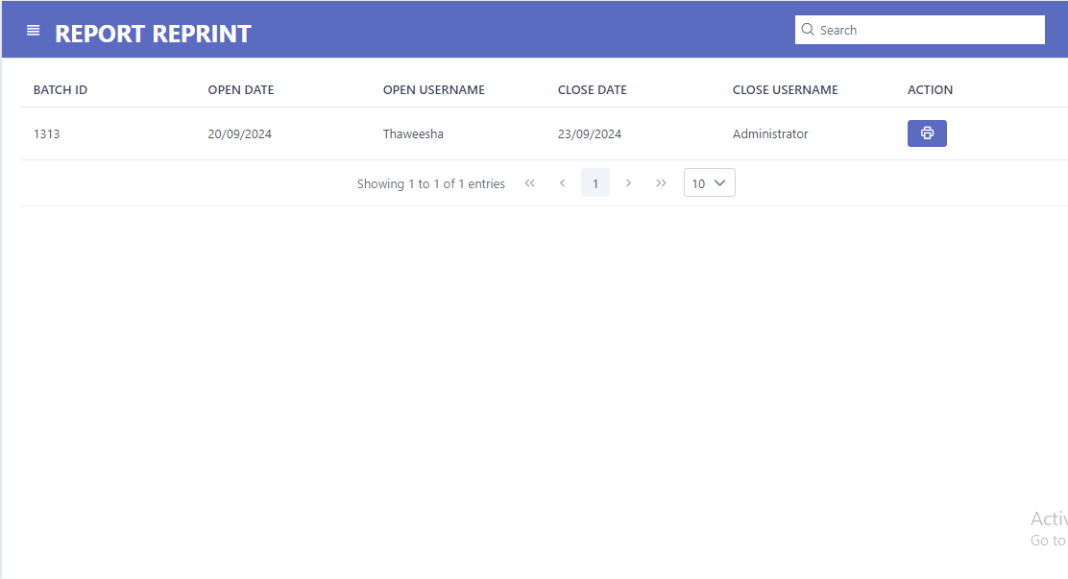

12.5 Receipt reprint
This functionality is used to reprint the receipts. Select the several categories such as Bill, complementary, duty meal, hotel posting, gift vouchers, city ledger.
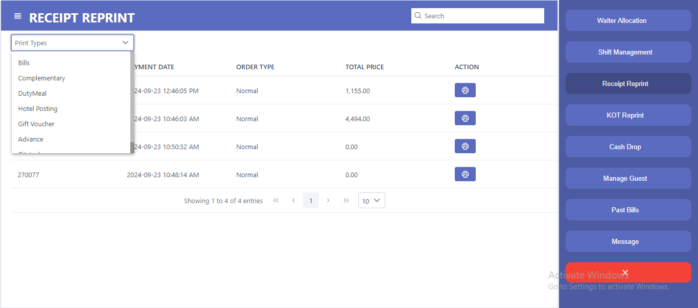

12.6 KOT reprint
In order to reprint the Kitchen Order Ticket.
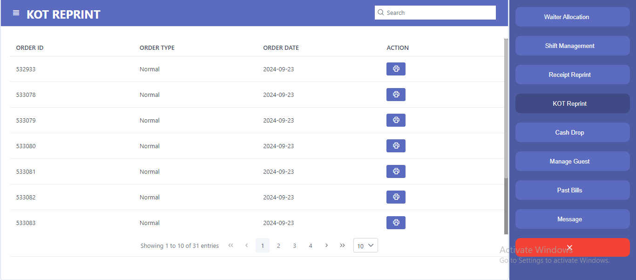

13. POS Report (Cashier)

13.1 Summery Report
POS Report portion of this system is used to generate reports for the cashier.
There are Current Sales Report, Current Category Report and Current Product Report.
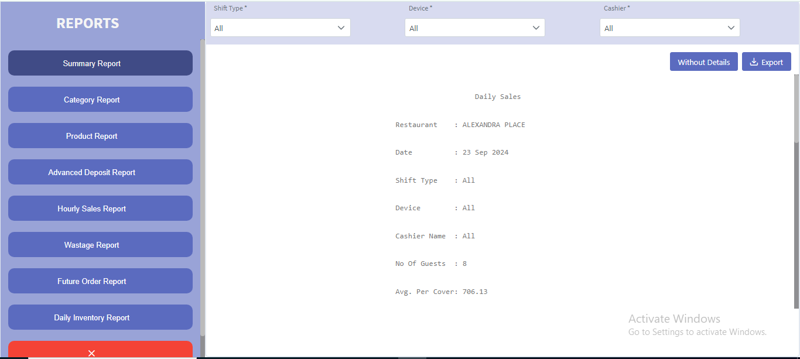

13.1 Category Report
This is to generate report regarding all the payments in a day. In this report the payments are detailed by payment types.
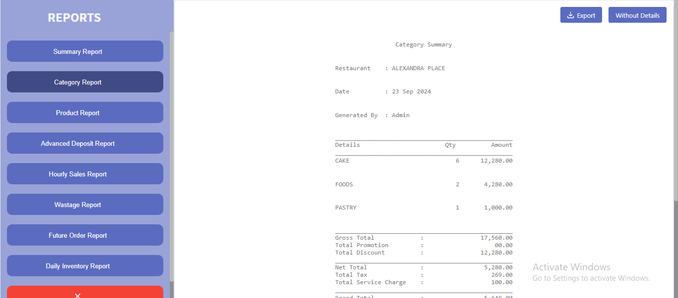

If you want to view report with more detail, click with details button and view the report.
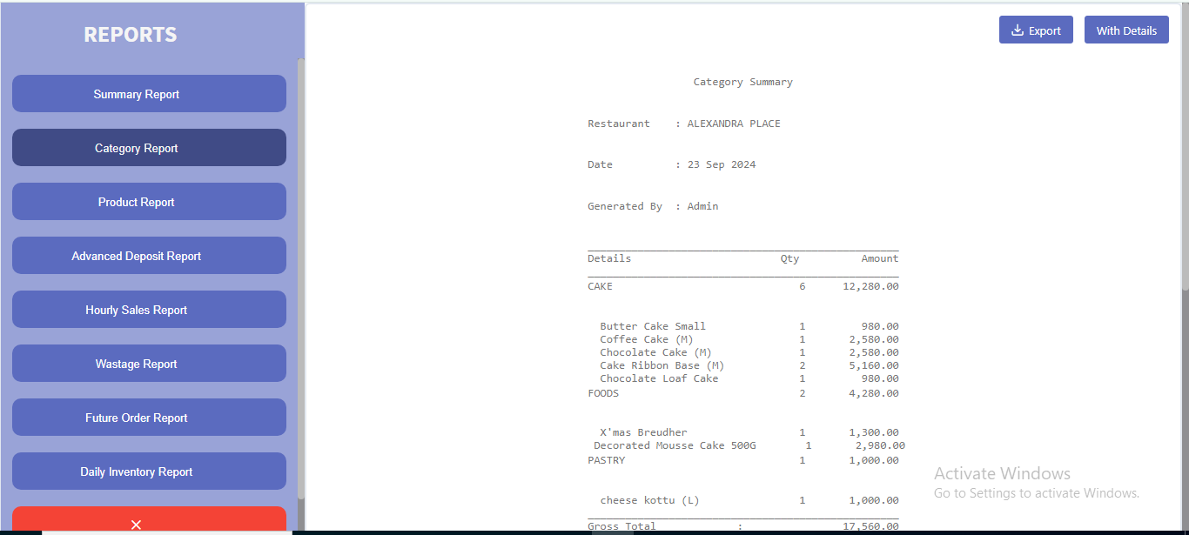

13.2 Product Summery
Generate product wise report. This includes items and the sales amount in Rs.
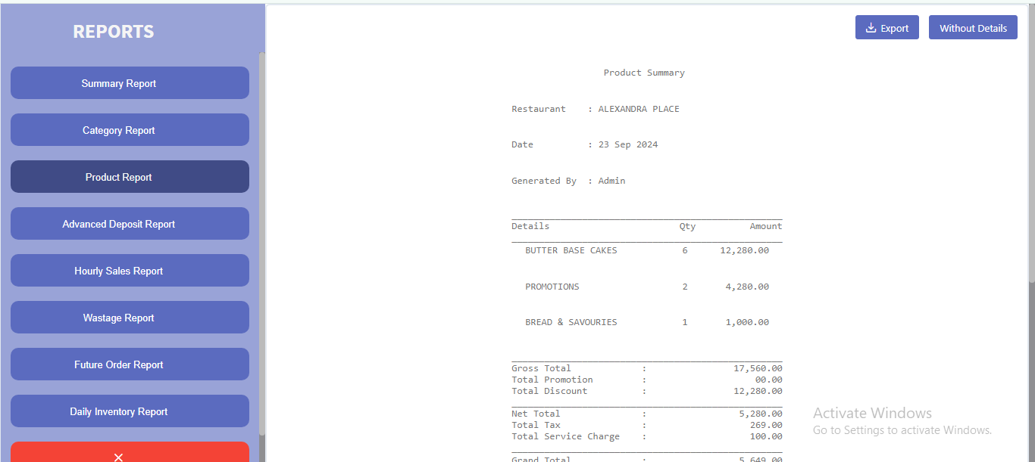

If you want to view report with more detail, click with details button and view the report.
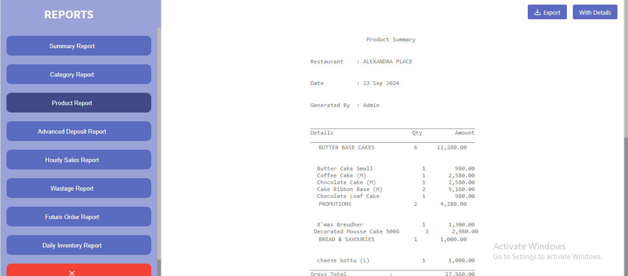

13.3 Advance deposit report
This report gives the details about advance deposit.
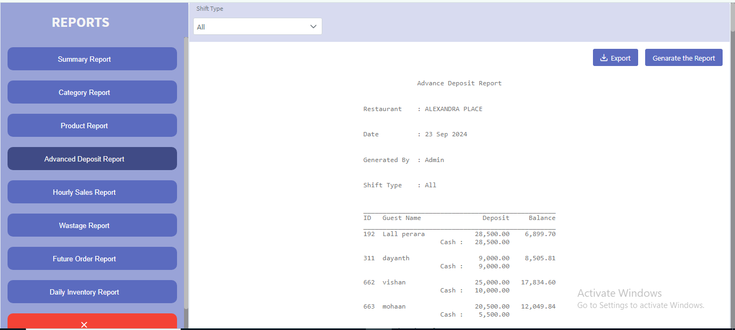

13.4 Hourly sales
This report gives the details hour wise.
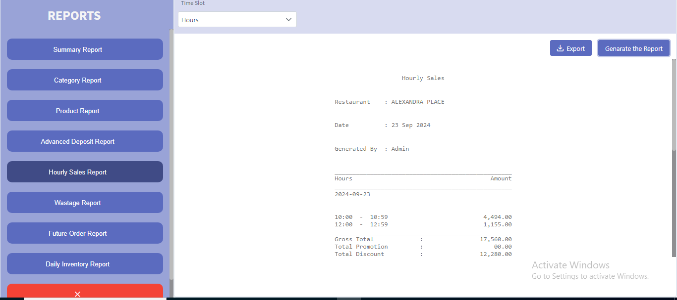

13.4 Daily Inventory
This report gives the details about daily inventory.
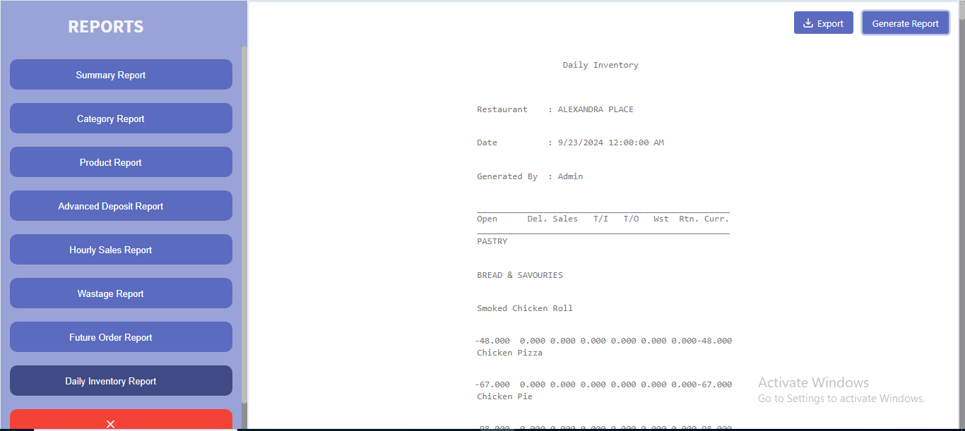

13.5 Wastage report
This report gives the details of wastage.
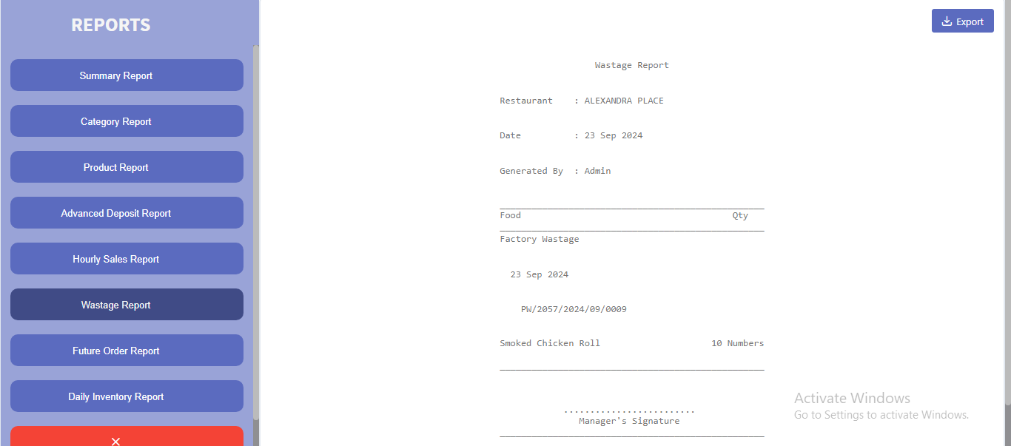

14. Wastage Management
Wastage management is for reporting wastage from the Restaurant operations.
