INTAHUB (PVT) LTD

BANQUET
User Guide
INTAHUB (PVT) LTD

Contents
1.0 Banquet Calendar 3
1.2 Banquet – Dashboard 5
1.3 Reservation 6
1.3.1 Detailed Reservation. 6
1.3.1.1 Guest Information 7
1.3.1.2 Event Information 7
Reservation Source 8
1.3.1.2.1 Event Overview 10
Session 10
Theme 12
Seating Plan 13
Shape Plan 14
Policy Management 15
1.3.1.2.2 Package Details 17
Package Information 20
Banquet Menu 21
Menu Section 24
Service Management 25
1.3.1.2.3 BEO Details 27
BEO Types 28
BEO Templete 29
1.3.1.2.4 Seating Details 30
1.3.1.2.5 Finalize Event 32
1.3.1.3 Payement Overview 33
1.3.1.4 Document 36
1.3.2 Quick Reservation. 37
Venue 38
1.4 Banquest Report 41
1.4.1 Sales Report 41
1.4.2 Reservation Report 42

Banquet

1.0 Banquet Calendar

After clicking on the Banquet Tab, you will be directed to the Banquet Calendar window. Here you can view the details of banquet venue reservations for the selected location, from the current date up to 7 days in the future.
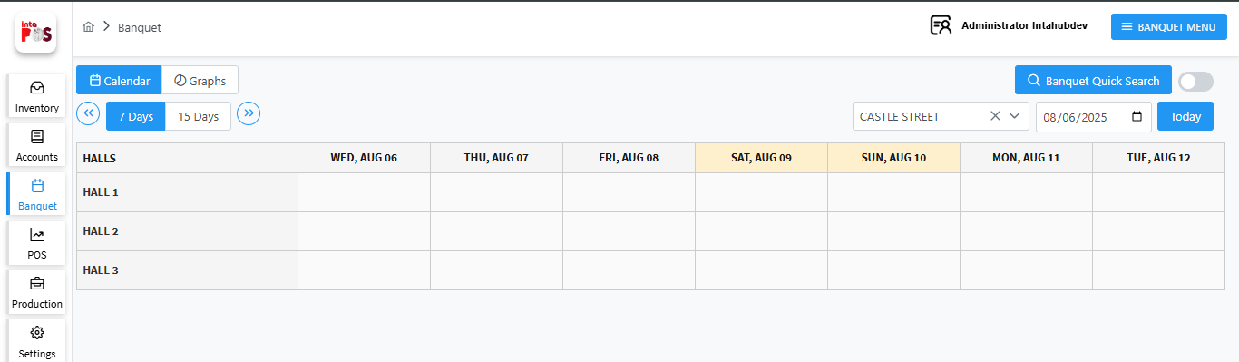
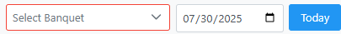
- Select a banquet from the dropdown list using this button.

- Use the calendar to filter records by date using option.

- When you click the button, it will display records for the current date again.

- Switch the table view between 7 days and 15 days using 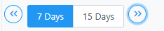 button and you can view the past 7 or 15 days of records from the selected date, as well as future records, by clicking button.

- You can select a date range horizontally, and choose venues vertically for the selected location

The status of the reservation details is displayed at the bottom of the window, as shown below.
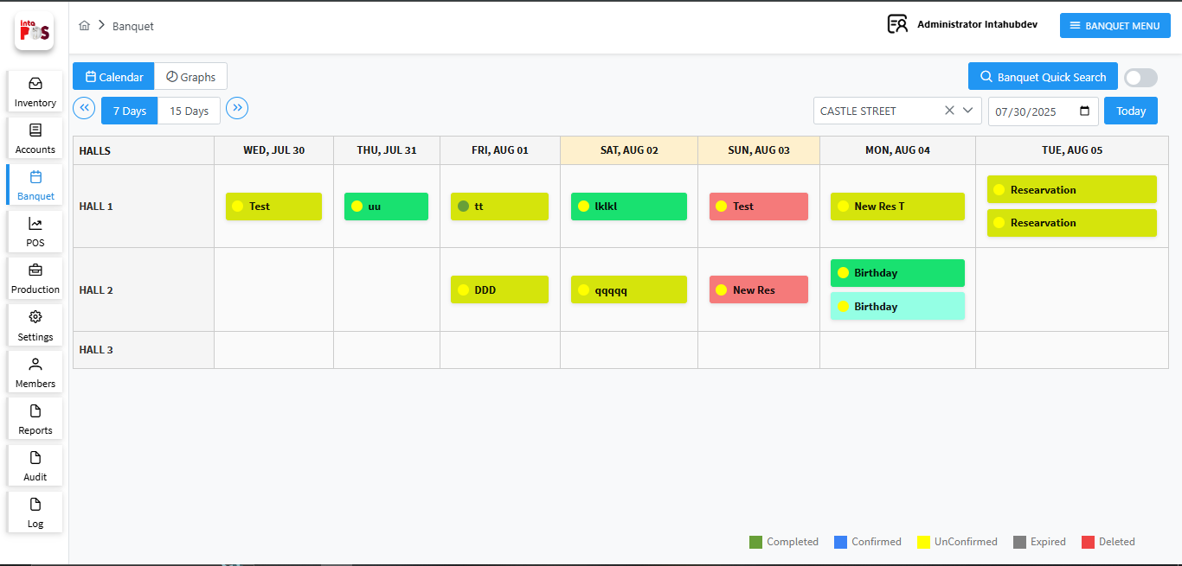

- By clicking button,you can view deleted reservations.

- When you select a record, the reservation details will be displayed in a popup window, as shown below.
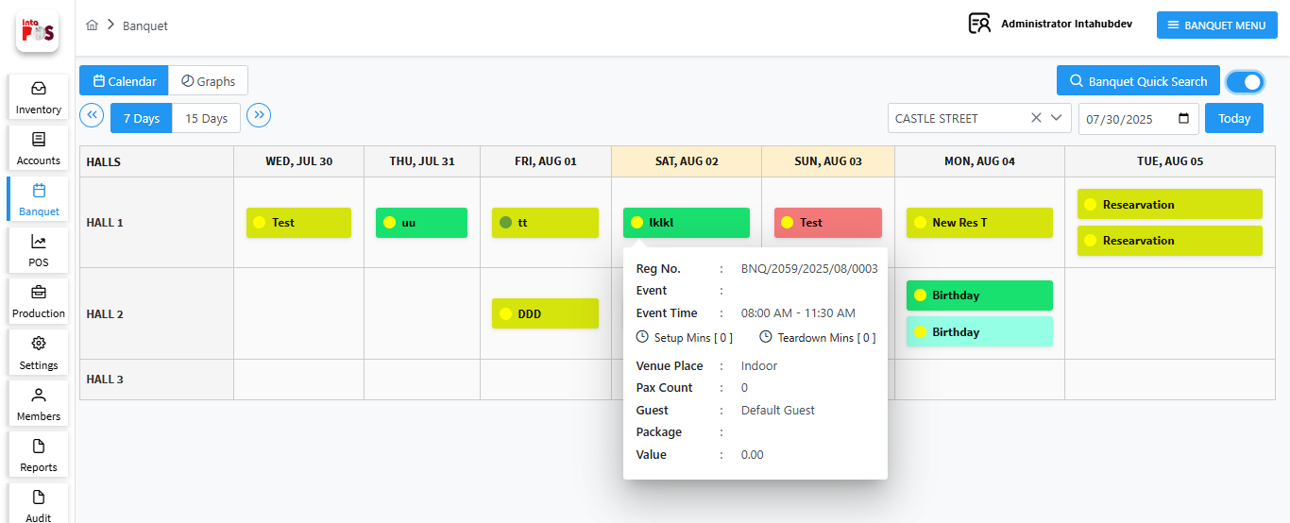

By clicking this  button, you can quickly search for reservations by selecting a start date, end date, and entering text.

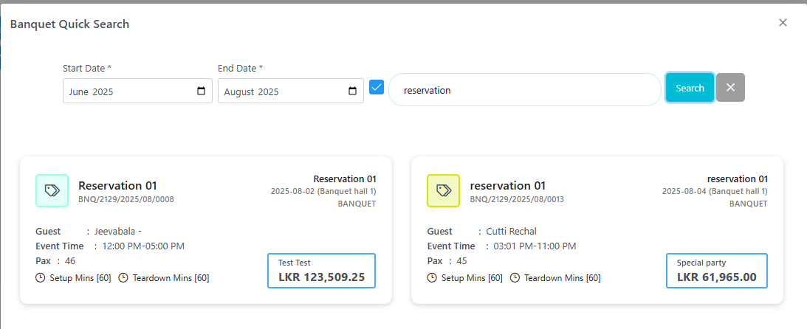

1.2 Banquet – Dashboard

By clicking this 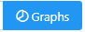 button you can view the Banquet – Dashboard and select a location using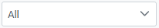 as shown below.
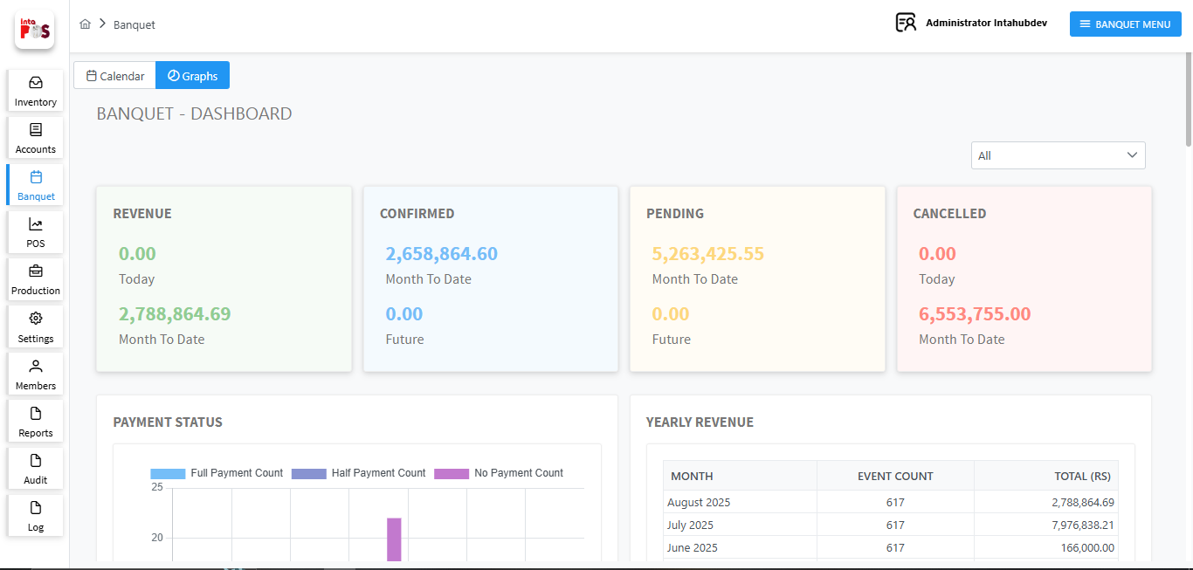

1.3 Reservation

When you click on a hall for the selected date in the calendar view, you can create a reservation in two ways.
- Detailed Reservation
- Quick Reservation
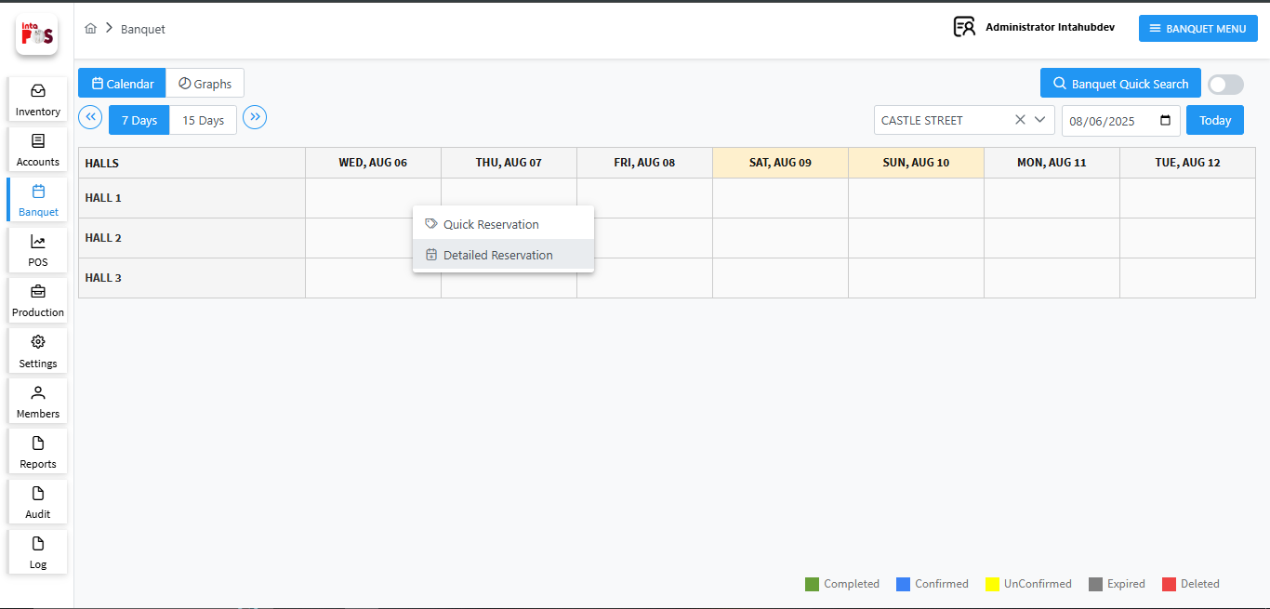

1.3.1 Detailed Reservation.

In the Detailed Reservation section, you must enter all information related to the reservation before confirming it.
Once all required details are filled in, you can proceed to reserve the venue for the selected date.
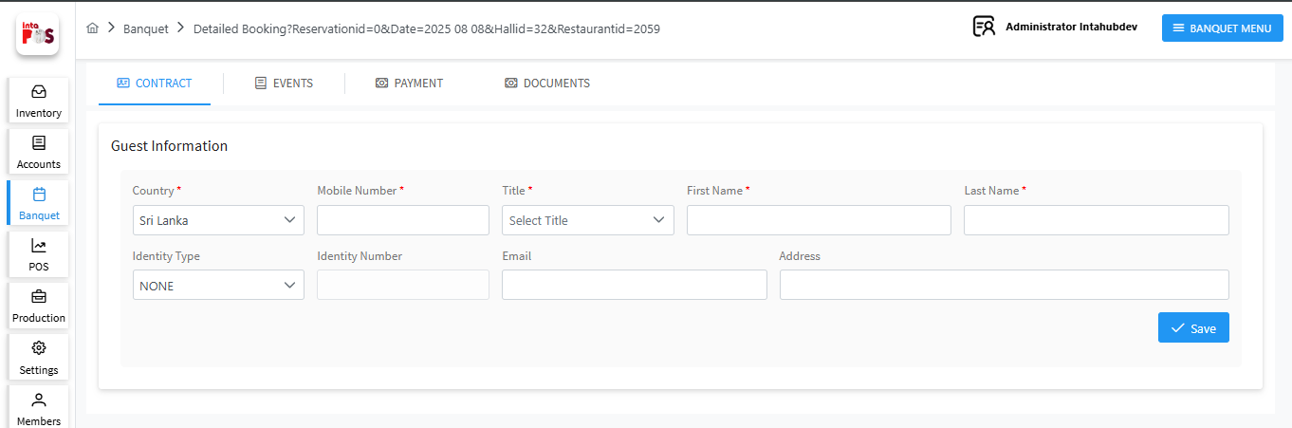

1.3.1.1 Guest Information

When you select a detailed reservation, you need to fill in the guest information. If the guest is already saved in the system, their details will be automatically loaded. Otherwise, you will need to enter the details manually.
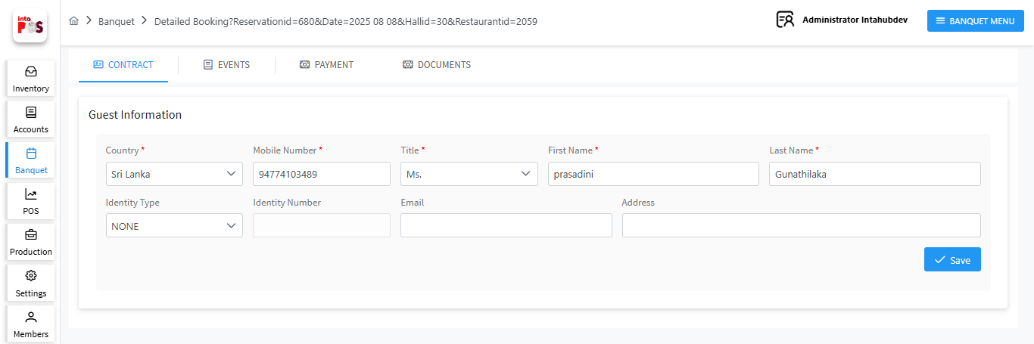
- You can save Contact Details using  button.

1.3.1.2 Event Information

After saving the guest details, navigates to the Event window, as shown below. Here, you can modify the reservation details and click 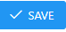 button to apply the changes. Also you can see the status of the reservation.
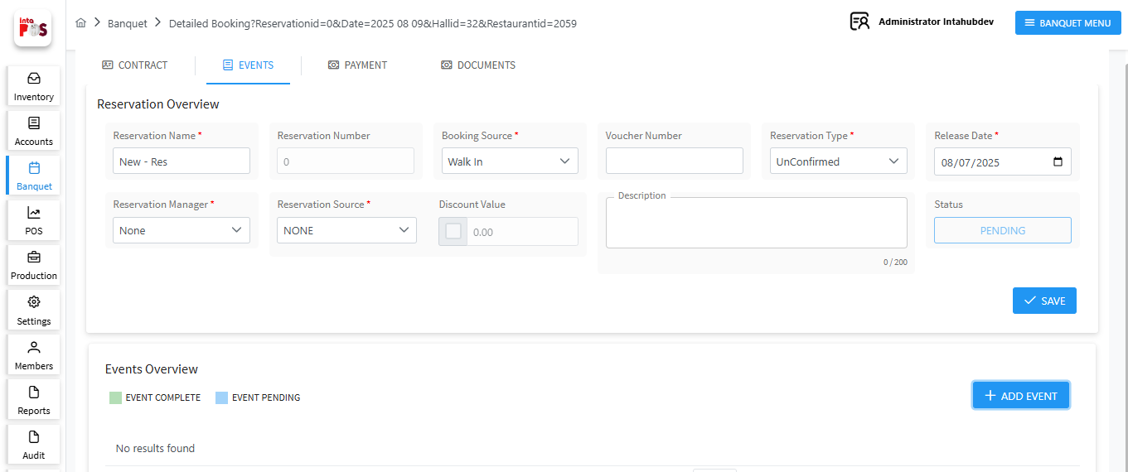

- When the guest makes an advance payment or full payment, you can mark the reservation as Confirmed. Otherwise, it will be marked as Unconfirmed by default.

- You can also assign a banquet user as the reservation manager, select the reservation source, and add any additional details in the Description field.

- The release date can be changed only up to the reservation date.

Reservation Source
To add a reservation source, navigate to: Banquet → Banquet Master → Reservation Source, as shown below.
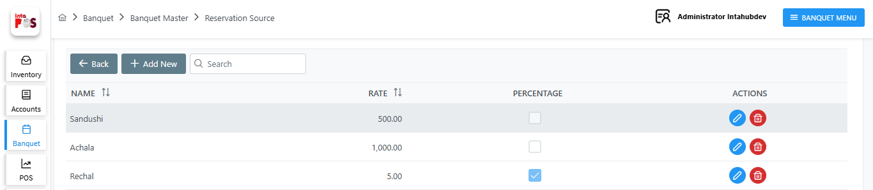
- Edit reservation source using 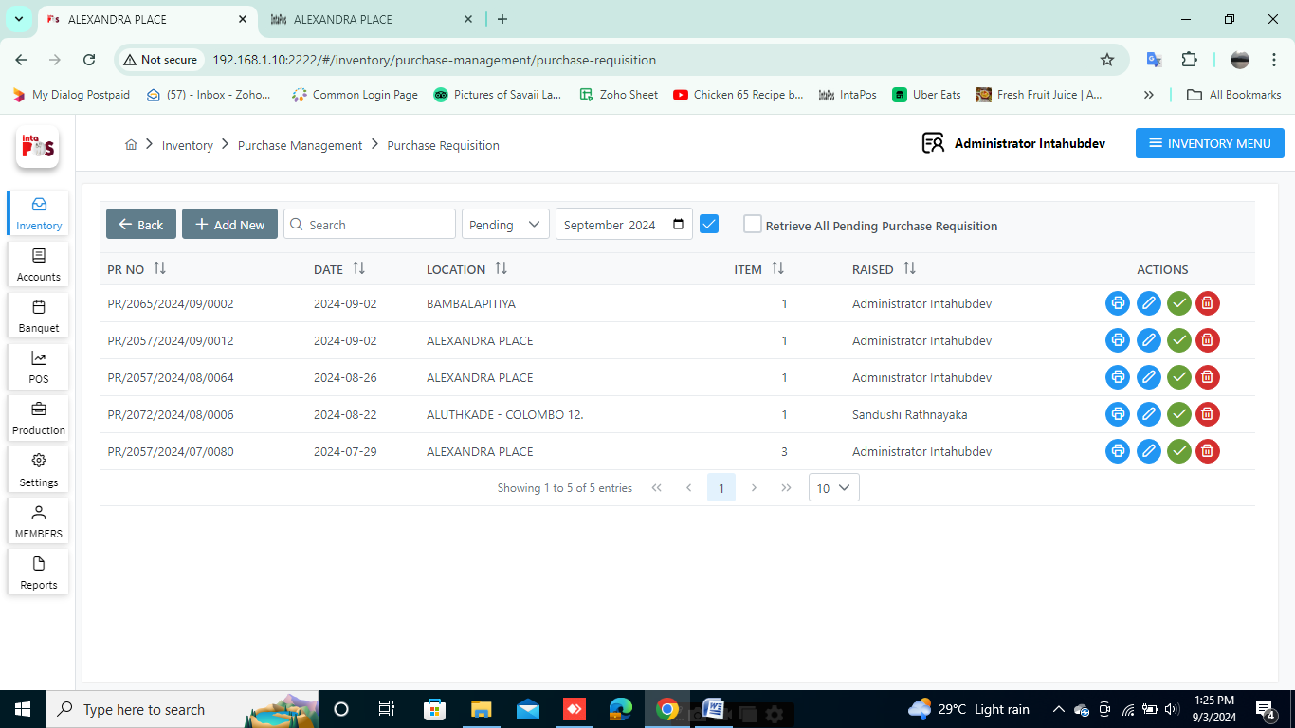 button.

- Delete reservation source using 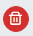 button.
- By clicking button, you can add a new reservation source by filling in the name, rate and percentage details.

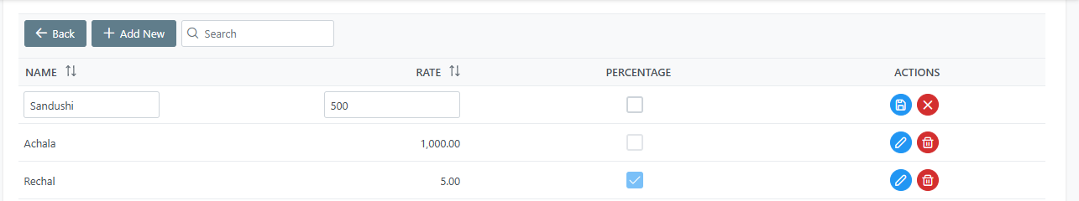
- After adding details click on 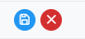 button Save the Record or click on button to Cancel.

After updating the reservation details you can add event for the reservation.

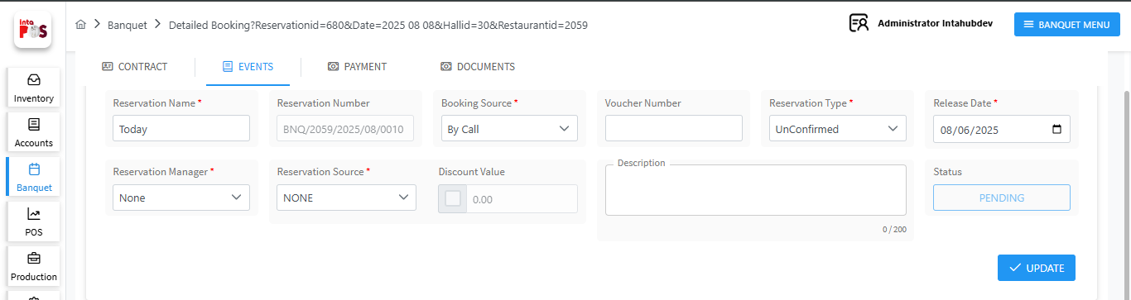

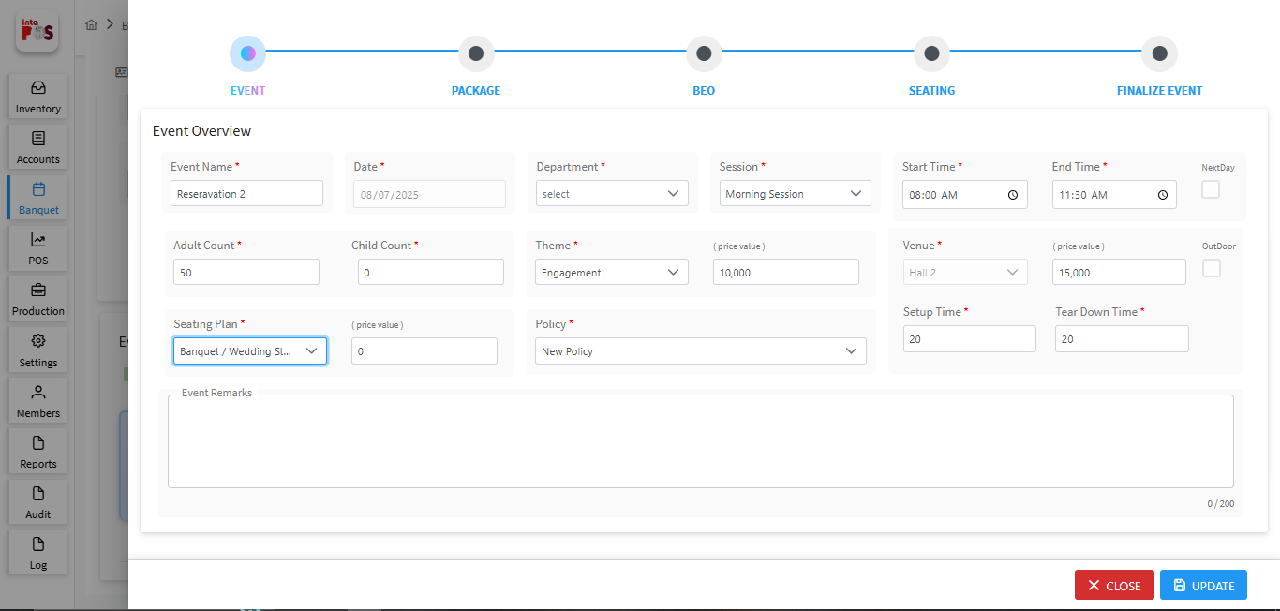

1.3.1.2.1 Event Overview

In this section you can add details for the events. You can assign adult and child Count for event, Event Time, Policy and etc.
- Save the event detail using 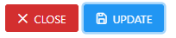 button.

- Close the window using button.

Session
You can create a session for the reservation by navigating to: Banquet → Banquet Master → Banquet Session.
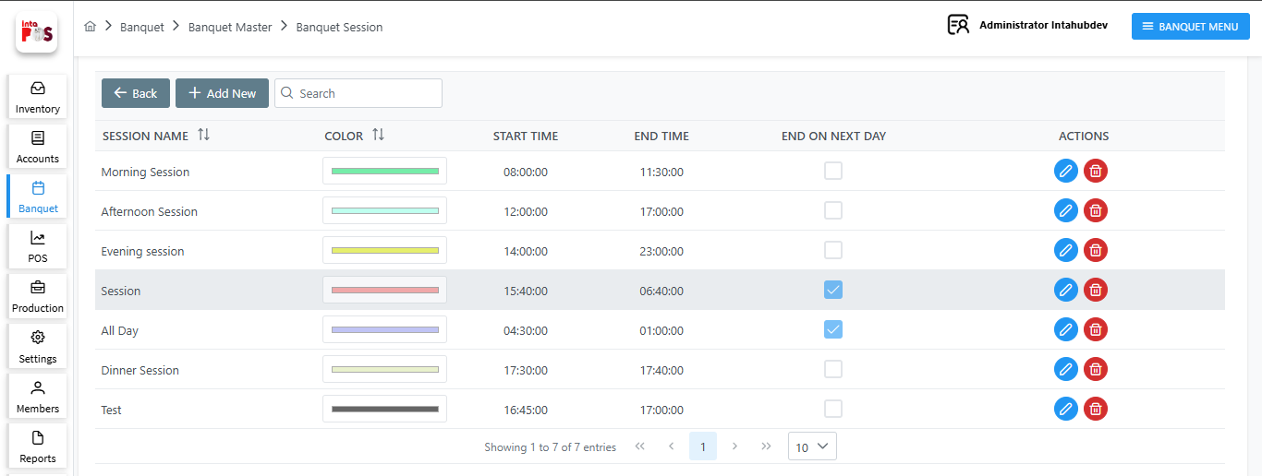

- Edit session using button.

- Delete session using button.

- By clicking button, you can add a new session by filling in the session name, color, start time, end time and end on next day details.

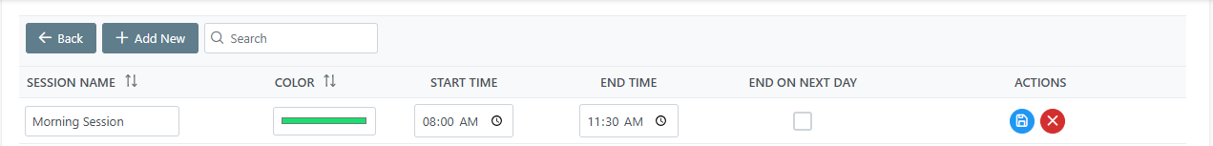
- After adding details click on button Save the Record or click on button to Cancel.

When making anevent, you can select that session as shown below.
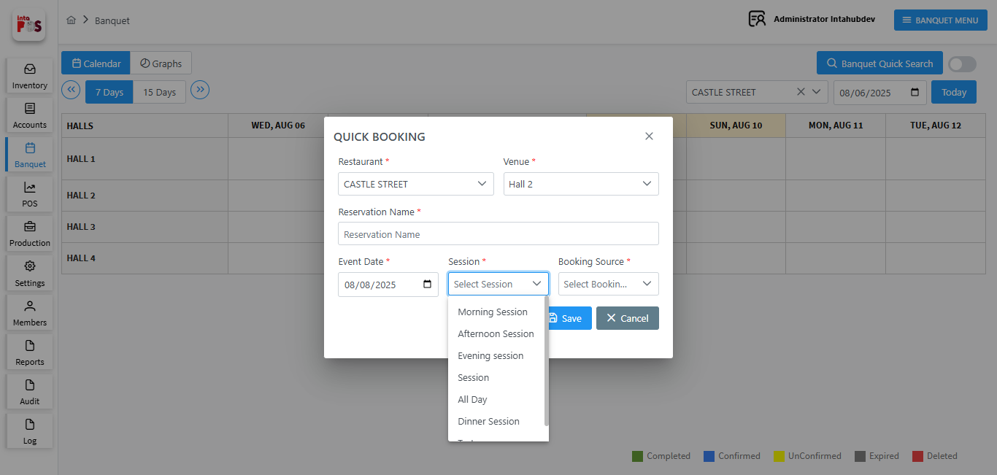

Theme
You can add new theme or modify the themes for the events. So you, navigate to: Banquet → Banquet Master → Theme Plan, as shown below.
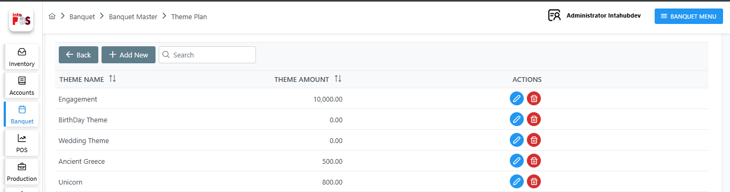

- Edit Theme Plan using button.
- DeleteTheme Plan using button.
- By clicking button, you can add a new theme by filling in theme name, and theme amount.
- After adding details click on button Save the Record or click on button to Cancel.

When making anevent, you can select that Theme as shown below.
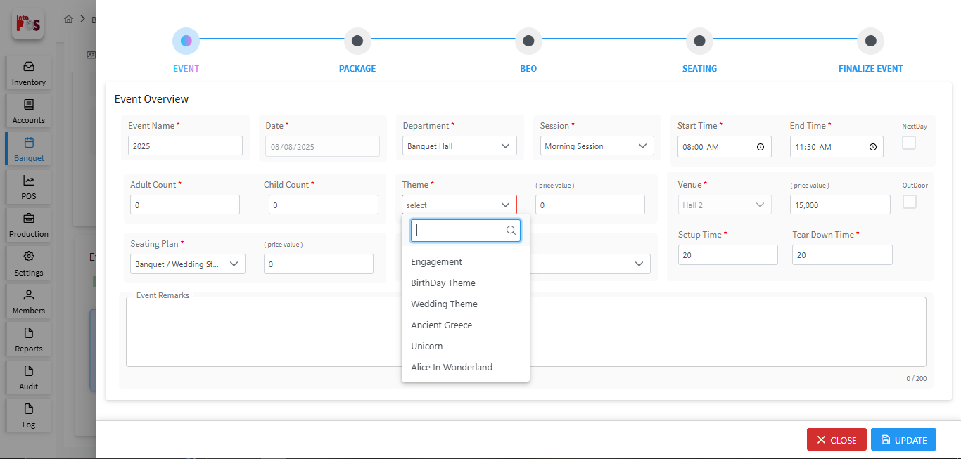

Seating Plan

You can design floor plan for the event using Banquet → Banquet Master → Seating Plan, as shown below
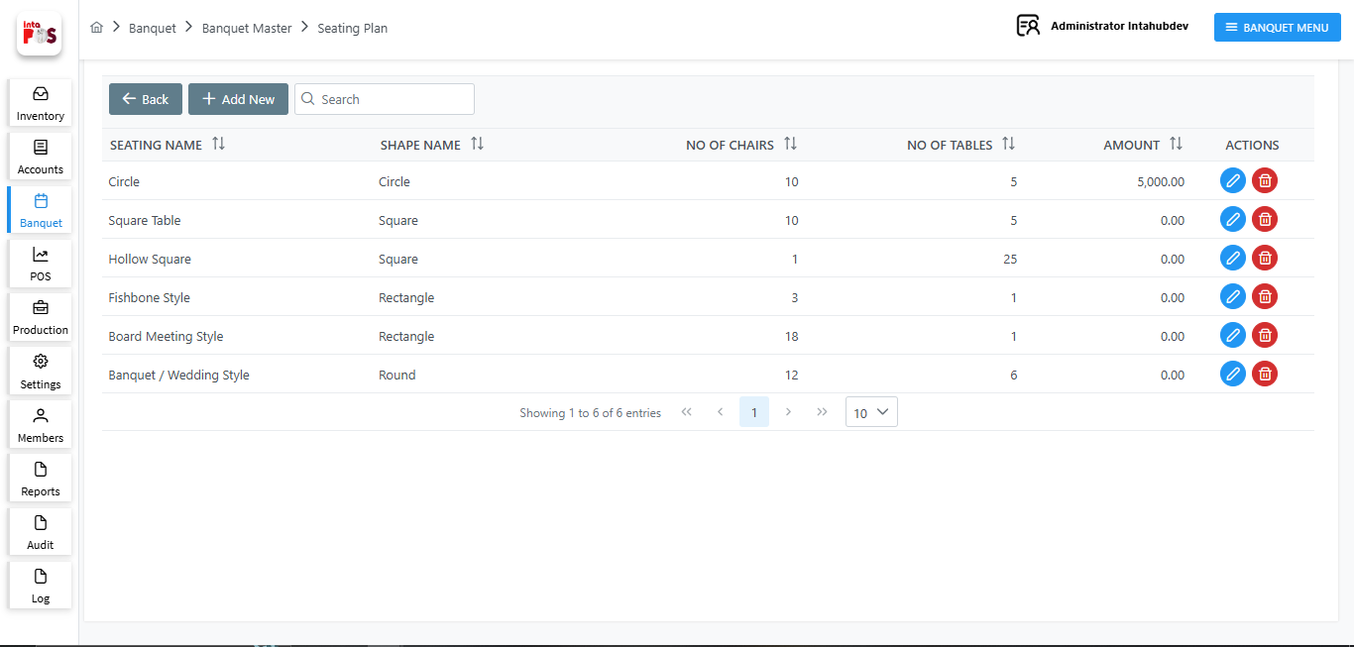
- By clicking button, you can add a new Seating Plan by filling in theme seating name, Seating Shape, No of chairs, tables and amount.

- After adding details click on button Save the Record or click on button to Cancel.

- Edit Seating Plan source using button.

- DeleteSeating Plan source using button.

When making an event, you can select that Seating Plan as shown below.
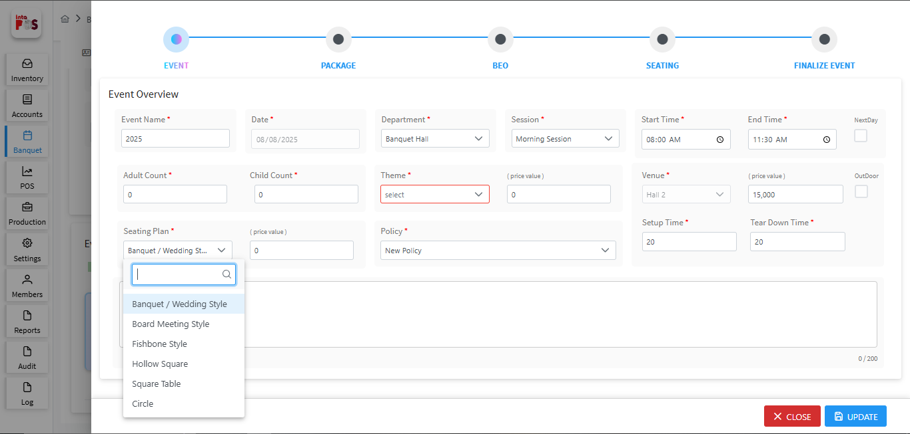

Shape Plan

To add a new Shape Plan, navigate to: Banquet → Banquet Master → Shape Plan, as shown below.
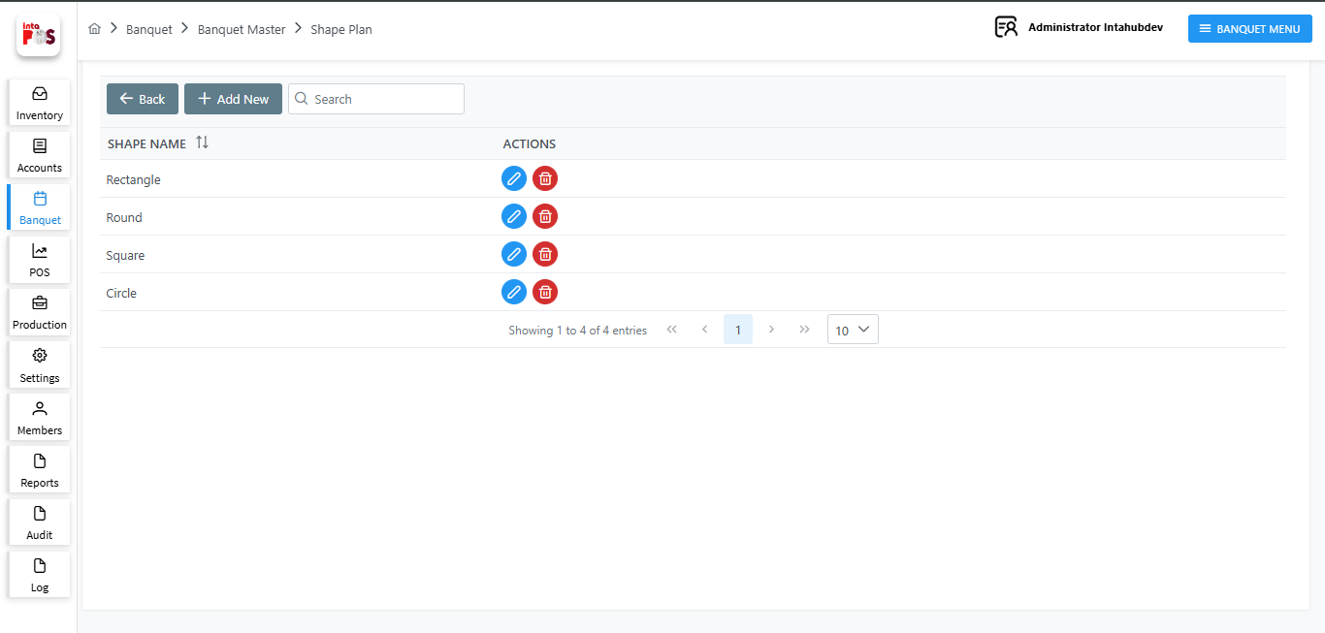
- By clicking button, you can add a new Shape Plan by filling in theme Shapename.
- After adding details click on button Save the Record or click on button to Cancel.

When making a seating plan, you can select that Shape, as shown below.
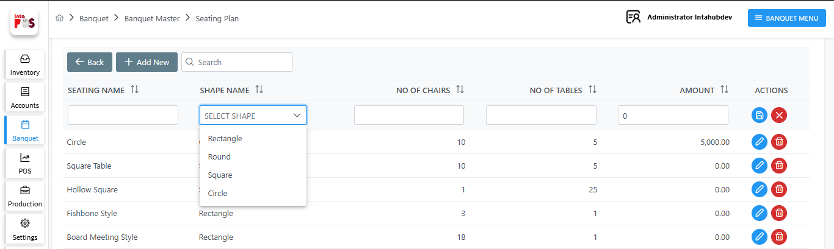

Policy Management

You can manage policy for the event using Banquet → Banquet Master → Policy Management, as shown below.
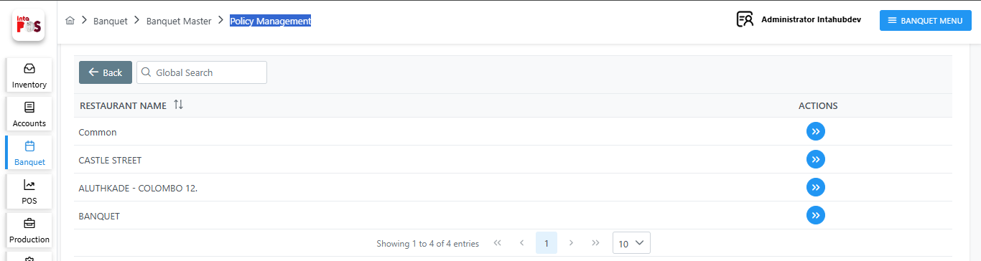
- Click  button to see policies for the selected location.

- By clicking button, you can add a new Policy Management by filling in the required fields, as shown below.
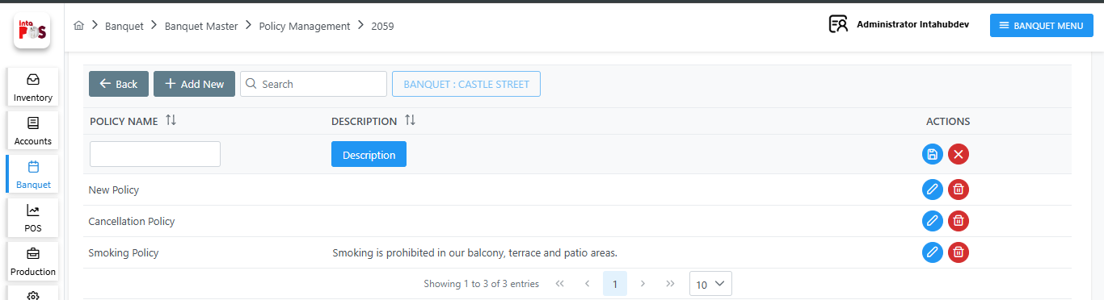

- By clicking 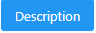 button you can add a description for the policy.

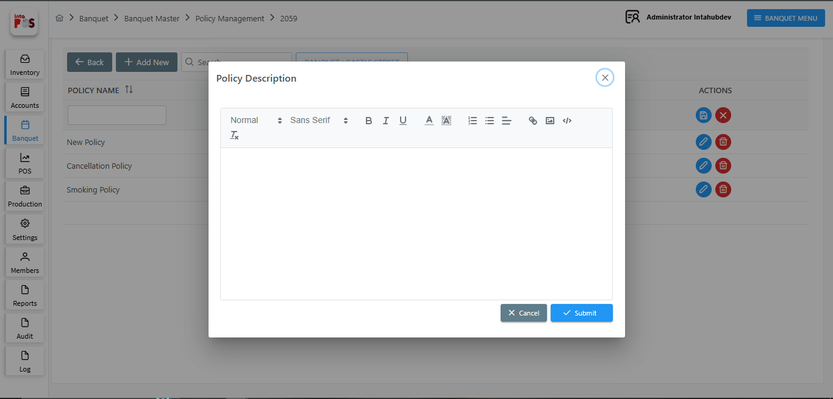
- Save description using 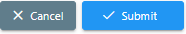 button.
- Cancel description using button.
- After adding details click on button Save the Record or click on button to Cancel.

When making an event, you can select that Policy, as shown below.
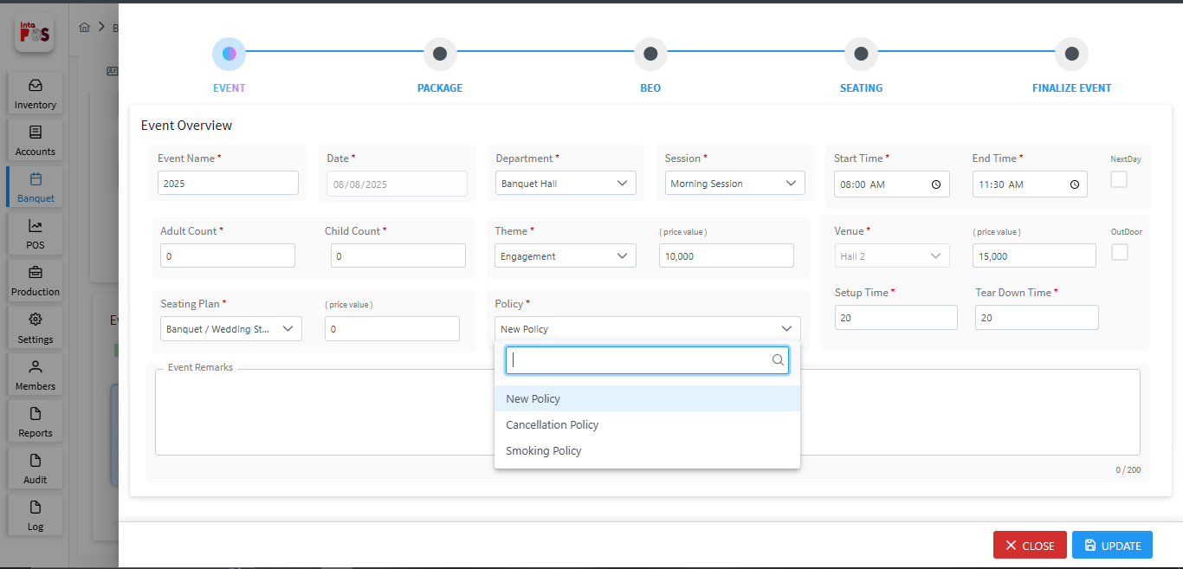
When adding event details such as theme, session, seating plan, policy, etc., you need to fill in the required fields. Once these values are loaded, they can be changed if needed.

1.3.1.2.2 Package Details

Once you update the event details, you can proceed to add the package details. Here you can apply the packeage details and you can view a summary of the selected package.

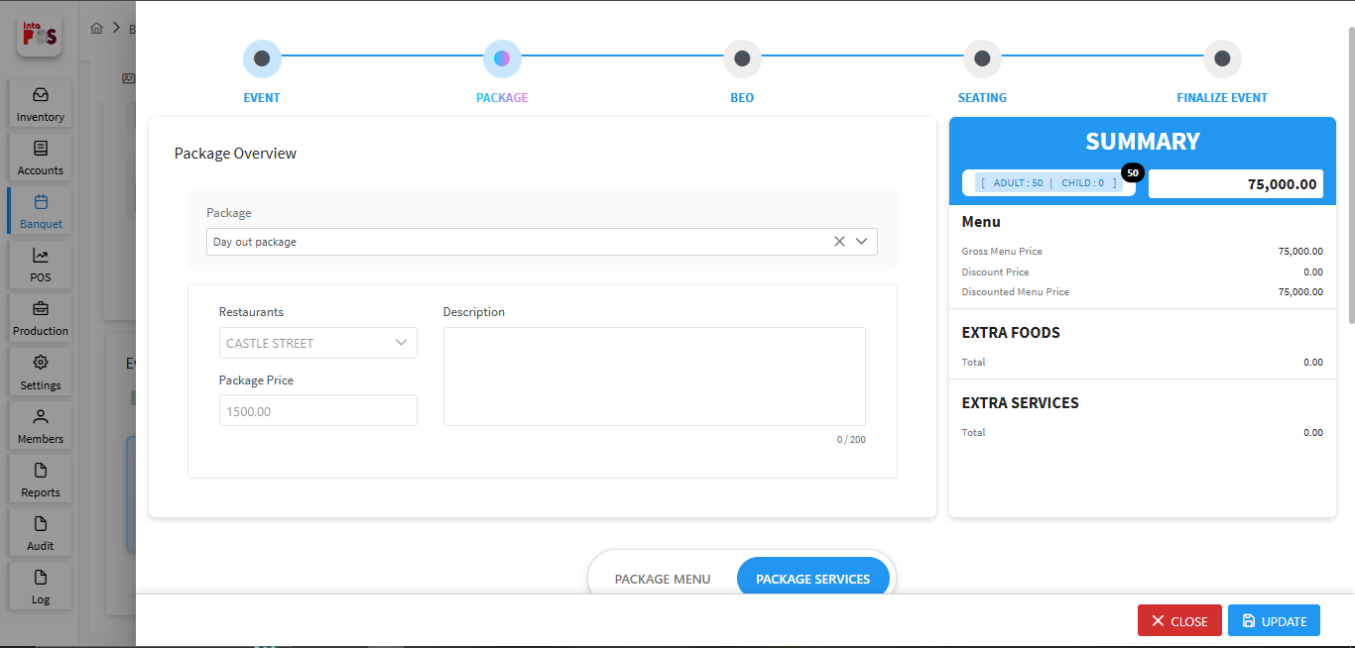
When you select a package, you can view the package price, the associated restaurant, and the package description in the Package Overview section.
Based on the selected package, you can choose the package menu details in the Menu Overview section. The menu price will be displayed, and you can apply discounts and select the pricing type using the dropdown list.
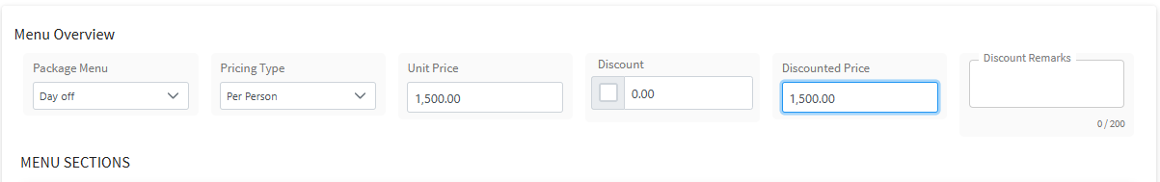
In the Menu section, you can select menu types based on the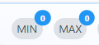 Quantity and total will be displayed here.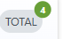

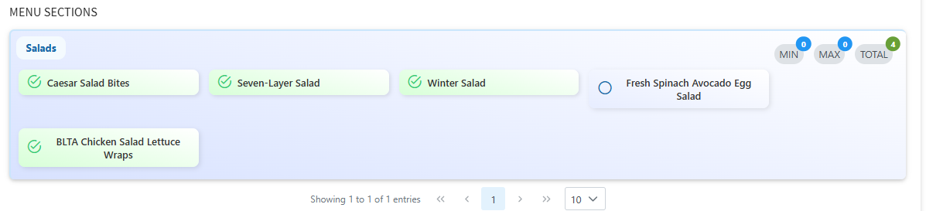

You can select extra food in the Extra Food section. Here, you can choose the food items, pricing type, quantity (QTY), unit of measure (UOM), and price. You can add a food item by clicking the button.

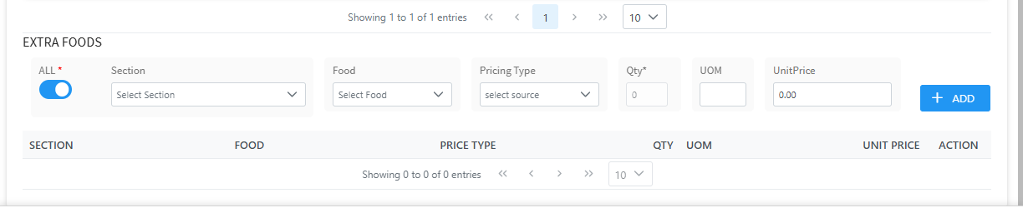
- If you click 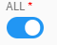 button you can add all food items; otherwise, only the menu foods can be selected.

You can choose how you want to charge for the event by selecting a pricing type
- Per Person – Charges are based on the number of guests.
- Per Event – A fixed price for the entire event, no matter how many guests attend.
- Per Consumption – Charges are based on the actual amount of food used during the event.

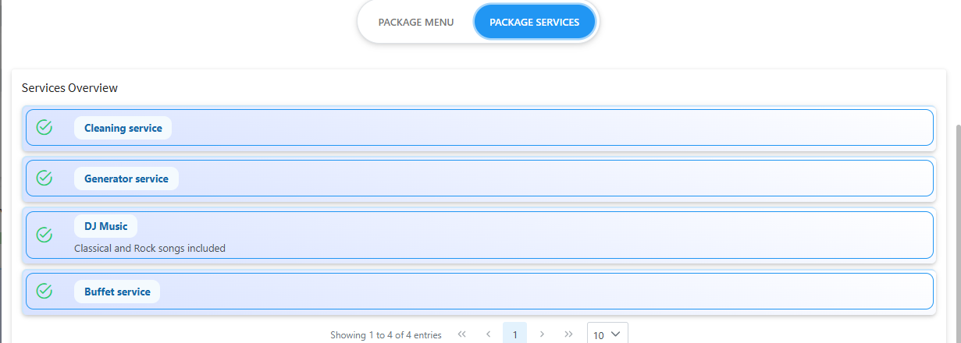
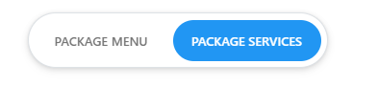
- By clicking button you can add services to the package.

You can select extra services in the Extra Services section. Here, you can choose the Services and BEO type. You can add services by clicking the button can delete services using button.

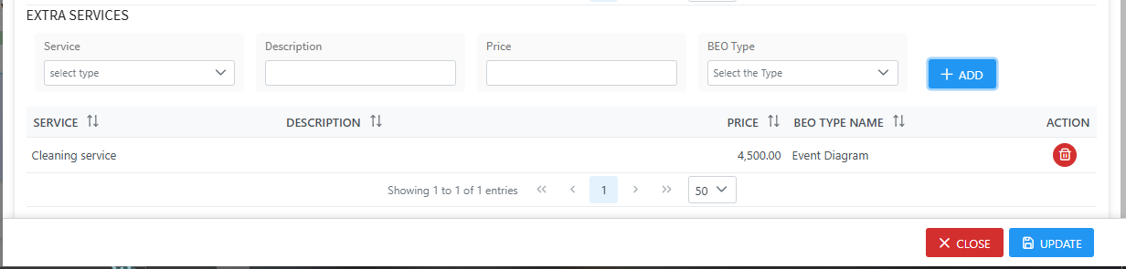

- Save the Package detail using button.

- Close the window using button.

Package Information

You can create or modify packages navigating to Banquet >> Banquet Master >> Package Information, as shown below.
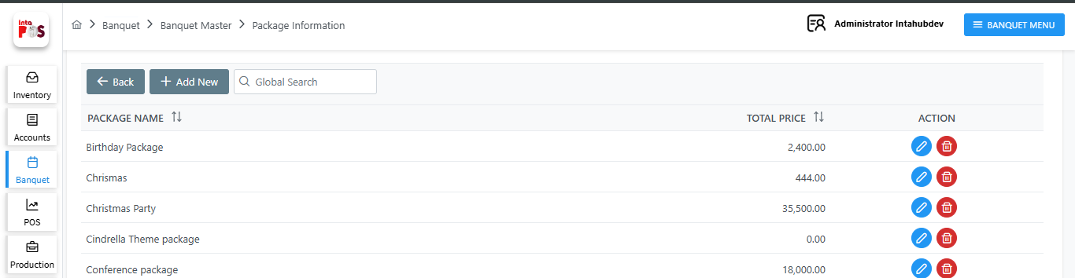
- Edit Package Information using button.

- DeletePackage Information using button.

- By clicking button, you can add a new Package by filling in the required fields, as shown below. Here, you can enter the package name, package location, and apply its banquet menu.
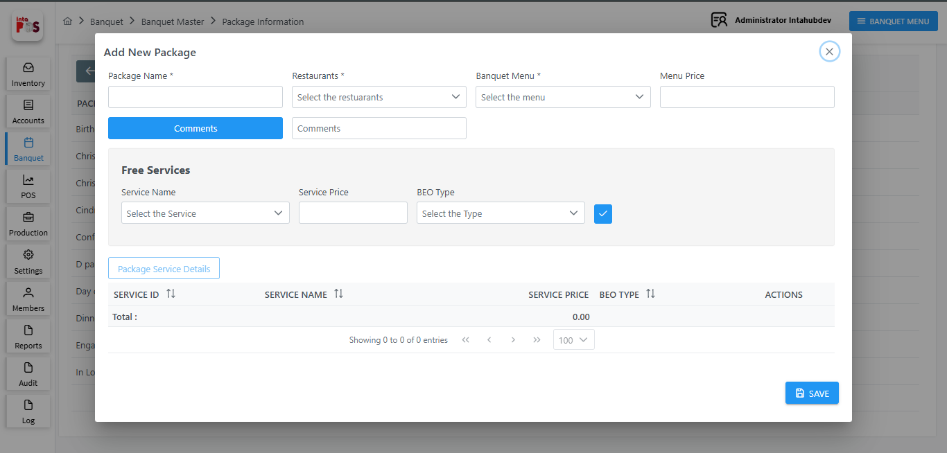

- Add comment using  button.
- You can also include the package services and select the BEO type and Click button to add services and click  button to save all details.

When you selecting a Package for the event, you can select that Package, as shown below.
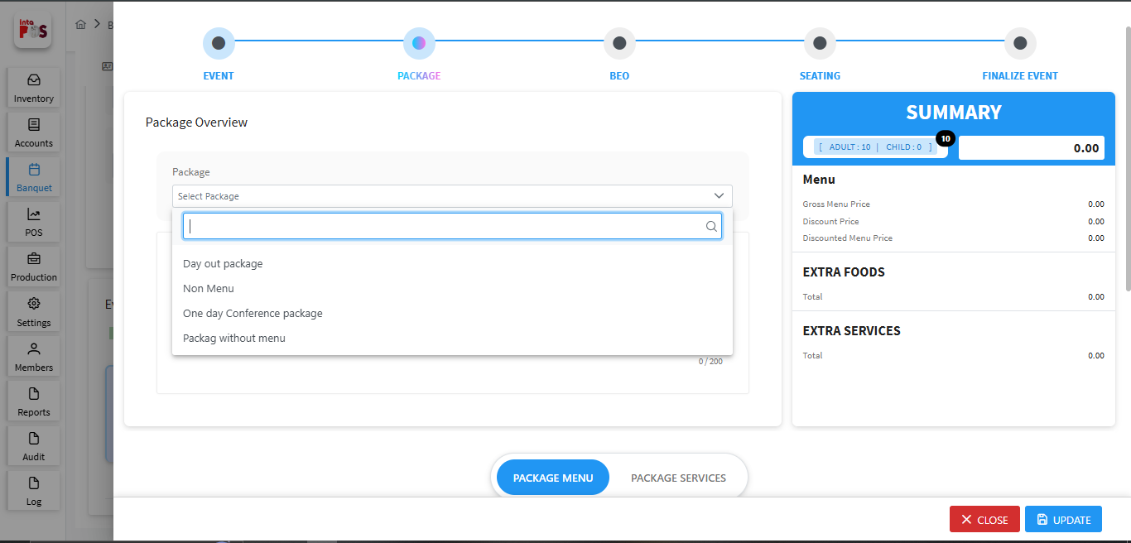

Banquet Menu

To add a new Banquet Menu, navigate to Banquet >> Banquet Master >>Banquet Menu, as shown below.
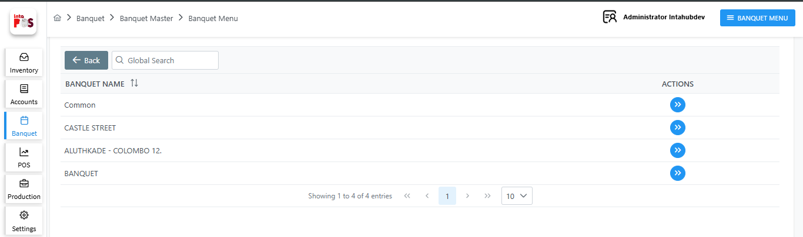
- Click button to see Banquet Menus for the selected location.
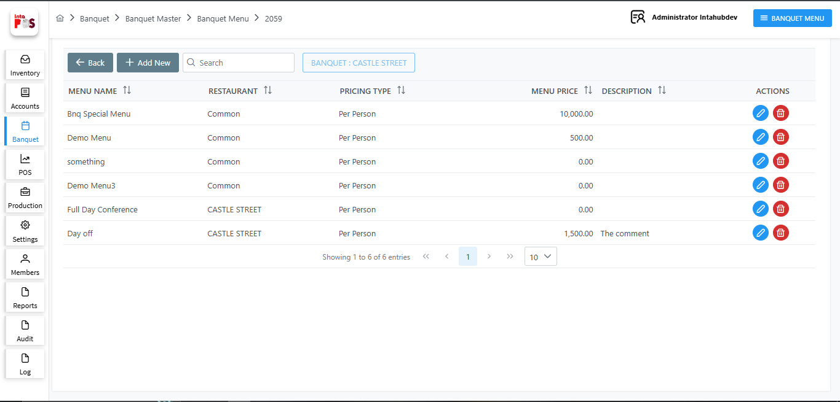
- Edit Banquet Menus using button.

- DeleteBanquet Menus using button.

- By clicking button, you can add a new Banquet Menu by filling in the required fields, as shown below.
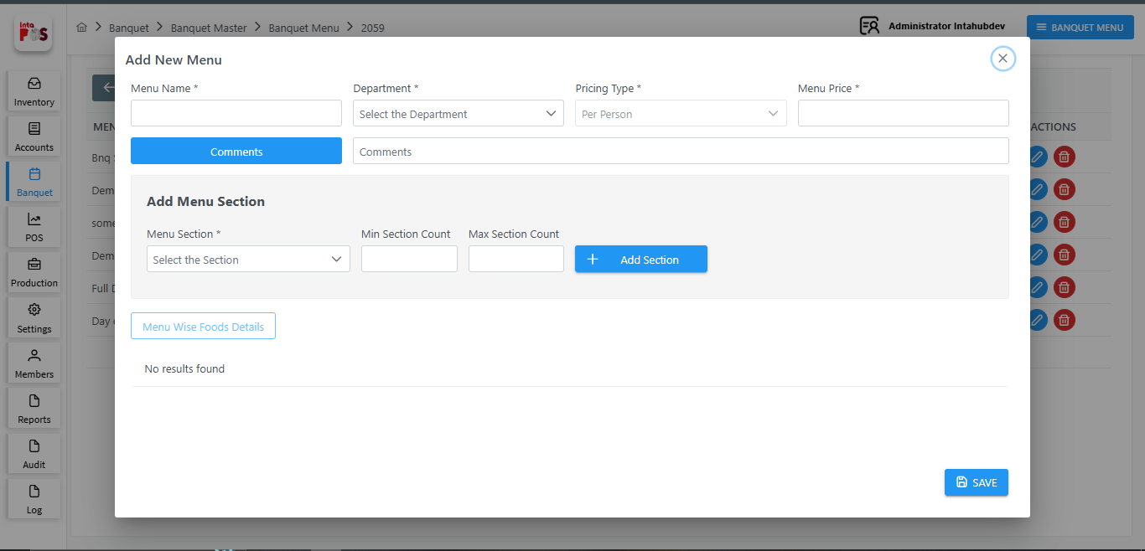
Here you can give the Menu name, department and the pricing type and Menu price.
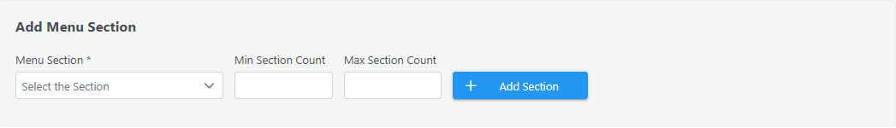
- Add selected menu, Min, and Max count using button.

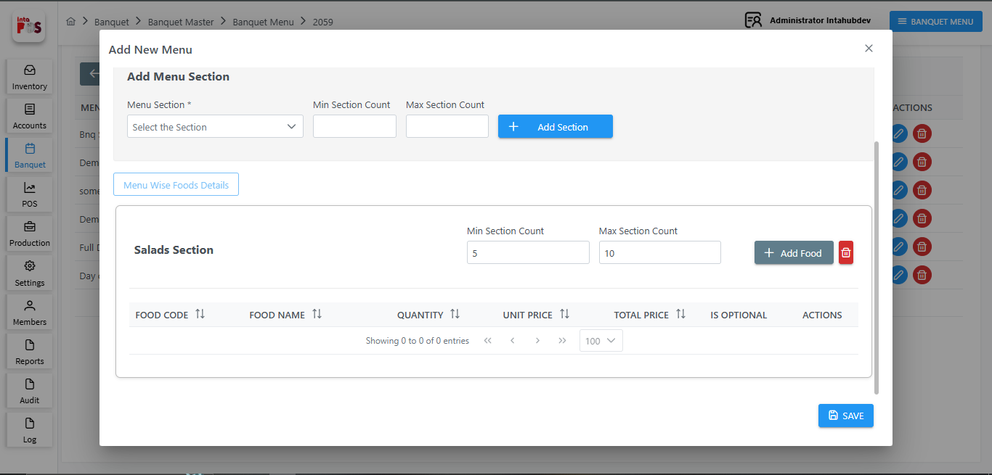
- By clicking 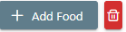you can add foods for the menu or delete Menu using button as shown below.
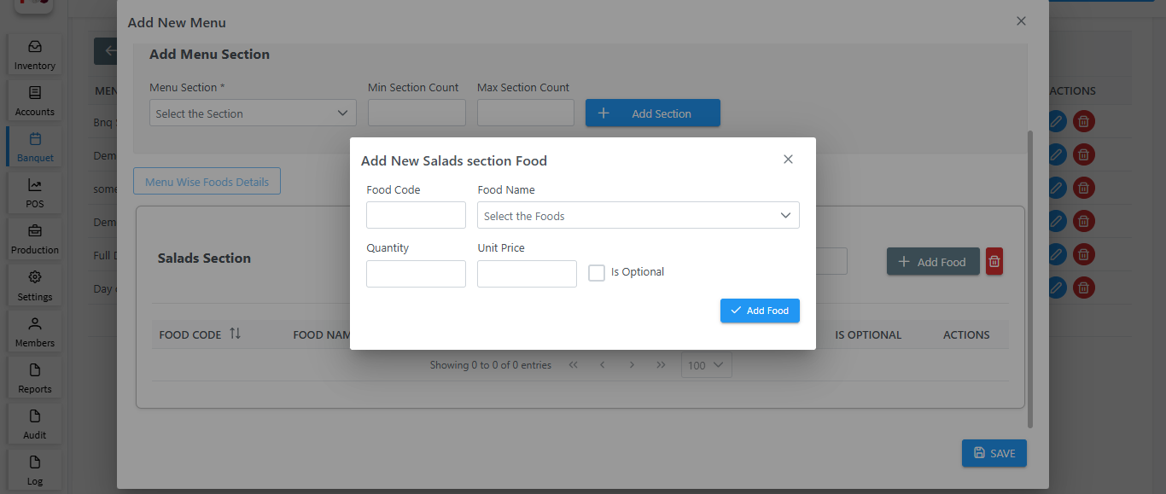
- Add Food using button.

- Save the All the Menu using button.

Menu Section

To add a new Menu Section, navigate to Banquet >> Banquet Master >>Menu Section, as shown below.
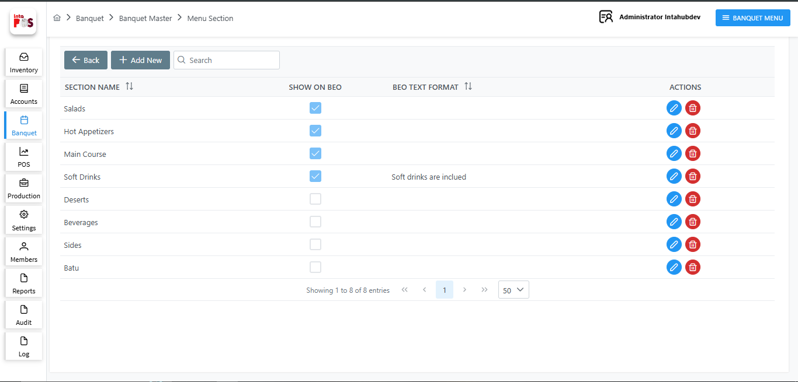
- Edit Menu using button.
- DeleteMenu using button.

- By clicking you can add new Menu by filling Menu section name, show or not in BEO, BEO text Format.
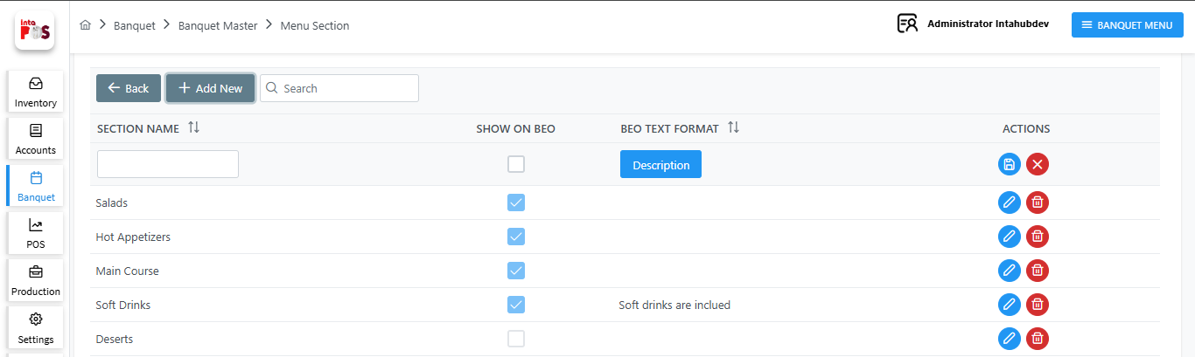
- Add description using 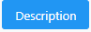 button. After adding description click 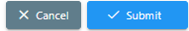 button to save or click button or cancel the description.

- Save the service using button cancel the service using button.

Service Management

You can add new services for the package, navigate to Banquet >> Banquet Master >> Service Management, as shown below.

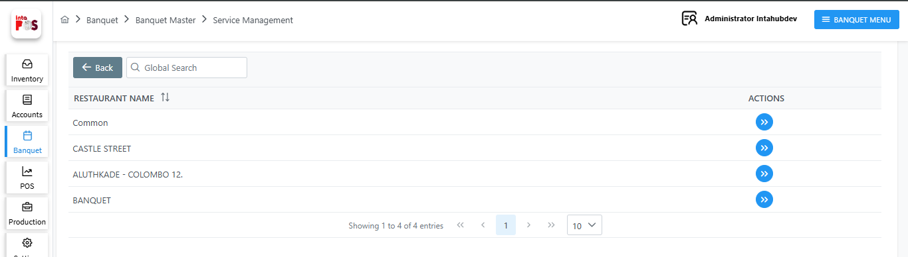

- Click button to see Services for the selected location.

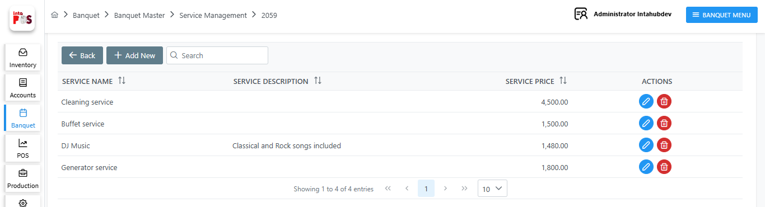
- Edit Services using button.

- DeleteServices using button.
- By clicking you can add new Services by filling Services name, Description and Service price.

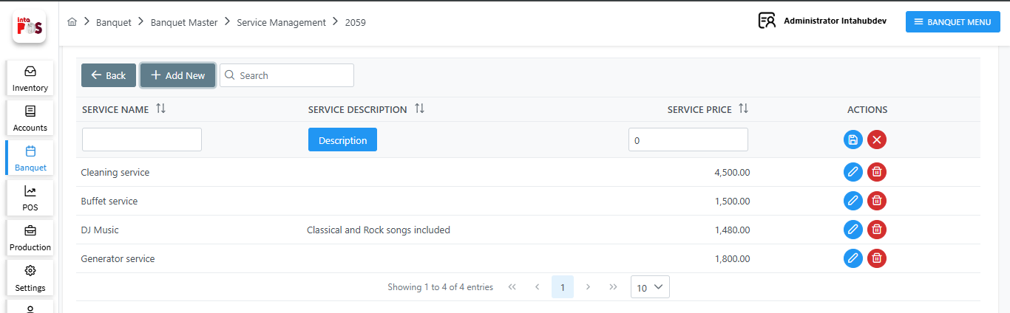

- Add description using button. After adding description click button to save or click button to cancel the description.

- Save the service using button cancel the service using button.

1.3.1.2.3 BEO Details

Once you update the Package details, you can proceed to add the BEO details.

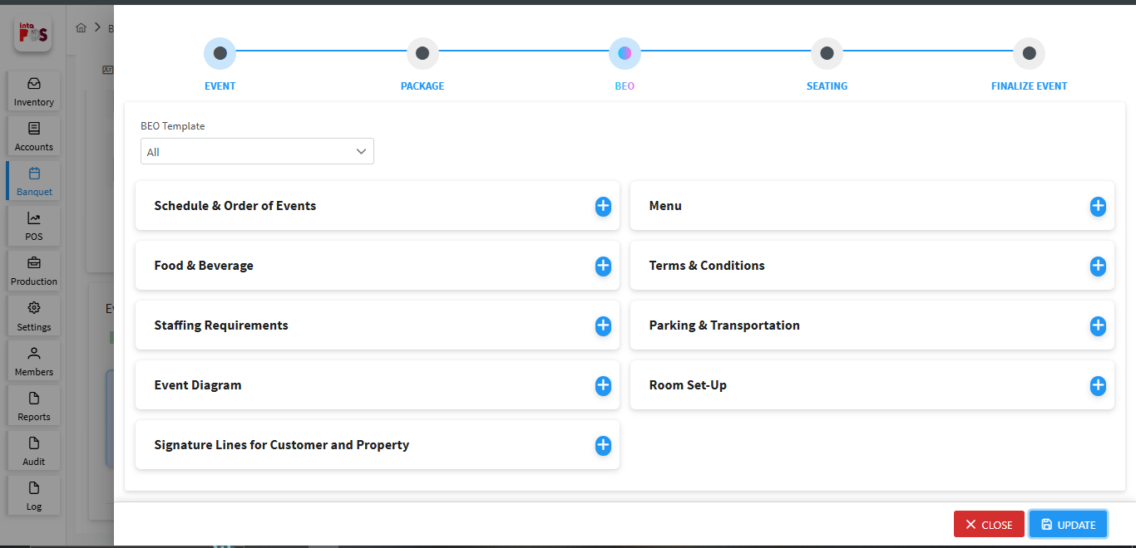
If you select “All” from the dropdown list in the BEO Template, it will load all BEO templates from Banquet >> Banquet Master >> BEO Templates. Otherwise, only the selected template will be displayed.
When click  button you can create schedule and order of events.
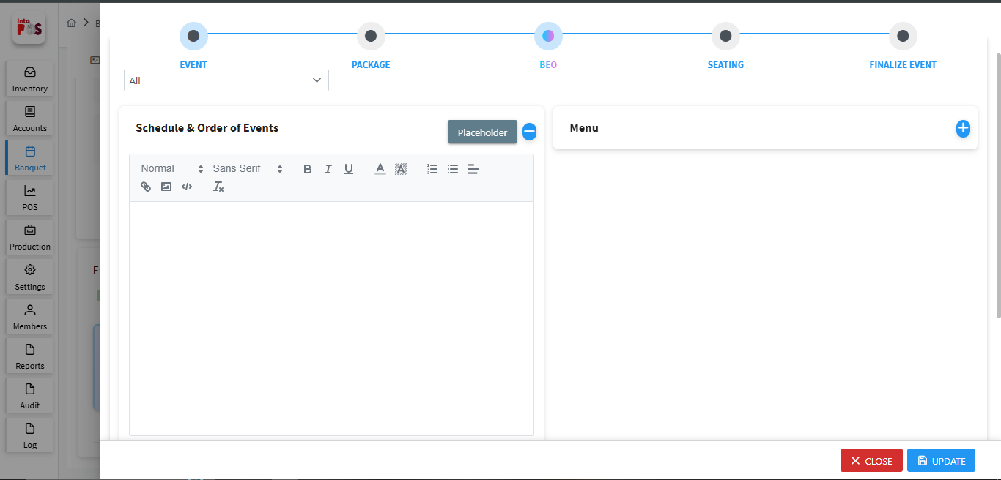

- Add details for the BEO by clicking 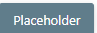 button and you can select already saved place holder menus . You can also type the BEO manually as well

- Save the BEO detail using button.

- Close the window using button.

BEO Types

A Banquet Event Order is a detailed document created by a venue. You can Banquet Event Order, navigating >> Banquet Master >> BEO Types, as shown below.
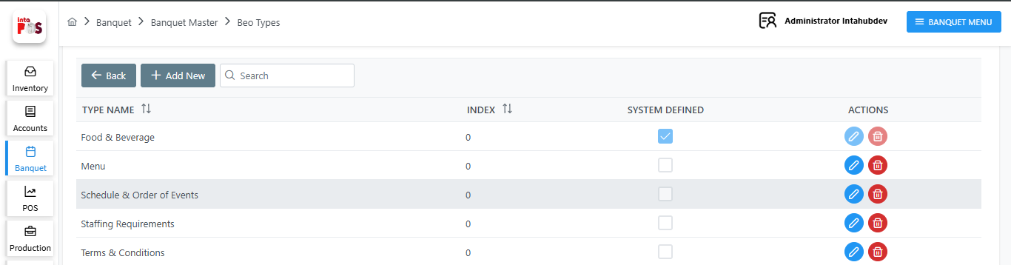

- Edit BEO Type using button.

- DeleteBEO Type using button.

- By clicking you can add BEO Type by filling name, index and indicating systen defined or not.

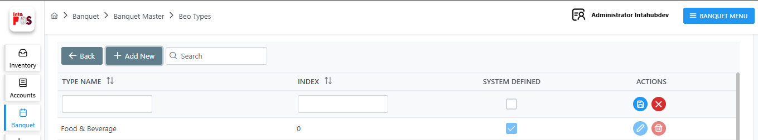
- Save the BEO Type using button cancel the BEO Type using button.

BEO Templete

You can create a templete for the Banquet Event Order, navigating >> Banquet Master >>BEO Template, as shown below.
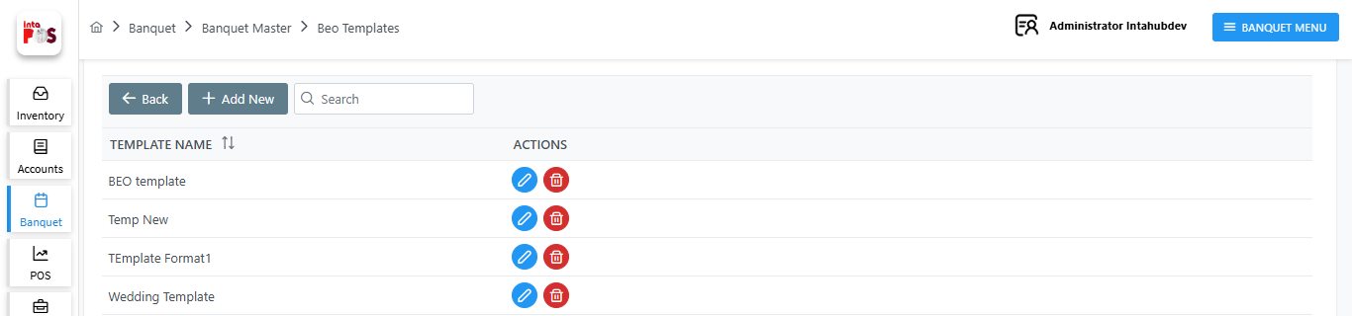

- Edit BEO Type using button.
- DeleteBEO Type using button.

- By clicking you can add BEO Type by filling name, index and indicating systen defined or not.
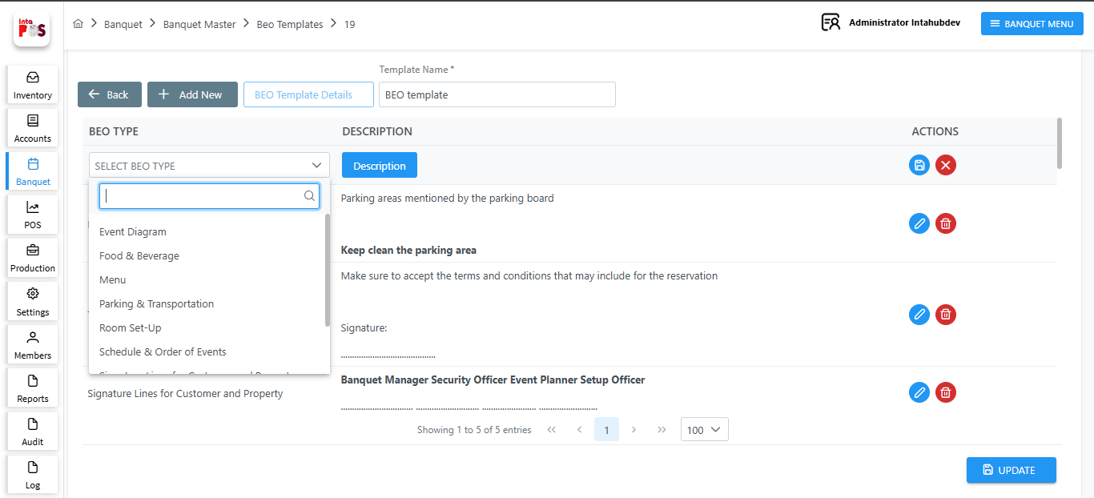
- Select the BEO Type from the dropdown list then add the description for the template using button.

- Save the BEO Type using button cancel the BEO Type using button.

- Save all template using button.

1.3.1.2.4 Seating Details

Once you update the BEO details, you can proceed to add the Seating details. Here you can apply the Seating Details.
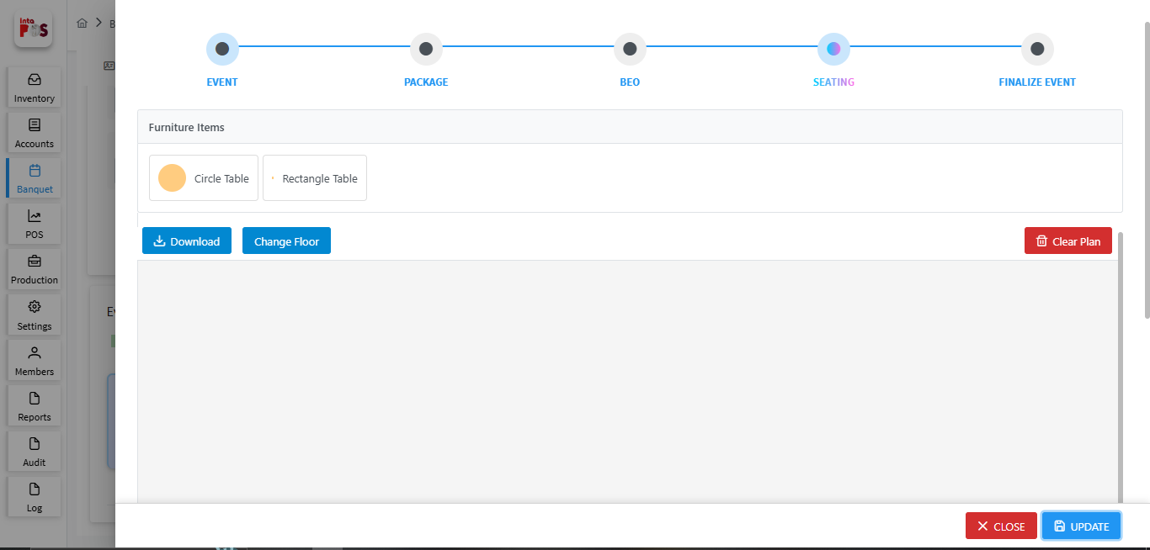

Here you can create the floor plan for the event by drag and dropping furniture items.
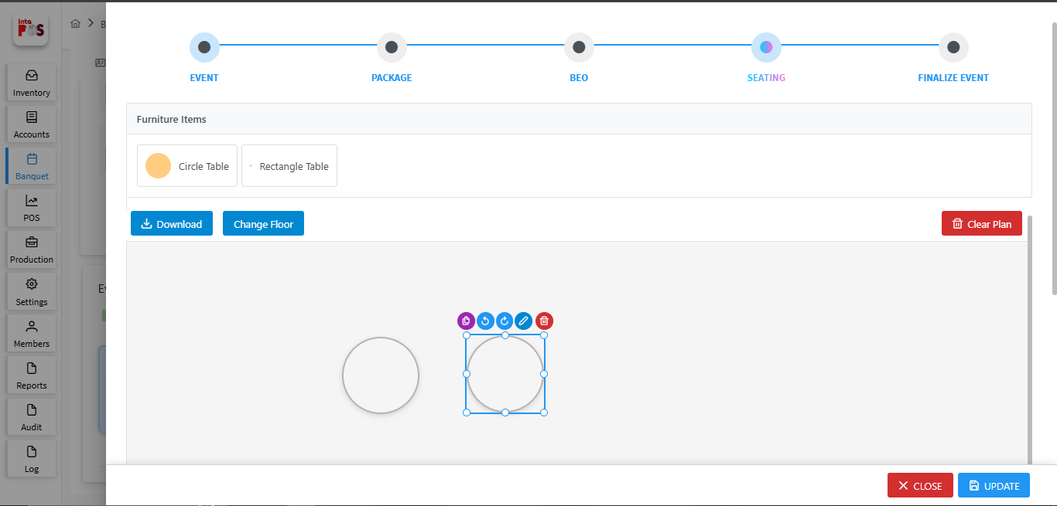
- Duplicate Furniture using 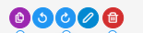 button.

- Rotate Furniture using button.

- Edit Furniture Name using button.

- Delete Furniture using button.

- Download the floor plan using button.

- Clear floor plan using button.

- Change flooar using button. This allow you to upload floor image using  button and cancel the floor using  button.

- Save the All Seating detail using button.

- Close the window using button.

1.3.1.2.5 Finalize Event
Once you update the Seating details, you can proceed to add the Event finalized details.
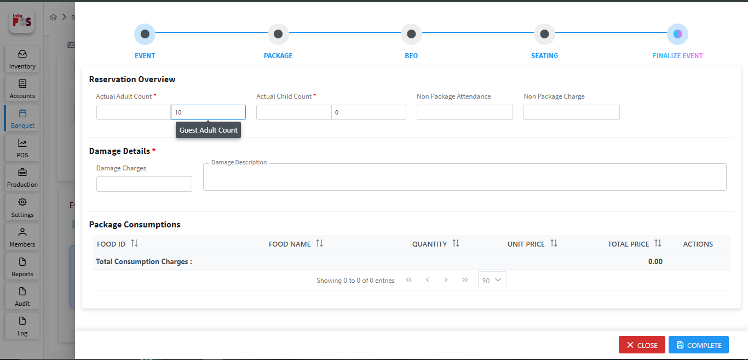
In the Reservation Overview section, you can enter the actual adult and child counts for the event compared to the planned counts. It will then calculate the non-package attendance and the charges for them.
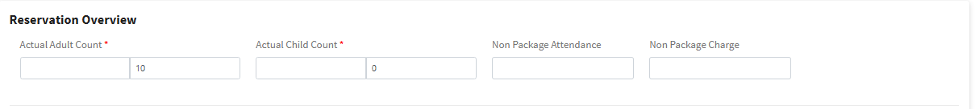
You can add damage cahrgers details in this section.
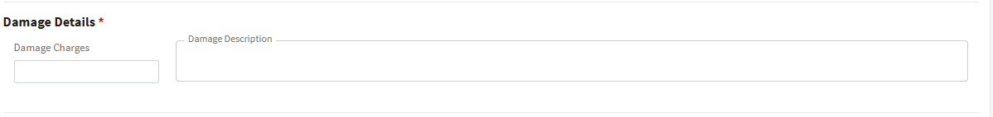
If your pricing type is Consumer Price, you can add consumption details in this section.
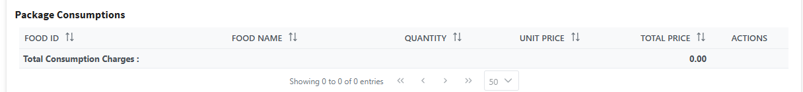

- Save the Event detail using 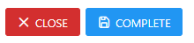 button. You cannot click this button before the end time.

- Close the window using button.

After adding all the event details, you can view a summary of the information in the Events Overview section.
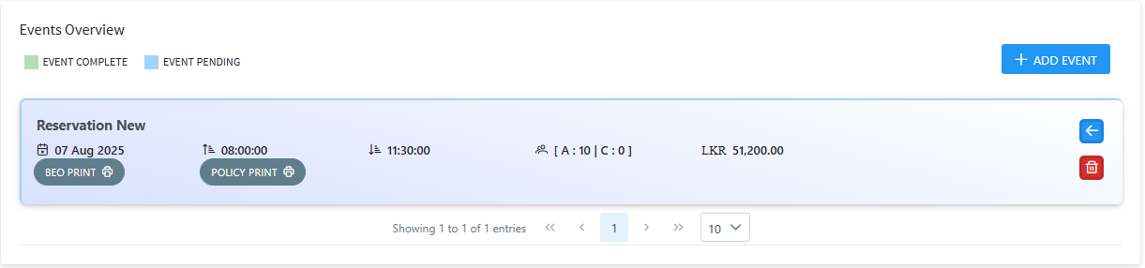
- Download the BEO using 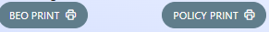 button.

- Download Policy Management using button.

- You can see the Reservation time Adult & Child count and the package price from this view.

- One Reservation can add more events using  button.

1.3.1.3Payement Overview

Here you can create a Payement for the reservation. You can see the payemnt details in this window.
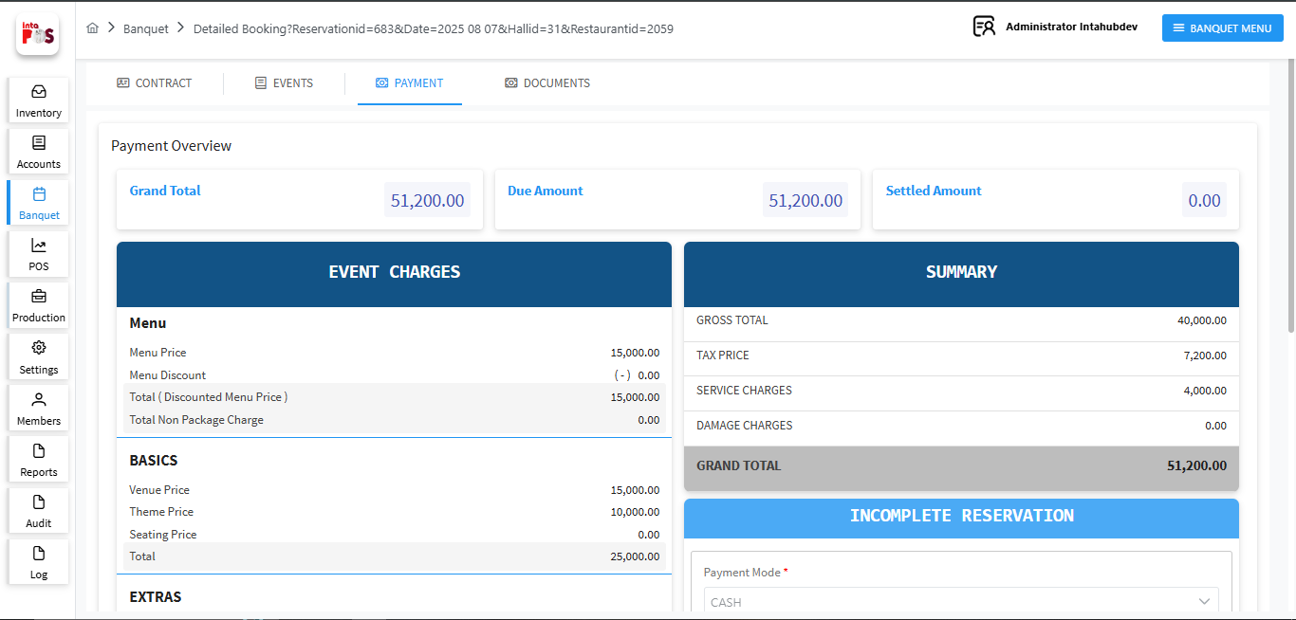
In the payement section you can select the payment mode and add the payement details. You can select Payement mode such as cash, card, city ledger, cheque, and other modes from the drop down list, as shown below.
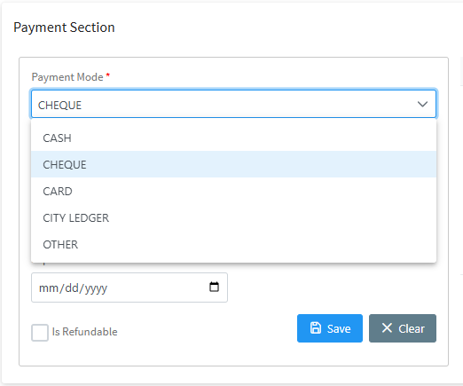
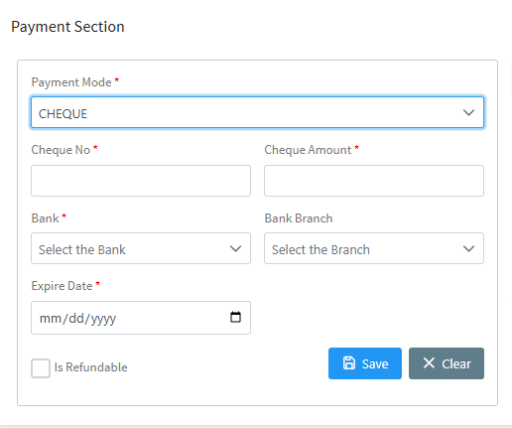
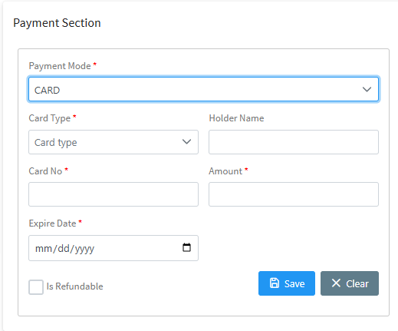
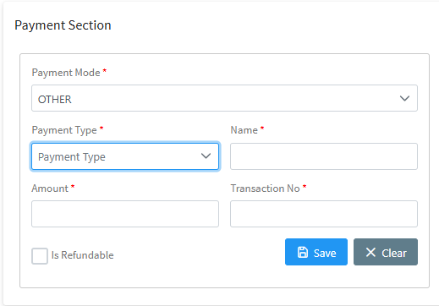
- Save the Payement using 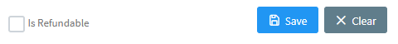 button.

- Cancel the Payement Using button.

- If the Payement is Refund then select .

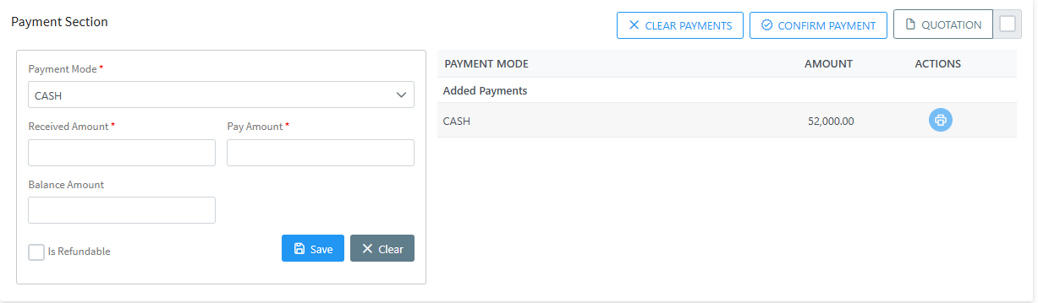
- Clear payement using button.

- Confirm payement using button.

- Download the Quotation using button. When you click checkbox you can download quotation without including package details.
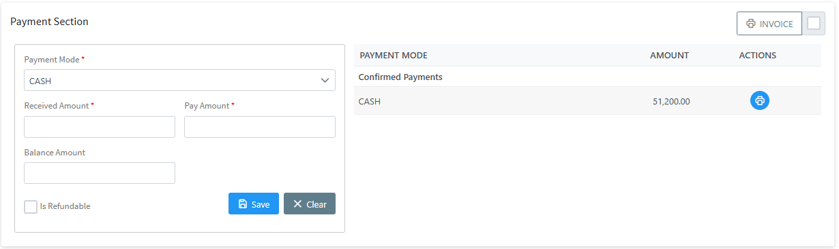
- Once you confirm the payment can download the invoice with all details using 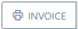 button. When you click checkbox you can download invoice without including package details.

- Download payment detail one by one using button.

After making a payment, you can view the payment record by navigating to Banquet >> Payment Cancellation.
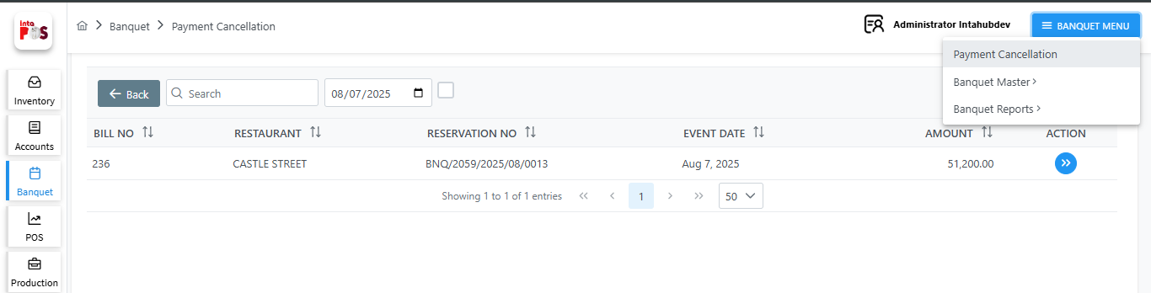
- Click button to see Payemnt for the selected location.

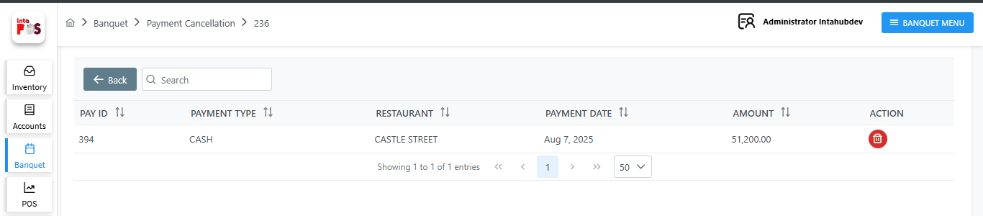

- Cancel Payment using button.

1.3.1.4 Document

In this section, you can upload any documents related to the reservation.
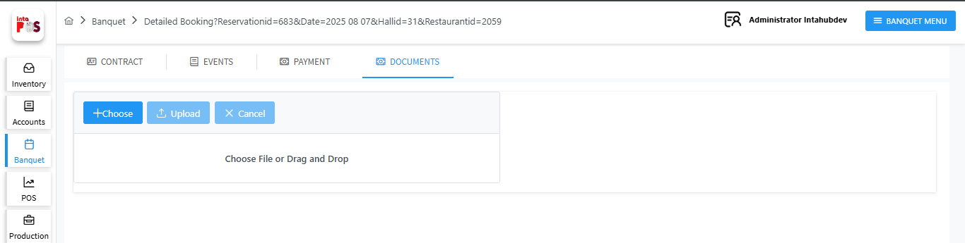
- Select a document from the device using  button.

- Save the document in the system using  button.

- Delete the selected document using  button.

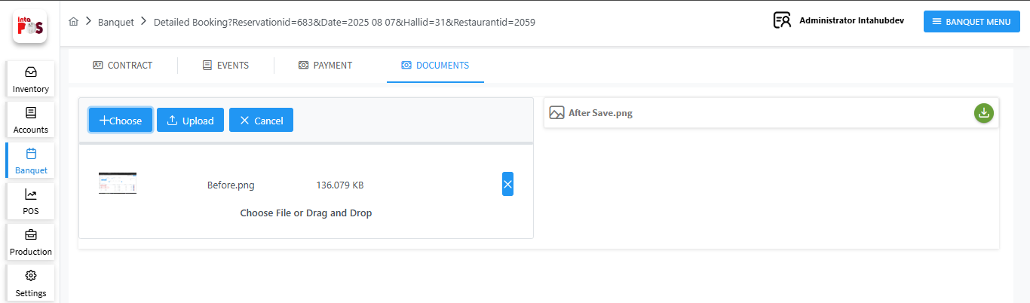
- By clicking button will cancel the document.

- You can also input a document by dragging and dropping it directly.
- To download the uploaded item, click the  button.

1.3.2Quick Reservation.

The second type of reservation is Quick Reservation. Designed for faster bookings.
This option allows you to reserve the venue quickly by filling out a simplified quick booking form.
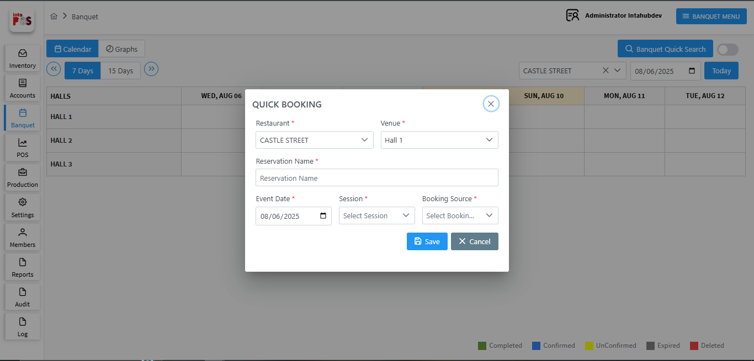
You can create a detailed reservation using this option. Fill in the required fields, then click button to save or the 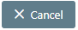 button to discard the reservation.

Venue

Here you can create a venue for the selected location by navigating to: Banquet → Banquet Master → Venue as shown below.
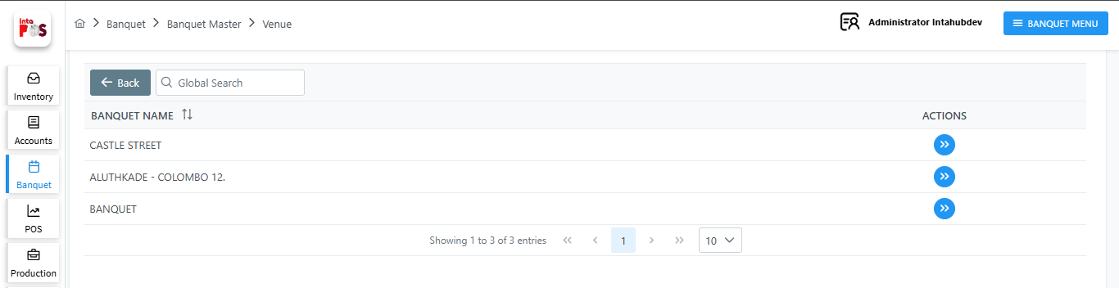
- Click button to see venues for the selected location.
- By clicking button, you can add a new venue by filling in the required fields, as shown below.
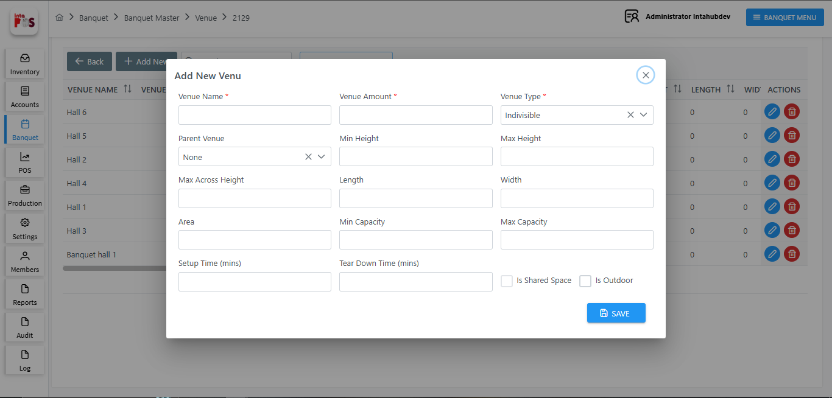
- You can save Venue using button.
- Once you save the venue, you can edit it using or delete it using button
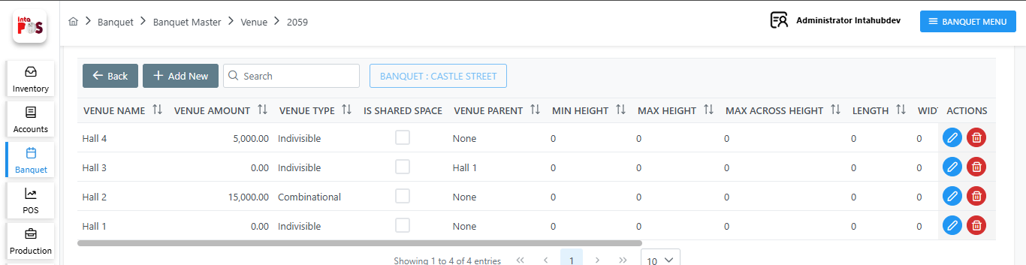

When you create a venue, it will appear under Halls in the calendar view. When making a reservation, you can select that venue, as shown below.
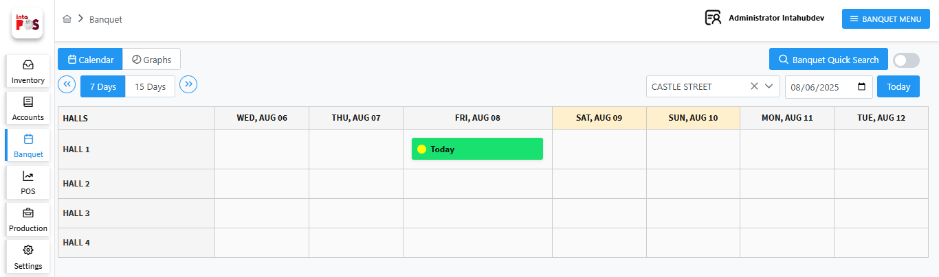

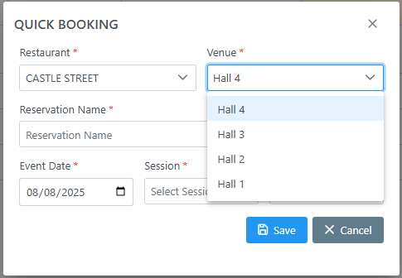

After saving Quick booking, complete the following steps:
- Enter Guest Information
- Provide Event Information
- Fill in Payment Details
- Upload any necessary Documents
These steps are similar to those in the Detailed Reservation process.

1.4 Banquest Report

The Banquet Report provides a detailed summary of all reservations, events, and activities scheduled within the banquet system. There are two types of Banquet Reports available in the system:

    - Sales Report
    - Reservation Report

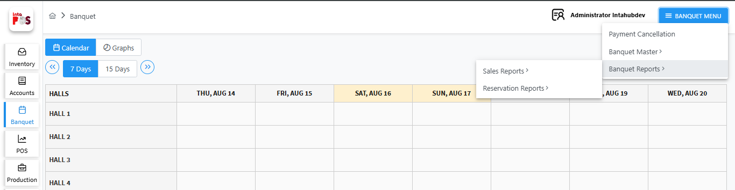

1.4.1 Sales Report

Provides a detailed overview of revenue generated from banquet reservations. This includes payment status, total amounts received, outstanding balances, and any discounts or taxes applied.
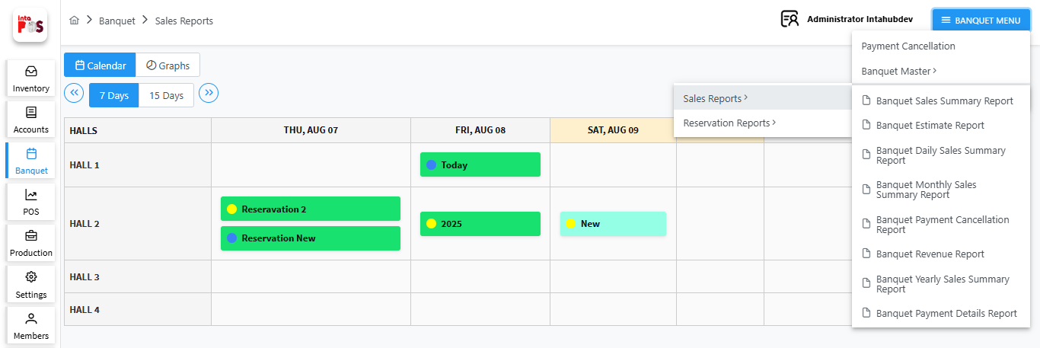

1.4.2 Reservation Report

The Reservation Report displays detailed information about all banquet reservations made within a selected date range. This report helps track current and upcoming bookings, cancellations, and overall event scheduling.

s