PETTY CASH
USER MANUAL

2024/09/30

TABLE OF CONTENTS

1. INTRODUCTION 3
2. EXPENSE CATEGORY 3
3. I OWE YOU 4
3.1 LIMIT I OWE YOU 5
3.2 I OWE YOU Reports 5
4. PETTY CASH MANAGEMENT 6
4.1 PETTY CASH Expenses Summery Reports 7
5. PETTY CASH REIMBURSEMENT 7
5.1 PETTY CASH REIMBURSEMENT Reports 8

INTRODUCTION
Petty cash provides an overview of essential feature for managing small expenses within accounting framework. Petty cash allows organizations to efficiently handle minor transactions such as office supplies, postage, and other incidental costs without the need for formal payment processes.
Petty cash have 5 main categories.
- Expense Category Management
- I owe you
- Petty cash Management
- Petty cash Reimbursement
- Reports

EXPENSE CATEGORY
Click on Petty Cash >> Expense Category Management to add expenses to petty cash.
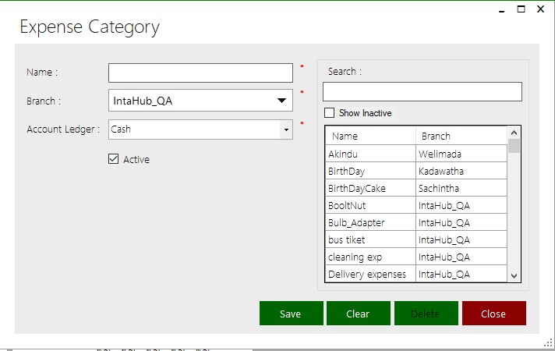
This form is for:
All existing expenses category are shown here.
- Click on the expenses category that you want to view.
- You can see the details of particular expenses category in corresponding fields
- Adding a new Expense category.
- Editing details of existing Expense category.
- Deleting an existing Expense category.
- View details of existing Expense category.
- Search details of Expense category.

Add a new Expense category
- Enter details such as name, under description in corresponding fields.
- Click on <Save> button to save.

Edit details of Expense category
- Select a row from register.
- Details of the selected expense will show in corresponding fields at left side of the form.
- Edit the details that you want.
- Click on <Update > button to save the changes.

Delete an existing Expense category
- Select a row from register.
- Click on <Delete > button.
- Confirmation is asked for deletion.
- The selected expense is deleted from the list if no reference exists for selected Expense category.

Searching of Expense category
Type the name of Expense category in search field. All account groups starting with that name are displayed in list from where particular expense can be selected.

I OWE YOU
Click on Petty Cash >> I Owe You.
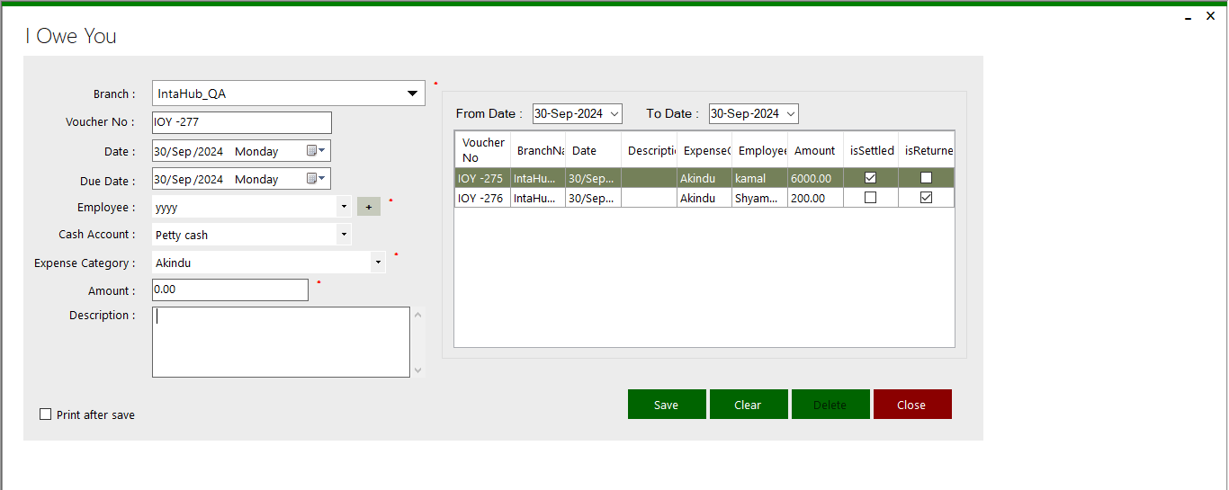
This form is for:
- Adding a new I owe you.
- Editing details of existing I owe you.
- Click on the isSettled tick to settle.
- Click on the isReturned tick to return.
- Deleting an existing I owe you.
- View details of existing I owe you.

Add a new I owe you
- Enter details such as name, under description in corresponding fields.
- Click on <Save> button to save.

Edit details of I owe you
- Select a row from register.
- Details of the selected I owe you will show in corresponding fields at left side of the form.
- Edit the details that you want.
- Click on <Update > button to save the changes.

Delete an existing I owe you
- Select a row from register.
- Click on <Delete > button.
- Confirmation is asked for deletion.
- The selected I owe you is deleted from the list if no reference exists for selected I owe you.

LIMIT I OWE YOU
Click on Settings >> Settings>> Petty cash to limit for employee.
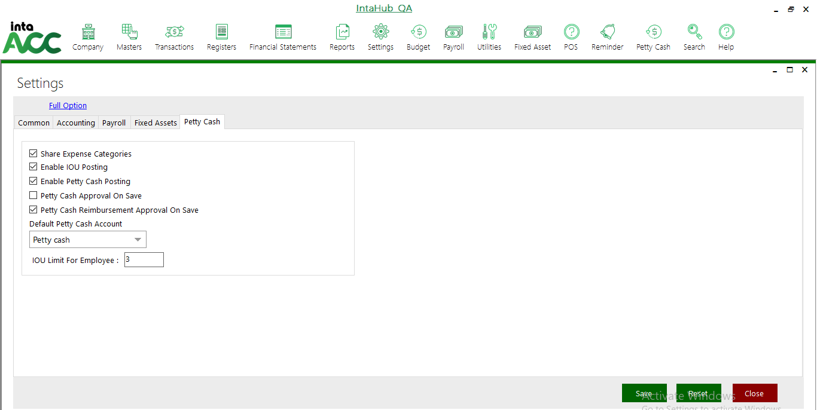
Give the amount of limit for the employee

I OWE YOU Reports
Click on Petty cash >> Reports>> I Owe You to view I owe you reports.
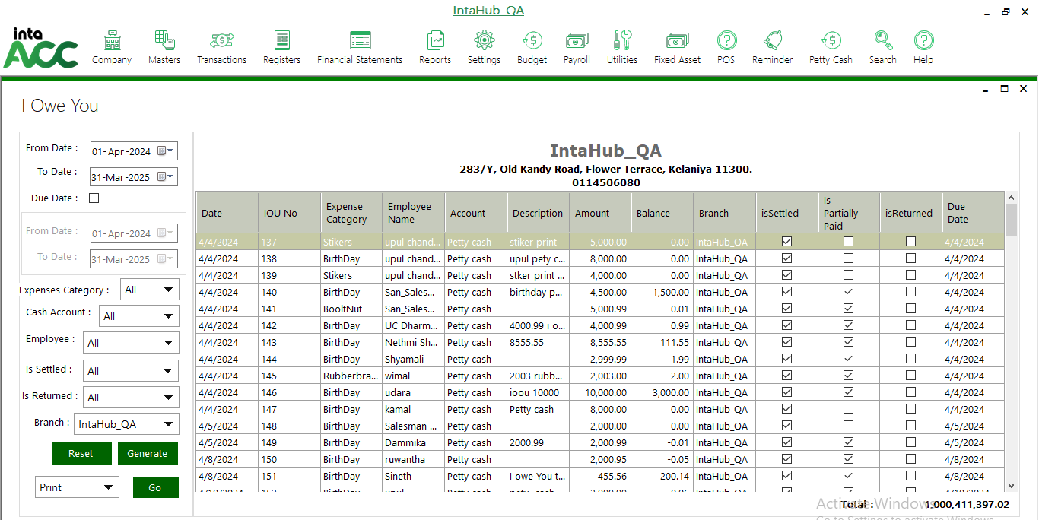

PETTY CASH MANAGEMENT
Click on Petty Cash >> Petty Cash Management for settle the petty cash.
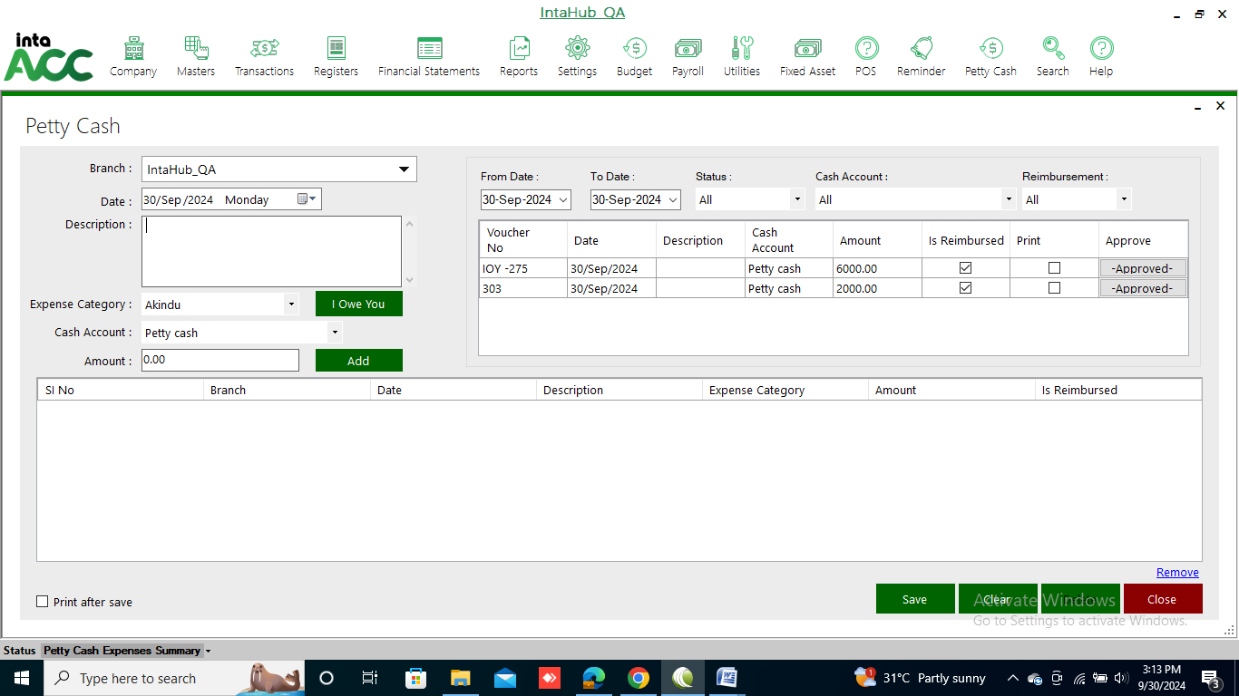
This form is for:
- Adding a new petty cash.
- Editing details of existing petty cash.
Click on the I owe You, then select a not settled I Owe You.
Click on the Approve and to approve the petty cash.
- Deleting an existing petty cash.
- View details of existing petty cash.

Add a new petty cash
- Enter details under description in corresponding fields.
- Click on <Save> button to save.

Edit details of petty cash
- Select a row from register.
- Details of the selected petty cash will show in corresponding fields at left side of the form.
- Edit the details that you want.
- Click on <Update > button to save the changes.

Delete an existing petty cash
- Select a row from register.
- Click on <Delete > button.
- Confirmation is asked for deletion.
- The selected petty cash is deleted from the list if no reference exists for selected petty cash.

PETTY CASH Expenses Summery Reports
Click on Petty cash >> Reports>> Petty Cash Expenses Summery to view Petty cash management reports.
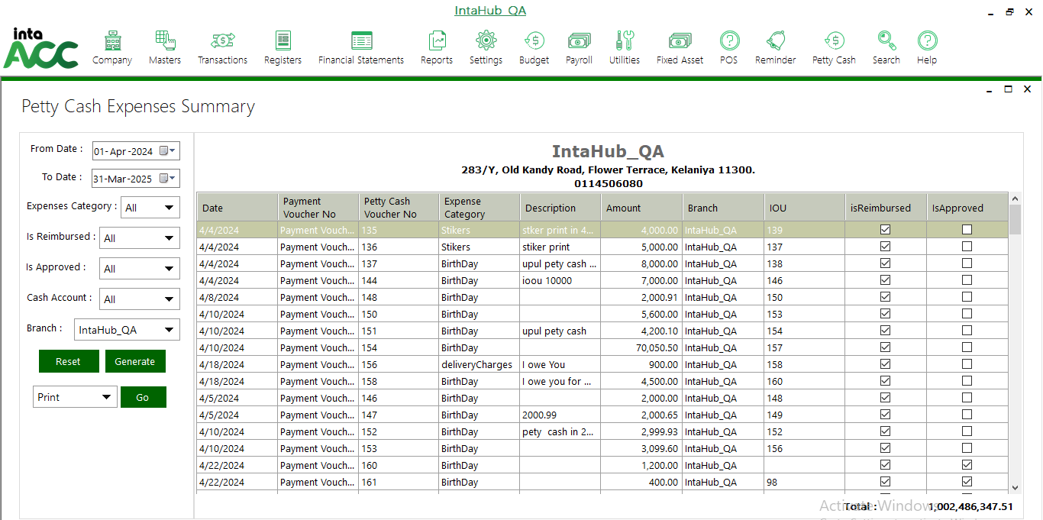

PETTY CASH REIMBURSEMENT
Click on Petty Cash >> Petty Cash Reimbursement for refill the petty cash account.
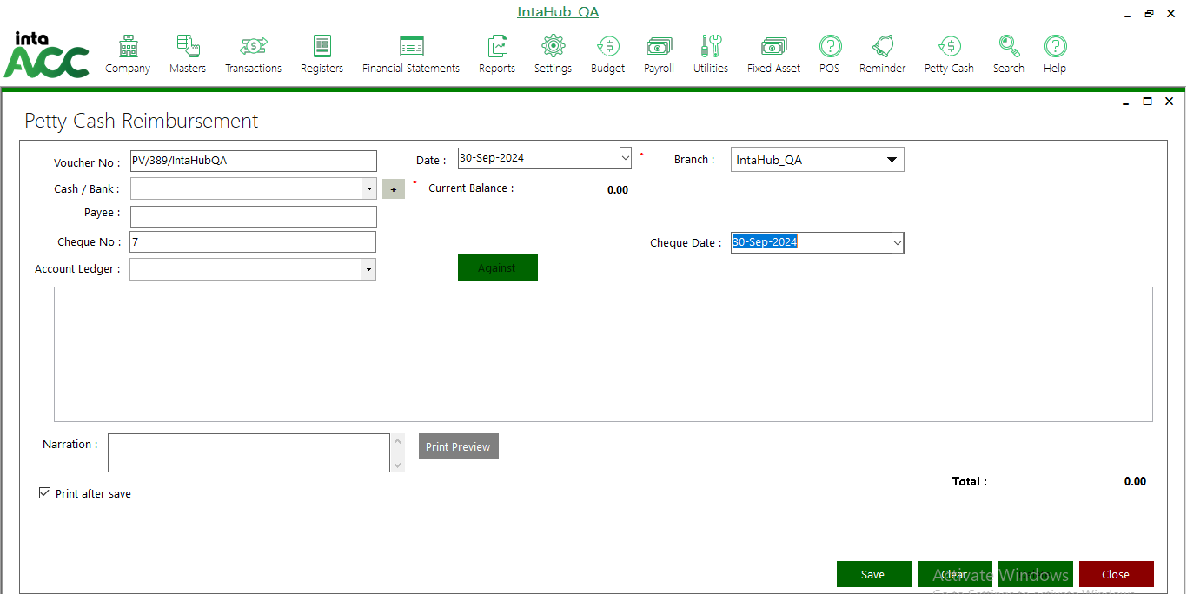
Click on against button, to select the petty cash.

PETTY CASH REIMBURSEMENT Reports
Click on Petty cash >> Reports>> Petty Cash Reimbursement to view Petty cash reimbursement reports.
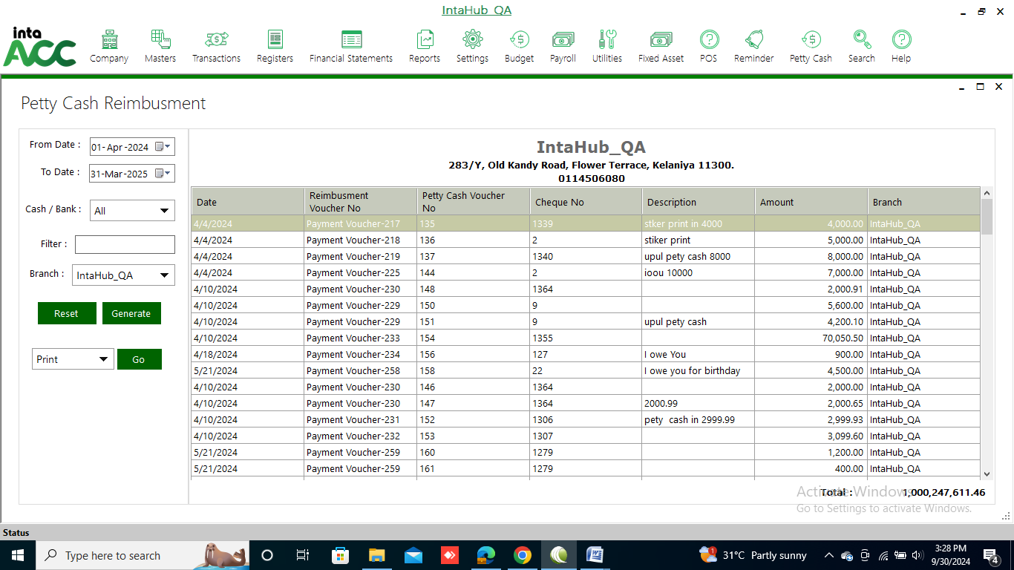
To view saved voucher click on Registers>> Vendors>> Payment Voucher.
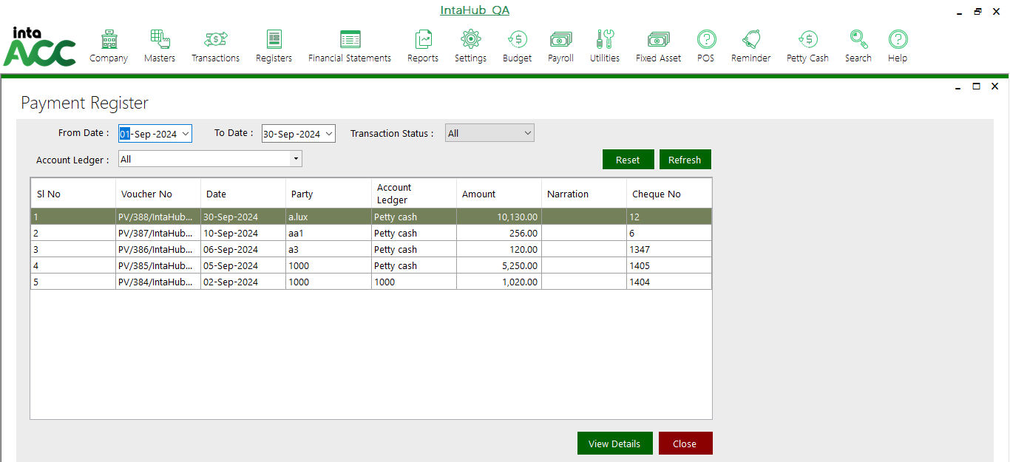
Select a voucher and click on View Details. Then below window is shown.
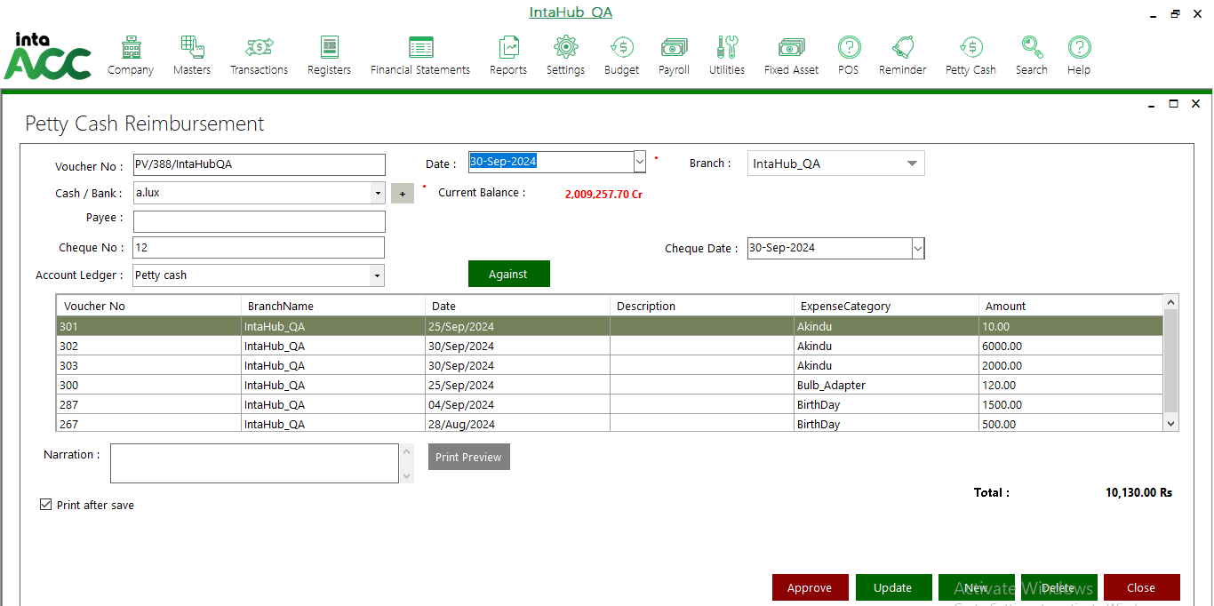
Then click the Approve button to approve.

