PAYROLL
USER MANUAL

2024/10/02

TABLE OF CONTENTS

1. INTRODUCTION 5
2. HOLIDAY SETTINGS 6
3. PAY HEAD 7
4. DESIGNATION 8
5. DEPARTMENT 9
6. SUB COMPANY 10
7. SALARY ACCOUNT MANAGEMENT 11
8. EMPLOYEE TYPE 12
9. EMPLOYEE 13
10. EMPLOYEE REGISTER 14
11. LEAVE MANAGEMENT & ATTENDANCE MANAGEMENT 15
12. WORK FROM OUTSIDE 15
13. MANUAL ATTENDANCE 16
14. MANUAL MONTHLY ATTENDANCE 16
15. MONTHLY ATTENDANCE 17
16. FINGERPRINT MANAGEMENT 17
17. MONTHLY FINGERPRINT MANAGEMENT 18
18. LOAN 18
19. LOAN EARLY SETTLEMENT 19
20. ADVANCE PAYMENT 19
21. BONUS/ DEDUCTION 20
22. ROASTER MANAGEMENT 20
23. ROASTER PLANNING 21
24. ROASTER SWAP 21
25. SERVICE CHARGE PROCESS 22
26. SALARY VOUCHER 23
27. ENTITLED LEAVE RESET 24
28. PAY SLIP 24
29. PAYROLL DASHBOARD 25
30. LETTERS/ CARDS 25
30.1 EMPLOYEE CARD 25
30.1.1 Template Manager 25
30.1.2 Employee Card Generation 26
30.2 SERVICE LETTER 26
30.2.1 Service Letter Template 26
30.2.2 Service Letter Generation 27
30.3 VOP LETTER 27
30.3.1 VOP Letter Template 27
30.3.2 VOP Letter Generation 28
31. HR REPORTS 29
31.1 Employee Information 29
31.2 Attendance 29
31.3 Department Wise Attendance 30
31.4 Employee Time Card 30
31.5 Monthly Attendance 31
31.6 Daily Absent Details 31
31.7 Absent Analysis 32
31.8 Leave balance 32
31.9 Roaster Details 33
31.10 Monthly Attendance Detail Report 33
31.11 Monthly Fingerprint Log Details 34
31.12 Attendance Audit Trial 34
31.13 Late In Early Out 34
32. PAYROLL REPORTS 35
32.1 Advance Payment 35
32.2 Bonus/ Deduction 35
32.3 Monthly Salary 35
32.4 Loan Report 36
32.5 Salary Payment Type 36
32.6 EPF/ETF Contribution 37
32.7 Salary Transfer Final Report 37
32.8 Monthly Hold Salary Details 38
32.9 Service Charge Report 38
32.10 Monthly Salary Report 39
32.11 C Report EPF/ETF 39
32.12 EPF Return Report 40
32.13 ETF Return Report 40
32.14 Monthly Salary Comparison Report 41
32.15 Basic Salary Reconciliation 41
32.16 EPF Submission 42
32.17 EPF/ ETF Export 42

INTRODUCTION
IntaAcc Payroll Management software streamlines the entire payroll process, ensuring accurate and timely compensation for employees. With its advanced features, IntaAcc Payroll Management automates complex calculations for salaries, bonuses, deductions, and tax withholdings, saving businesses valuable time compared to manual payroll processing.
The Payroll manages various aspects of employee compensation, including overtime, benefits, and compliance with tax regulations, all while maintaining detailed records for audits and reporting. IntaAcc Payroll Management also includes employee self-service functionalities, enhancing transparency and engagement within the workforce. By leveraging this comprehensive solution, organizations can minimize errors, improve efficiency, and focus more on strategic initiatives rather than administrative tasks.
- Features of the product
- Holiday Settings.
- Pay Head / Designation /Employee creation.
- Roaster Management.
- Department, sub Department Creation.
- Loan Management.
- Advance Payment Processing.
- Salary Processing.
- Pay Slip Printing.
- 10+ Reports.
Payroll module shown as following window.
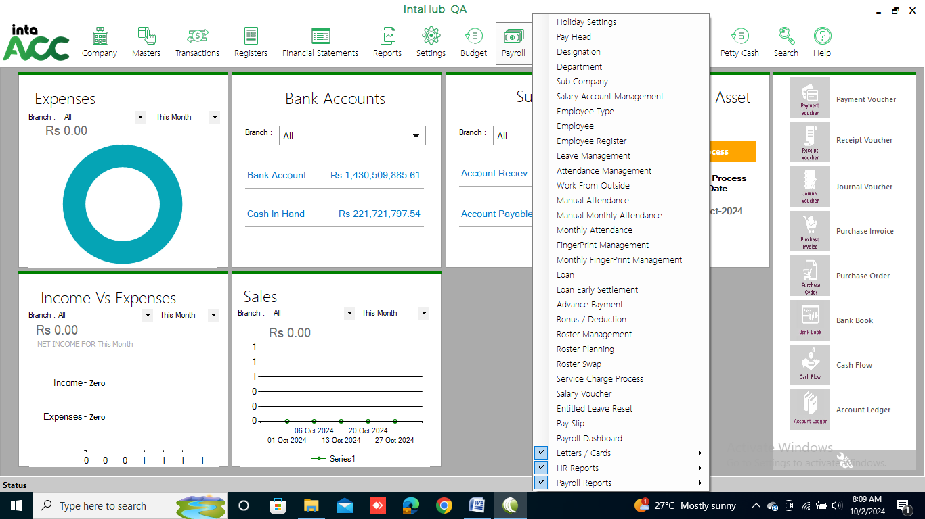

HOLIDAY SETTINGS
Click on Payroll >> Holiday Settings
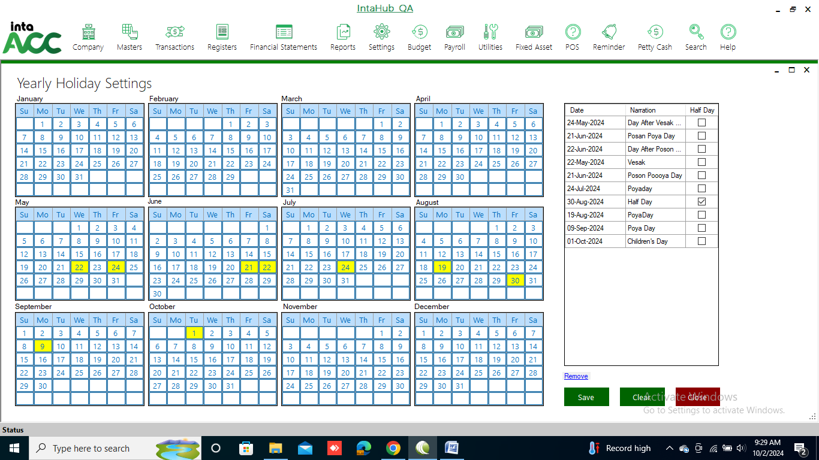

This form is for:
- Adding a new Holiday.
- Editing details of existing Holiday.
- Deleting an existing Holiday.

Add a new Holiday
- Select the day in the calendar.
- Enter details such as Holiday name in corresponding fields.
- Click on <Save> button to save.

Edit details of Holiday
- Select a row from register.
- Details of the selected Holiday will show in corresponding fields at right side of the form.
- Edit the details that you want.
- Click on <Save> button to save the changes.

Delete an existing Holiday
- Select a row from register.
- Click on <Clear > button.
- Confirmation is asked for deletion.
- The selected Holiday is deleted from the list if no reference exists for selected Holiday.

PAY HEAD
Click on Payroll >> Pay Head to add Salary structures for the Heads.
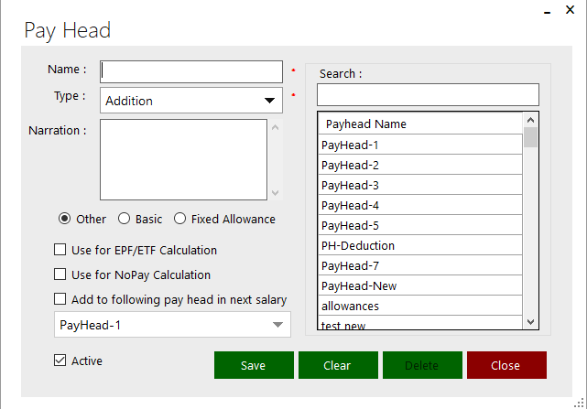
Select the Salary Method that what you want to add
Click on Type and select the Addition or Deductions.

This form is for:
- Adding a new Material.
- Editing details of existing Material.
- Deleting an existing Material.
- View details of existing Material.
- Search details of Material.

Add a new Material
- Enter details such as Material, under description in corresponding fields.
- Click on <Save> button to save.

Edit details of Material
- Select a row from register.
- Details of the selected Material will show in corresponding fields at left side of the form.
- Edit the details that you want.
- Click on <Update > button to save the changes.

Delete an existing Material
- Select a row from register.
- Click on <Delete > button.
- Confirmation is asked for deletion.
- The selected Policy is deleted from the list if no reference exists for selected Material.

Searching of Material
Type the name of Material in search field. All Meterials starting with that name are displayed in list from where particular Material can be selected.

DESIGNATION
Click on Payroll >> Designation.
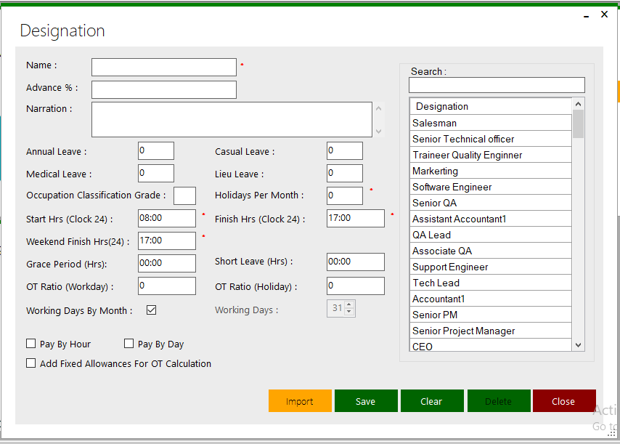
This form is for:
- Import a Designation
- Adding a new Designation.
- Editing details of existing Designation.
- Deleting an existing Designation.
- View details of existing Designation.
- Search details of Designation.

Import a Designation.
- Select the file that you want to add designation.
- Give the Name for the designation.
- Click on <Import>.

Add a new Designation
- Enter details such as Fixed Asset, under description in corresponding fields.
- Click on <Save> button to save.

Edit details of Designation
- Select a row from register.
- Details of the selected Fixed Asset will show in corresponding fields at left side of the form.
- Edit the details that you want.
- Click on <Update > button to save the changes.

Delete an existing Designation
- Select a row from register.
- Click on <Delete > button.
- Confirmation is asked for deletion.
- The selected Fixed Asset is deleted from the list if no reference exists for selected Fixed Asset.

Searching of Designation
Type the name of Designation in search field. All Designation starting with that name are displayed in list from where particular Designation can be selected.

DEPARTMENT
Click on Payroll >> Department.
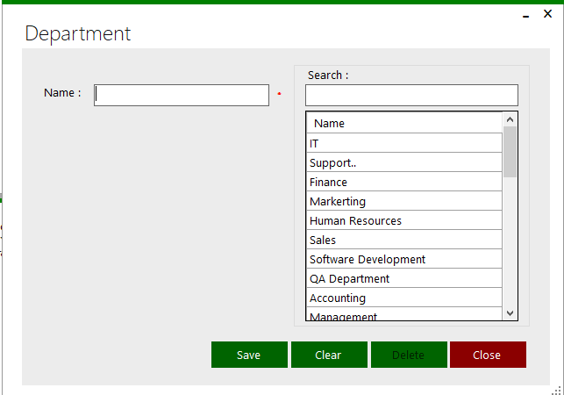
This form is for:
- Adding a new Department.
- Editing details of existing Department.
- Deleting an existing Department.
- View details of existing Department.
- Search details of Department

Add a new Department
- Enter details such as Department name, in corresponding fields.
- Click on <Save> button to save.

Edit details of Department
- Select a row from register.
- Details of the selected Department will show in corresponding fields at right side of the form.
- Edit the details that you want.
- Click on <Update > button to save the changes.

Delete an existing Department
- Select a row from register.
- Click on <Delete > button.
- Confirmation is asked for deletion.
- The selected Department is deleted from the list if no reference exists for selected Department.

Searching of Department
Type the name of Department in search field. All Departments starting with that name are displayed in list from where particular Department can be selected.

SUB COMPANY
Click on Payroll >> Sub Company.
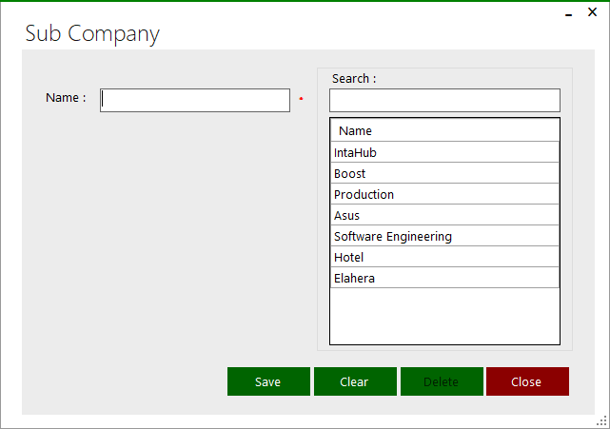

This form is for:
- Adding a new Sub Company.
- Editing details of existing Sub Company.
- Deleting an existing Sub Company.
- View details of existing Sub Company.
- Search details of Sub Company

Add a new Sub Company
- Enter details such as Sub Company name, in corresponding fields.
- Click on <Save> button to save.

Edit details of Sub Company
- Select a row from register.
- Details of the selected Sub Company will show in corresponding fields at left side of the form.
- Edit the details that you want.
- Click on <Update > button to save the changes.

Delete an existing Sub Company
- Select a row from register.
- Click on <Delete > button.
- Confirmation is asked for deletion.
- The selected Sub Company is deleted from the list if no reference exists for selected Sub Company.
Searching of Sub Company
- Type the name of Sub Company in search field. All Sub companies starting with that name are displayed in list from where particular Sub Company can be selected.

SALARY ACCOUNT MANAGEMENT
Click on Payroll >> Salary Account Management to add not added entry in opening balance.
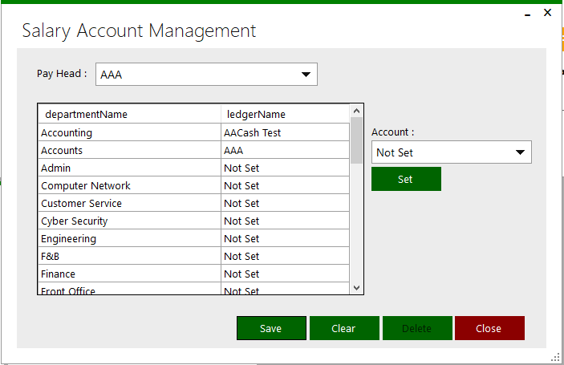
This form is for:
- Adding a new Salary Account Management.
- Editing details of existing Salary Account Management.
- Deleting an existing Salary Account Management.
- View details of existing Fixed Salary Account Management.

Add a new Salary Account Management
- Select new pay head and account.
- Click on <Save> button to save.

Edit details of Fixed Salary Account Management
- Select a row from register.
- Details of the selected Salary Account Management will show in corresponding fields at left side of the form.
- Edit the details that you want.
- Click on <Update > button to save the changes.

Delete an existing Salary Account Management
- Select a row from register.
- Click on <Delete > button.
- Confirmation is asked for deletion.
- The selected Salary Account Management is deleted from the list if no reference exists for selected Salary Account Management.

EMPLOYEE TYPE
Click on Payroll >> Employee Type.
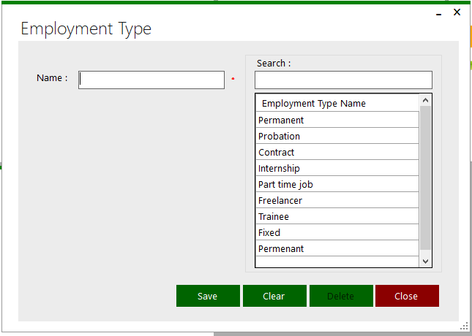
This form is for:
- Adding a new Employee Type.
- Editing details of existing Employee Type.
- Deleting an existing Employee Type.
- View details of existing Employee Type.
- Search details of Employee Type.

Add a new Employee Type
- Enter details such as Name, under description in corresponding fields.
- Click on <Save> button to save.

Edit details of Employee Type
- Select a row from register.
- Details of the selected Employee Type will show in corresponding fields at left side of the form.
- Edit the details that you want.
- Click on <Update > button to save the changes.

Delete an existing Employee Type
- Select a row from register.
- Click on <Delete > button.
- Confirmation is asked for deletion.
- The selected Employee Type is deleted from the list if no reference exists for selected Employee Type.

Searching of Department
Type the name of Department in search field. All departments starting with that name are displayed in list from where particular Department can be selected.

EMPLOYEE
Click on Payroll >> Employee
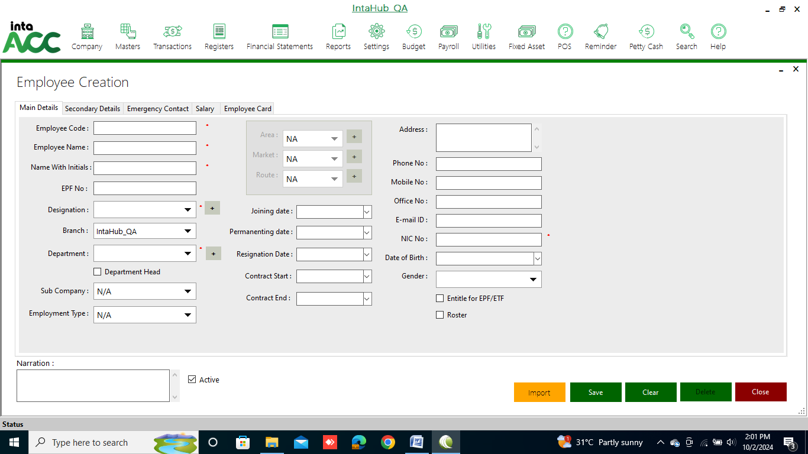
Click on Roster to work for the Shifts

This form is for:
- Import an Employee data.
- Adding a new Employee.
- Editing details of Employee.
- Deleting an existing Employee.
- View details of existing Employee.

Import an Employee data.
- Select the file that you want to add employee.
- Give the Name for the employee.
- Click on <Import>.

Add a new Employee
- Enter details such as Name, code, under description in corresponding fields.
- Click on <Save> button to save.

Edit details of Employee
- Select a row from register.
- Details of the selected employee will show in corresponding fields at left side of the form.
- Edit the details that you want.
- Click on <Update > button to save the changes.

Delete an existing Employee
- Select a row from register.
- Click on <Delete > button.
- Confirmation is asked for deletion.
- The selected employee is deleted from the list if no reference exists for selected employee.

EMPLOYEE REGISTER
Click on Payroll >> Employee Register.
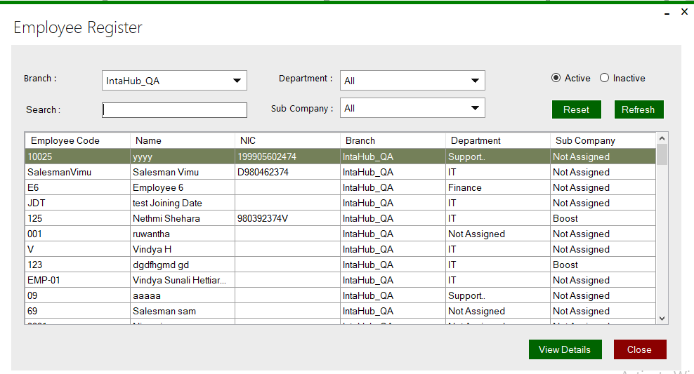
Once select employee and click on view details then it will be open this window.
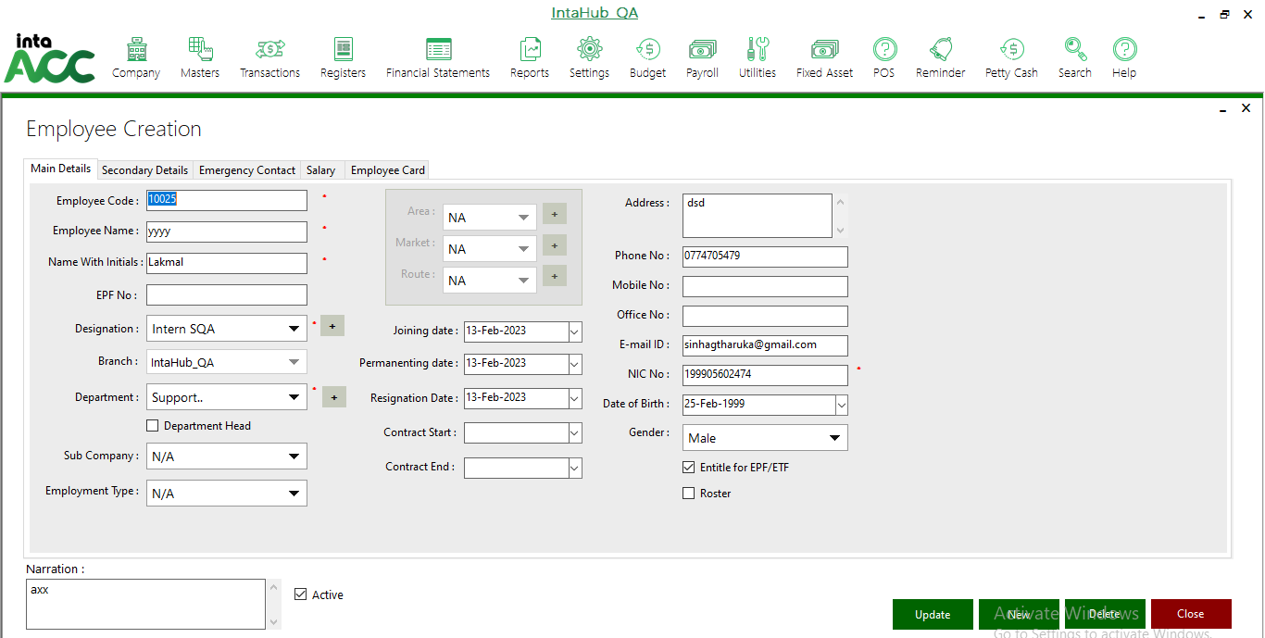

LEAVE MANAGEMENT & ATTENDANCE MANAGEMENT
Click on Payroll >> Leave Management.
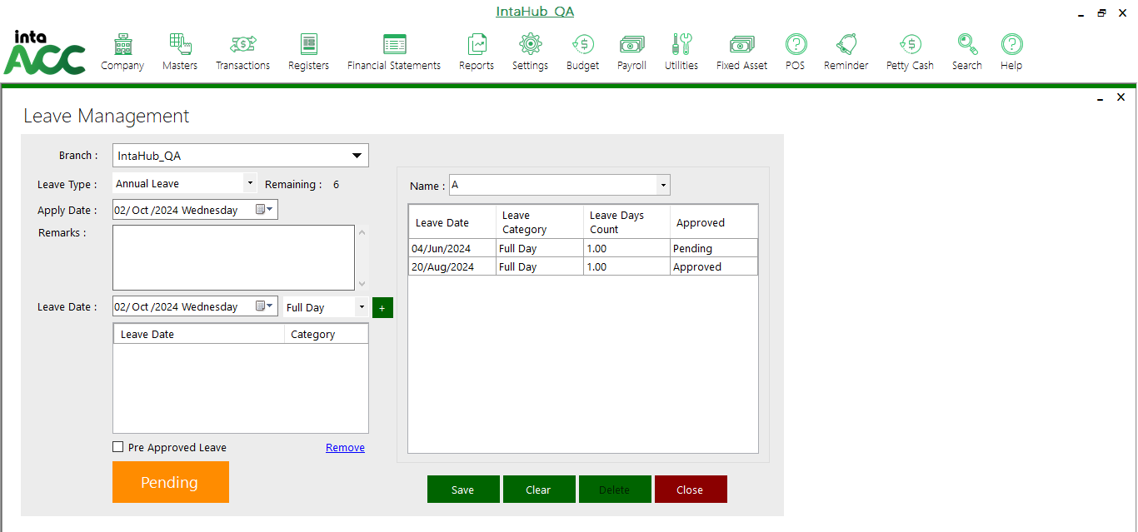
Then click on the Pending button it can be approve the leave.

WORK FROM OUTSIDE
Click on Payroll >> Work from Outside.
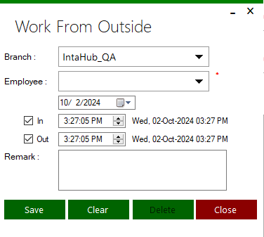
First, Select Branch and employee. Then select the date and time of work from outside employee.

MANUAL ATTENDANCE
Click on Payroll >> Manual Attendance to add attendance of all employees manually.
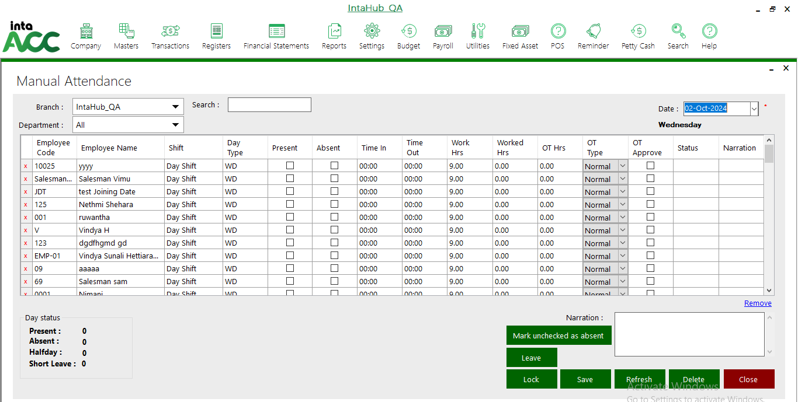

MANUAL MONTHLY ATTENDANCE
Click on Payroll >> Manual Monthly Attendance to add attendance the one employee manually.
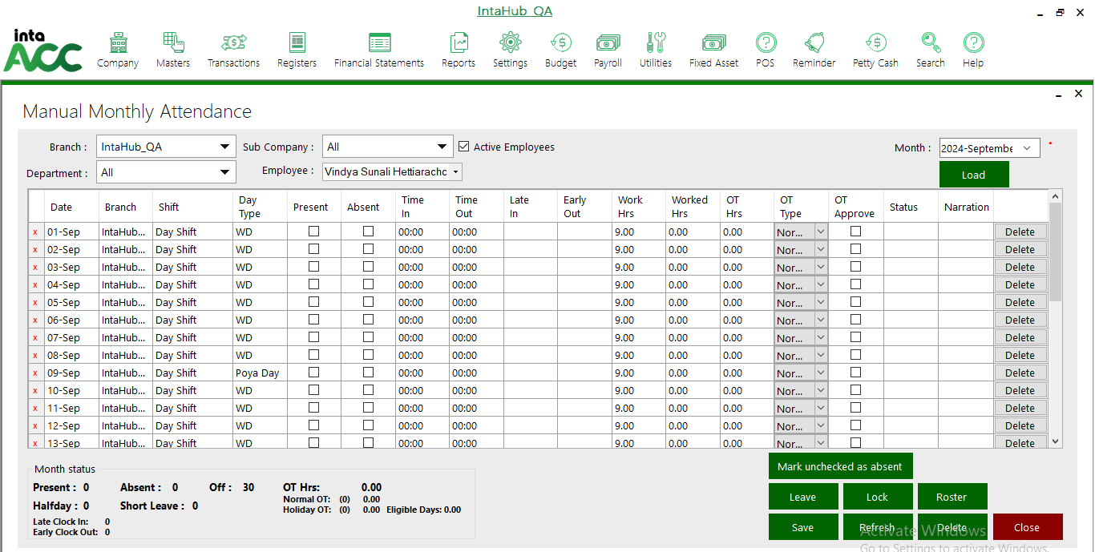

MONTHLY ATTENDANCE
Click on Payroll >> Monthly Attendance to view attendance of employees.
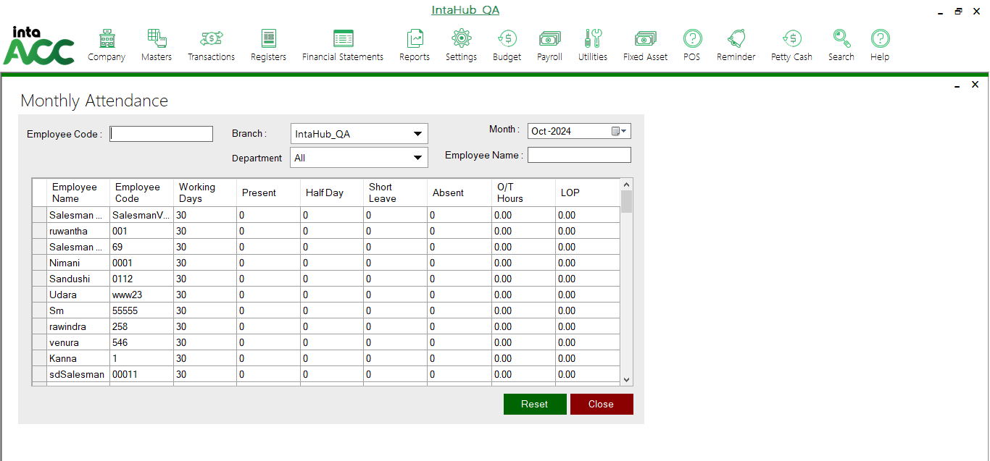

FINGERPRINT MANAGEMENT
Click on Payroll >> FingerPrint Management to view attendance of employees.
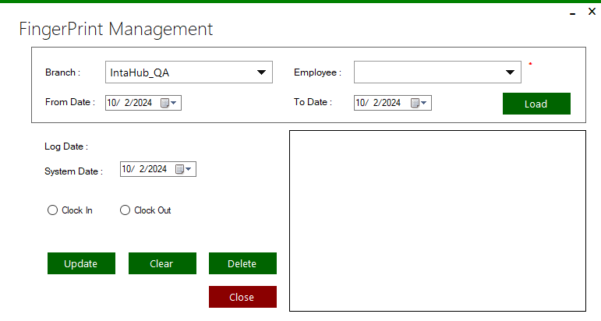
Select the employee and Load data.

MONTHLY FINGERPRINT MANAGEMENT
Click on Payroll >> Monthly Finger Print Management to view attendance of employees.
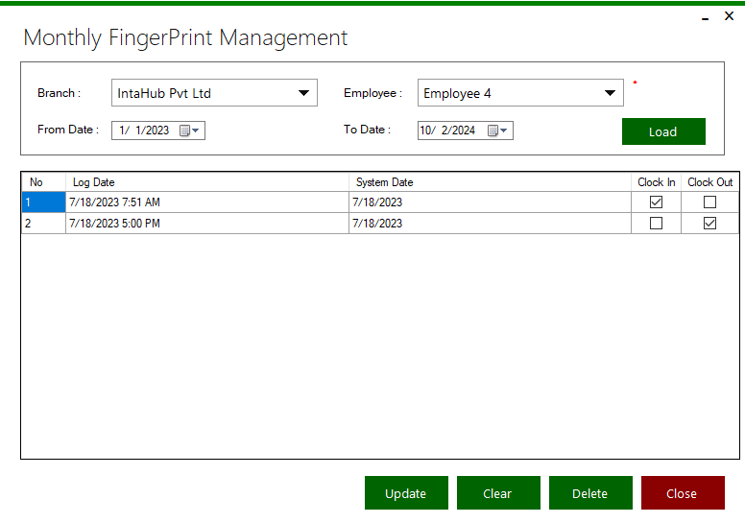
First select the branch and employee. Then give date that you want to Load data.

LOAN
Click on Payroll >> Loan
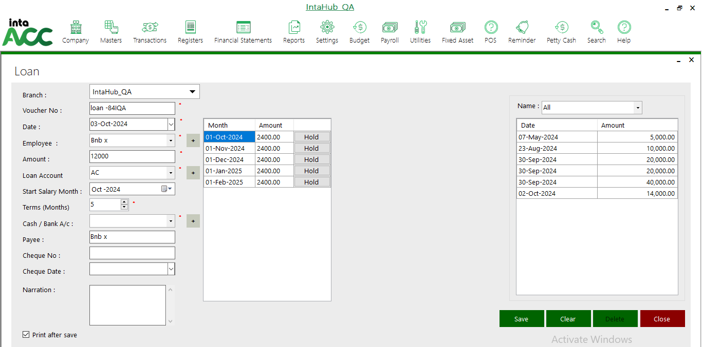
Here can see amounts of terms and it can hold the monthly wise.

First select the branch and employee. Then give date, Amount, Loan Account and terms of loan settlement.

LOAN EARLY SETTLEMENT
Click on Payroll >> Loan early Settlement for the settle the loan before loan terms.
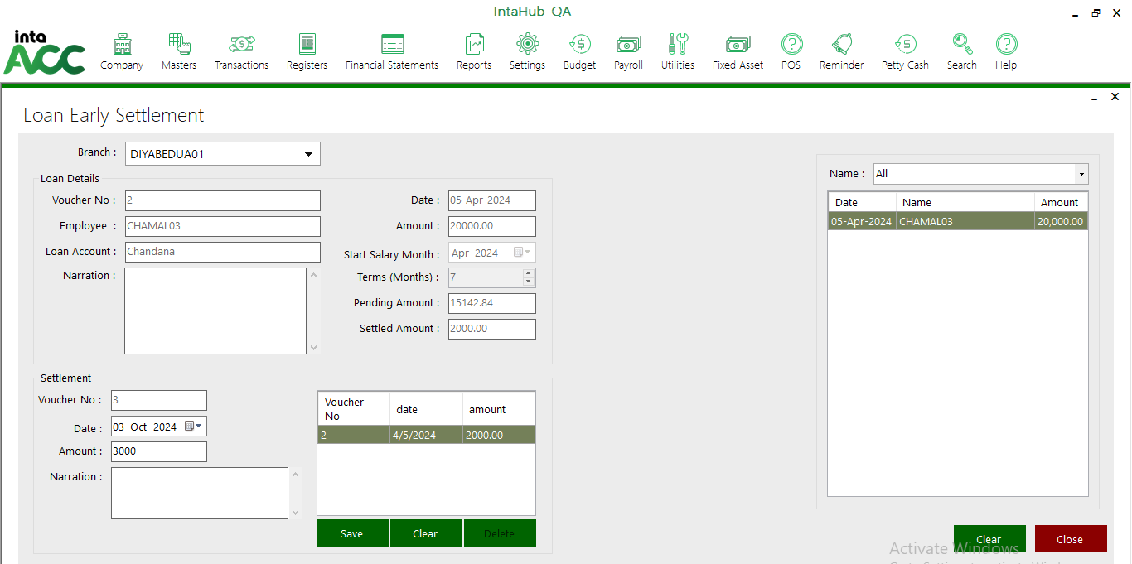
- Saved loans are displayed here
- Select the loan before the give settle amount

First select the branch and Loan. Then give early settle Amount and save it.

ADVANCE PAYMENT
Click on Payroll >> Advance Payment to select the advance amounts for the employees.
Here can give advance amount for the employee designation percentage only. If it is exceed the percentage it cannot select.
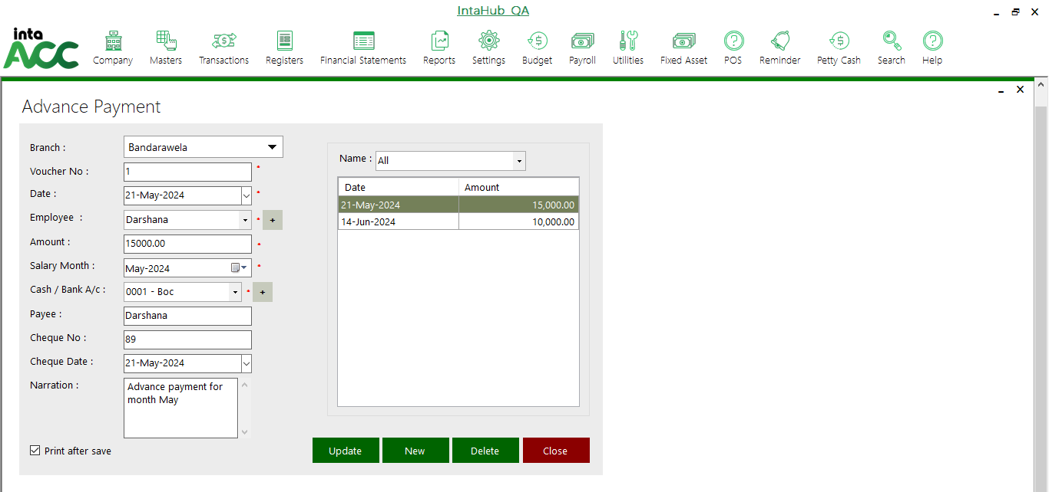

BONUS/ DEDUCTION
Click on Payroll >> Bonus/ Deduction.
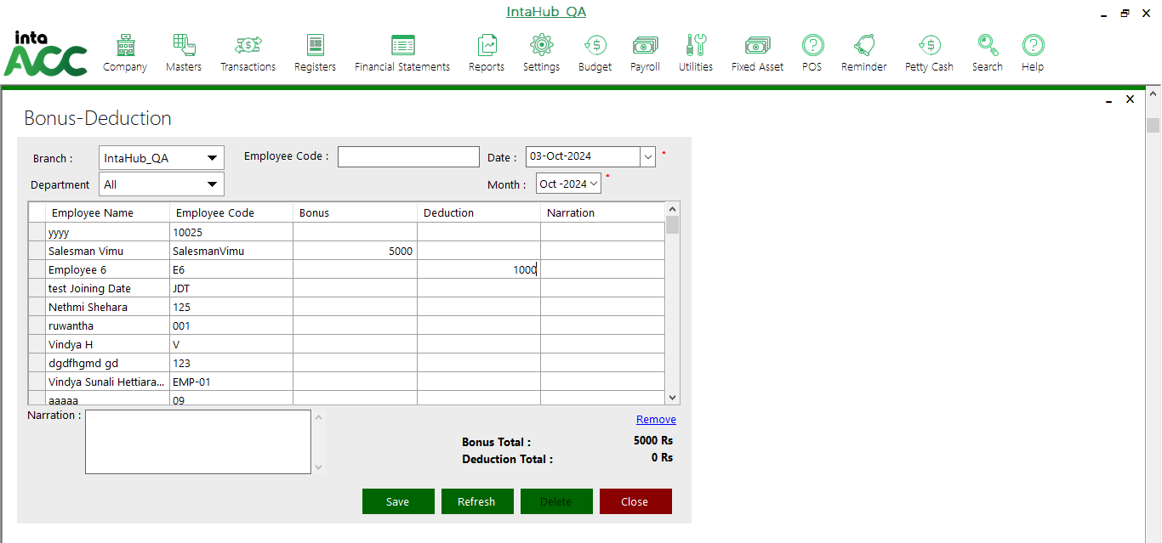
Click on these slots to add Bonus or deductions

ROASTER MANAGEMENT
Roaster is the employee who work for the shifts.
Click on Payroll >> Roaster Management
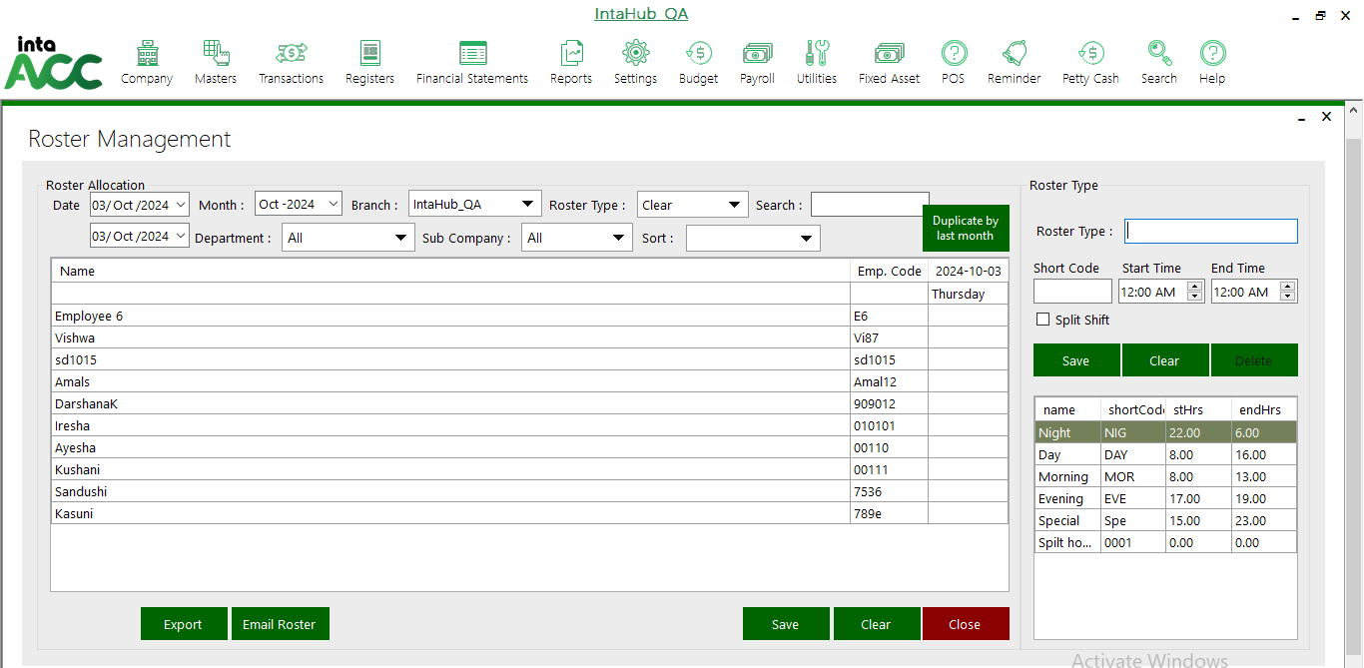
Click on this button to duplicate last month roaster.

ROASTER PLANNING
Click on Payroll >> Roaster Planning
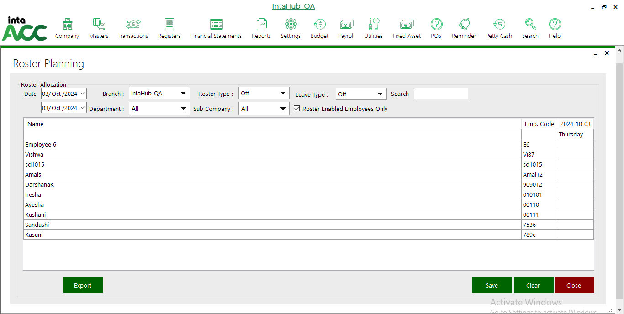
Select the roaster type as Morning, Evening, Day, Night, Special or Spilt hover.

Enable this tick mark to view Roaster employees.

ROASTER SWAP
Click on Payroll >> Roaster Swap to swap the employee roaster.
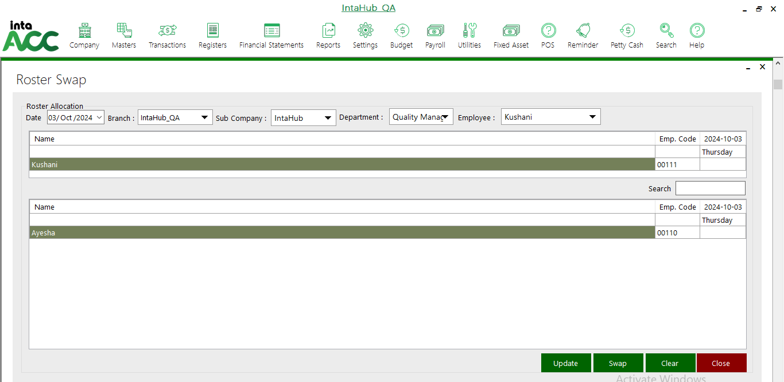
First select the Date, branch, Sub Company, Department and the employee who want to swap. Then select the employees and click on Save.
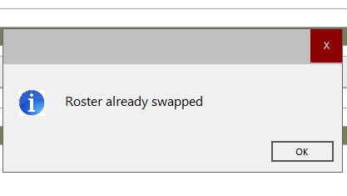

SERVICE CHARGE PROCESS
Click on Payroll >> Service Charge Process>> Allocation
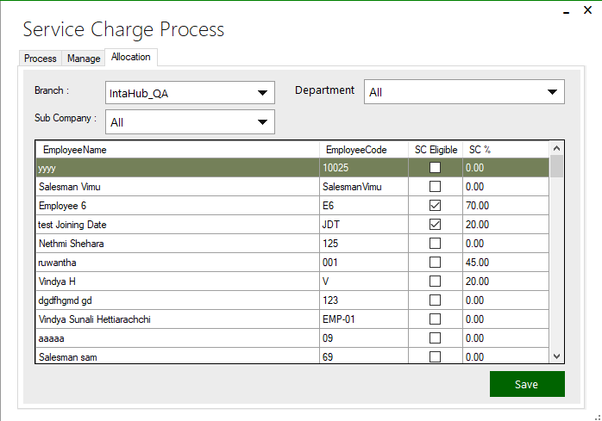
Enable this tick mark to enable service charge.

Click on Payroll >> Service Charge Process>> Process
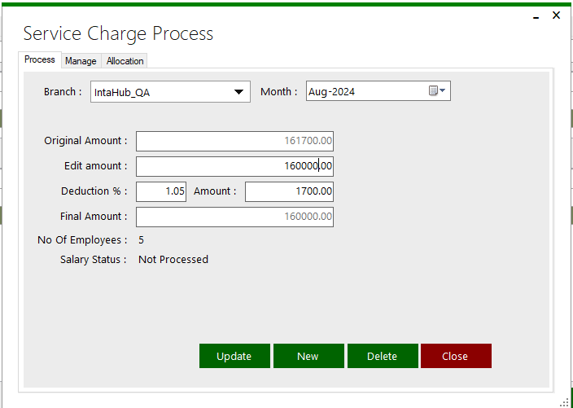
Original amount cannot be change.

SALARY VOUCHER
Click on Payroll >> Salary Voucher to view the salary voucher
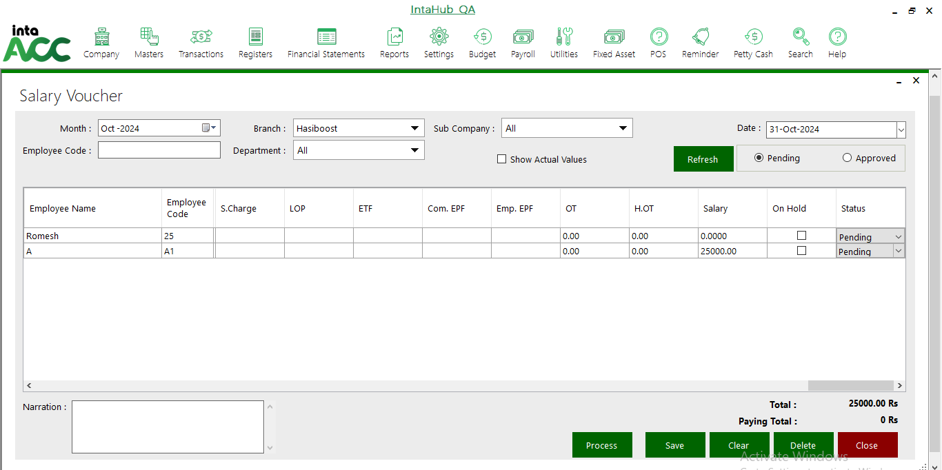
Select the pending or approved foe view pending vouchers and approved vouchers

Approve the pending voucher that you want to approve.

Approve the Pending vouchers and click on Save.
Then go to the Approved and Select the employee and click on Process to get the backup.
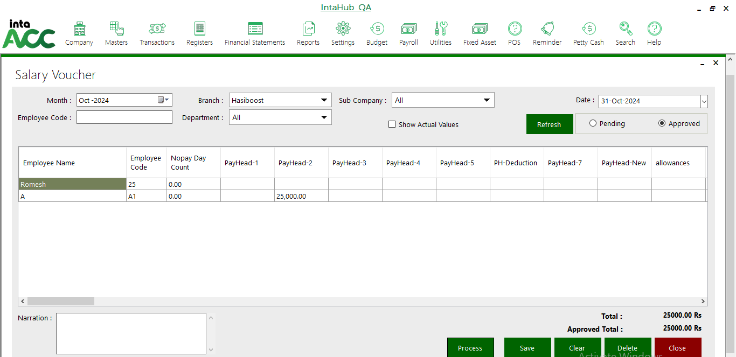
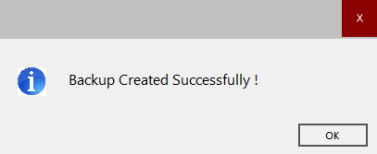

ENTITLED LEAVE RESET
Click on Payroll >> Entitled leave reset
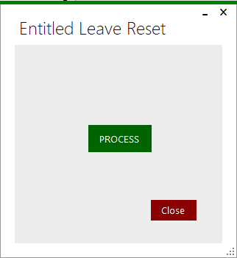
Click on process button, and then it will be reset all leaves.
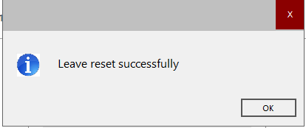

PAY SLIP
Click on Payroll >> Pay Slip to get salary slips.
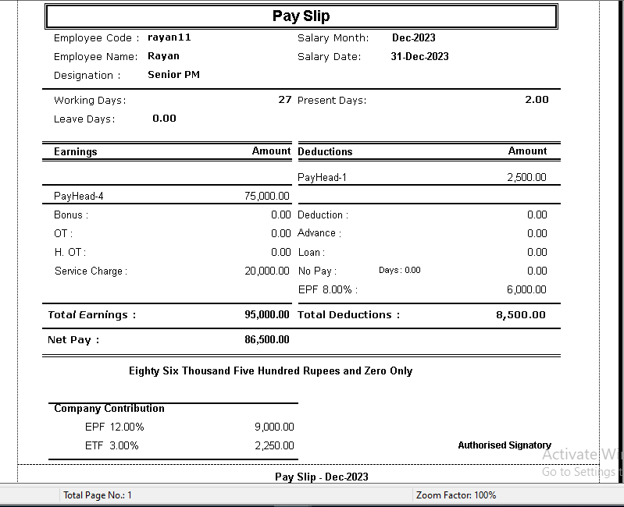
Select the salary and Employee to get pay slip. Then click OK.
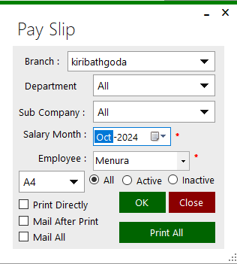
Click on tick to print directly, Mail after Print or Mail all.

PAYROLL DASHBOARD
Click on Payroll >> Payroll Dashboard
Select the date and branch and click on Load to view dashboard.
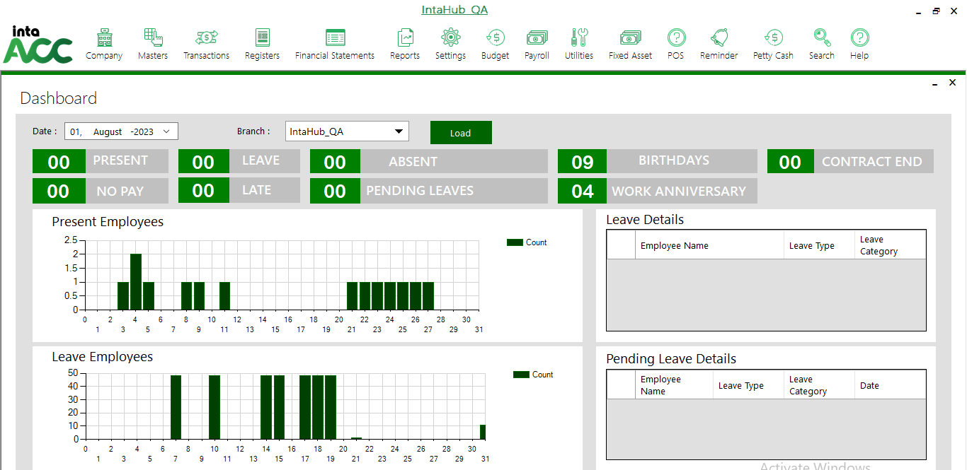

LETTERS/ CARDS

EMPLOYEE CARD

Template Manager
Click on Payroll >> Letters/Cards>>Employee Card>>Template Manager to create template
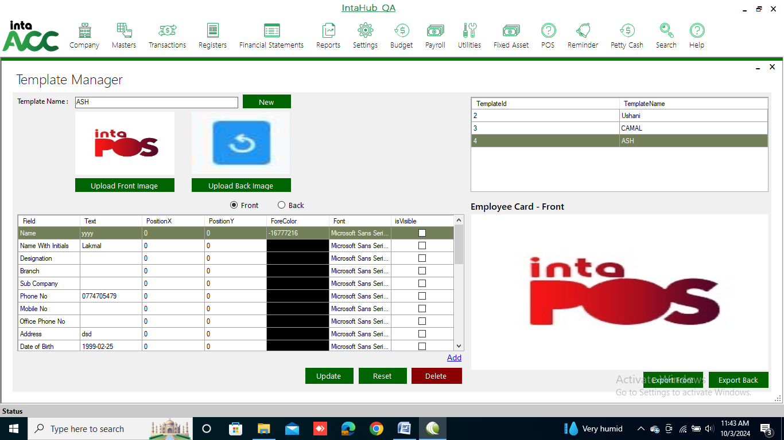

Employee Card Generation
Click on Payroll >> Letters/Cards>>Employee Card>> Employee Card Generation
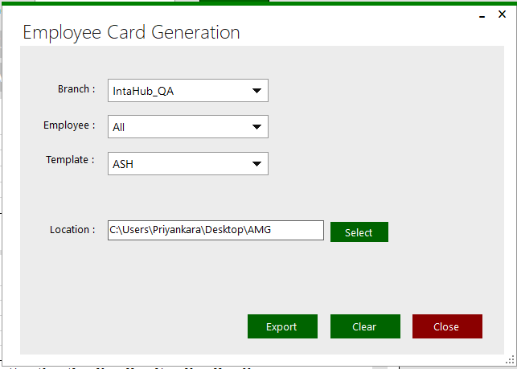
Select the template and location to Export employee card.
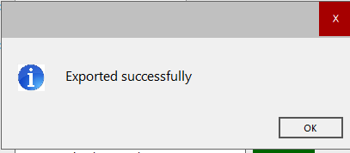

SERVICE LETTER

Service Letter Template
Click on Payroll >> Letters/Cards>>Service Letter>> Service Letter Template
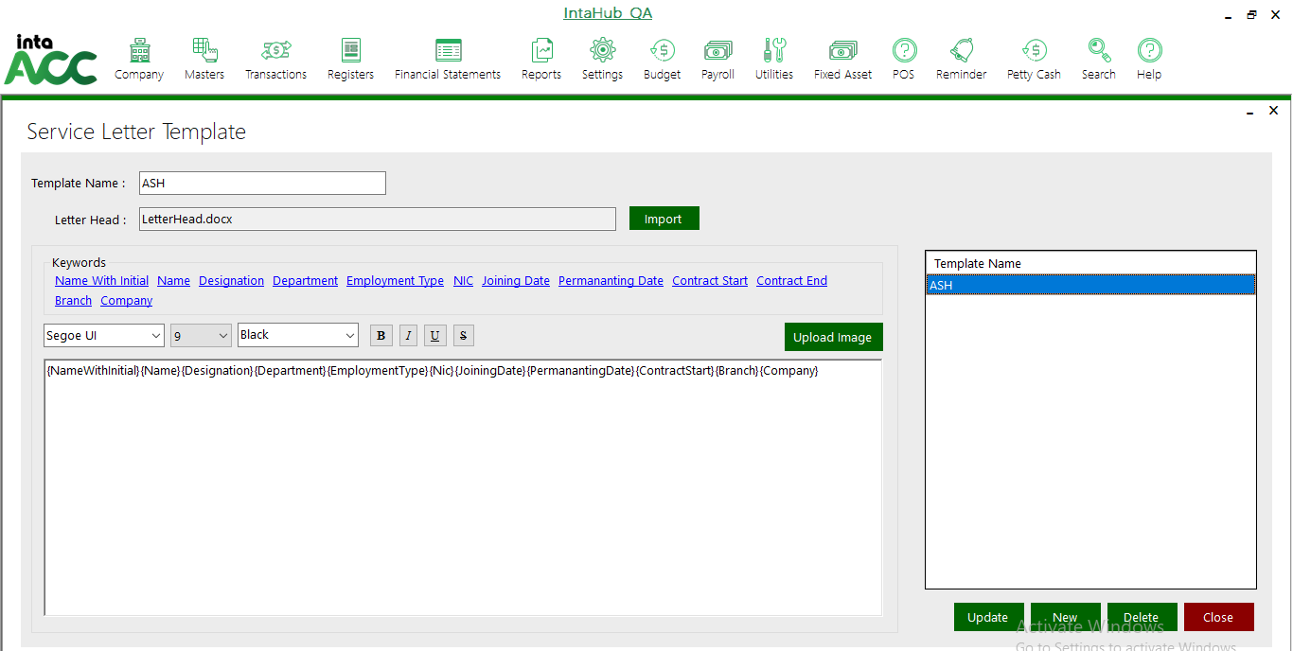
Insert template name and Import a document for letter head. Then enter the keywords to service letter.

Service Letter Generation
Click on Payroll >> Letters/Cards>>Service Letter>> Service Letter Generation
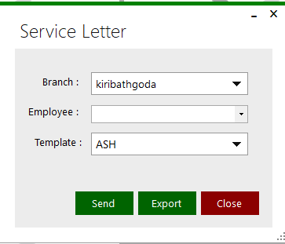

VOP LETTER
VOP letters is the letter for employee who gets not informed leaves.

VOP Letter Template
Click on Payroll >> Letters/Cards>>VOP Letter>> VOP Letter Template
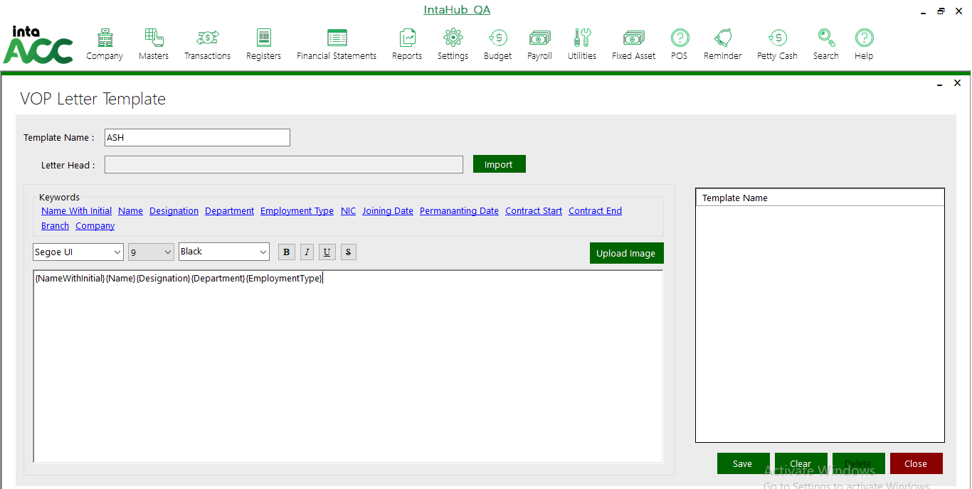
Insert template name and Import a document for letter head. Then enter the keywords to service letter.

VOP Letter Generation
Click on Payroll >> Letters/Cards>>VOP Letter>> VOP Letter Generation.
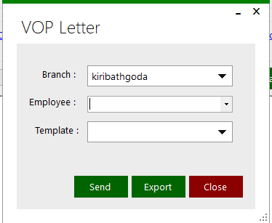

HR REPORTS

Employee Information
Click on Payroll >> HR Reports>> Employee Information
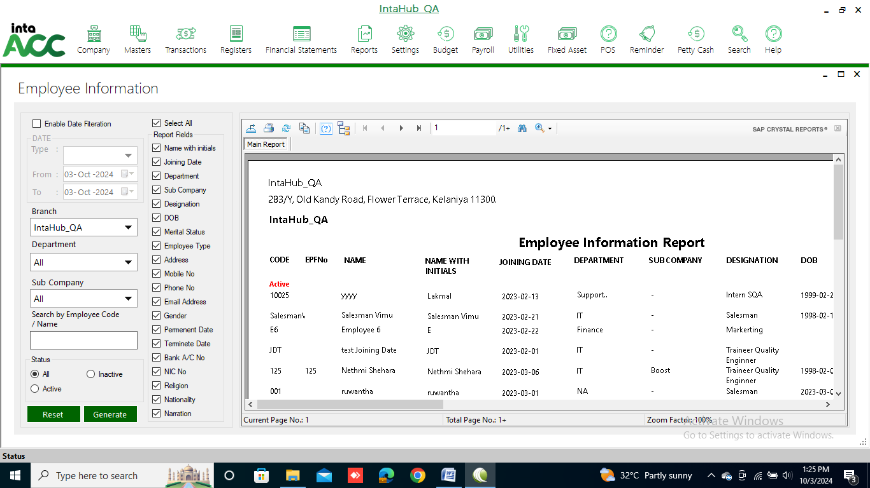

Attendance
Click on Payroll >> HR Reports>> Attendance
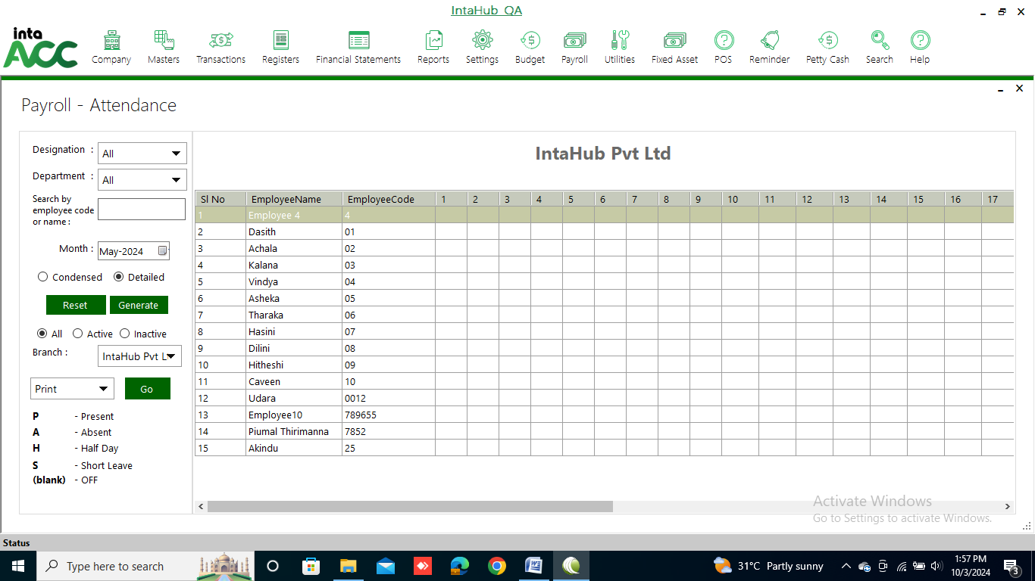

Department Wise Attendance
Click on Payroll >> HR Reports>> Department Wise Attendance
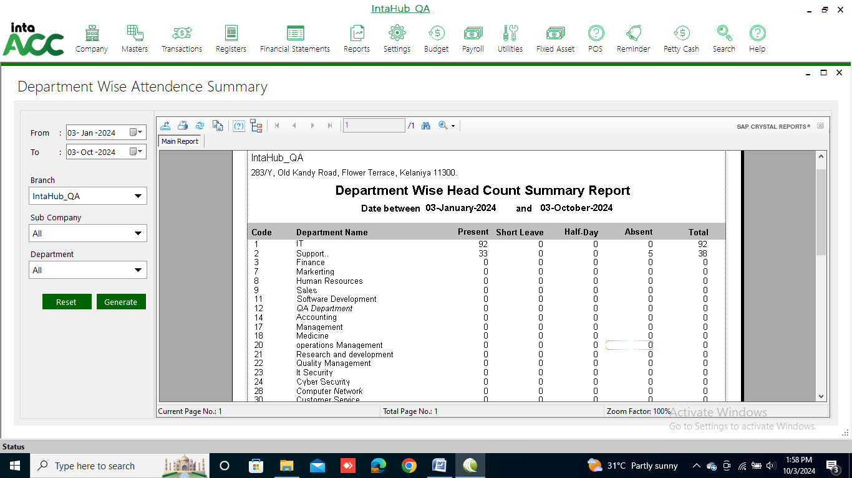

Employee Time Card
Click on Payroll >> HR Reports>> Employee Time Card
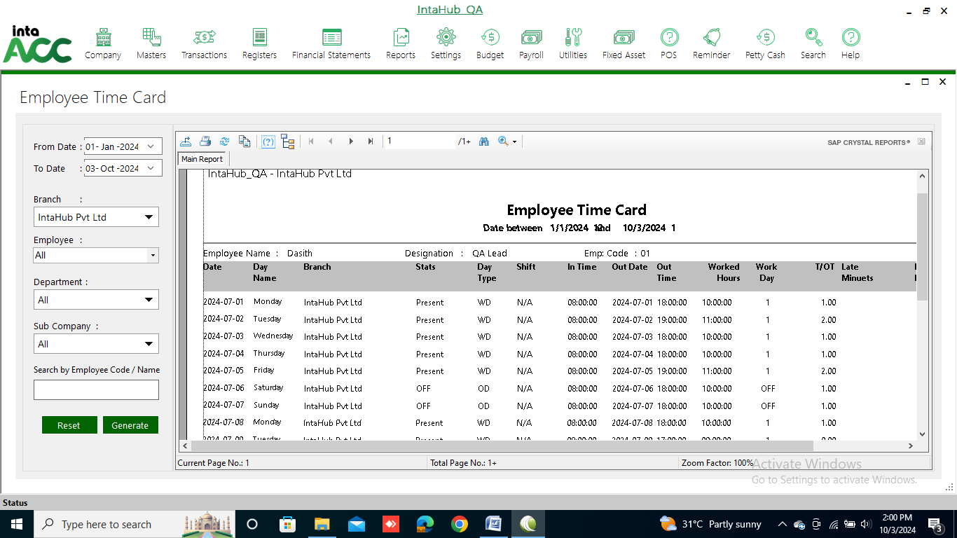

Monthly Attendance
Click on Payroll >> HR Reports>> Monthly Attendance
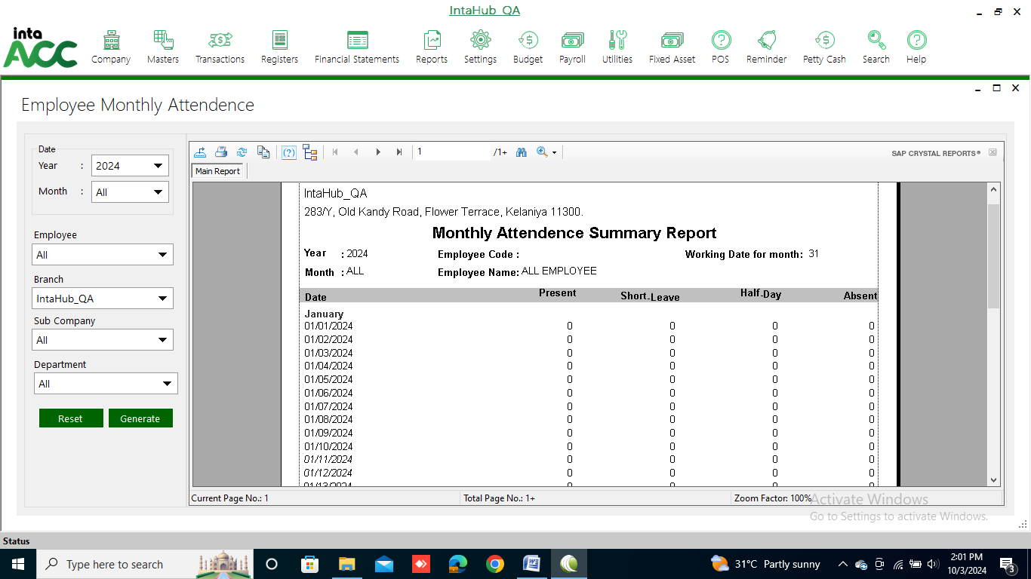

Daily Absent Details
Click on Payroll >> HR Reports>> Daily Absent Details
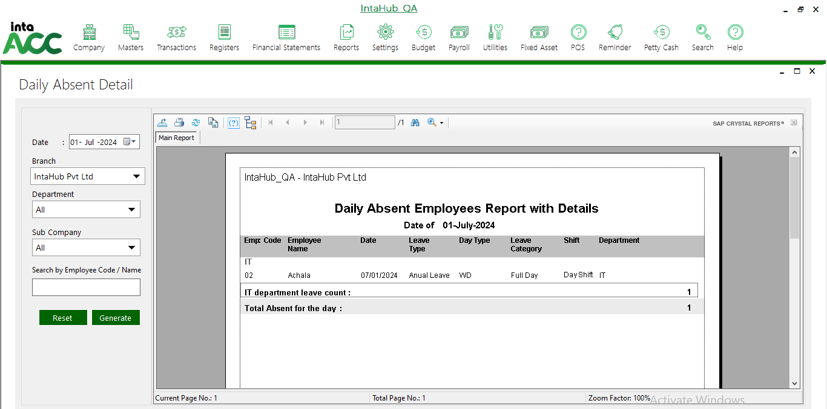

Absent Analysis
Click on Payroll >> HR Reports>> Absent Analysis
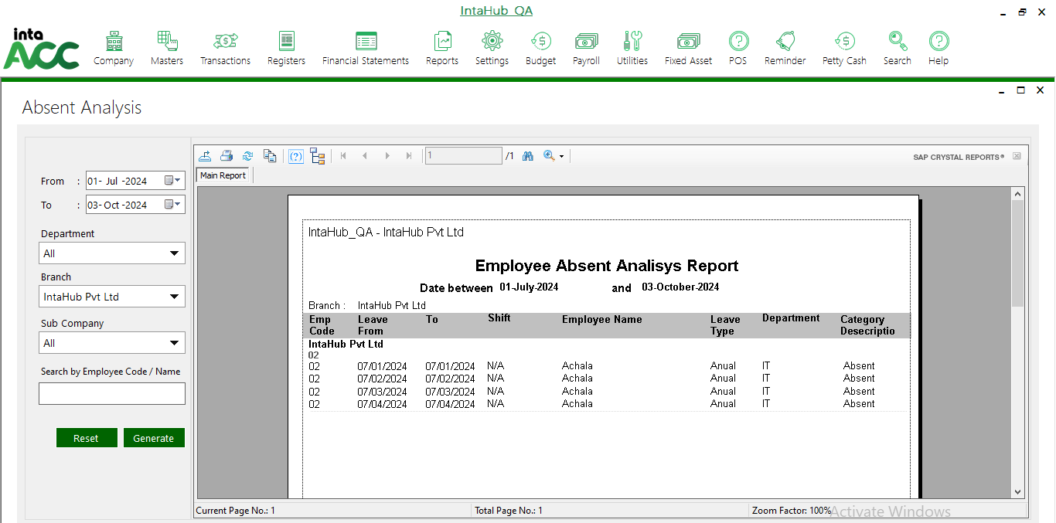

Leave balance
Click on Payroll >> HR Reports>> Leave balance
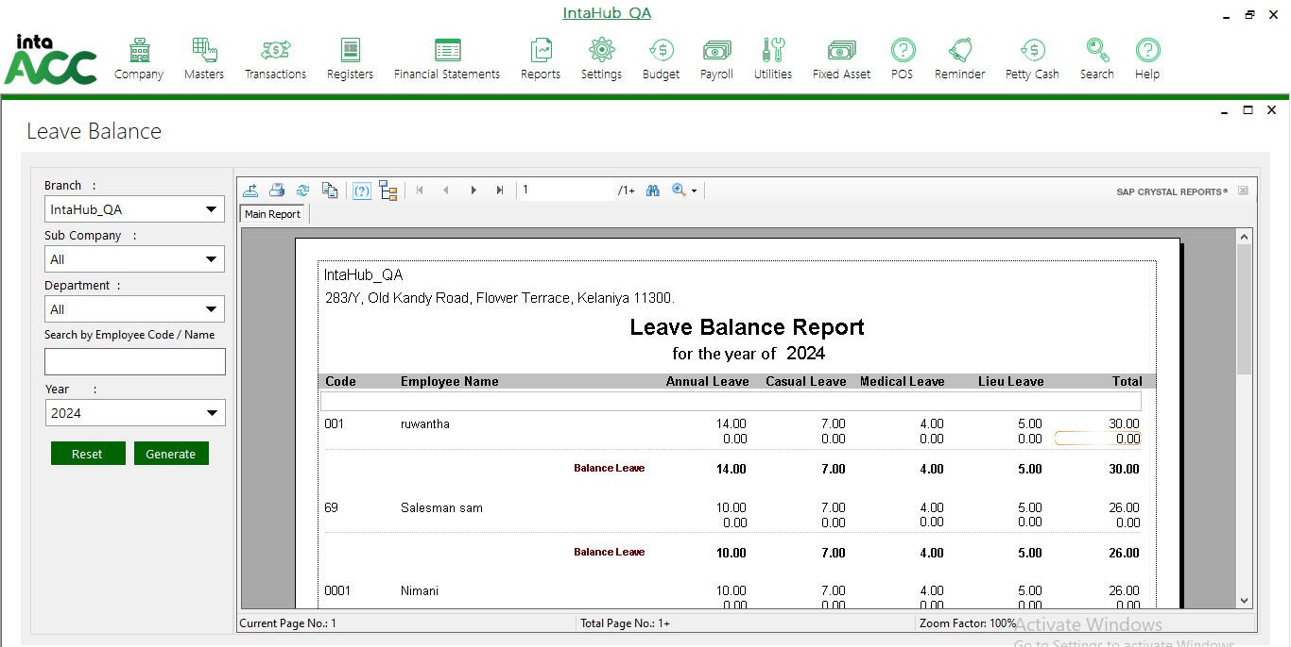

Roaster Details
Click on Payroll >> HR Reports>> Roaster Details
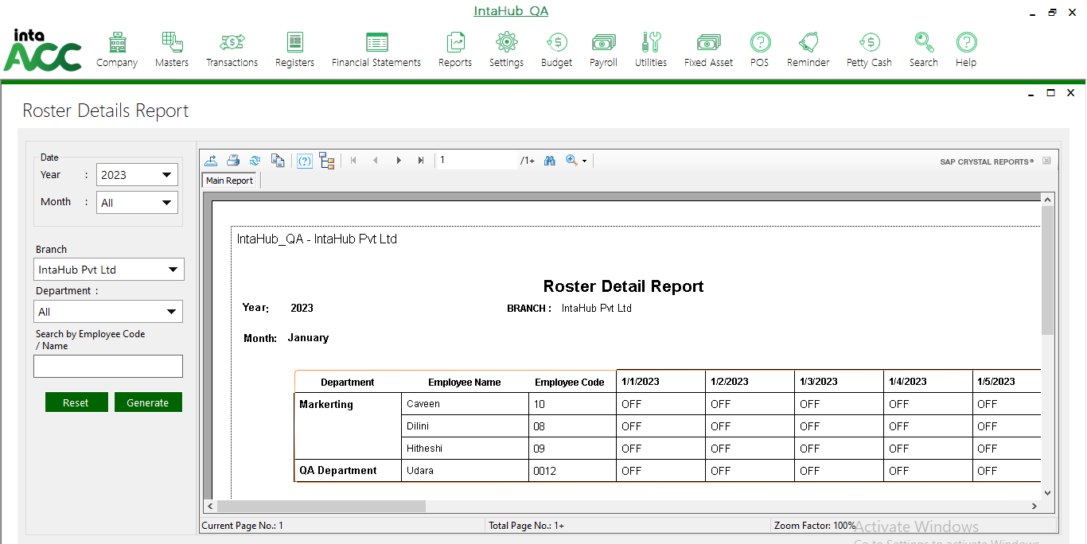

Monthly Attendance Detail Report
Click on Payroll >> HR Reports>> Monthly Attendance Detail Report
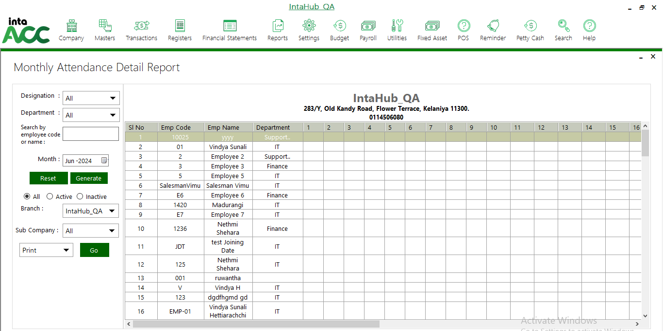

Monthly Fingerprint Log Details
Click on Payroll >> HR Reports>> Monthly Fingerprint Log Details
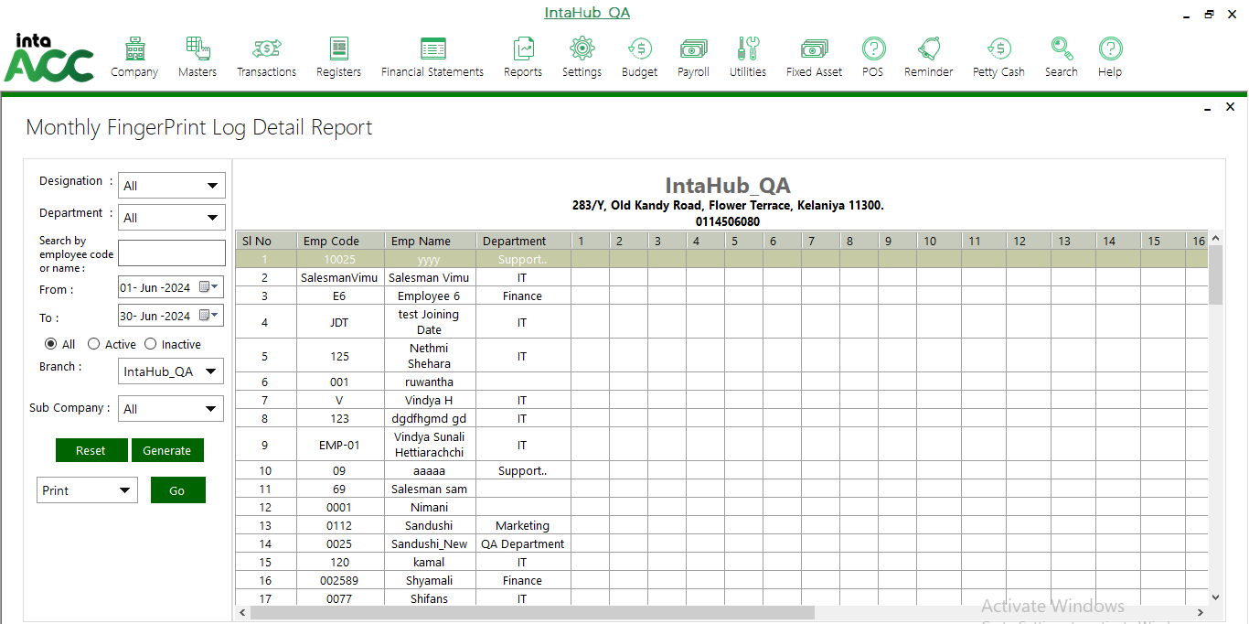

Attendance Audit Trial
Click on Payroll >> HR Reports>> Attendance Audit Trial
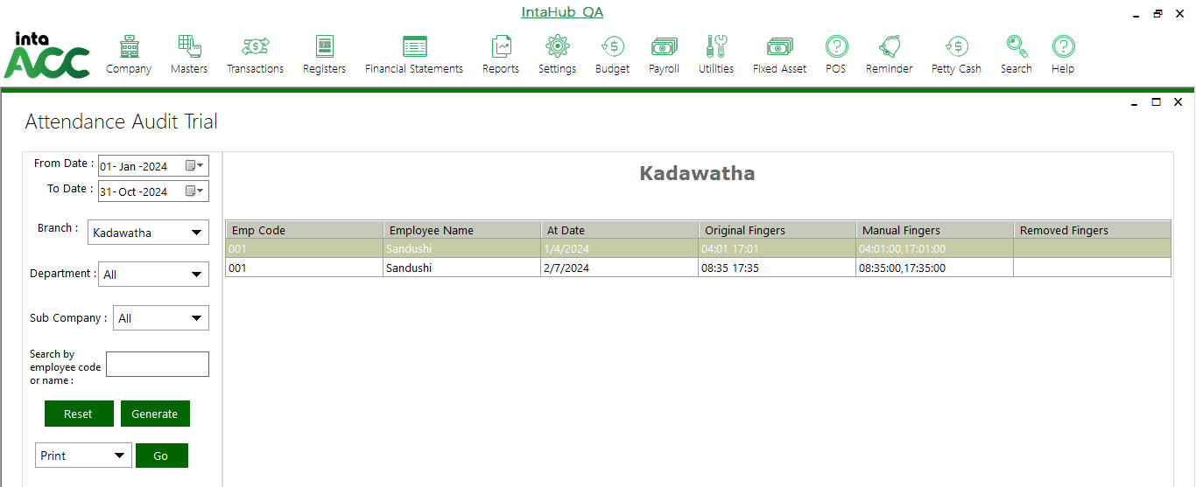

Late In Early Out
Click on Payroll >> HR Reports>> Late In Early Out
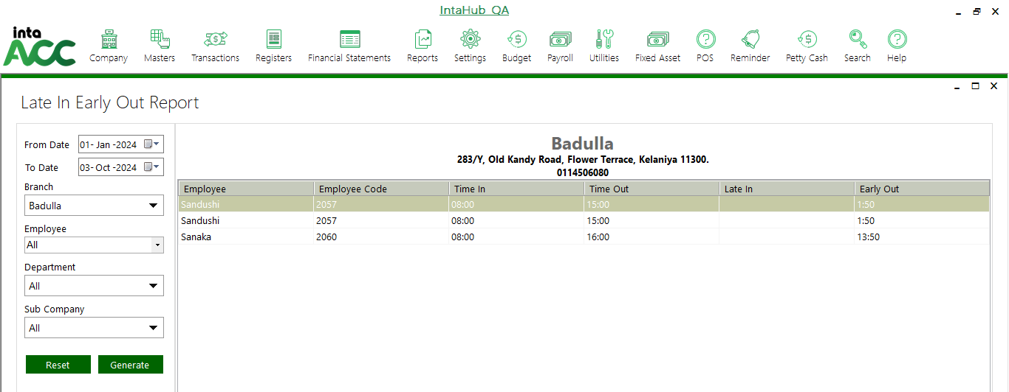

PAYROLL REPORTS

Advance Payment
Click on Payroll >> Payroll Reports>> Advance Payment
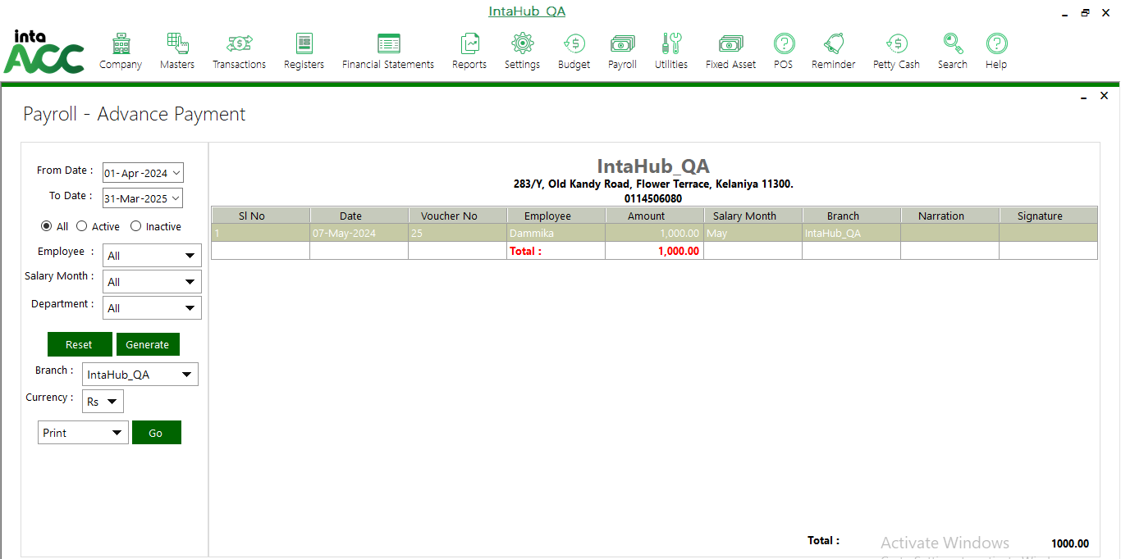

Bonus/ Deduction
Click on Payroll >> Payroll Reports>>Bonus Deduction
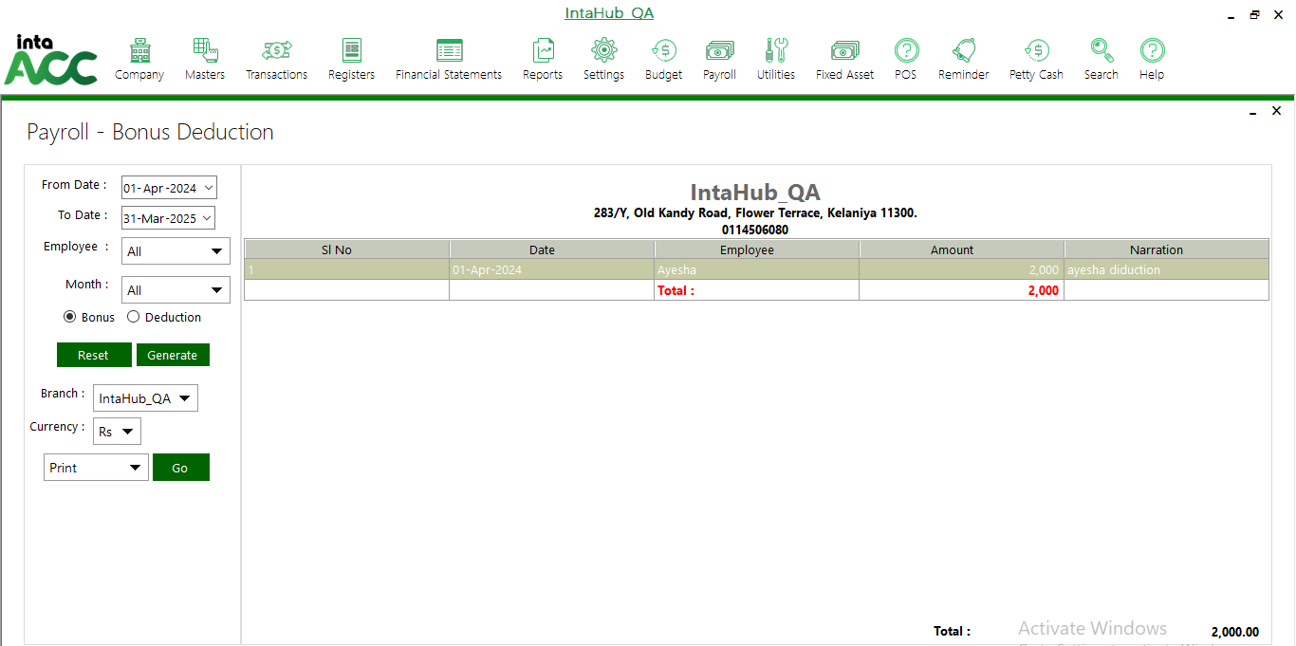

Monthly Salary
Click on Payroll >> Payroll Reports>> Monthly Salary
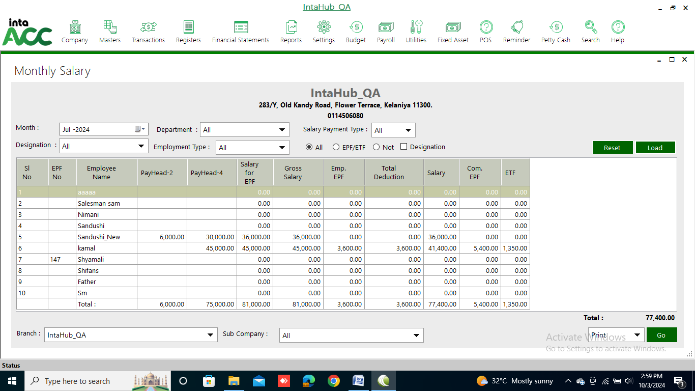

Loan Report
Click on Payroll >> Payroll Reports>> Loan Report
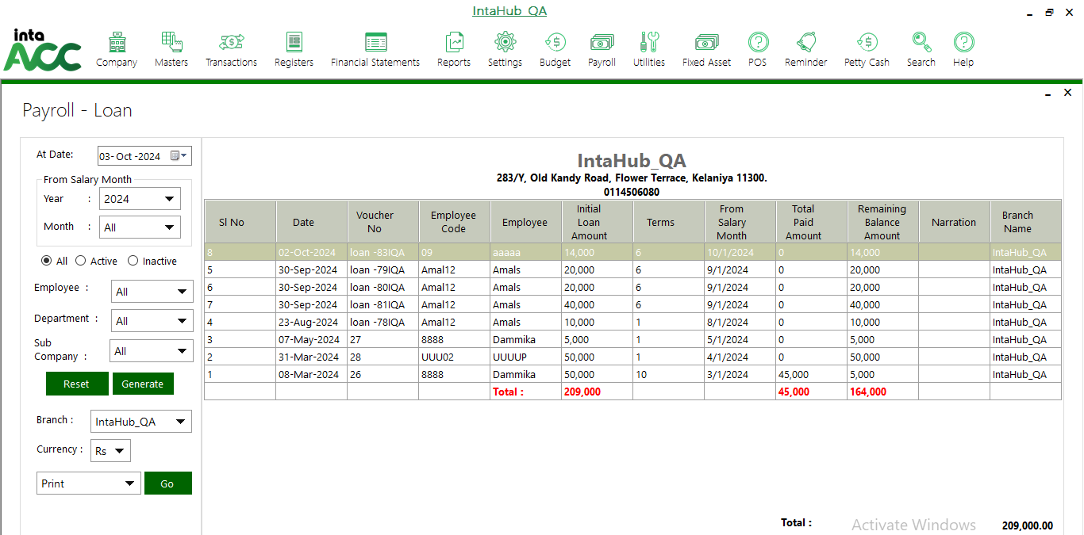

Salary Payment Type
Click on Payroll >> Payroll Reports>> Salary Payment Type
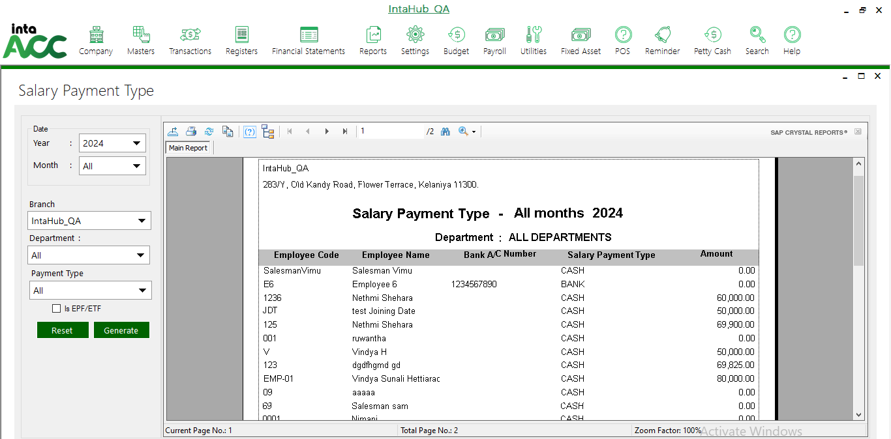

EPF/ETF Contribution
Click on Payroll >> Payroll Reports>> EPF/ETF Contribution
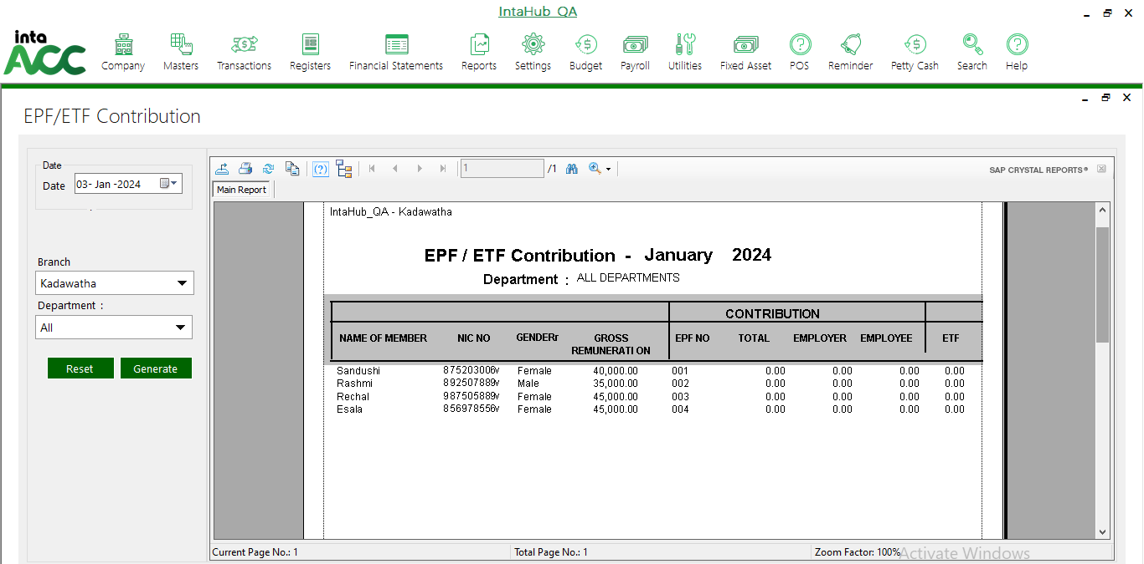

Salary Transfer Final Report
Click on Payroll >> Payroll Reports>> Salary Transfer Final Report
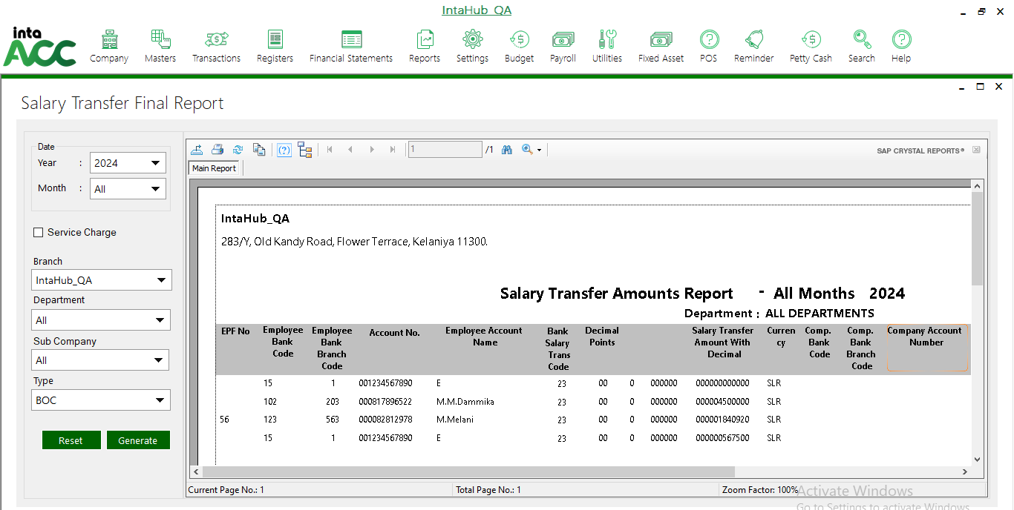

Monthly Hold Salary Details
Click on Payroll >> Payroll Reports>> Monthly Hold Salary
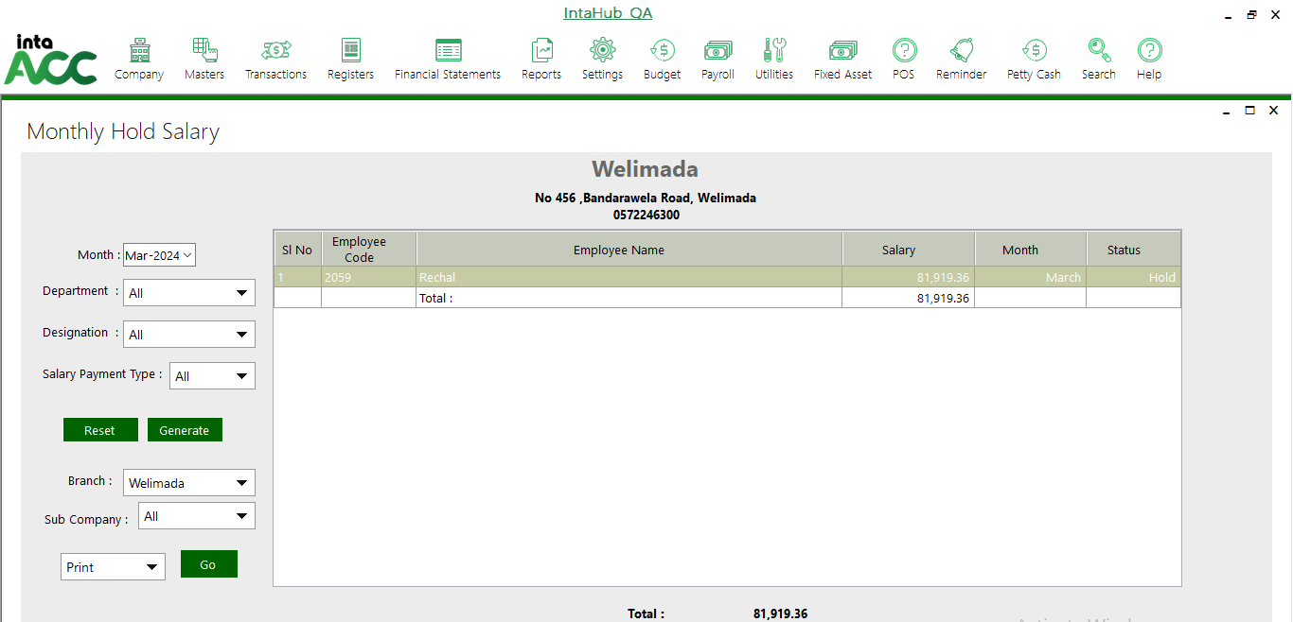

Service Charge Report
Click on Payroll >> Payroll Reports>>Service Charge Report
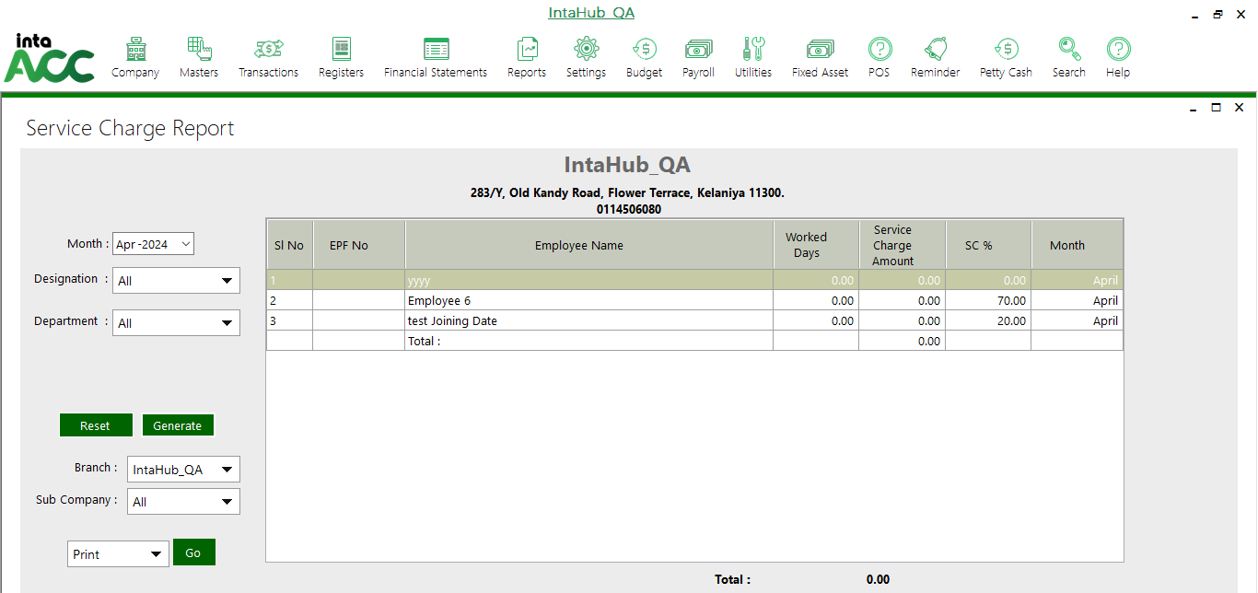

Monthly Salary Report
Click on Payroll >> Payroll Reports>> Monthly Salary Report
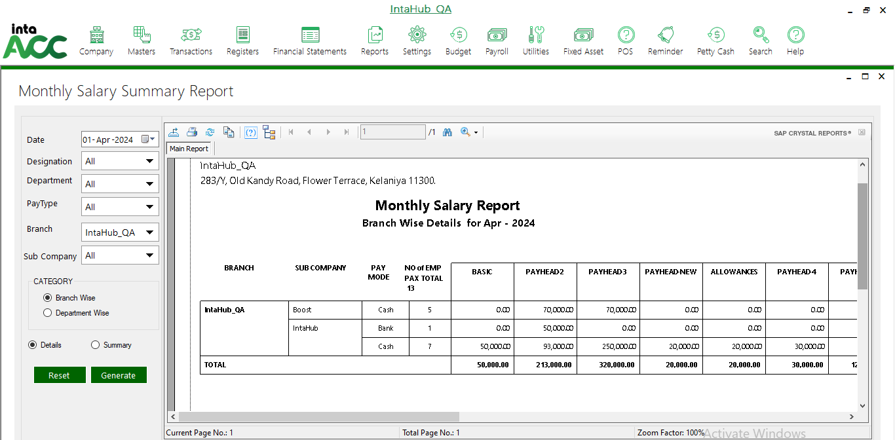

C Report EPF/ETF
Click on Payroll >> Payroll Reports>> C Report EPF/ETF
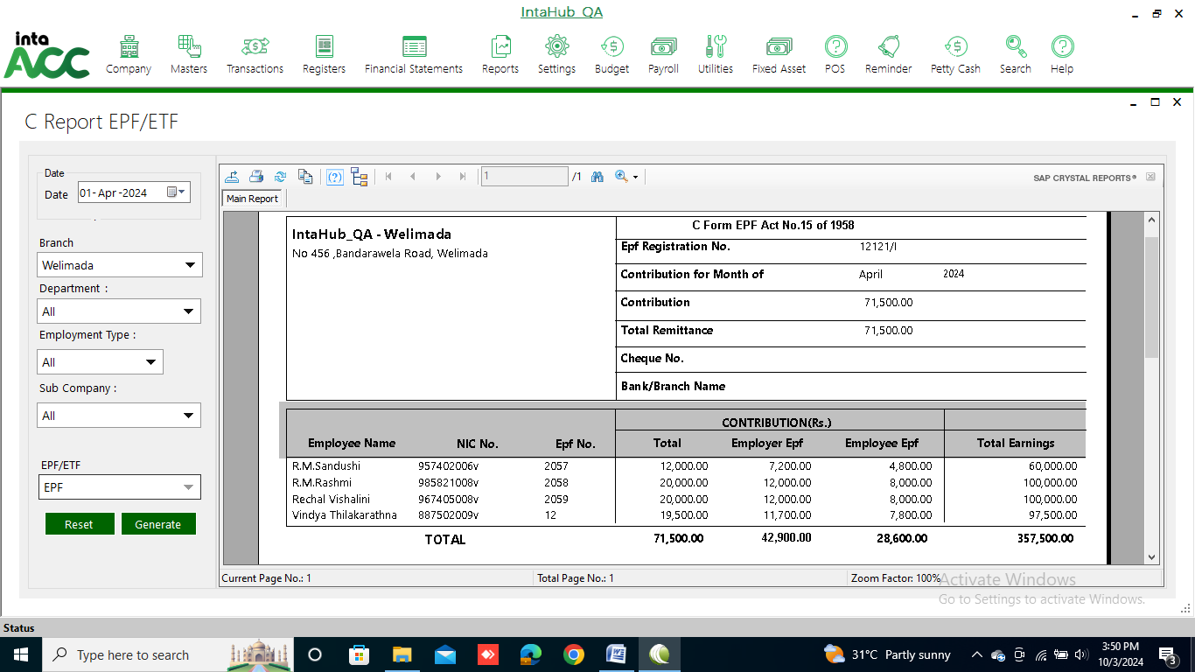

EPF Return Report
Click on Payroll >> Payroll Reports>> EPF Return Report
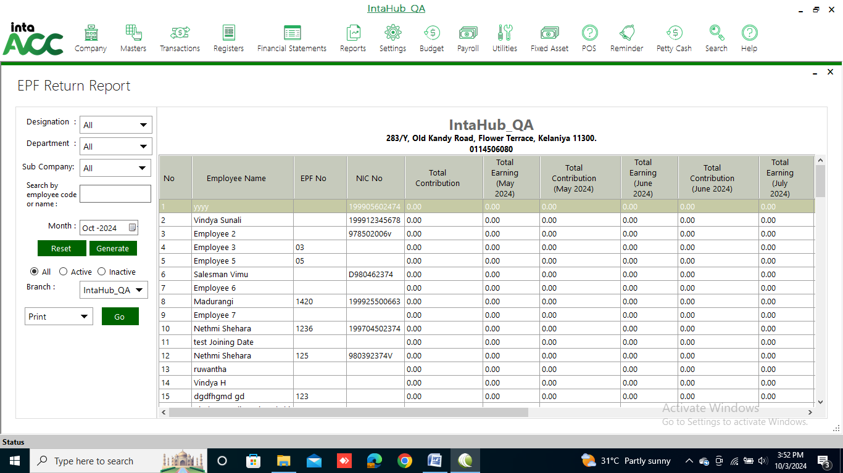

ETF Return Report
Click on Payroll >> Payroll Reports>> ETF Return Report
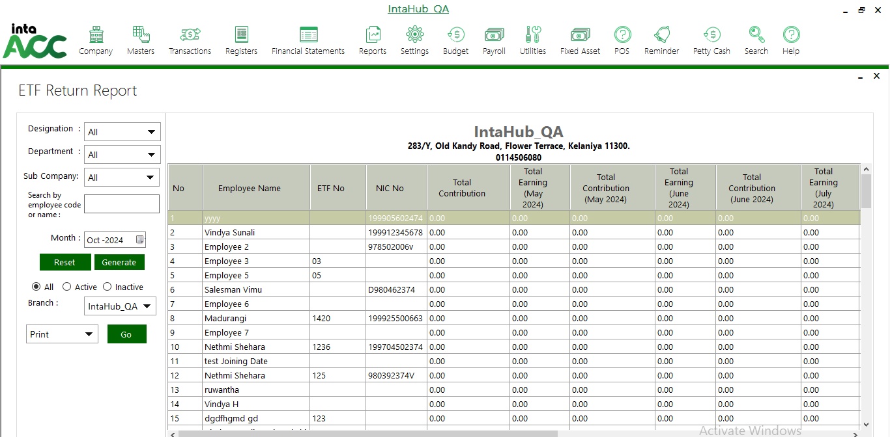

Monthly Salary Comparison Report
Click on Payroll >> Payroll Reports>> Monthly Salary Comparison Report
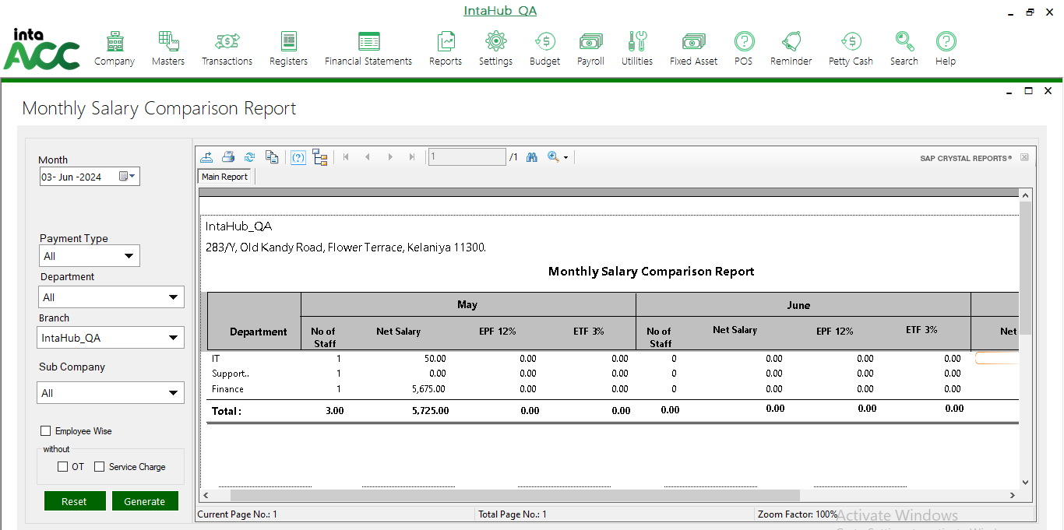

Basic Salary Reconciliation
Click on Payroll >> Payroll Reports>> Basic Salary Reconciliation
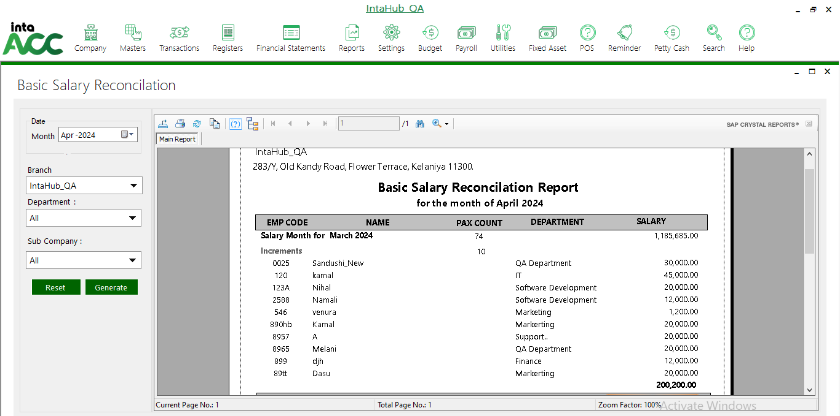

EPF Submission
Click on Payroll >> Payroll Reports>> EPF Submission
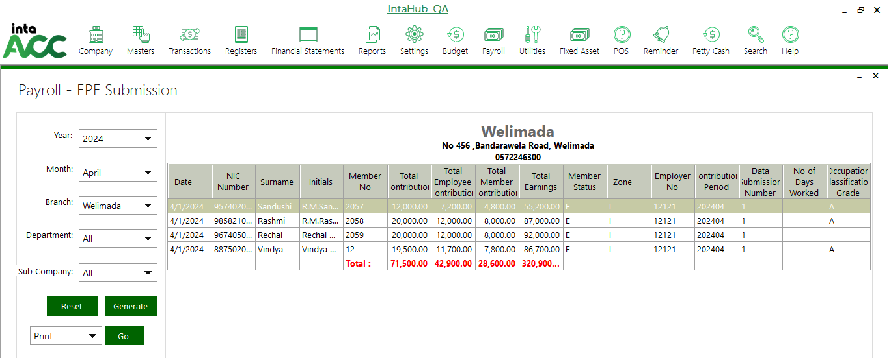

EPF/ ETF Export
Click on Payroll >> Payroll Reports>> EPF/ETF Export
