FIXED ASSET
USER MANUAL

2024/10/01

TABLE OF CONTENTS

1. INTRODUCTION 3
2. POLICY 4
3. MATERIAL 5
4. STATUS 6
5. FIXED ASSET PRODUCT 7
6. FIXED ASSET PURCHASE INVOICE 8
7. FIXED ASSET OPEN ENTRY PURCHASE INVOICE 9
8. FIXED ASSET DISPOSAL 11
9. FIXED ASSET REVALUATION 12
10. REGISTER 14
11. DEPRICIATION SCHEDULAR 15
12. REPORTS 16
12.1 Fixed Assets Listing Report 16
12.2 Fixed Assets Register Report 16
12.3 Fixed Assets Transaction Report 17
12.4 Fixed Assets Detail Summary Report 17
12.5 Fixed Assets Category Summary Report 18
12.6 Depreciation Transaction Report 18
12.7 Depreciation Details Report 19
12.8 Depreciation Category Report 19
12.9 Purchase/Open Entry Invoice Report 20
12.10 Purchase/Open Entry Invoice Listing Report 20
12.11 Disposal Transaction Report 21
12.12 Revaluation Transaction Report 21
12.13 Revaluation Gain/Loss Report 22

INTRODUCTION
IntaAcc Fixed Assets Management software helps you track purchase cost, valuation, depreciation and gain or loss on your assets. Because of the complexity of the financial calculations, using IntaAcc Fixed Assets Management can save hours compared to manual Fixed asset management.
Fixed asset software tracks and maintains an organization’s entire physical asset and equipment inventory, including vehicles, computers, furniture, and machinery. The software can also automate inventory management capabilities combined with audit trails involved in asset tracking.
- Features of the product
- Assets management
- Assets tracking
- Depreciation calculation
- Assets Transactions
- Reporting
- Get notified
Fixed asset module shown as following window.
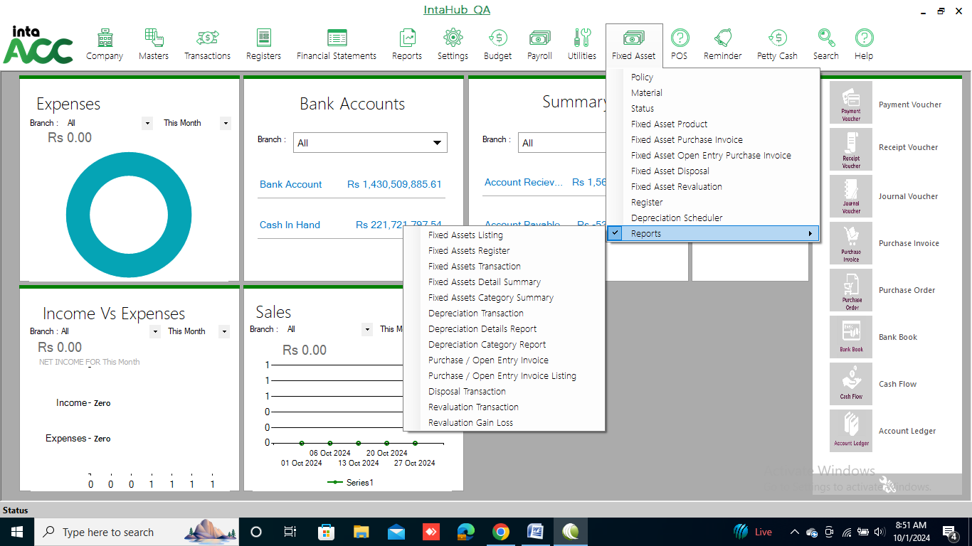

POLICY
Click on Fixed Asset >> Policy.
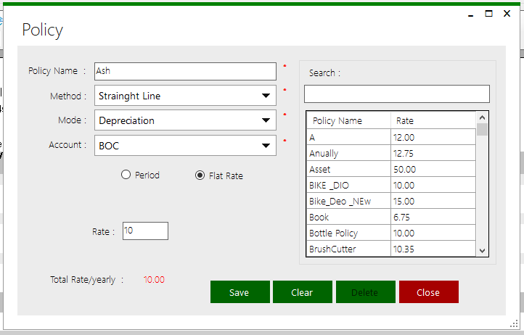
- Click on flat rate and give amount to give flat rate.
- Click on period and select No of years or months to give period rate.

All existing policies are shown here.
- Click on the policy that you want to view.
- You can see the details of particular policy in corresponding fields

This form is for:
- Adding a new Policy.
- Editing details of existing Policy.
- Deleting an existing Policy.
- View details of existing Policy.
- Search details of Policy.

Add a new Policy
- Enter details such as Policy name, under description in corresponding fields.
- Click on <Save> button to save.

Edit details of Policy
- Select a row from register.
- Details of the selected Policy will show in corresponding fields at left side of the form.
- Edit the details that you want.
- Click on <Update > button to save the changes.

Delete an existing Policy
- Select a row from register.
- Click on <Delete > button.
- Confirmation is asked for deletion.
- The selected Policy is deleted from the list if no reference exists for selected Policy.

Searching of Policy
Type the name of Policy in search field. All account groups starting with that name are displayed in list from where particular Policy can be selected.

MATERIAL
Click on Fixed Asset >> Material.
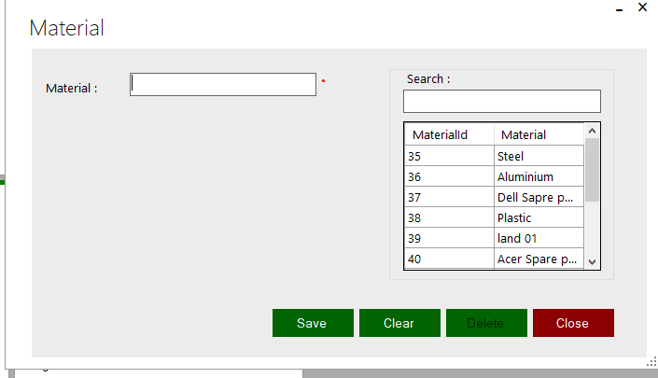
This form is for:
- Adding a new Material.
- Editing details of existing Material.
- Deleting an existing Material.
- View details of existing Material.
- Search details of Material.

Add a new Material
- Enter details such as Material, under description in corresponding fields.
- Click on <Save> button to save.

Edit details of Material
- Select a row from register.
- Details of the selected Material will show in corresponding fields at left side of the form.
- Edit the details that you want.
- Click on <Update > button to save the changes.

Delete an existing Material
- Select a row from register.
- Click on <Delete > button.
- Confirmation is asked for deletion.
- The selected Policy is deleted from the list if no reference exists for selected Material.

Searching of Material
Type the name of Material in search field. All account groups starting with that name are displayed in list from where particular Material can be selected.

STATUS
Click on Fixed Asset >> Status.
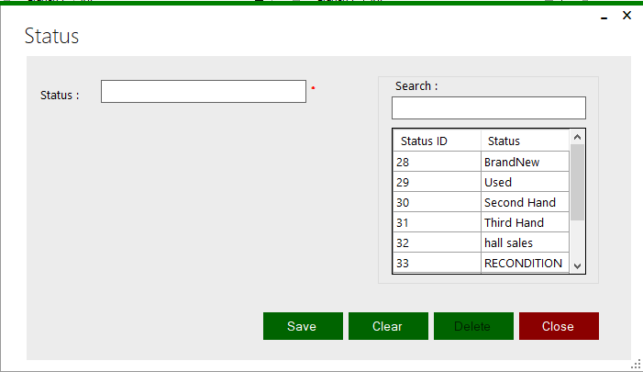
This form is for:
- Adding a new Fixed Asset.
- Editing details of existing Fixed Asset.
- Deleting an existing Fixed Asset.
- View details of existing Fixed Asset.
- Search details of Fixed Asset.

Add a new Fixed Asset
- Enter details such as Fixed Asset, under description in corresponding fields.
- Click on <Save> button to save.

Edit details of Fixed Asset
- Select a row from register.
- Details of the selected Fixed Asset will show in corresponding fields at left side of the form.
- Edit the details that you want.
- Click on <Update > button to save the changes.

Delete an existing Fixed Asset
- Select a row from register.
- Click on <Delete > button.
- Confirmation is asked for deletion.
- The selected Fixed Asset is deleted from the list if no reference exists for selected Fixed Asset.

Searching of Fixed Asset
Type the name of Fixed Asset in search field. All account groups starting with that name are displayed in list from where particular Fixed Asset can be selected.

FIXED ASSET PRODUCT
Click on Fixed Asset >> Fixed Asset Product.
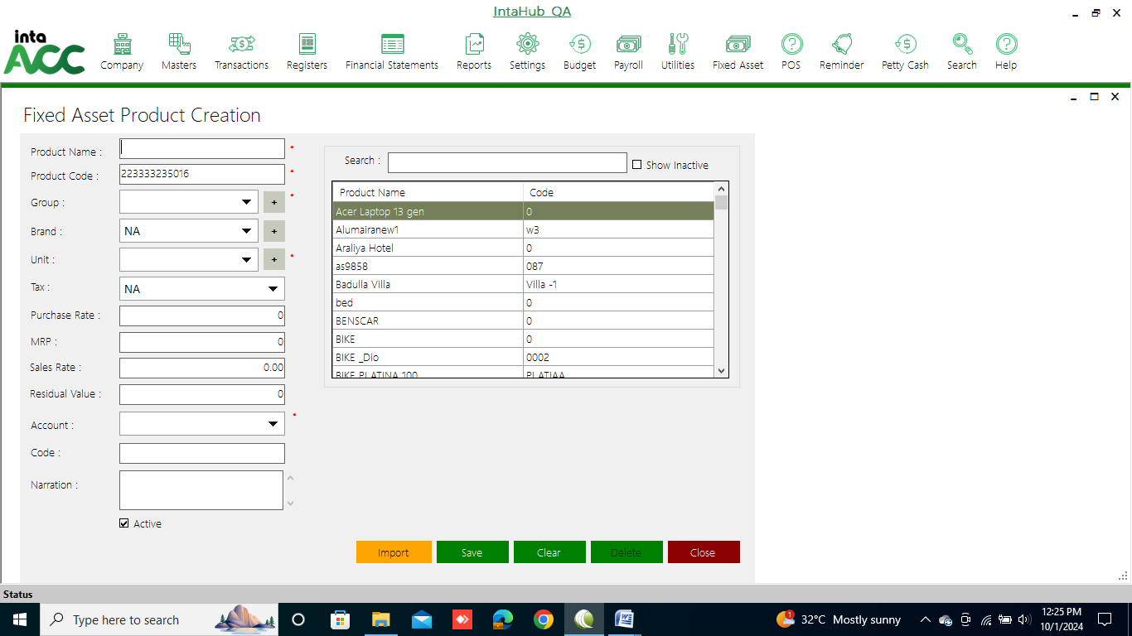
This form is for:
- Adding a new Fixed Asset Product.
- Editing details of existing Fixed Asset Product.
- Deleting an existing Fixed Asset Product.
- View details of existing Fixed Asset Product.
- Search details of Fixed Asset Product.

Add a new Fixed Asset Product
- Enter details such as Fixed Asset Product, under description in corresponding fields.
- Click on <Save> button to save.

Edit details of Fixed Asset Product
- Select a row from register.
- Details of the selected Fixed Asset Product will show in corresponding fields at left side of the form.
- Edit the details that you want.
- Click on <Update > button to save the changes.

Delete an existing Fixed Asset Product
- Select a row from register.
- Click on <Delete > button.
- Confirmation is asked for deletion.
- The selected Fixed Asset Product is deleted from the list if no reference exists for selected Fixed Asset Product.

Searching of Fixed Asset Product
Type the name of Fixed Asset Product in search field. All account groups starting with that name are displayed in list from where particular Fixed Asset Product can be selected.

FIXED ASSET PURCHASE INVOICE
Click on Fixed Asset >> Fixed Asset Purchase Invoice.
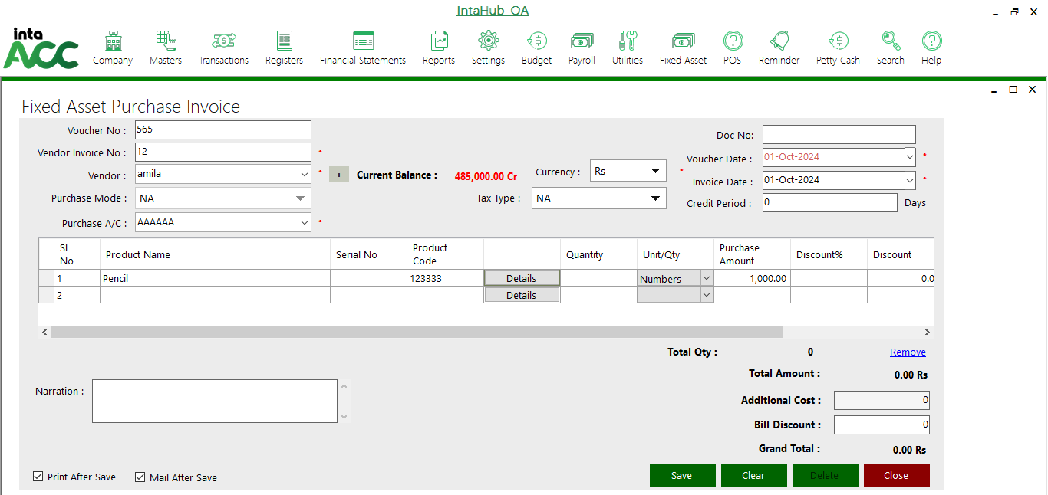
Enter details under description in corresponding fields. Then add product code and click Details to get following window.
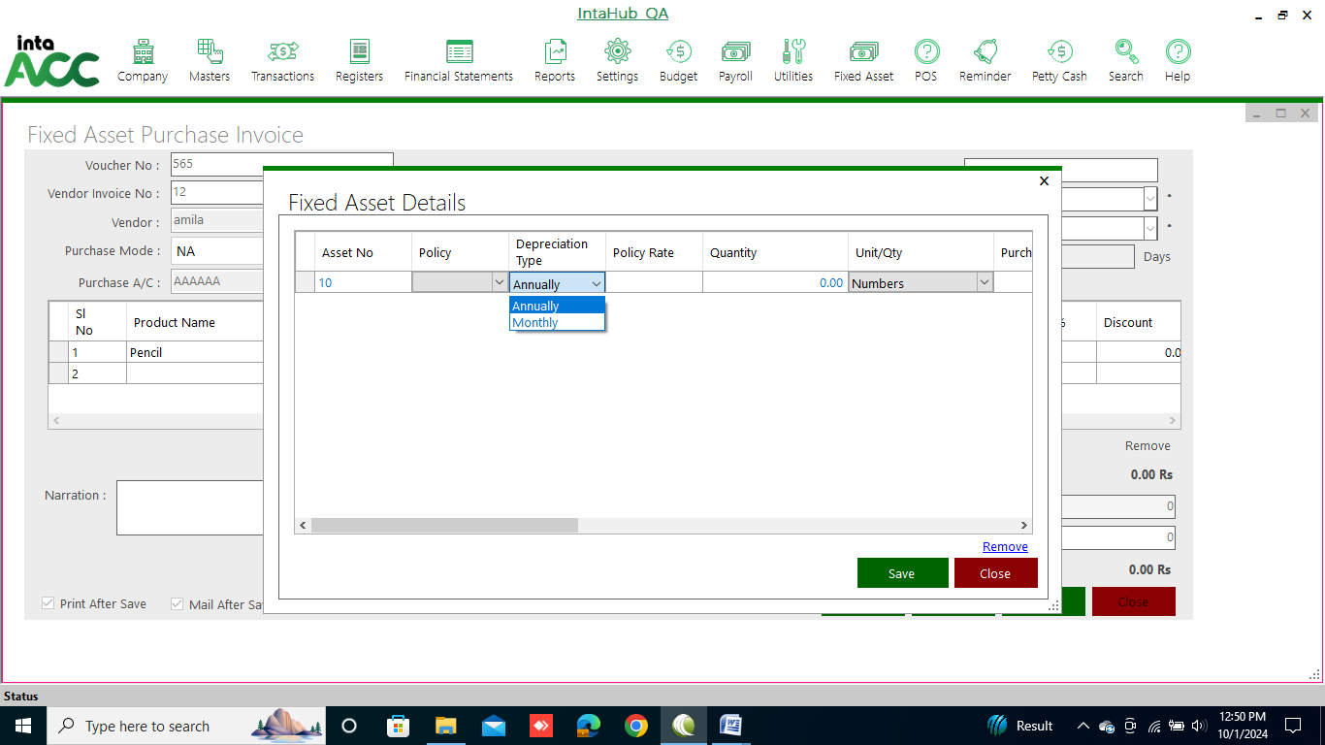
This form is for:
- Adding a new Fixed Asset Purchase Invoice.
- Editing details of existing Fixed Asset Purchase Invoice.
- Deleting an existing Fixed Asset Purchase Invoice.
- View details of existing Fixed Asset Purchase Invoice.

Add a new Fixed Asset Purchase Invoice
- Enter details such as Fixed Asset Purchase Invoice, under description in corresponding fields.
- Click on <Save> button to save.

Edit details of Fixed Asset Purchase Invoice
- Select a row from register.
- Details of the selected Fixed Asset Purchase Invoice will show in corresponding fields at left side of the form.
- Edit the details that you want.
- Click on <Update > button to save the changes.

Delete an existing Fixed Asset Purchase Invoice
- Select a row from register.
- Click on <Delete > button.
- Confirmation is asked for deletion.
- The selected Fixed Asset Purchase Invoice is deleted from the list if no reference exists for selected Fixed Asset Purchase Invoice.

FIXED ASSET OPEN ENTRY PURCHASE INVOICE
Click on Fixed Asset >> Fixed Asset Open Entry Purchase Invoice to add not added entry in opening balance.
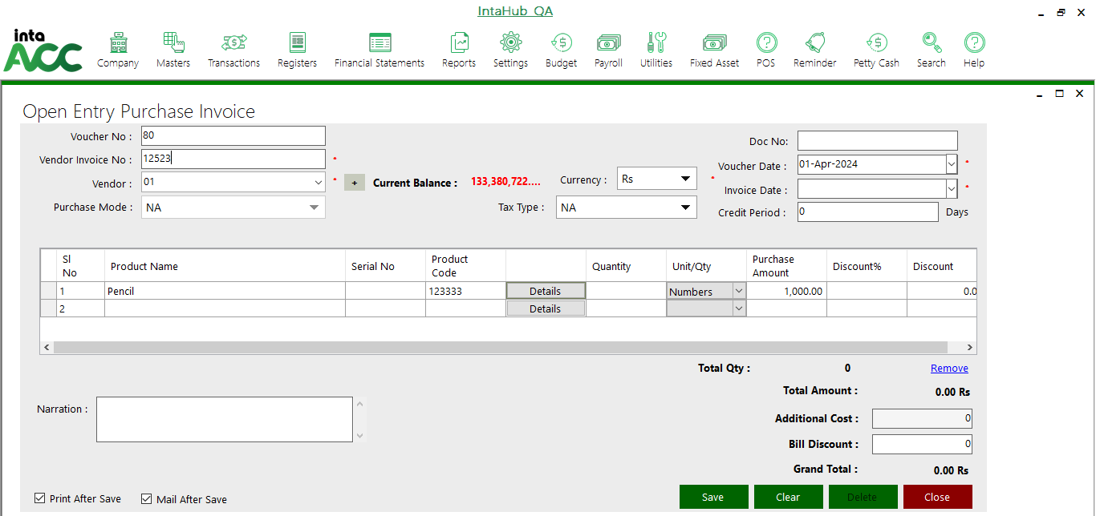
Enter details under description in corresponding fields. Then add product code and click Details to get following window.
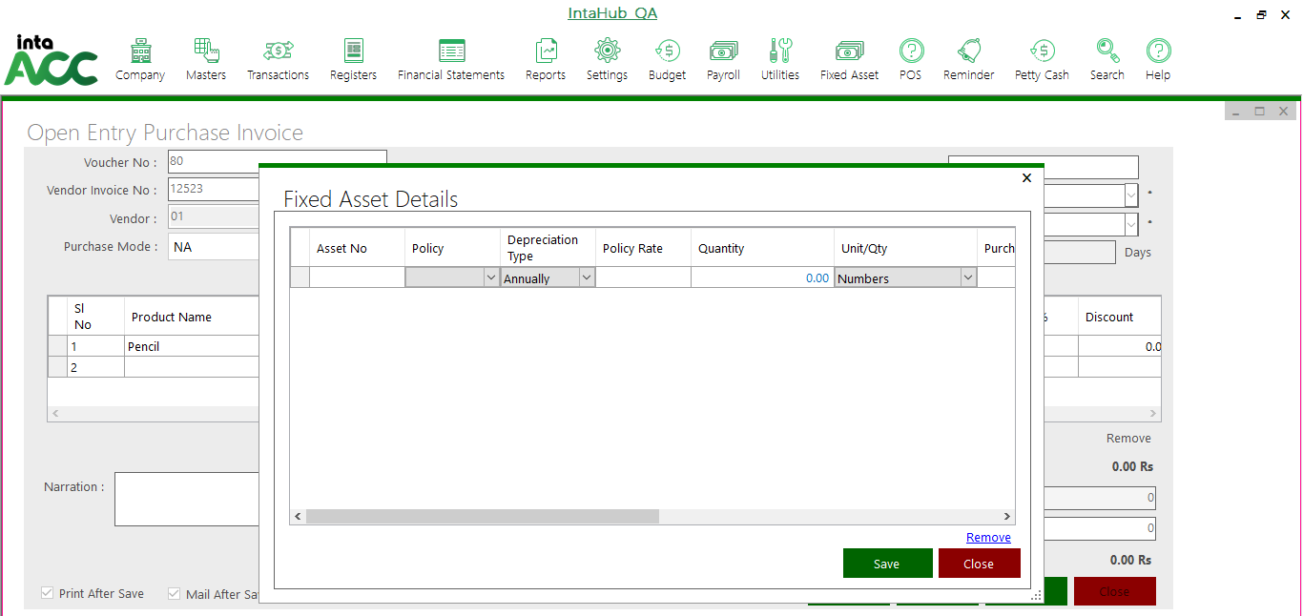
This form is for:
- Adding a new Fixed Asset Open Entry Purchase Invoice.
- Editing details of existing Fixed Asset Open Entry Purchase Invoice.
- Deleting an existing Fixed Asset Open Entry Purchase Invoice.
- View details of existing Fixed Asset Open Entry Purchase Invoice.

Add a new Fixed Asset Open Entry Purchase Invoice
- Enter details such as Fixed Asset Open Entry Purchase Invoice, under description in corresponding fields.
- Click on <Save> button to save.

Edit details of Fixed Asset Open Entry Purchase Invoice
- Select a row from register.
- Details of the selected Fixed Asset Open Entry Purchase Invoice will show in corresponding fields at left side of the form.
- Edit the details that you want.
- Click on <Update > button to save the changes.

Delete an existing Fixed Asset Open Entry Purchase Invoice
- Select a row from register.
- Click on <Delete > button.
- Confirmation is asked for deletion.
- The selected Fixed Asset Open Entry Purchase Invoice is deleted from the list if no reference exists for selected Fixed Asset Open Entry Purchase Invoice.

FIXED ASSET DISPOSAL
Click on Fixed Asset >> Fixed Asset Disposal.
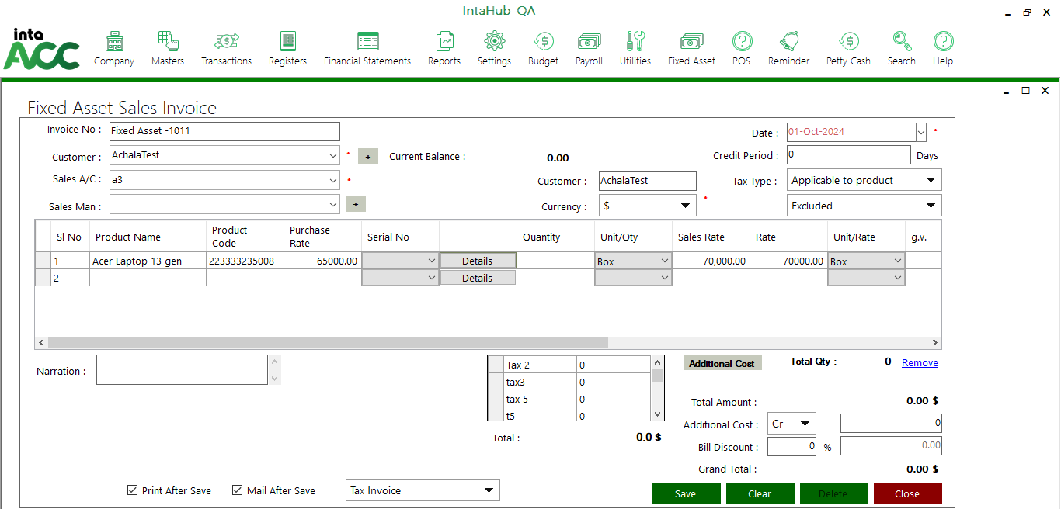
Enter details under description in corresponding fields. Then add product Name or code and click Details to get following window.
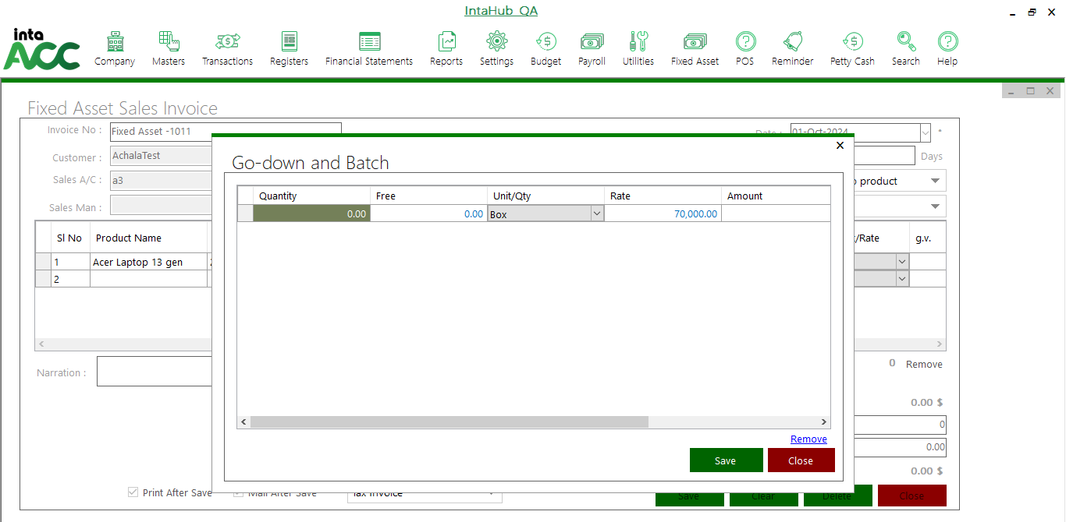
This form is for:
- Adding a new Fixed Asset Disposal.
- Editing details of existing Fixed Asset Disposal.
- Deleting an existing Fixed Asset Disposal.
- View details of existing Fixed Asset Disposal.

Add a new Fixed Asset Disposal
- Enter details such as Fixed Asset Disposal, under description in corresponding fields.
- Click on <Save> button to save.

Edit details of Fixed Asset Disposal
- Select a row from register.
- Details of the selected Fixed Asset Disposal will show in corresponding fields at left side of the form.
- Edit the details that you want.
- Click on <Update > button to save the changes.

Delete an existing Fixed Asset Disposal
- Select a row from register.
- Click on <Delete > button.
- Confirmation is asked for deletion.
- The selected Fixed Asset Disposal is deleted from the list if no reference exists for selected Fixed Asset Disposal.

FIXED ASSET REVALUATION
Click on Fixed Asset >> Fixed Asset Revaluation.
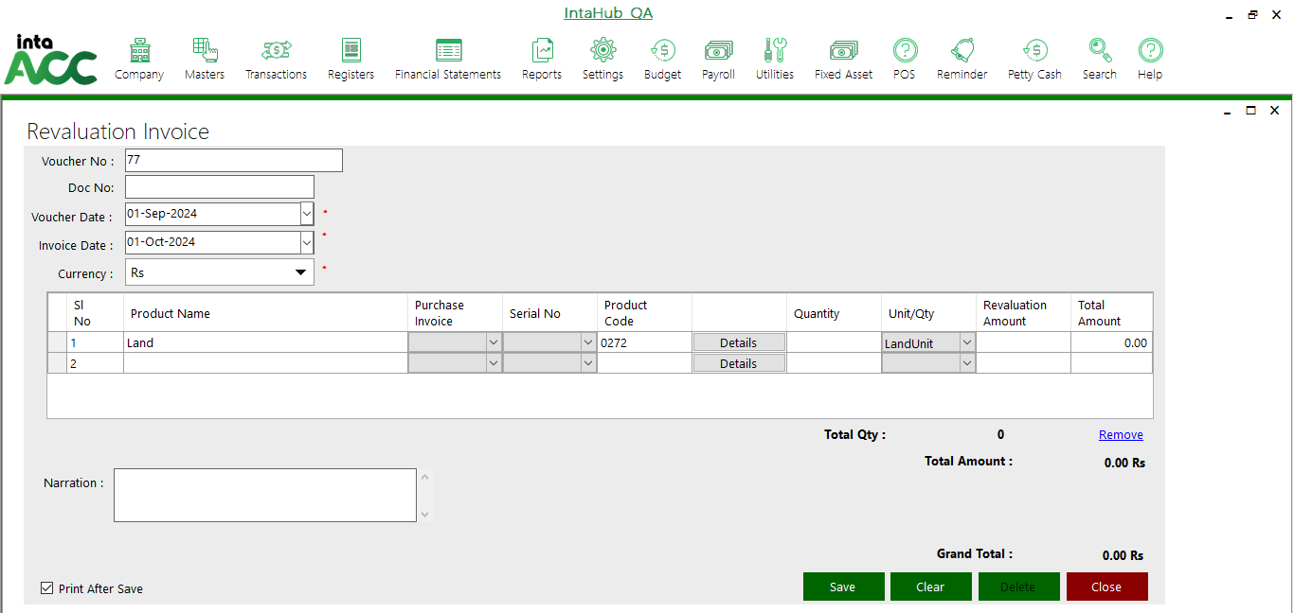
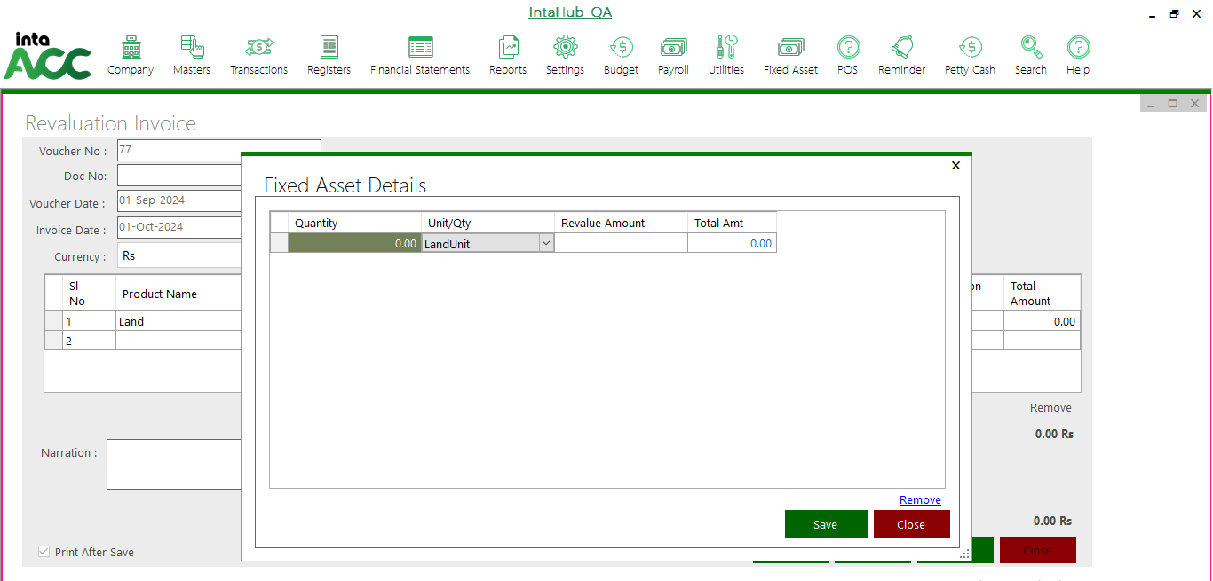

This form is for:
- Adding a new Fixed Asset Revaluation.
- Editing details of existing Fixed Asset Revaluation.
- Deleting an existing Fixed Asset Revaluation.
- View details of existing Fixed Asset Revaluation.

Add a new Fixed Asset Revaluation
- Enter details such as Fixed Asset Revaluation, under description in corresponding fields.
- Click on <Save> button to save.

Edit details of Fixed Asset Revaluation
- Select a row from register.
- Details of the selected Fixed Asset Revaluation will show in corresponding fields at left side of the form.
- Edit the details that you want.
- Click on <Update > button to save the changes.

Delete an existing Fixed Asset Revaluation
- Select a row from register.
- Click on <Delete > button.
- Confirmation is asked for deletion.
- The selected Fixed Asset Revaluation is deleted from the list if no reference exists for selected Fixed Asset Revaluation.

REGISTER
Click on Fixed Asset >> Register.
Here select the date to view Open entry, Current entry, Sales Invoice, or Revaluation entry fixed asset Register
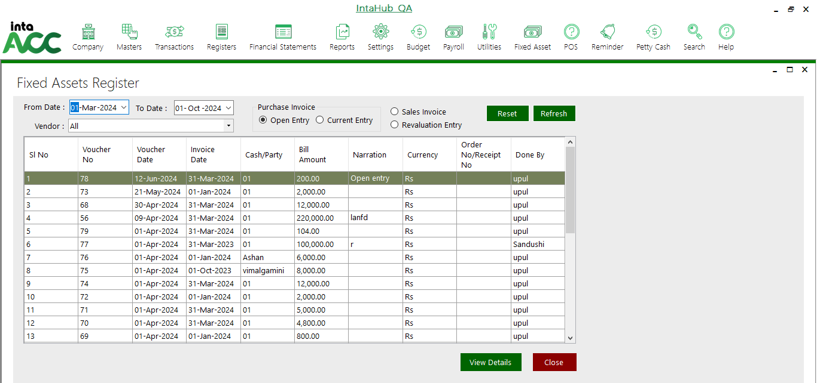
Once select voucher and click on view details then it will be open the this window.
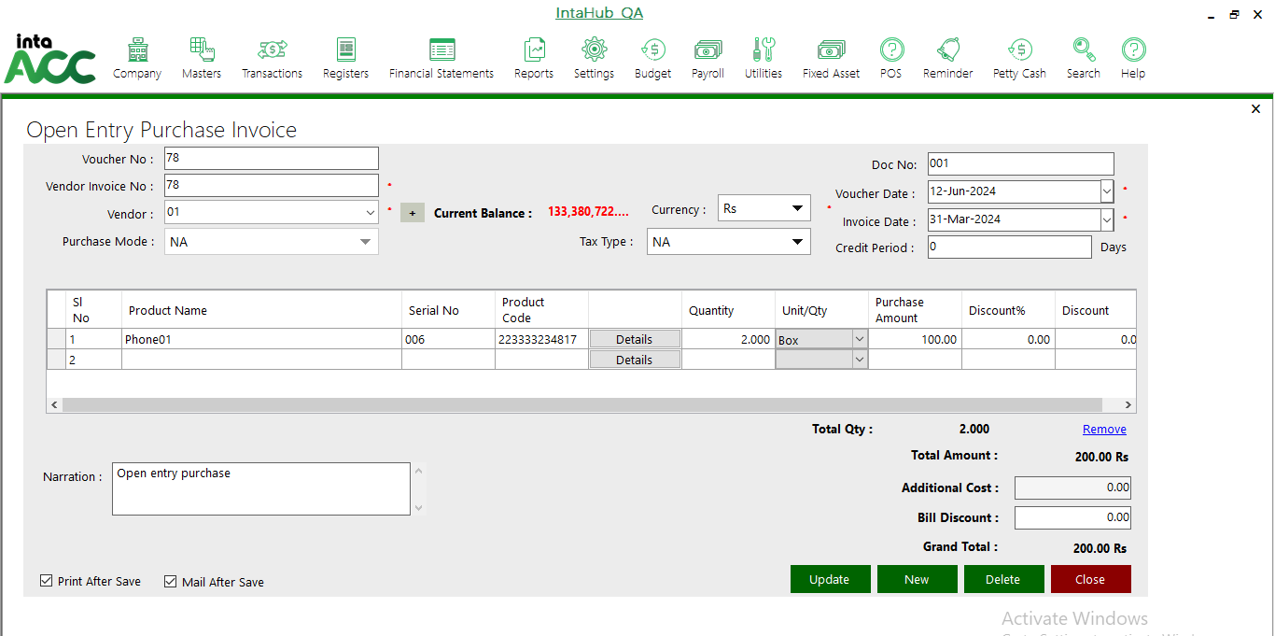

DEPRICIATION SCHEDULAR
Click on Fixed Asset >> Depreciation Scheduler.
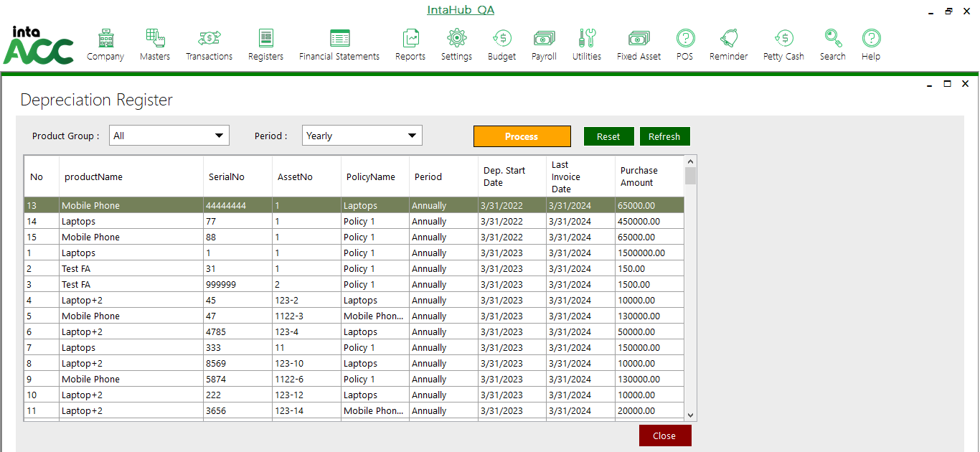
Then click on the Process button and take a backup. It can be shown as follow.
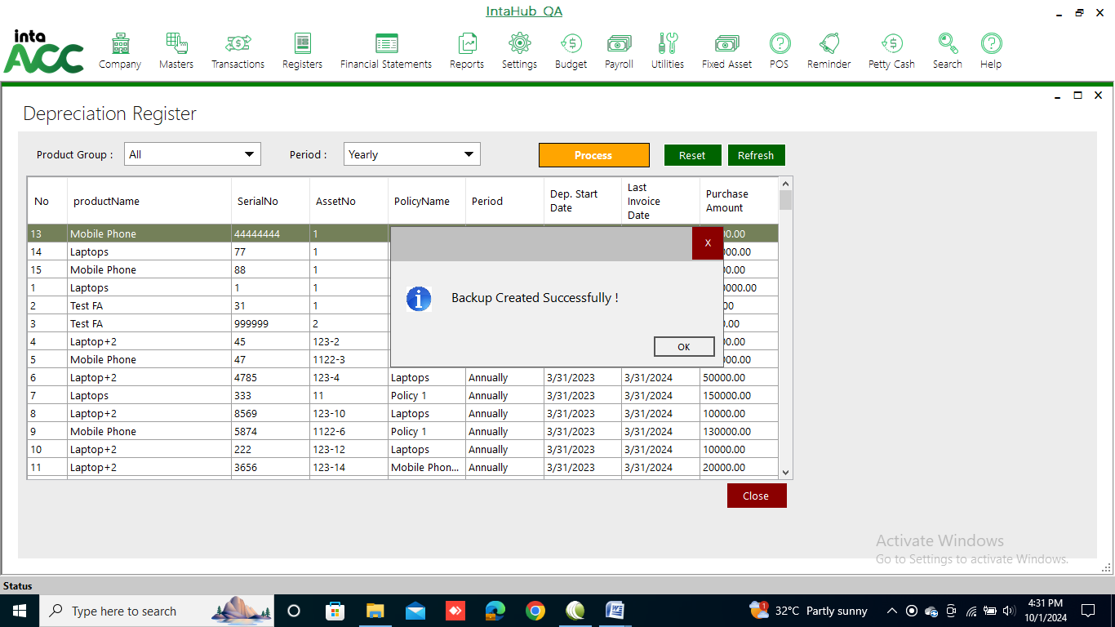

REPORTS
Click on Fixed Asset>> Reports. Following reports can see under the reports.

Fixed Assets Listing Report
Click on Fixed Assets >> Reports>> Fixed Asset Listing Report to view the report.
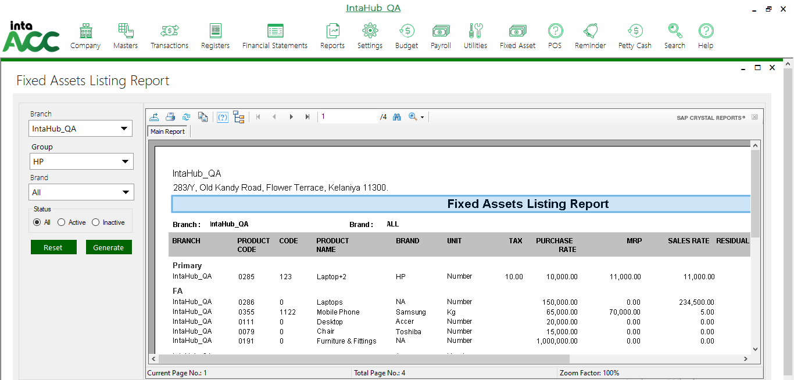

Fixed Assets Register Report
Click on Fixed Assets >> Reports>> Fixed Asset Register Report to view the report.
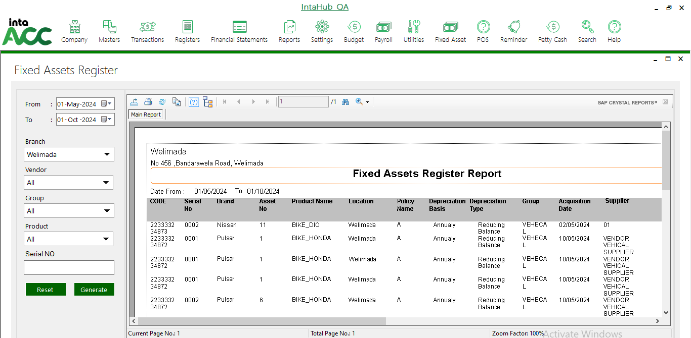

Fixed Assets Transaction Report
Click on Fixed Assets >> Reports>> Fixed Asset Transaction Report to view the report.
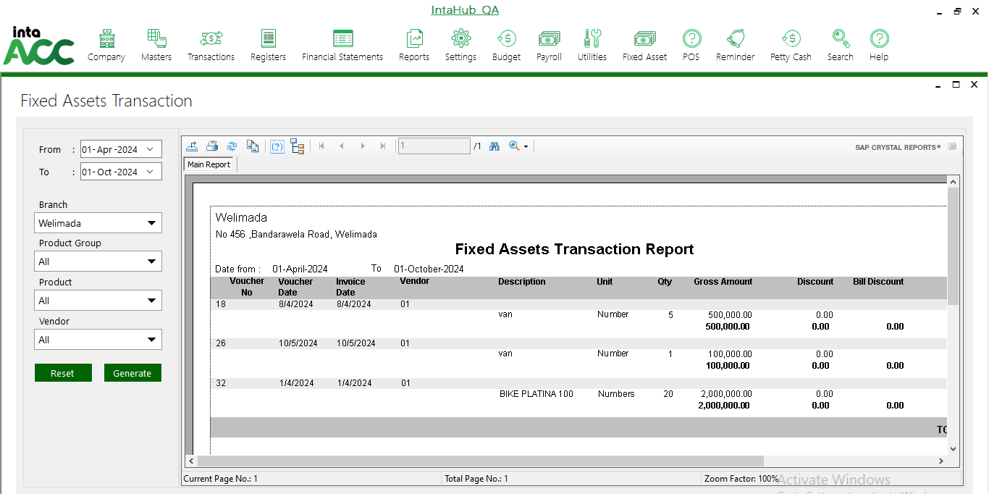

Fixed Assets Detail Summary Report
Click on Fixed Asset >> Reports>> Fixed Assets Detail Summary Report to view the report.
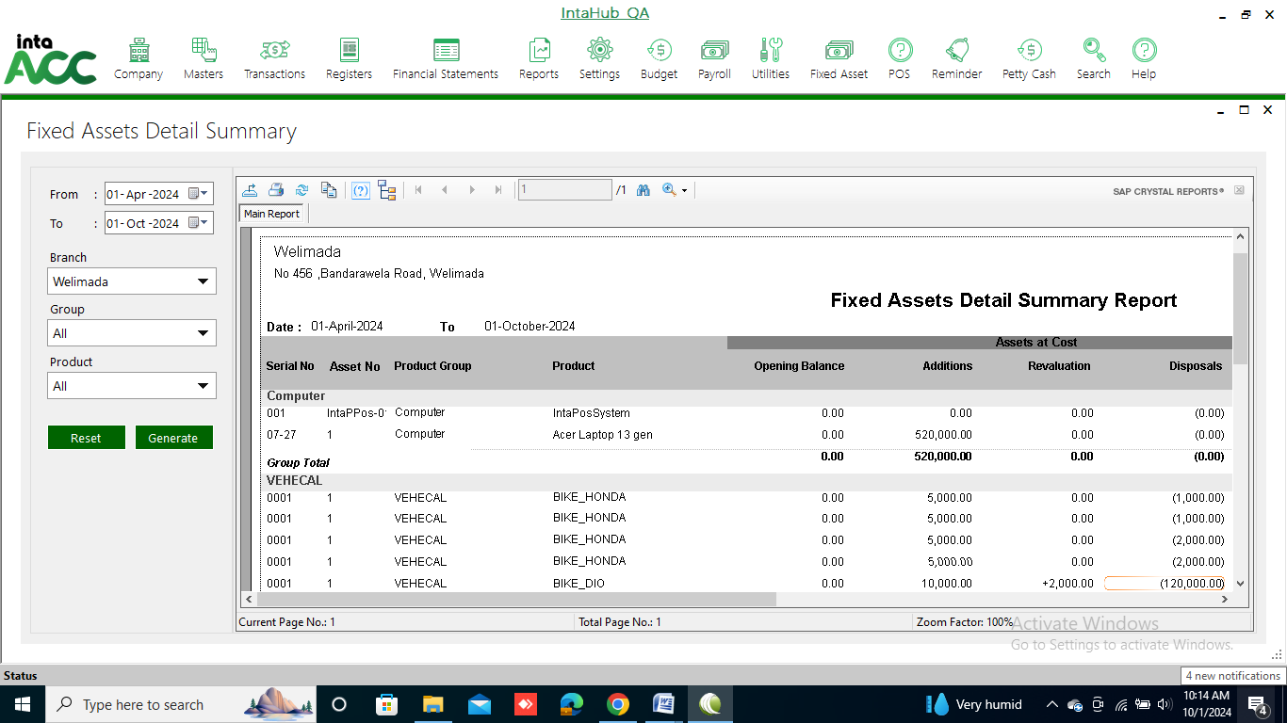

Fixed Assets Category Summary Report
Click on Fixed Asset >> Reports>> Fixed Assets Category Summary Report to view the report.
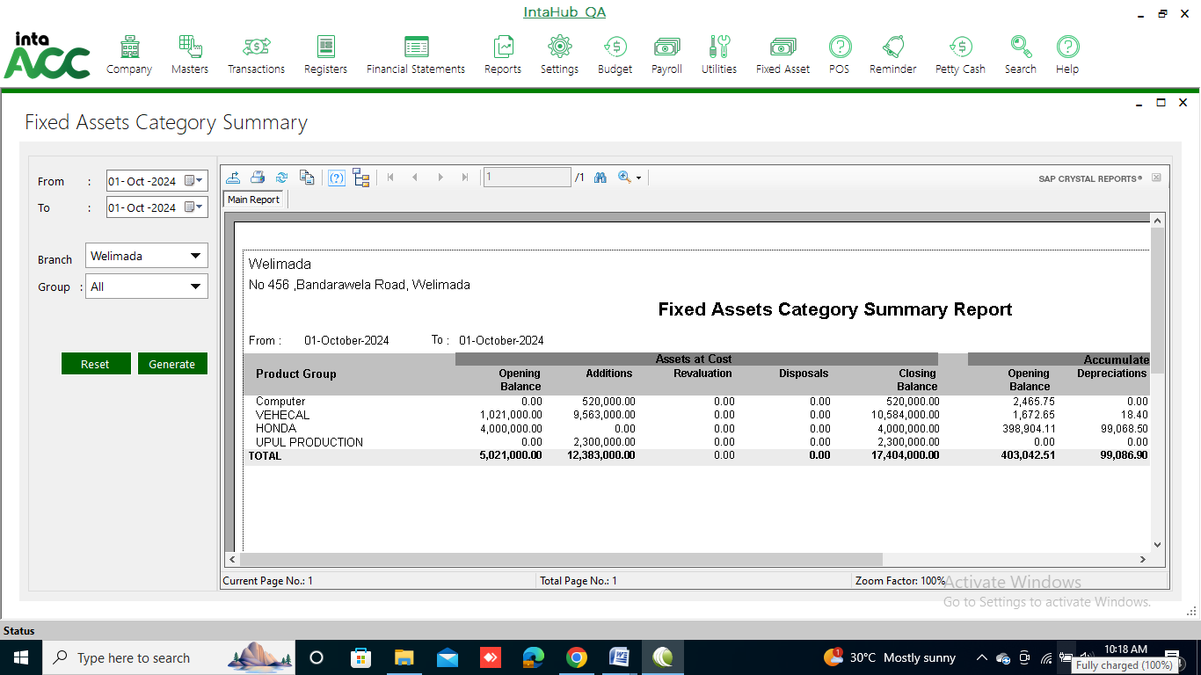

Depreciation Transaction Report
Click on Fixed Asset >> Reports>> Depreciation Transaction Report to view the report.
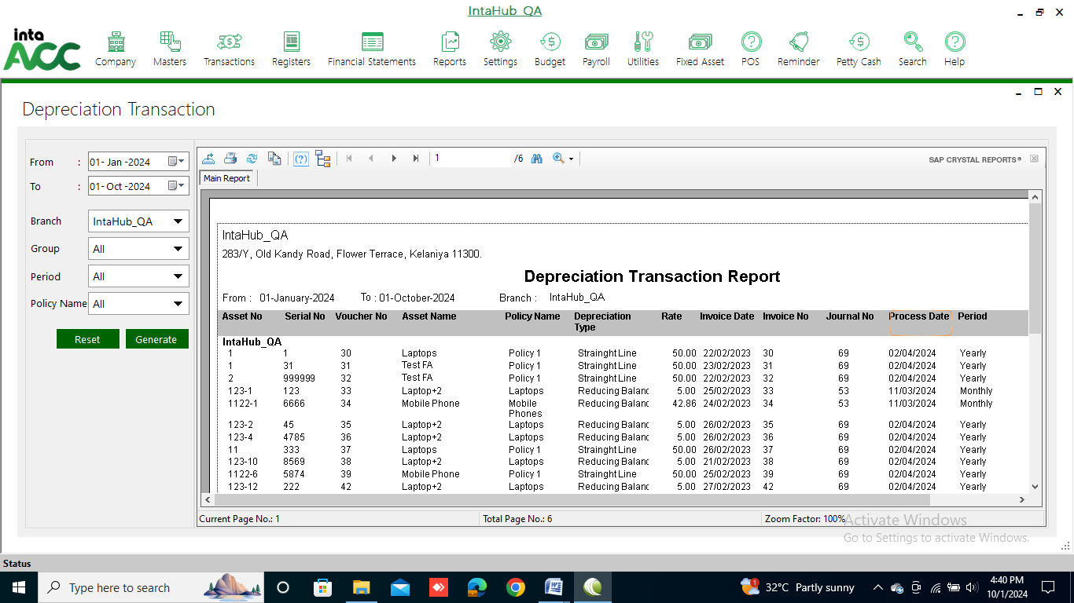

Depreciation Details Report
Click on Fixed Asset >> Reports>> Depreciation Details Report to view the report.
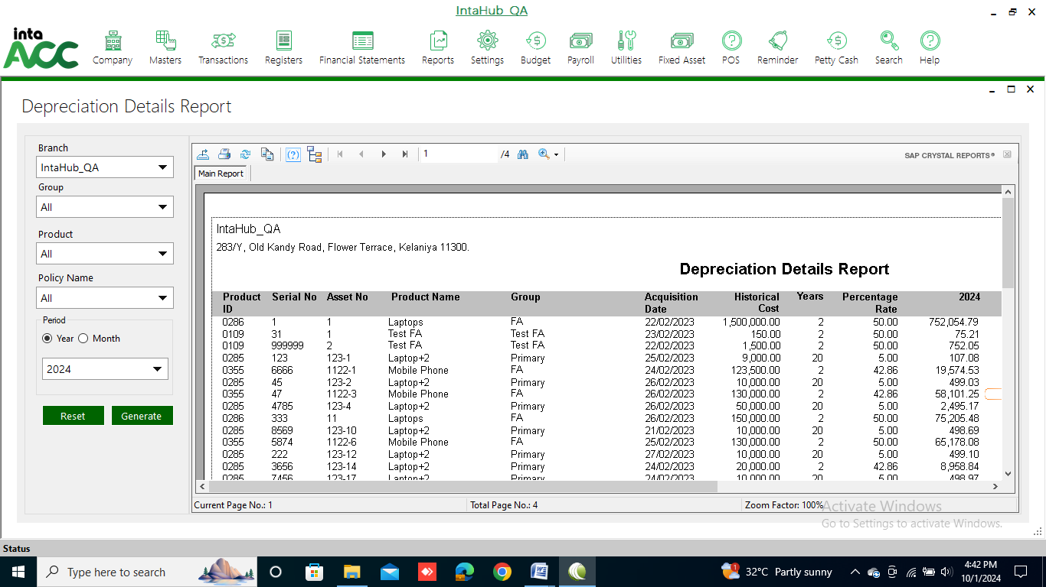

Depreciation Category Report
Click on Fixed Asset >> Reports>> Depreciation Category Report to view the report.
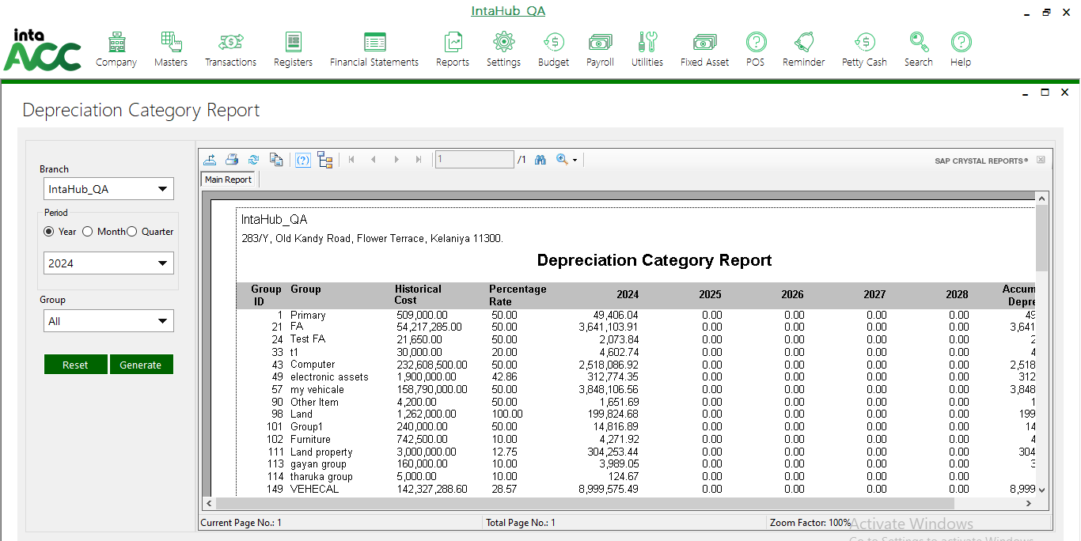

Purchase/Open Entry Invoice Report
Click on Fixed Asset >> Reports>> Purchase/Open Entry Invoice Report to view the report.
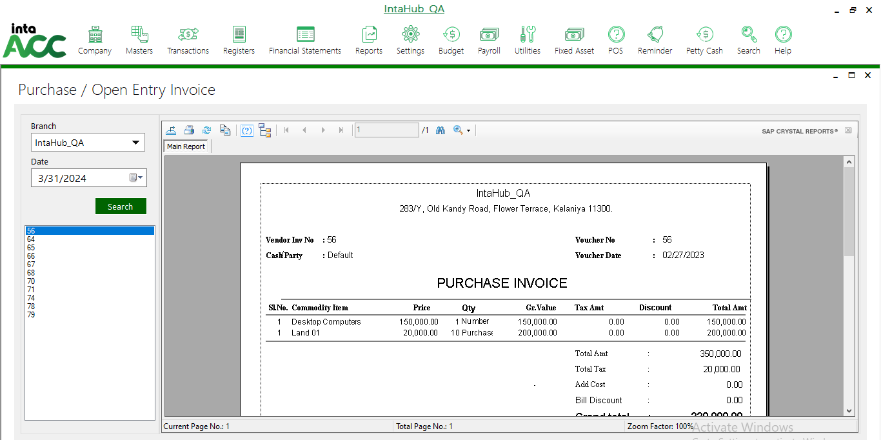

Purchase/Open Entry Invoice Listing Report
Click on Fixed Asset >> Reports>> Purchase/Open Entry Invoice Listing Report to view the report.
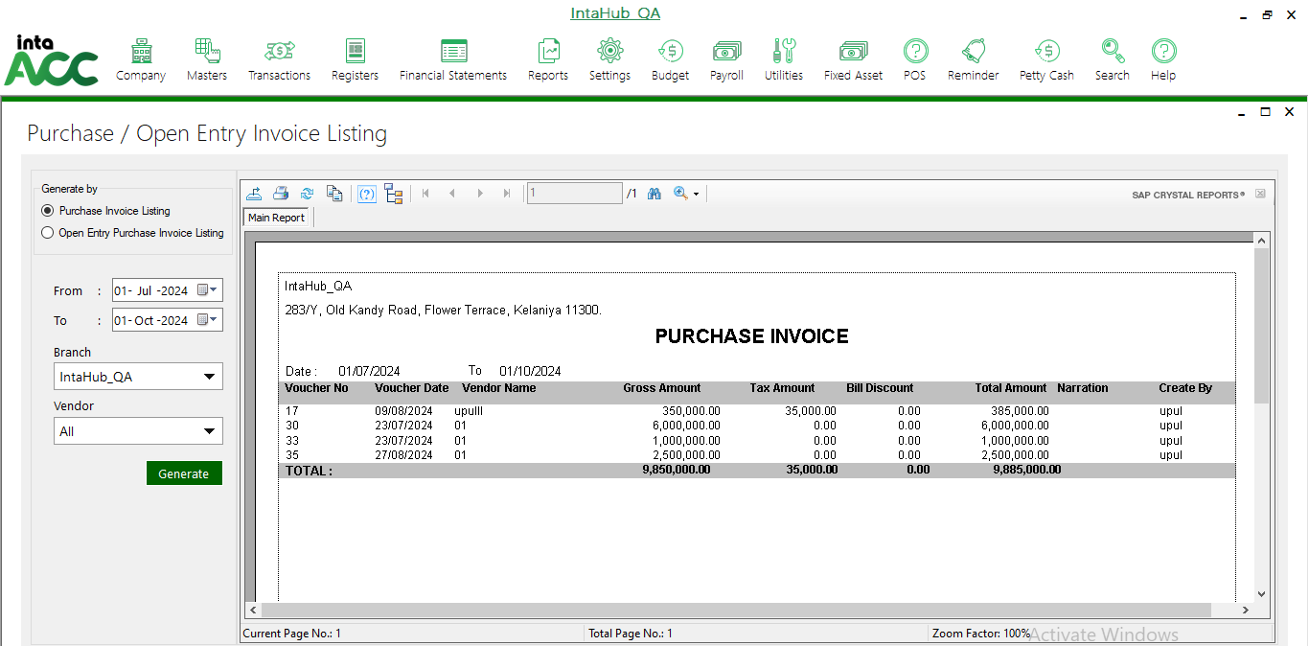

Disposal Transaction Report
Click on Fixed Asset >> Reports>> Disposal Transaction Report to view the report.
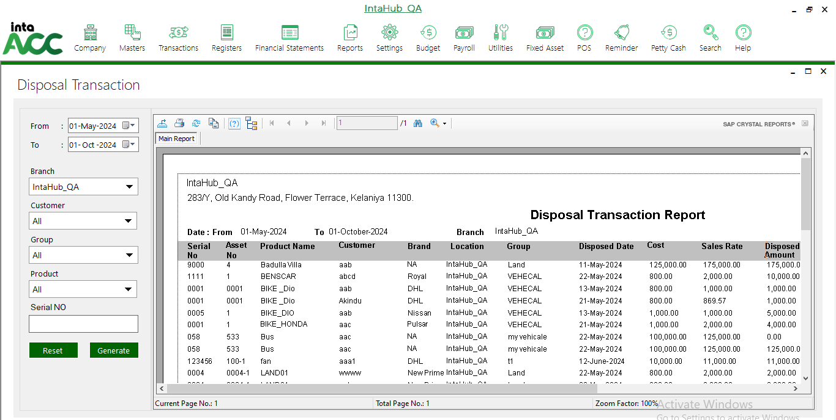

Revaluation Transaction Report
Click on Fixed Asset >> Reports>> Revaluation Transaction Report to view the report.
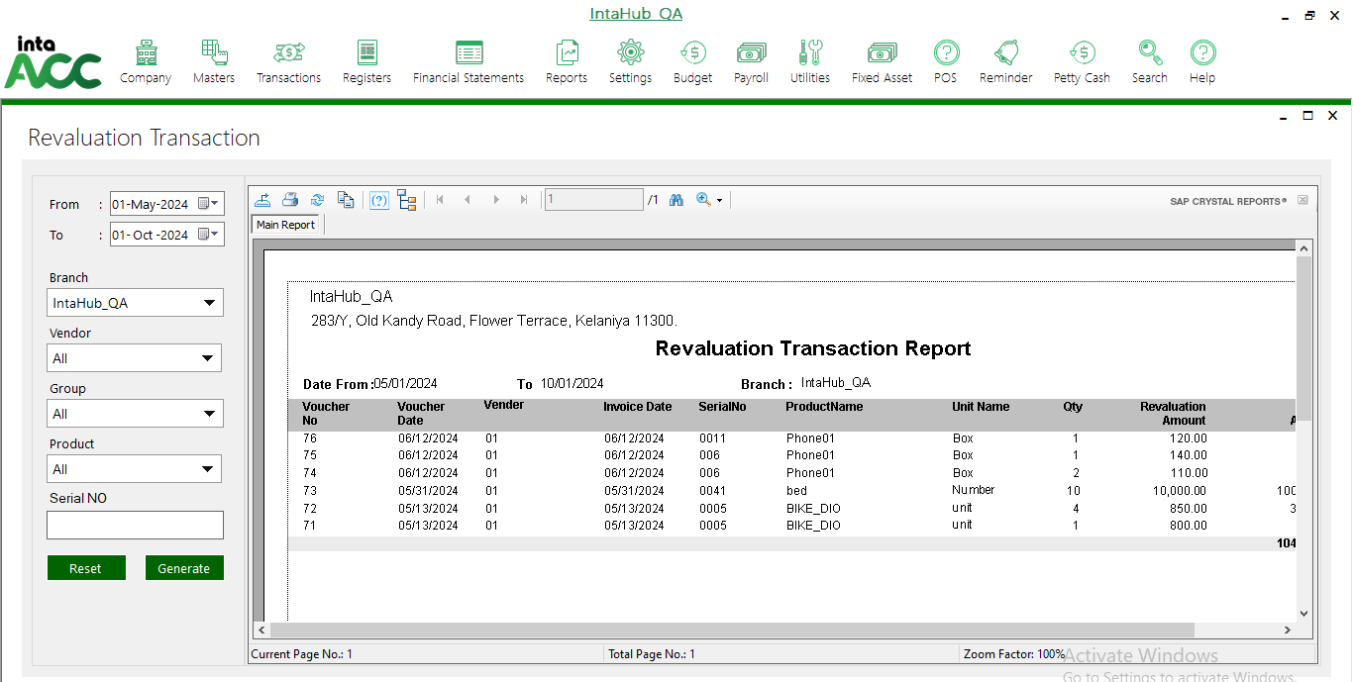

Revaluation Gain/Loss Report
Click on Fixed Asset >> Reports>> Revaluation Gain/Loss Report to view the report.
